**DAILY REPORT**

**Student Name :SUSHMITHA.B.POOJARY**

**Class and Sec : VI B**

**USN :4AL17CS103**

**DATE:15-06-2020**

|  |  |  |  |  |
| --- | --- | --- | --- | --- |
| **Online Test Details** | | | | |
| **Subject** | **C programming and python workshop quiz** | | | |
| **Semester** | **VI -B** | | **Duration** | **30 Minutes** |
| **% of marks 20-python workshop quiz**  **6-c programming quiz** | | **13(python workshop quiz**  **6(c programming quiz)** | | |

**snapshot of the test result**

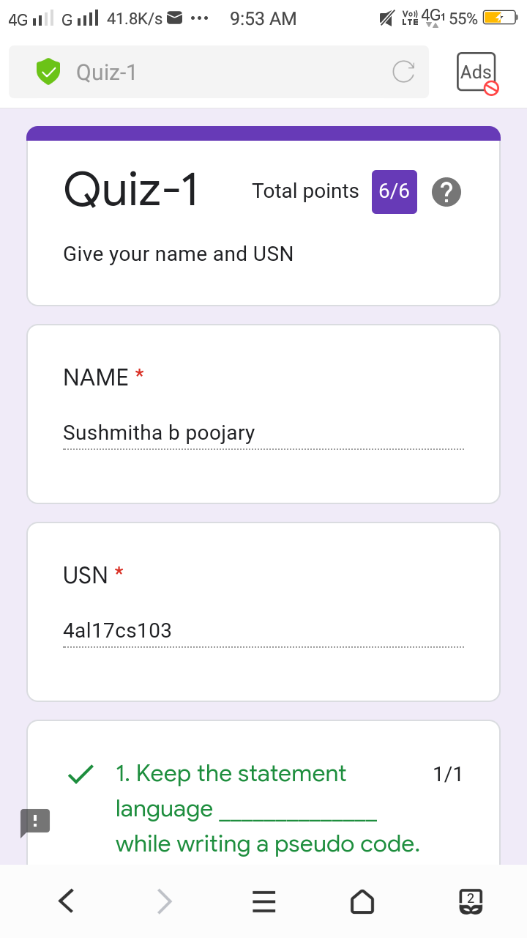

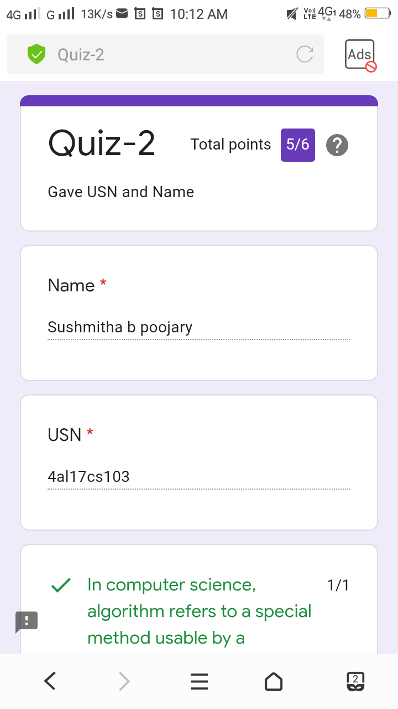

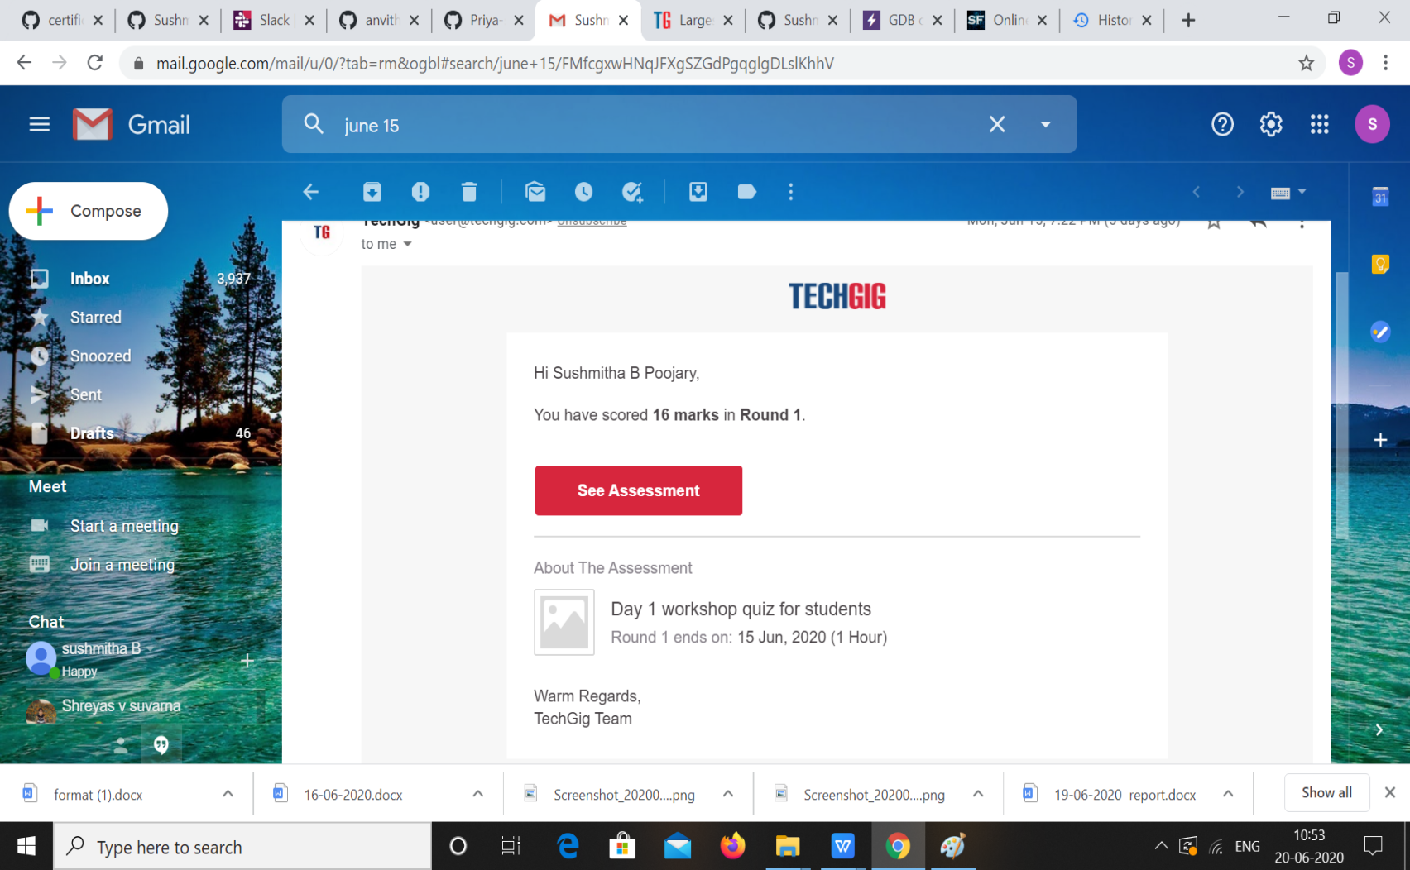

|  |  |  |  |
| --- | --- | --- | --- |
| **Pre-Placement Training Summary** | | | |
| **PREPLACEMRNT TRAINING** | **PROGRAMMING IN C (9 to 11am)**  **APPLICATION OF PYTHON DA AND ML(11am to 1pm)** | | |
| **FACULTY** | **Vivek Sharma,**  **Dr. Mohideen Badusha** | **Duration** | **4HOURS** |

**snapshots of the daily class acitivities**

**Programming in c**

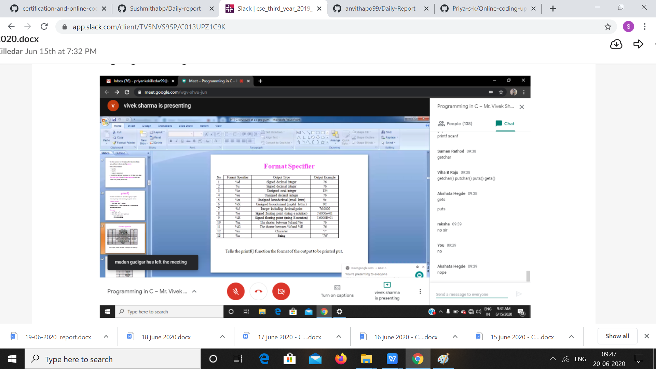

**Python workshop**

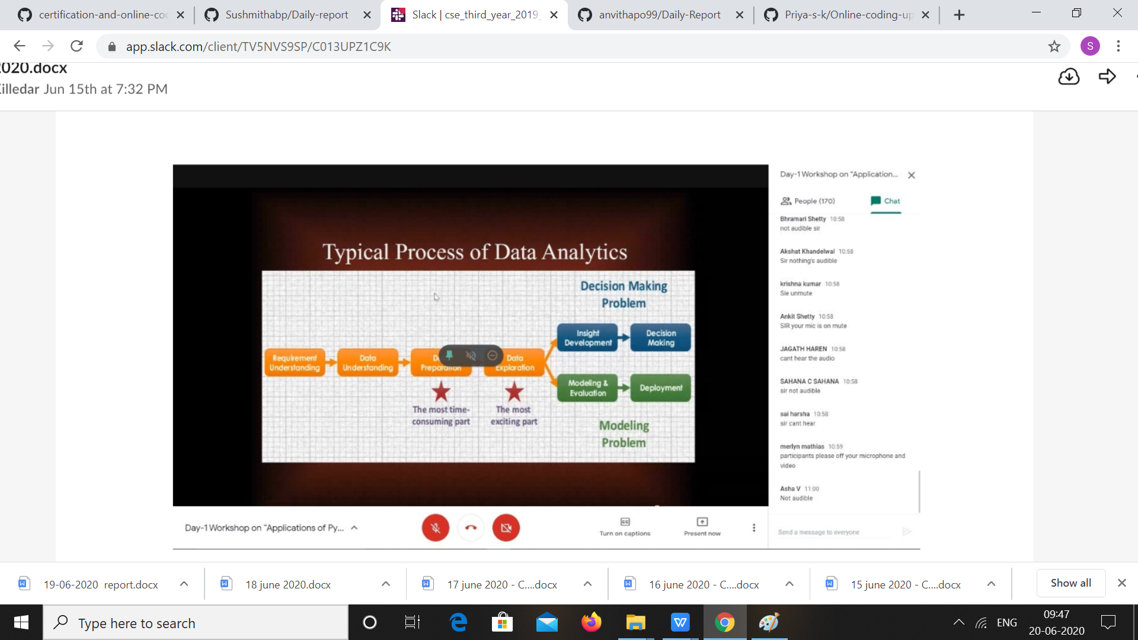

|  |  |
| --- | --- |
| **Coding Challenges** | |
| **Problem Statement:**  1. C program to count number of distinct elements in an array.  2. Examples and Exercises on python workshop  **(Linked Google-colab to GitHub).**  <https://github.com/Sushmithabp/Workshop-on-python-programming-in-DA-and-ML> | |
| **Status: Executed** | |
| **Uploaded the report both in Github & Slack** | **Yes** |

**Snapshots of your response to challenge.**

**C program to count distinct elements in an array.**

#include <stdio.h>

void distict_elements(int a[], int n);

int main()

{

int size_array, i, arr[20];

printf("enter the size of the array: ");

scanf("%d", &size_array);

printf("enter the array elements: ");

for(i=0; i<size_array; i++)

{

scanf("%d", &arr[i]);

}

distict_elements(arr, size_array);

return 0;

}

void distict_elements(int a[], int n)

{

int i, j;

for (i=0; i<n; i++)

{

for (j=0; j<i; j++)

{

if (a[i] == a[j])

break;

}

if (i == j)

printf("%d ",a[i]);

}

}

**Output**

