**DAILY REPORT**

**Student Name :SUSHMITHA.B.POOJARY**

**Class and Sec : VI B**

**USN :4AL17CS103**

**DATE:16-07-2020**

|  |  |  |  |  |
| --- | --- | --- | --- | --- |
| **Online Test Details** | | | | |
| **Subject** | **------** | | | |
| **Semester** | **VI -B** | | **Duration** | **-----** |
| **% of marks** | | **-----** | | |

|  |  |  |  |
| --- | --- | --- | --- |
| **Certification Course Details** | | | |
| **Course** | **Python for Everybody** | | |
| **Certificate Provider** | **Coursera** | **Duration** | **19hours** |

**Snapshots of the daily class acitivities.**

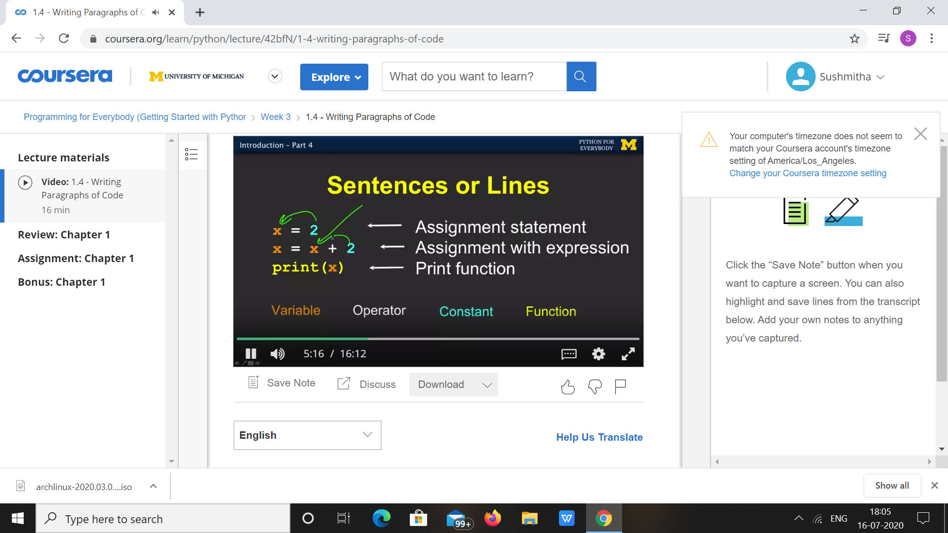

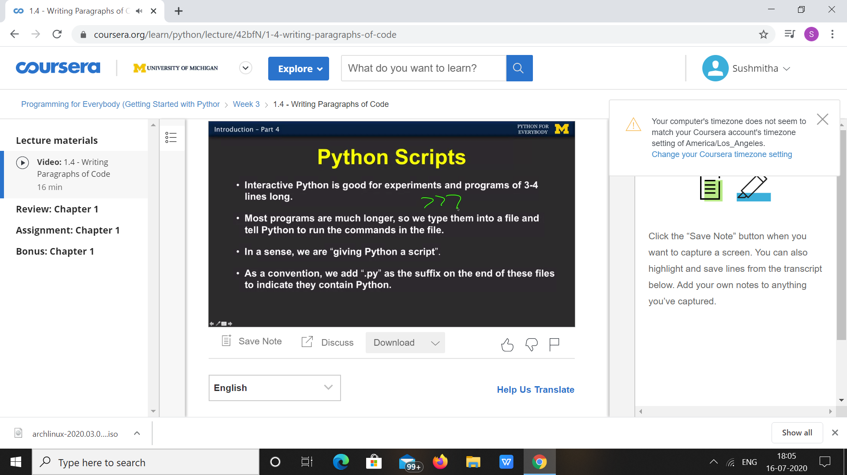

|  |  |
| --- | --- |
| **Coding Challenges** | |
| **Problem Statement: 1.Python Program to Check if binary representation is palind.** | |
| **Status:** Executed | |
| **Uploaded the report both in Github & Slack** | Yes |

**Snapshots of your response to challenge.**

1. ****Python Program to Check if binary representation is palindrome.****

**def palindromenumber(n):**

**bn_number = bin(n)**

**bn_number = bn_number[2:]**

**if(bn_number == bn_number[-1::-1]):**

**print(n," IS A PALINDROME NUMBER")**

**else:**

**print(n, "IS NOT A PALINDROME NUMBER")**

**if __name__ == "__main__":**

**n=int(input("Enter Number ::>"))**

**palindromenumber(n)**

****OUTPUT****

****