**DAILY REPORT**

**Student Name :SUSHMITHA.B.POOJARY**

**Class and Sec : VI B**

**USN :4AL17CS103**

**DATE:17-07-2020**

|  |  |  |  |  |
| --- | --- | --- | --- | --- |
| **Online Test Details** | | | | |
| **Subject** | **------** | | | |
| **Semester** | **VI -B** | | **Duration** | **-----** |
| **% of marks** | | **-----** | | |

|  |  |  |  |
| --- | --- | --- | --- |
| **Certification Course Details** | | | |
| **Course** | **Python for Everybody** | | |
| **Certificate Provider** | **Coursera** | **Duration** | **19hours** |

**Snapshots of the daily class acitivities.**

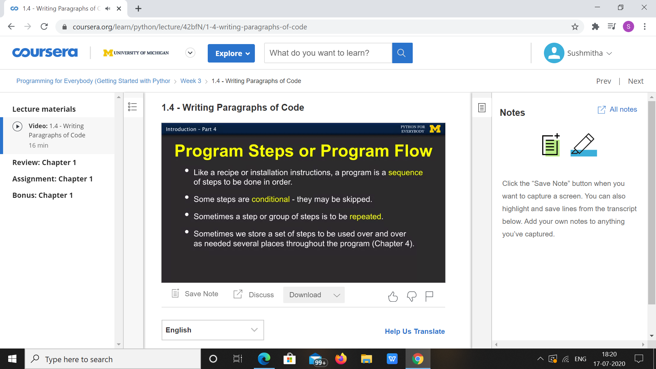

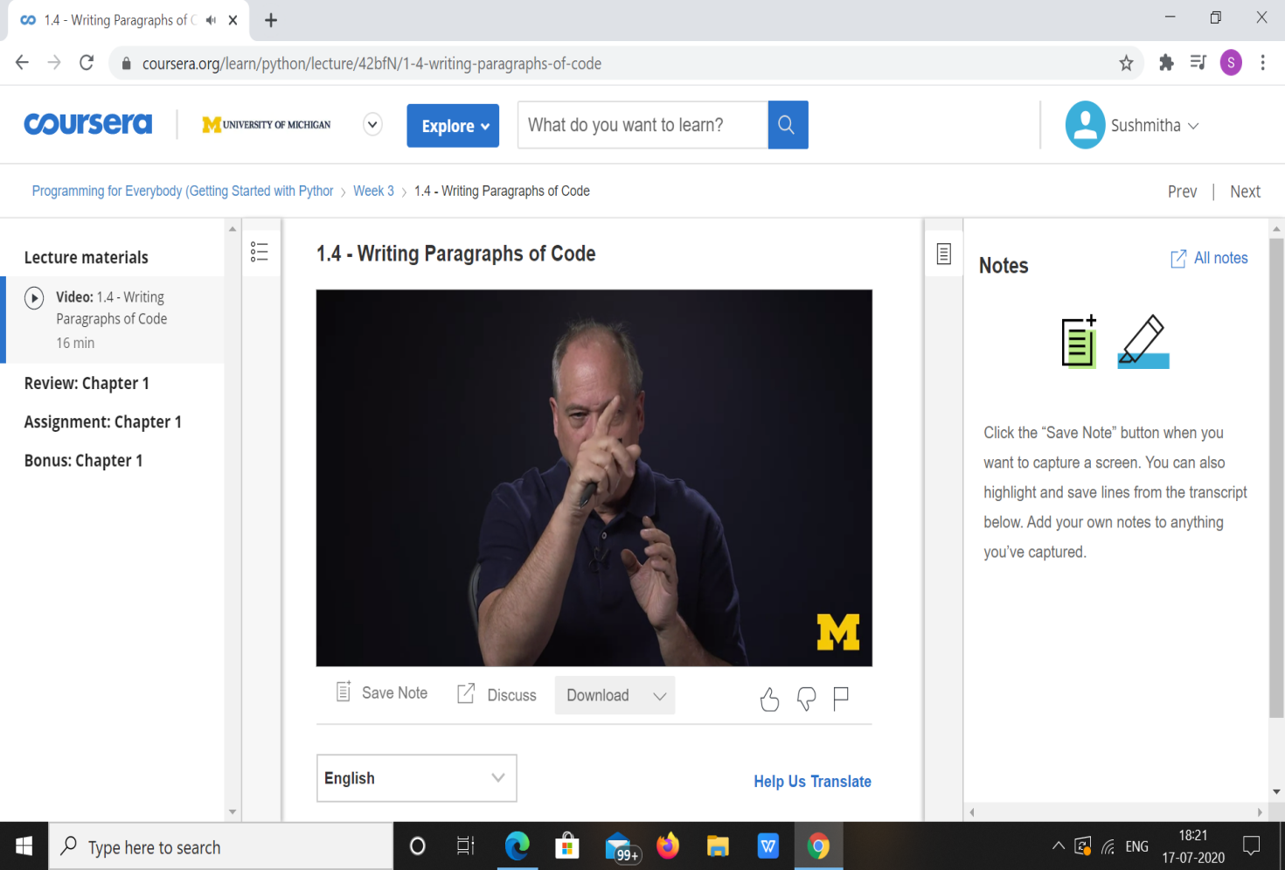

|  |  |
| --- | --- |
| **Coding Challenges** | |
| **Problem Statement: 1.Python Program for Extended Euclidean algorithms.** | |
| **Status:** Executed | |
| **Uploaded the report both in Github & Slack** | Yes |

**Encl : snapshots of your response to challenge.**

****1.Python Program for Extended Euclidean algorithms.****

def gcdExtended(a, b):

if a == 0 :

return b,0,1

gcd,x1,y1 = gcdExtended(b%a, a)

x = y1 - (b//a) * x1

y = x1

return gcd,x,y

a, b = 60,15

g, x, y = gcdExtended(a, b)

print("gcd(", a , "," , b, ") = ", g)

**OUTPUT**

