**DAILY REPORT**

**Student Name :SUSHMITHA .B.POOJARY**

**Class and Sec : VI A/B**

**USN :**

|  |  |  |  |  |
| --- | --- | --- | --- | --- |
| **Online Test Details** | | | | |
| **Subject** | **No Exam** | | | |
| **Semester** | **VI -B** | | **Duration** | **------** |
| **% of marks ------------** | | **---------** | | |

**snapshot of the test result**

|  |  |  |  |
| --- | --- | --- | --- |
| **Pre-Placement Training Summary** | | | |
| **Pre placement training** | **-** Programming in C(9:00 am to 11:00 am )  - Applications of python in DA and ML(11:00 am to 1:00pm ) | | |
| **Faculty** | Mr. Vivek Sharma,  Dr. Mohideen Badusha | **Duration** | 4 hours |

**snapshots of the daily class acitivities**

**Programming in c**

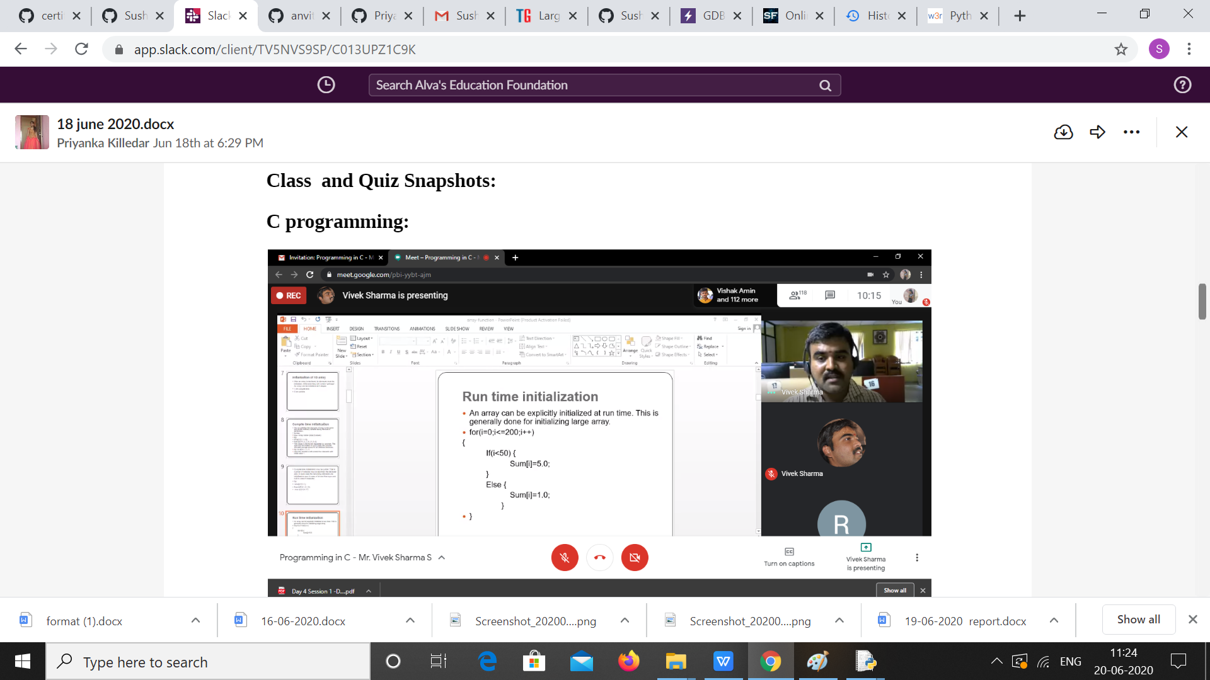

**Python Workshop**

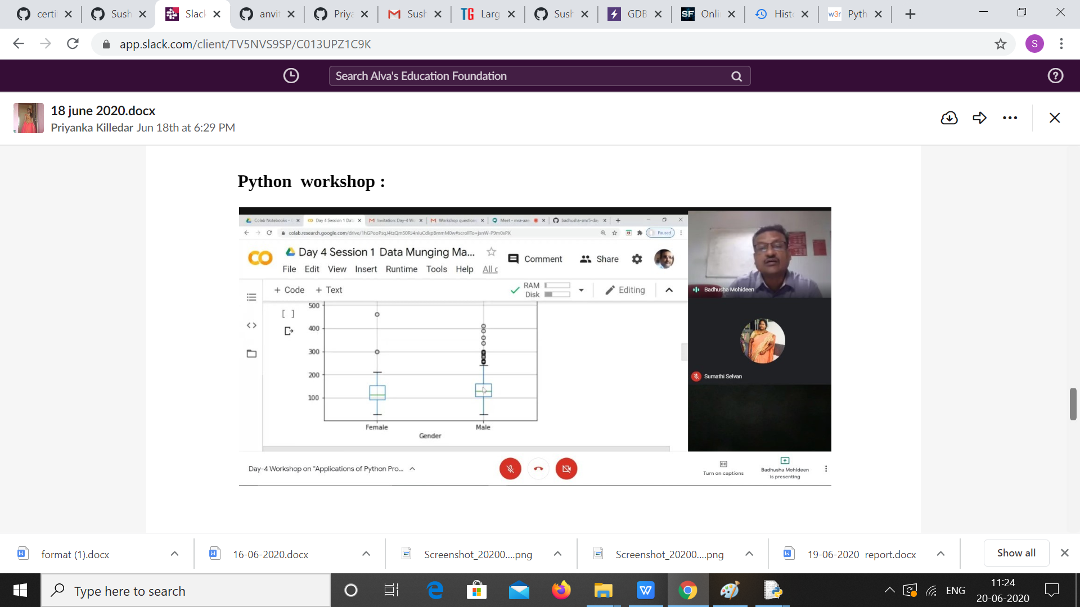

|  |  |
| --- | --- |
| **Coding Challenges** | |
| **Problem Statement:** 1. Examples and Exercises on python. (Linked Google-colab to GitHub).  <https://github.com/Sushmithabp/Workshop-on-python-programming-in-DA-and-ML>  2.Write a C Program to generate first N Magic Numbers. | |
| **Status: Executed** | |
| **Uploaded the report both in Github & Slack** | **Yes** |

**snapshots of your response to challenge.**

**Write a C Program to generate first N Magic Numbers.**

#include <stdio.h>

#include <stdlib.h>

int main()

{

int n,b[100],i;

printf("Enter The N: ");

scanf("%d",&n);

for(i=0;i<n;i++)

{

int j=0,a=i+1;

while(a>0)

{

b[j++] = a%2;

a=a/2;

}

int l=j,k,s=0;

for(k=0;k<l;k++)

{

s=s+b[k]*pow(5,(k+1));

}

printf("%d\t",s);

}

return 0;

}

**Output:**

