**DAILY REPORT**

**Student Name :SUSHMITHA.B.POOJARY**

**Class and Sec : VI B**

**USN :4AL17CS103**

**DATE:18-07-2020**

|  |  |  |  |  |
| --- | --- | --- | --- | --- |
| **Online Test Details** | | | | |
| **Subject** | **CGV** | | | |
| **Semester** | **VI -B** | | **Duration** | **-----** |
| **% of marks 30** | | **-----** | | |

|  |  |  |  |
| --- | --- | --- | --- |
| **Certification Course Details** | | | |
| **Course** | **Python for Everybody** | | |
| **Certificate Provider** | **Coursera** | **Duration** | **19hours** |

**Snapshots of the daily class acitivities.**

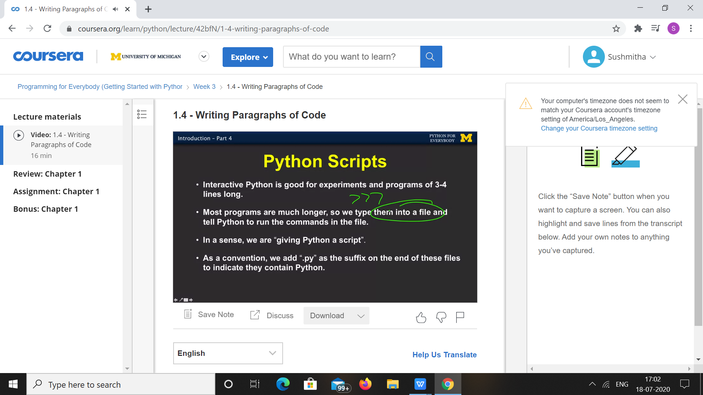

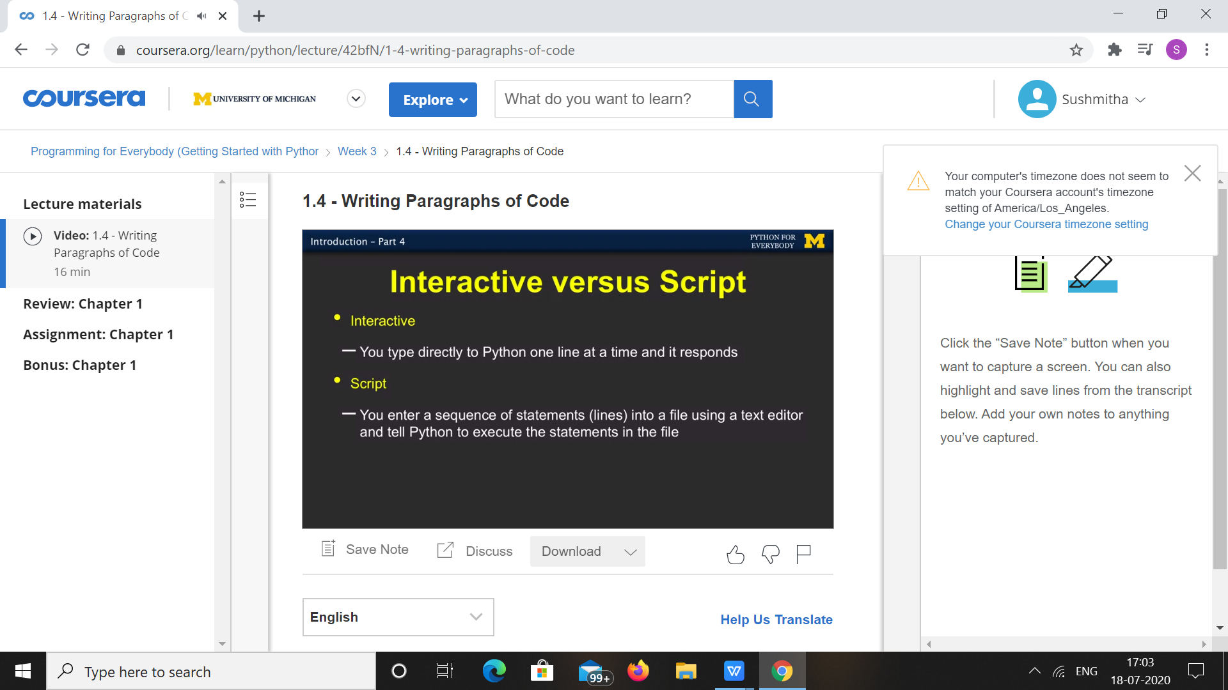

|  |  |
| --- | --- |
| **Coding Challenges** | |
| **Problem Statement: 1**.Python Program to find GCF of two numbers. | |
| **Status:** Executed | |
| **Uploaded the report both in Github & Slack** | Yes |

**Encl : snapshots of your response to challenge.**

## Python Program to find GCF of two numbers.

## num1 = int(input("Enter 1st number: "))

## num2 = int(input("Enter 2nd number: "))

## i = 1

## while(i <= num1 and i <= num2):

## if(num1 % i == 0 and num2 % i == 0):

## gcd = i

## i = i + 1

## print("GCD is", gcd)

## OUTPUT

