**DAILY REPORT**

**Student Name :SUSHMITHA.B.POOJARY**

**Class and Sec : VI B**

**USN :4AL17CS103**

**DATE:19-06-2020**

|  |  |  |  |  |
| --- | --- | --- | --- | --- |
| **Online Test Details** | | | | |
| **Subject** | **-------------(No Exam)** | | | |
| **Semester** | **VI -B** | | **Duration** | **---------** |
| **% of marks** | | **----------------** | | |

|  |  |  |  |
| --- | --- | --- | --- |
| **Pre-Placement Training Summary** | | | |
| **Pre placement training** | **-** Programming in C(9:00 am to 11:00 am)  - Applications of python in DA and ML(11:00 am to 1:00pm) | | |
| **Faculty** | Ms. Shilpa,  Dr. Mohideen Badusha | **Duration** | 4 hours |

**Snapshots of the daily class acitivities (atleast two snap shots)**

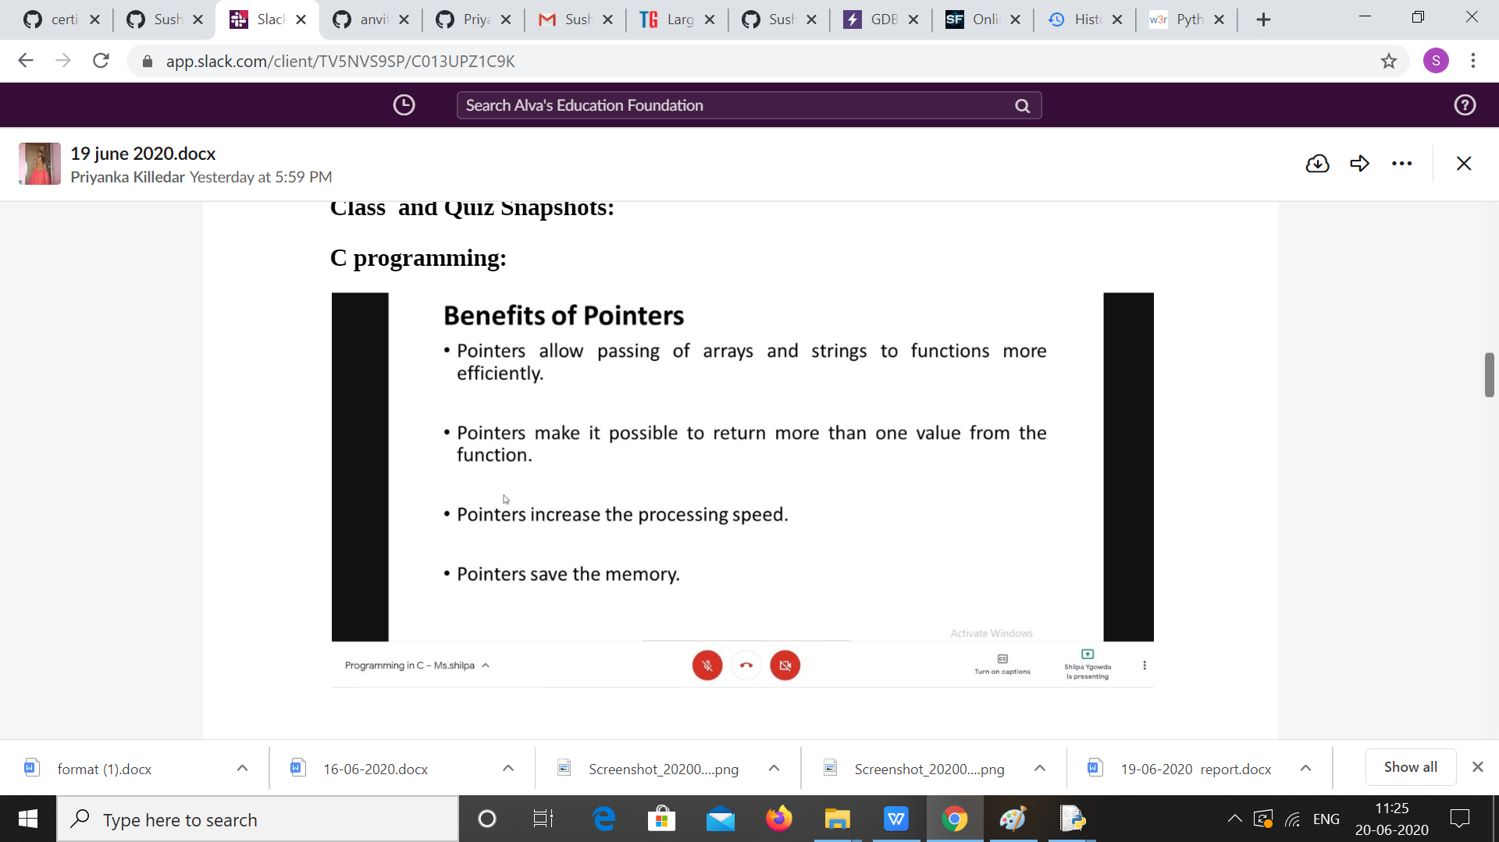

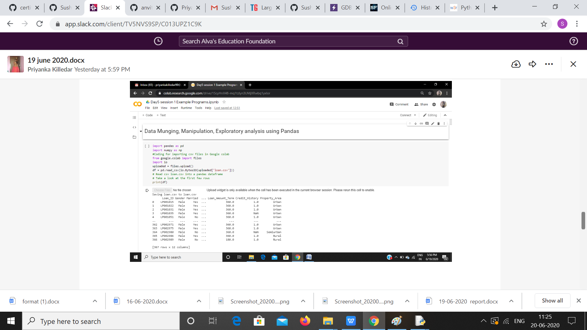

|  |  |
| --- | --- |
| **Coding Challenges** | |
| **Problem Statement:** 1. Examples and Exercises on python. (Linked Google-colab to GitHub)  <https://github.com/Sushmithabp/Workshop-on-python-programming-in-DA-and-ML>  2.Write a C Program to rotate a Matrix by 90 Degree in Clockwise or Anticlockwise Direction**.** | |
| **Status: Executed** | |
| **Uploaded the report both in Github & Slack** | **YES** |

**Snapshots of your response to challenge.**

**Write a C Program to rotate a Matrix by 90 Degree in Clockwise or Anticlockwise Direction.**

#include <stdio.h>

int main()

{

int c,l=1,n;

printf("Enter size of matrix (NxN): ");

scanf("%d",&n);

int arr[n][n];

printf("\nEnter matrix elements:\n");

for(int i=0;i<n;i++)

{

for(int j=0;j<n;j++)

{

scanf("%d",&arr[i][j]);

}

}

printf("\ngiven matrix elements:\n");

for(int i=0;i<n;i++)

{

for(int j=0;j<n;j++)

{

printf("%d ",arr[i][j]);

}

printf("\n");

}

while(l)

{

printf("MENU\n");

printf("1.clockwise\n");

printf("2.Anticlockwise\n");

printf("3.display\n");

printf("4.exit\n");

printf("enter choice\n");

scanf("%d",&c);

{

if(c==1){

for (int i=0;i<n/2;i++)

{

for (int j=i;j<n-i-1;j++)

{

int temp=arr[i][j];

arr[i][j]=arr[n-1-j][i];

arr[n-1-j][i]=arr[n-1-i][n-1-j];

arr[n-1-i][n-1-j]=arr[j][n-1-i];

arr[j][n-1-i]=temp;

}

}

}

else if(c==2){

for(int i=0;i<n/2;i++)

{

for(int j=i;j<n-i-1;j++)

{

int temp=arr[i][j];

arr[i][j]=arr[j][n-i-1];

arr[j][n-i-1]=arr[n-i-1][n-j-1];

arr[n-i-1][n-j-1]=arr[n-j-1][i];

arr[n-j-1][i]=temp;

}

}

}

else if(c==3)

{

printf("\nMatrix after rotating 90 degree:\n");

for(int i=0;i<n;i++)

{

for(int j=0;j<n;j++)

{

printf("%d ",arr[i][j]);

}

printf("\n");

}

}

else l=0;

}

}

}

