**1. Write a C Program to rotate an array by K positions.**

#include <stdio.h>

#include <stdlib.h>

int main()

{

int n,a[50],i,k,j,l,m,o;

printf("Enter The Number Of Elements:\n");

scanf("%d",&n);

printf("Enter The Array Elements:\n");

for(i=0;i<n;i++)

{

scanf("%d",&a[i]);

}

printf("The Initial Array:\n");

for(o=0;o<n;o++)

{

printf("%d\t",a[o]);

}

printf("\n");

printf("Enter The Number Of Rotations:\n");

scanf("%d",&k);

for(j=0;j<k;j++)

{

int t=a[n-1];

for(l=n-2;l>=0;l--)

{

a[l+1]=a[l];

}

a[0]=t;

printf("After %d Rotations:",j+1);

for(m=0;m<n;m++)

{

printf("%d\t",a[m]);

}

printf("\n");

}

return 0;

}

**OUTPUT**

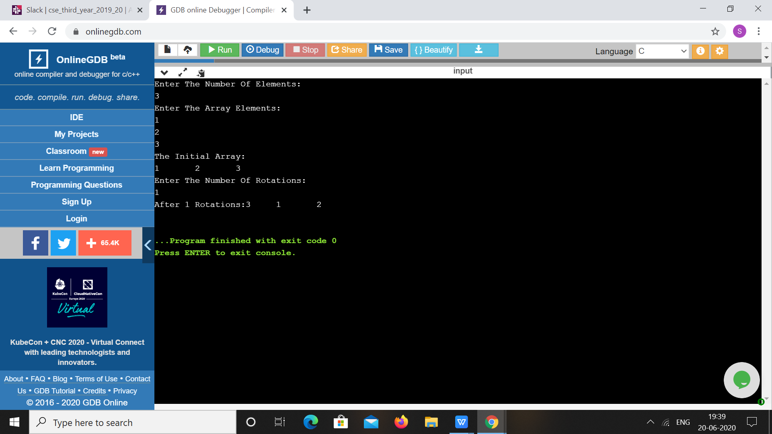

**2.Write a Java Program to find area of Square, Rectangle and Circle using Method Overloading.**

**class** OverloadDemo

{

**void** area(**float** x)

{

System.***out***.println("The area of the square is "+Math.*pow*(x, 2)+" sq units");

}

**void** area(**float** x, **float** y)

{

System.***out***.println("The area of the rectangle is "+x*y+" sq units");

}

**void** area(**double** x)

{

**double** z = 3.14 * x * x;

System.***out***.println("The area of the circle is "+z+" sq units");

}

}

**class** Overload

{

**public** **static** **void** main(String args[])

{

OverloadDemo ob = **new** OverloadDemo();

ob.area(5);

ob.area(11,12);

ob.area(2.5);

}

}

**OUTPUT**

