**DAILY REPORT**

**Student Name :SUSHMITHA.B.POOJARY**

**Class and Sec : VI B**

**USN :4AL17CS103**

**DATE:20-07-2020**

|  |  |  |  |  |
| --- | --- | --- | --- | --- |
| **Online Test Details** | | | | |
| **Subject** | **OS** | | | |
| **Semester** | **VI -B** | | **Duration** | 50minutes |
| **% of marks 30** | | **-----** | | |

|  |  |  |  |
| --- | --- | --- | --- |
| **Certification Course Details** | | | |
| **Course** | **Python for Everybody** | | |
| **Certificate Provider** | **Coursera** | **Duration** | **19hours** |

**Snapshots of the daily class acitivities.**

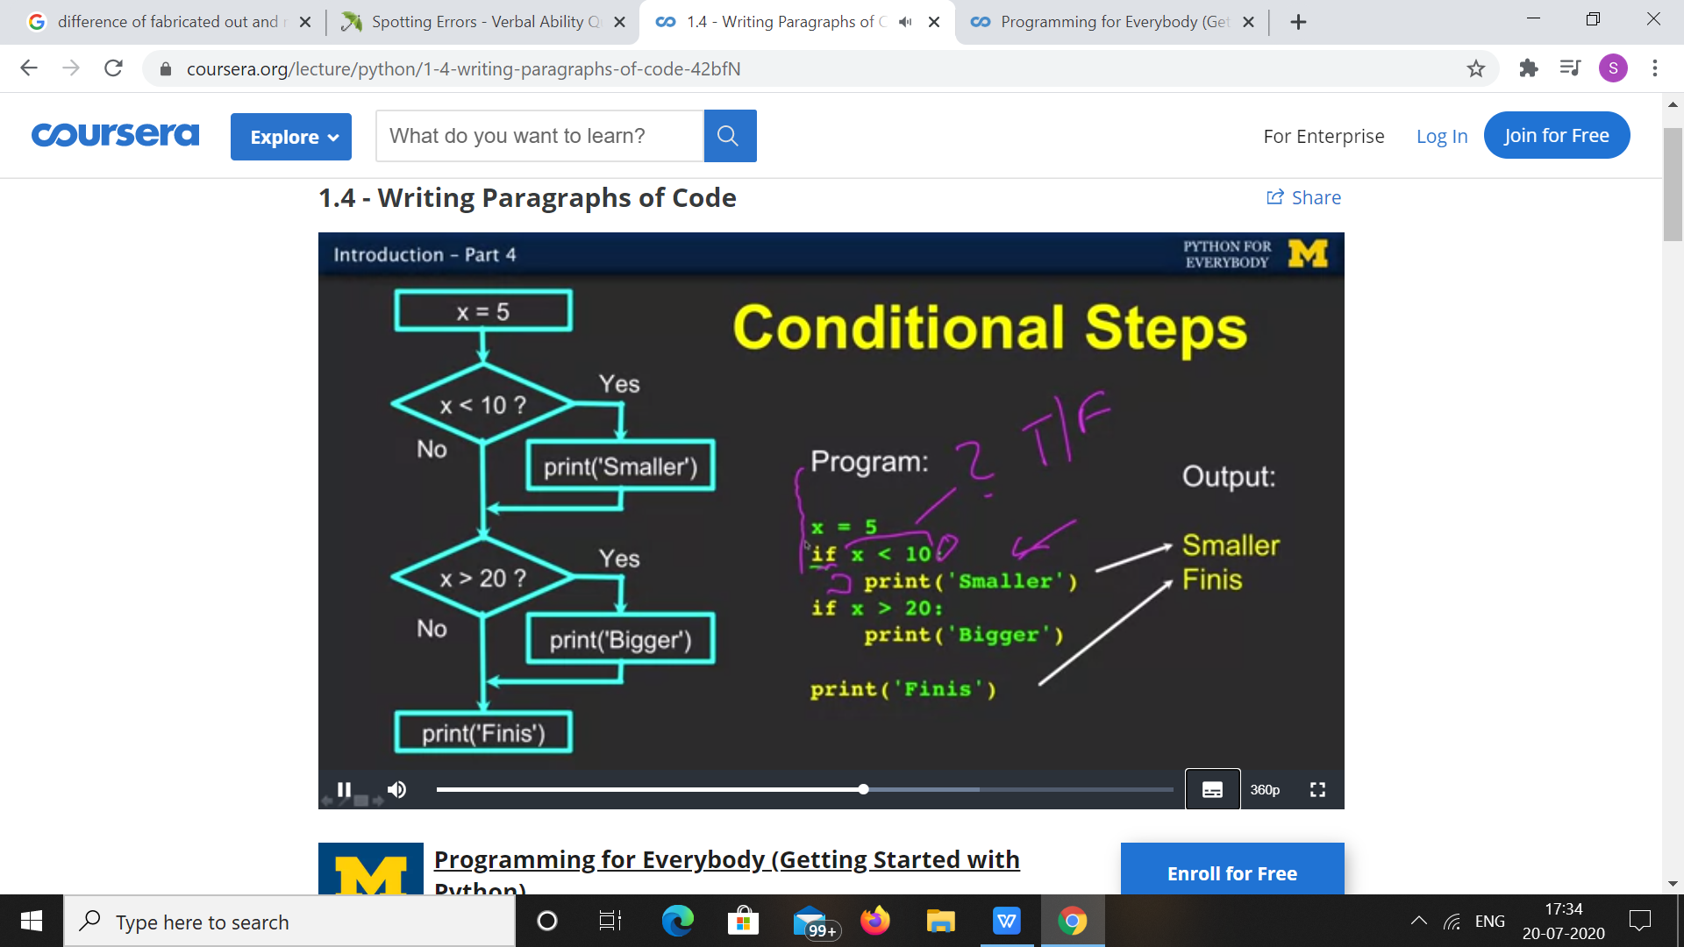

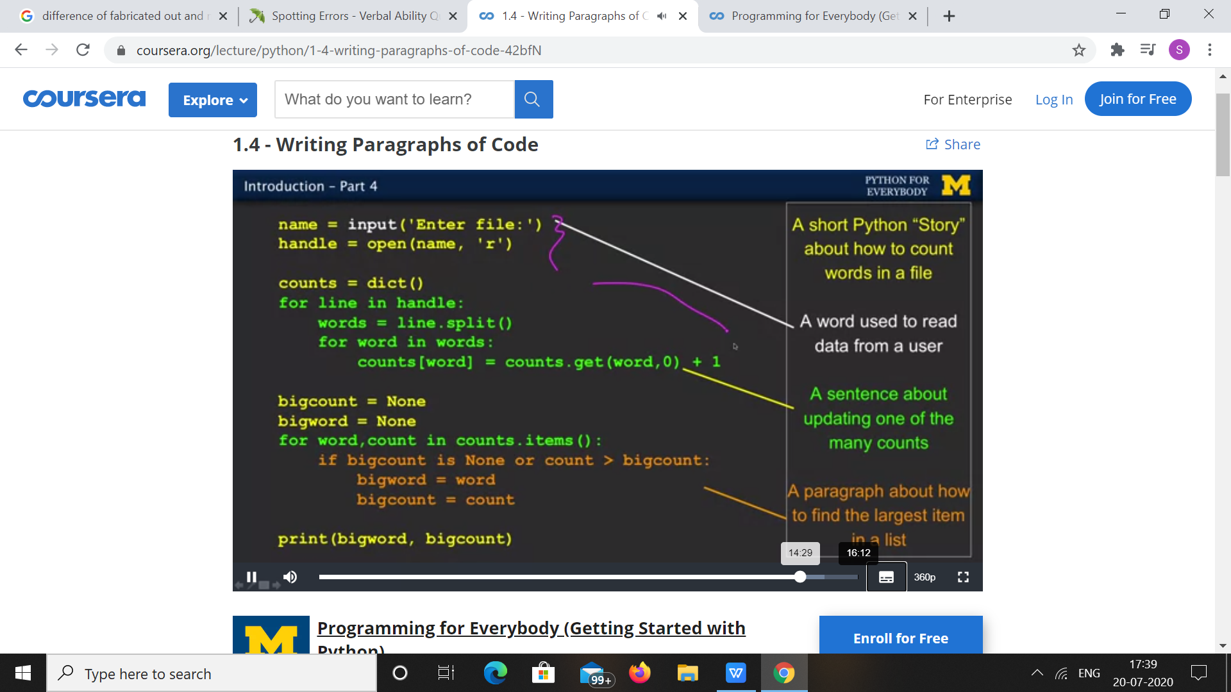

|  |  |
| --- | --- |
| **Coding Challenges** | |
| **Problem Statement: 1.Python Program that Reads a Text File and Counts the Number of Times a Certain Letter Appears in the Text File.** | |
| **Status:** Executed | |
| **Uploaded the report both in Github & Slack** | Yes |

**Snapshots of your response to challenge.**

1. ****Python Program that Reads a Text File and Counts the Number of Times a Certain Letter Appears in the Text File.****

**fname = input("Enter file name: ")**

**l=input("Enter letter to be searched:")**

**k = 0**

**with open(fname, 'r') as f:**

**for line in f:**

**words = line.split()**

**for i in words:**

**for letter in i:**

**if(letter==l):**

**k=k+1**

**print("Occurrences of the letter:")**

**print(k)**

****OUTPUT****

****