**DAILY REPORT**

**Student Name :SUSHMITHA.B.POOJARY**

**Class and Sec : VI B**

**USN :4AL17CS103**

**DATE:21-06-2020**

|  |  |  |  |  |
| --- | --- | --- | --- | --- |
| **Online Test Details** | | | | |
| **Subject** | **-------(No Exam)** | | | |
| **Semester** | **VI -B** | | **Duration** | **---------** |
| **% of marks** | | **------------------** | | |

|  |  |  |  |
| --- | --- | --- | --- |
| **Certification Course Details** | | | |
| **Course** | **Introduction to cloud computing** | | |
| **Certificate Provider** | **Cognitiveclass.ai** | **Duration** | **6hours** |

**Snapshots of the daily class acitivities**

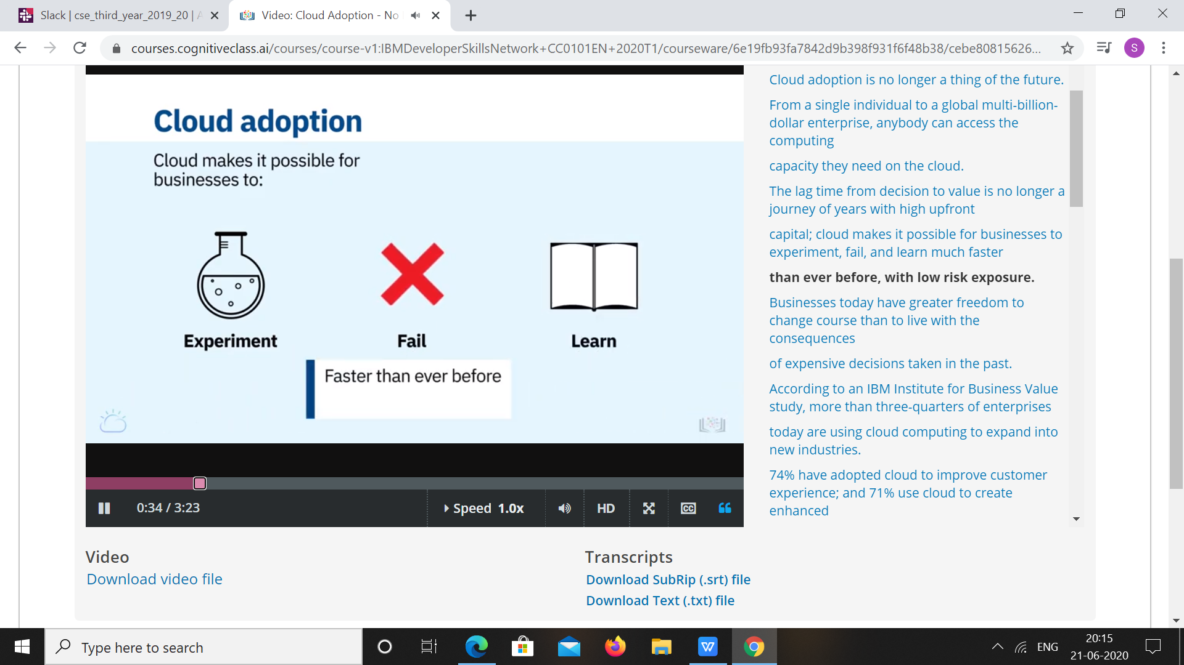

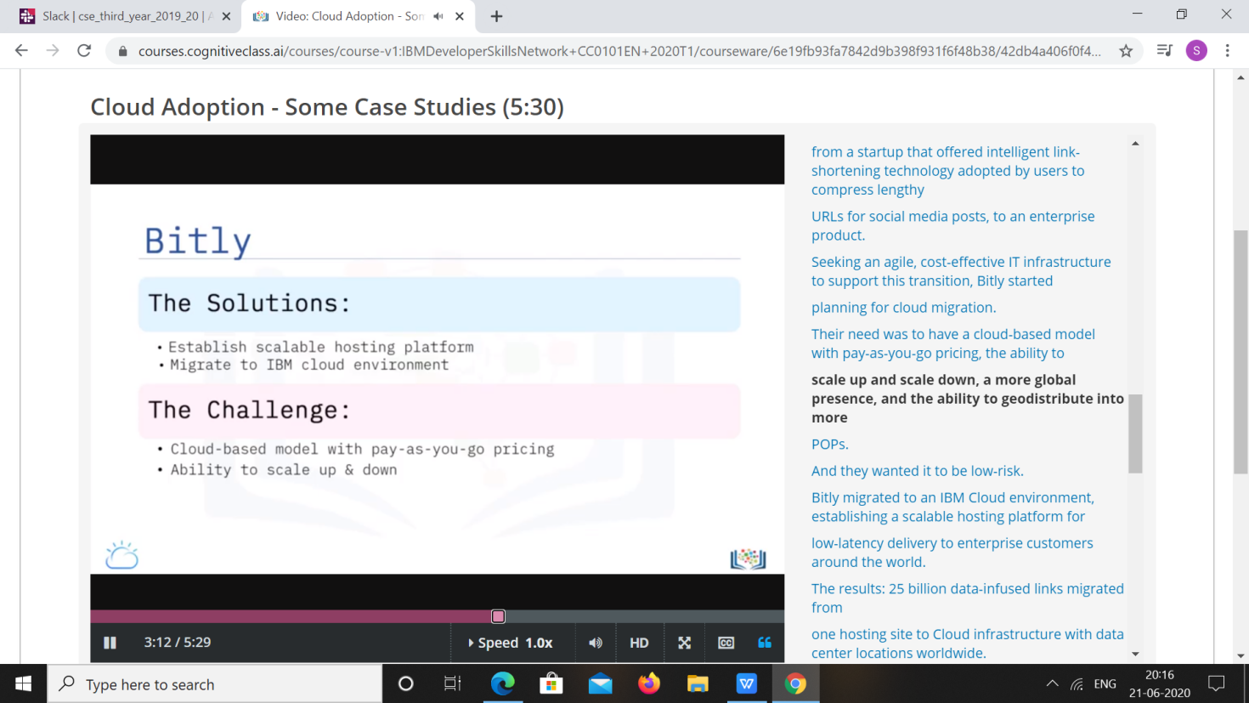

|  |  |
| --- | --- |
| **Coding Challenges** | |
| **Problem Statement: 1.**Python Program to Read a Text File and Print all the Numbers Present in the Text File. | |
| **Status: Executed** | |
| **Uploaded the report both in Github & Slack** | **Yes** |

**Snapshots of your response to challenge.**

# **Python Program to Read a Text File and Print all the Numbers Present in the Text File**

fname = input("Enter file name: ")

with open(fname, 'r') as f:

for line in f:

words = line.split()

for i in words:

for letter in i:

if(letter.isdigit()):

print(letter)

