**DAILY REPORT**

**Student Name :SUSHMITHA.B.POOJARY**

**Class and Sec : VI B**

**USN :4AL17CS103**

**DATE:21-07-2020**

|  |  |  |  |  |
| --- | --- | --- | --- | --- |
| **Online Test Details** | | | | |
| **Subject** | **------** | | | |
| **Semester** | **VI -B** | | **Duration** | **-----** |
| **% of marks** | | **-----** | | |

|  |  |  |  |
| --- | --- | --- | --- |
| **Certification Course Details** | | | |
| **Course** | **Python for Everybody** | | |
| **Certificate Provider** | **Coursera** | **Duration** | **19hours** |

**Snapshots of the daily class acitivities.**

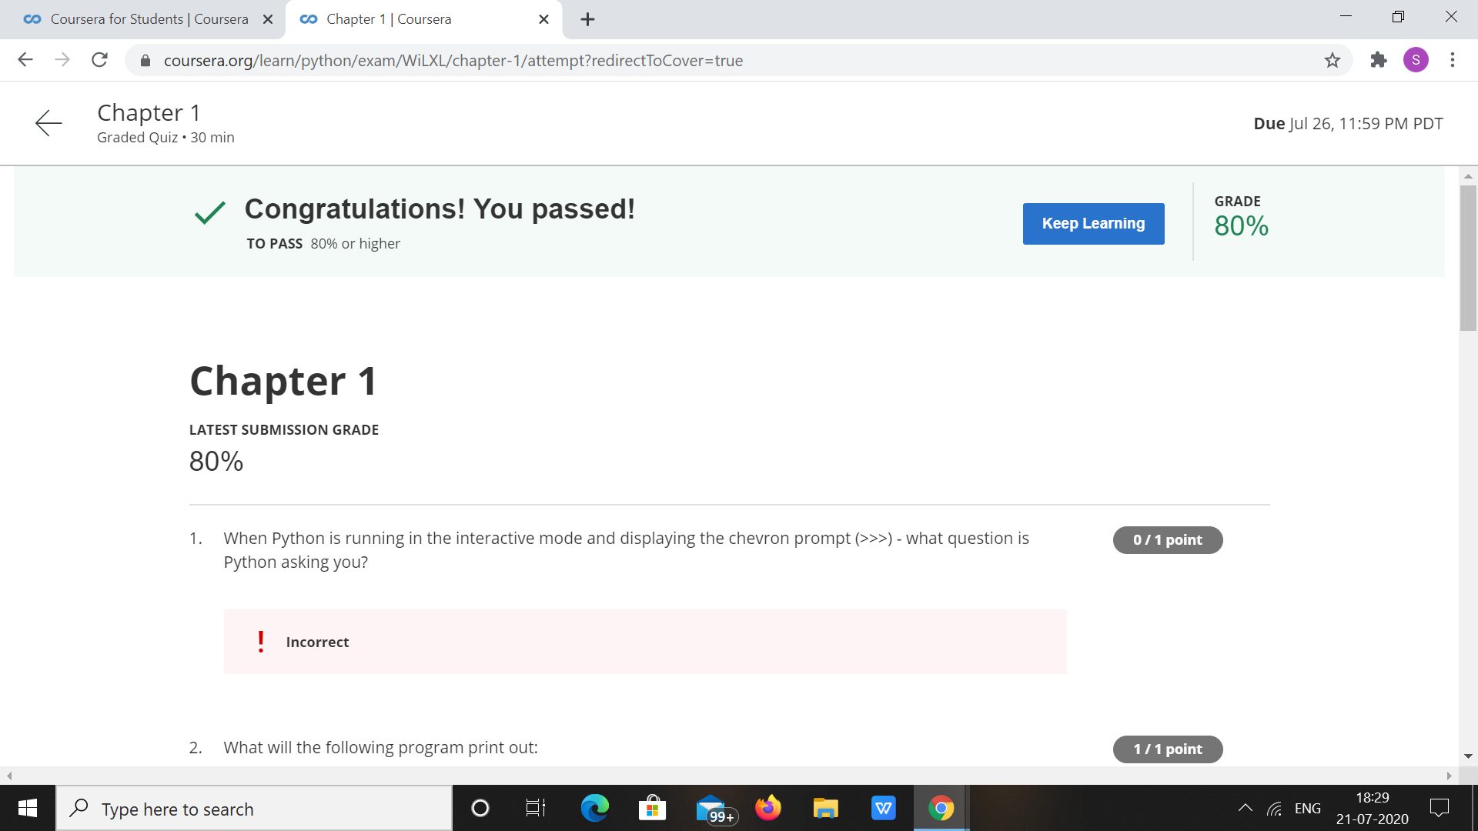

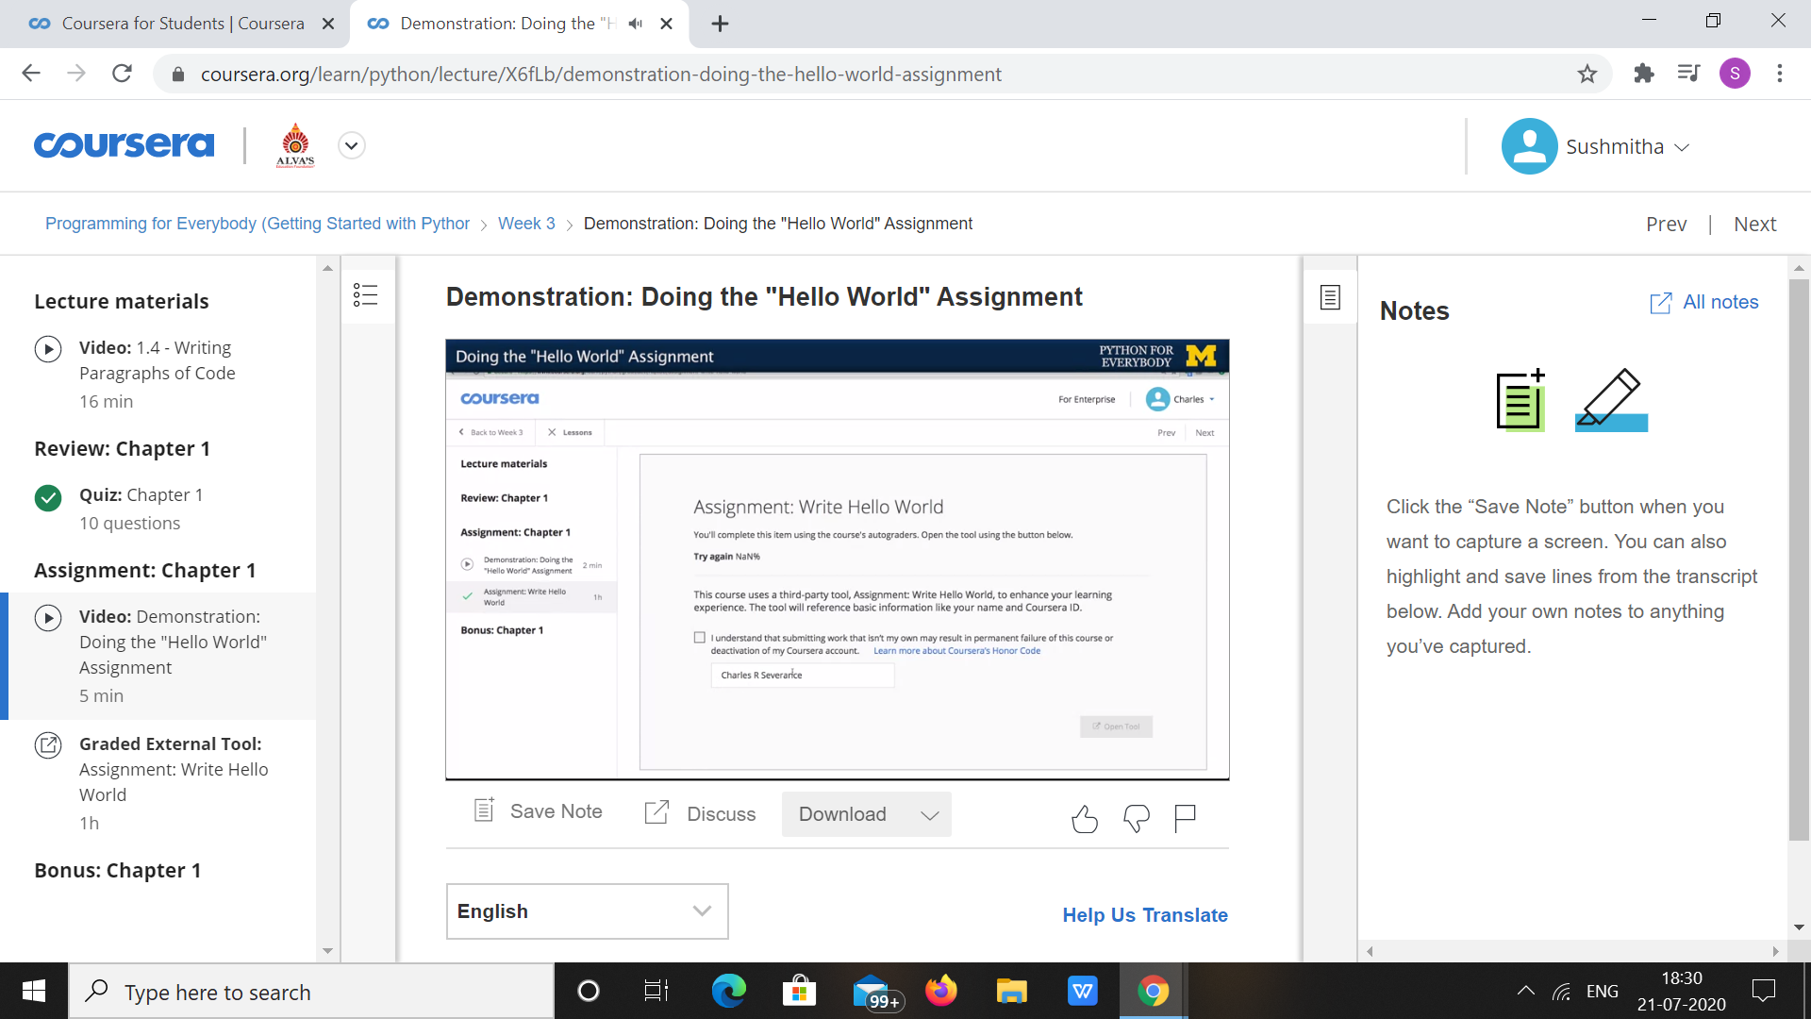

|  |  |
| --- | --- |
| **Coding Challenges** | |
| **Problem Statement: 1.Python Program for GCD of more than two (or array) numbers.** | |
| **Status:** Executed | |
| **Uploaded the report both in Github & Slack** | Yes |

**Snapshots of your response to challenge.**

1. ****Python Program for GCD of more than two (or array) numbers.****

**def findgcd(x, y):**

**while(y):**

**x, y = y, x % y**

**return x**

**l = [22, 44, 66, 88, 99]**

**num1=l[0]**

**num2=l[1]**

**gcd=findgcd(num1,num2)**

**for i in range(2,len(l)):**

**gcd=findgcd(gcd,l[i])**

**print("gcd is: ",gcd)**

****OUTPUT****

