**DAILY REPORT**

**Student Name :SUSHMITHA.B.POOJARY**

**Class and Sec : VI B**

**USN :4AL17CS103**

**DATE:22-06-2020**

|  |  |  |  |  |
| --- | --- | --- | --- | --- |
| **Online Test Details** | | | | |
| **Subject** | **------------(No Exam)** | | | |
| **Semester** | **VI -B** | | **Duration** | **-----** |
| **% of marks -----------** | | **----------------** | | |

**Snapshot of the test result**

|  |  |  |  |
| --- | --- | --- | --- |
| **Pre-Placement Training Summary** | | | |
| **Pre placement training** | **-** Programming in C++(9:00 am to 11:00 am)  - Programming in C++(11:00 am to 1:00pm) | | |
| **Faculty** | Ms. Shilpa Y Gowda  Ms. Ankitha Shetty | **Duration** | 4 hours |

**Snapshots of the daily class acitivities.**

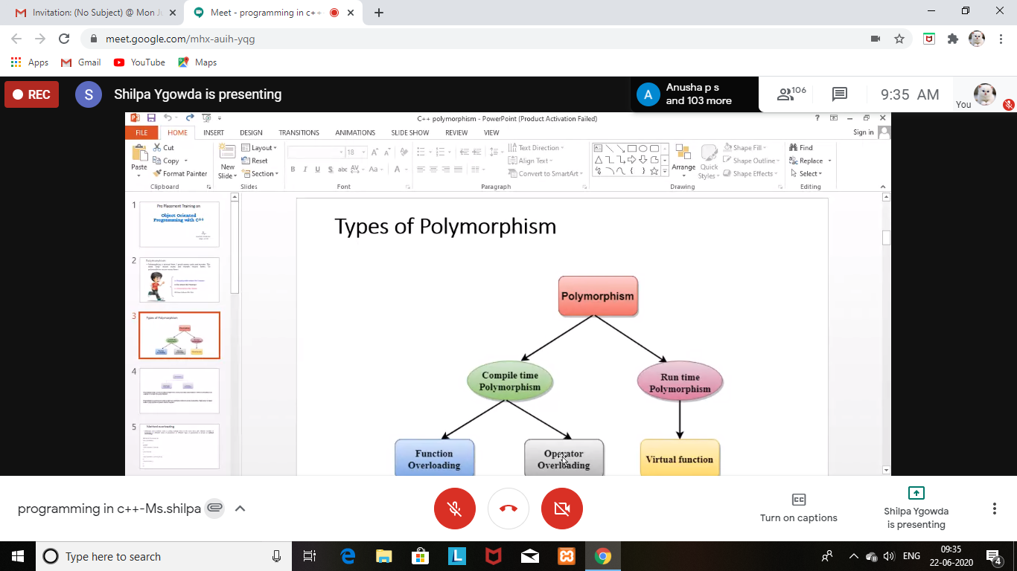

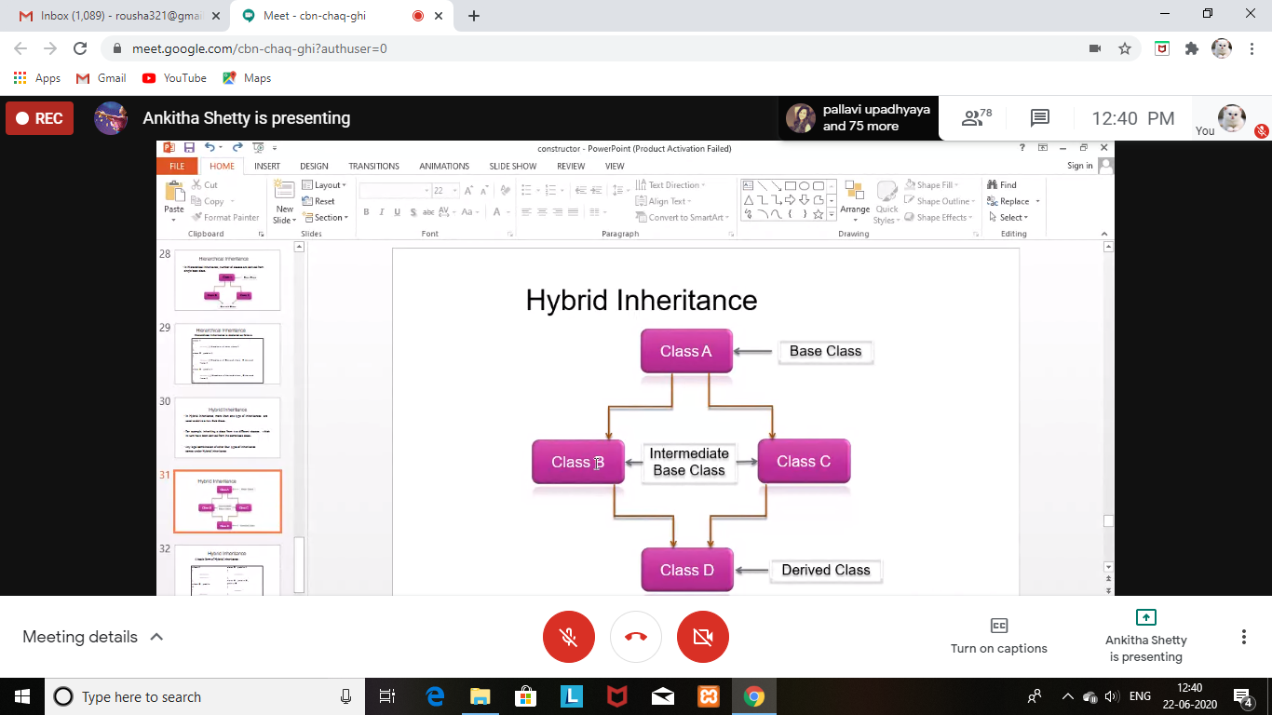

|  |  |
| --- | --- |
| **Coding Challenges** | |
| **Problem Statement: 1.**Java program to find maximum repeated words from a file. | |
| **Status: Executed** | |
| **Uploaded the report both in Github & Slack** | **Yes** |

**Snapshots of your response to challenge.**

1. **Java program to find maximum repeated words from a file.**

import java.io.BufferedReader;

import java.io.FileReader;

import java.io.IOException;

import java.util.HashMap;

import java.util.Map.Entry;

import java.util.Set;

public class RepeatedWordInFile

{

public static void main(String[] args)

{

HashMap<String, Integer> wordCountMap = new HashMap<String, Integer>();

BufferedReader reader = null;

try

{

reader = new BufferedReader(new FileReader("C:\sample.txt"));

String currentLine = reader.readLine();

while (currentLine != null)

{

String[] words = currentLine.toLowerCase().split(" ");

for (String word : words)

{

if(wordCountMap.containsKey(word))

{

wordCountMap.put(word, wordCountMap.get(word)+1);

}

else

{

wordCountMap.put(word, 1);

}

}

currentLine = reader.readLine();

}

String mostRepeatedWord = null;

int count = 0;

Set<Entry<String, Integer>> entrySet = wordCountMap.entrySet();

for (Entry<String, Integer> entry : entrySet)

{

if(entry.getValue() > count)

{

mostRepeatedWord = entry.getKey();

count = entry.getValue();

}

}

System.out.println("The most repeated word in input file is : "+mostRepeatedWord);

System.out.println("Number Of Occurrences : "+count);

}

catch (IOException e)

{

e.printStackTrace();

}

finally

{

try

{

reader.close();

}

catch (IOException e)

{

e.printStackTrace();

}

}

}

}

**OUTPUT**

