**DAILY REPORT**

**Student Name :SUSHMITHA.B.POOJARY**

**Class and Sec : VI B**

**USN :4AL17CS103**

**DATE:23-07-2020**

|  |  |  |  |  |
| --- | --- | --- | --- | --- |
| **Online Test Details** | | | | |
| **Subject** | **------** | | | |
| **Semester** | **VI -B** | | **Duration** | **-----** |
| **% of marks -----** | | **-----** | | |

|  |  |  |  |
| --- | --- | --- | --- |
| **Certification Course Details** | | | |
| **Course** | **Python for Everybody** | | |
| **Certificate Provider** | **Coursera** | **Duration** | **19hours** |

**Snapshots of the daily class acitivities.**

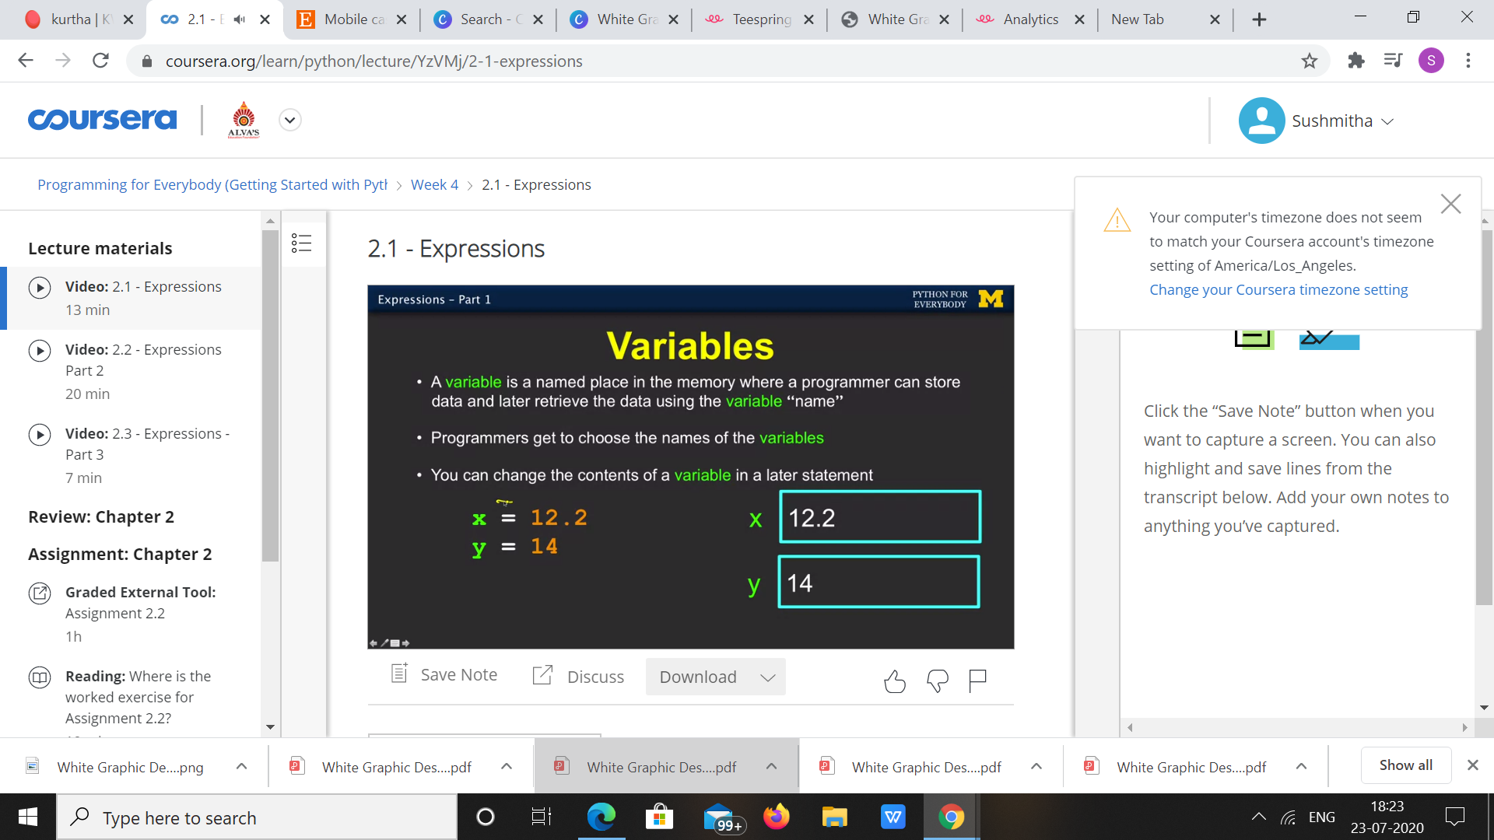

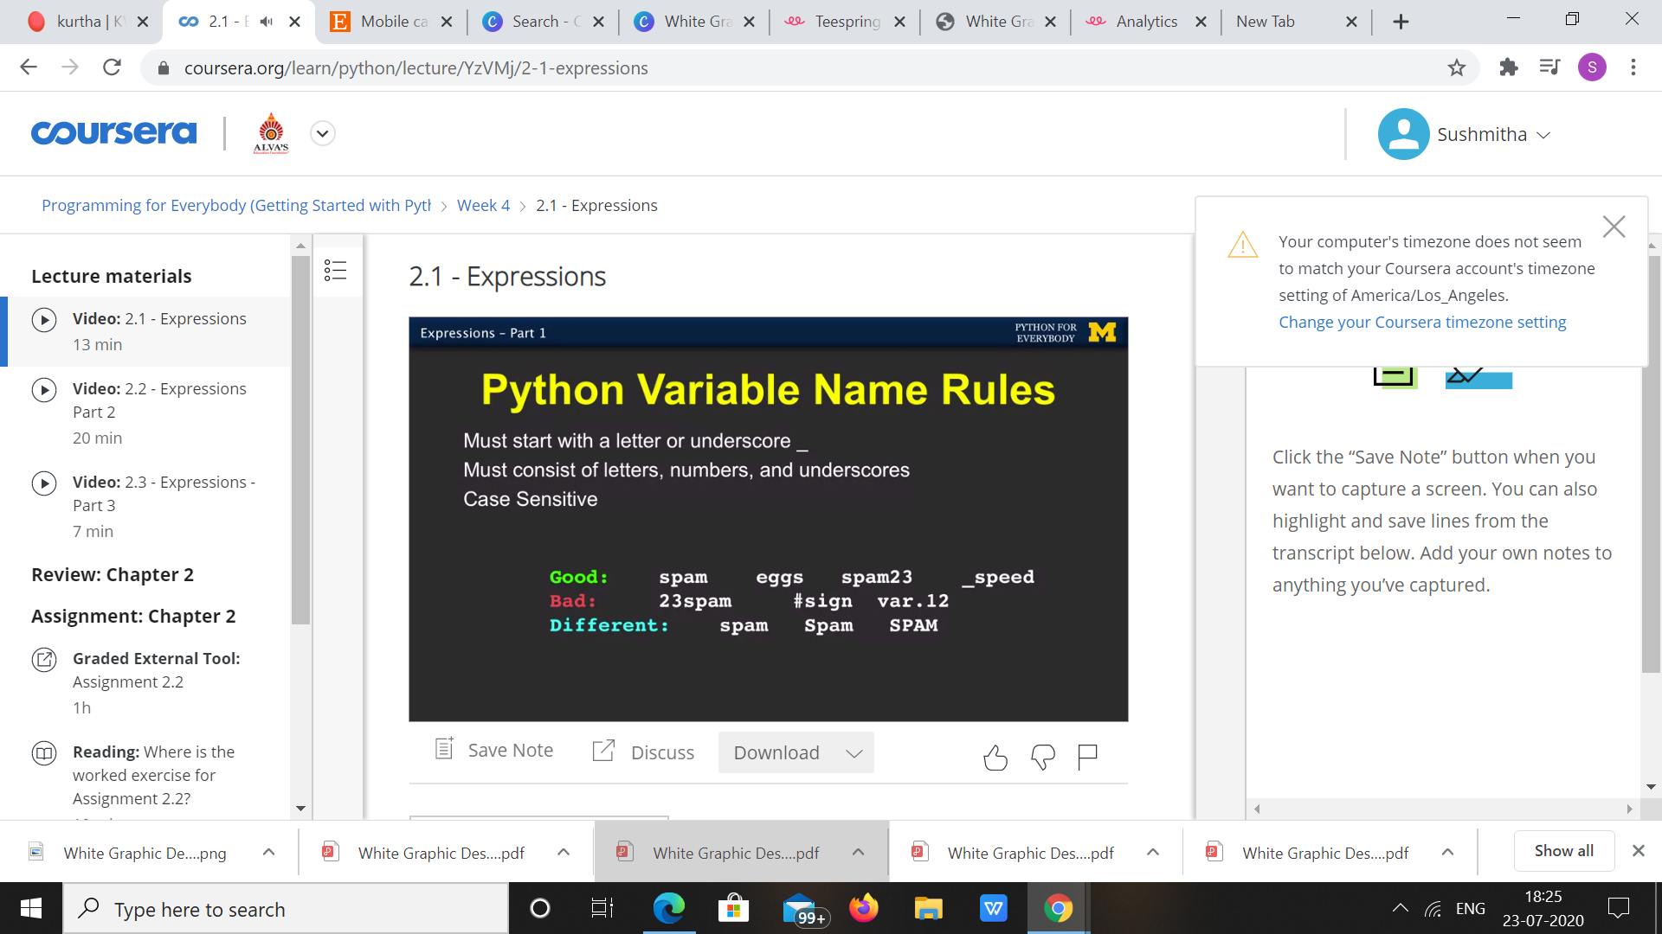

|  |  |
| --- | --- |
| **Coding Challenges** | |
| **Problem Statement: 1.Python Program for Find minimum sum of factors of number.** | |
| **Status:** Executed | |
| **Uploaded the report both in Github & Slack** | Yes |

**Snapshots of your response to challenge.**

**1.**Python Program for Find minimum sum of factors of number.****

def findMinSum(num):

sum = 0

i = 2

while(i * i <= num):

while(num % i == 0):

sum += i

num /= i

i += 1

sum += num

return sum

num = 12

print(findMinSum(num))

**OUTPUT**

