**DAILY REPORT**

**Student Name :SUSHMITHA.B.POOJARY**

**Class and Sec : VI B**

**USN :4AL17CS103**

**DATE:24-06-2020**

|  |  |  |  |  |
| --- | --- | --- | --- | --- |
| **Online Test Details** | | | | |
| **Subject** | **-----------** | | | |
| **Semester** | **VI -B** | | **Duration** | **----------** |
| **% of marks ---------** | | **-------------** | | |

|  |  |  |  |
| --- | --- | --- | --- |
| **PRE-PLACEMENT DETAILS** | | | |
| **Course** | **-**JAVA and J2EE(9.15-11)  -Data structure in C(11.15-1.00) | | |
| **Faculty** | Ms.Shilpha  Mr.Venkatesh.Bhat | **Duration** | 4hours |

**Snapshots of the daily class acitivities.**

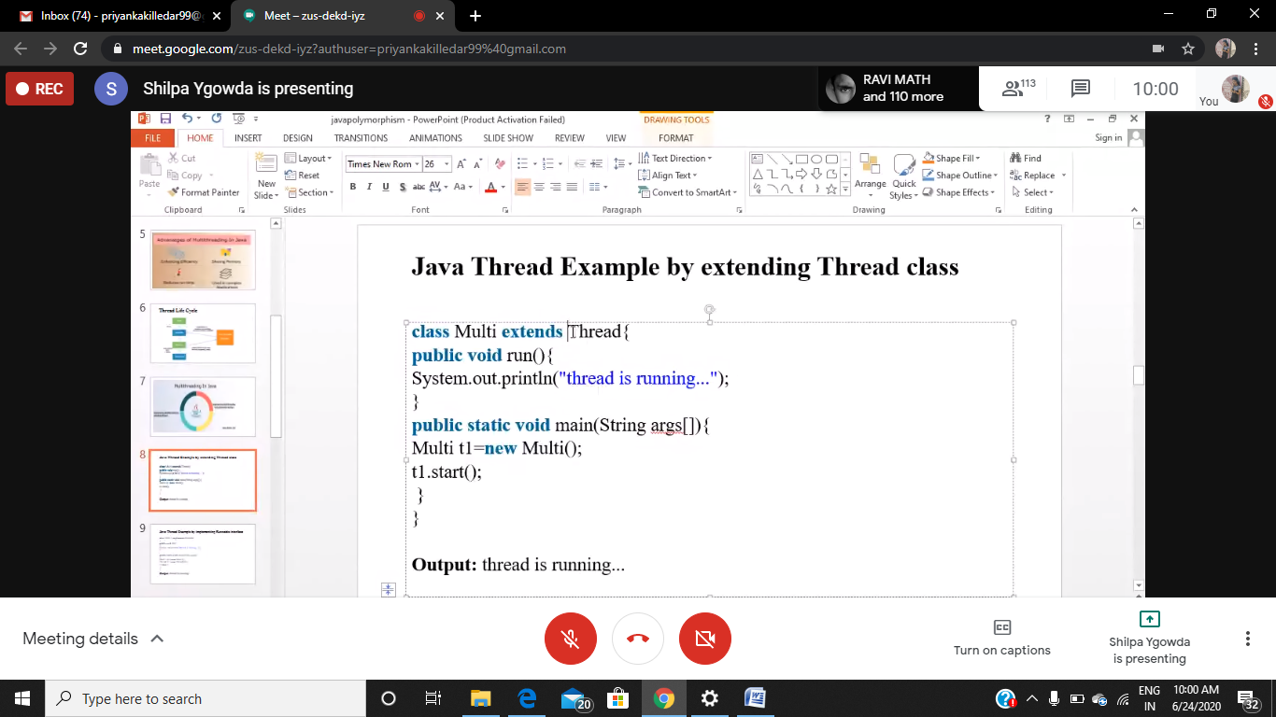

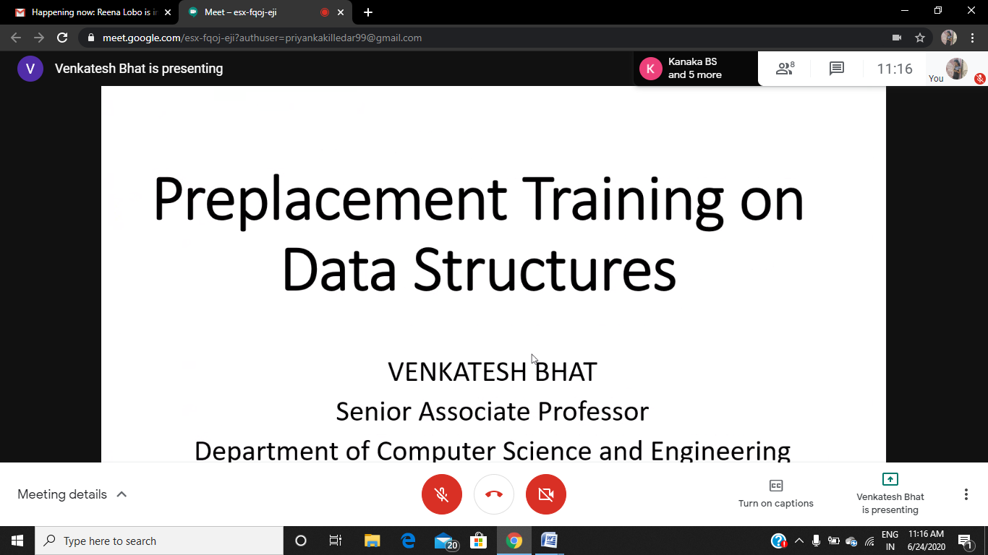

|  |  |
| --- | --- |
| **Coding Challenges** | |
| 1. **Problem Statement:** Create a class named 'Shape' with a method to print "This is This is shape". Then create two other classes named 'Rectangle', 'Circle' inheriting the Shape class, both having a method to print "This is rectangular shape" and "This is circular shape" respectively. Create a subclass 'Square' of 'Rectangle' having a method to print "Square is a rectangle". Now call the method of 'Shape' and 'Rectangle' class by the object of 'Square' class. | |
| **Status: Executed** | |
| **Uploaded the report both in Github & Slack** | **Yes** |

**Snapshots of your response to challenge.**

**1.Create a class named 'Shape' with a method to print "This is This is shape". Then create two other classes named 'Rectangle', 'Circle' inheriting the Shape class, both having a method to print "This is rectangular shape" and "This is circular shape" respectively. Create a subclass 'Square' of 'Rectangle' having a method to print "Square is a rectangle". Now call the method of 'Shape' and 'Rectangle' class by the object of 'Square' class.**

class Shape{

public void print_shape(){

System.out.println("This is shape");

}

}

class Rectangle extends Shape{

public void print_rect(){

System.out.println("This is rectangular shape");

}

}

class Circle extends Shape{

public void print_circle(){

System.out.println("This is circular shape");

}

}

class Square extends Rectangle{

public void print_square(){

System.out.println("Square is a rectangle");

}

}

class Main{

public static void main(String[] args){

Square sq = new Square();

sq.print_shape();

sq.print_rect();

}

}

**Output:**

