**DAILY REPORT**

**Student Name :SUSHMITHA.B.POOJARY**

**Class and Sec : VI B**

**USN :4AL17CS103**

**DATE:24-07-2020**

|  |  |  |  |  |
| --- | --- | --- | --- | --- |
| **Online Test Details** | | | | |
| **Subject** | **SSCD** | | | |
| **Semester** | **VI -B** | | **Duration** | **50Minutes** |
| **% of marks 30** | |  | | |

|  |  |  |  |
| --- | --- | --- | --- |
| **Certification Course Details** | | | |
| **Course** | **Python for Everybody** | | |
| **Certificate Provider** | **Coursera** | **Duration** | **19hours** |

**Snapshots of the daily class acitivities.**

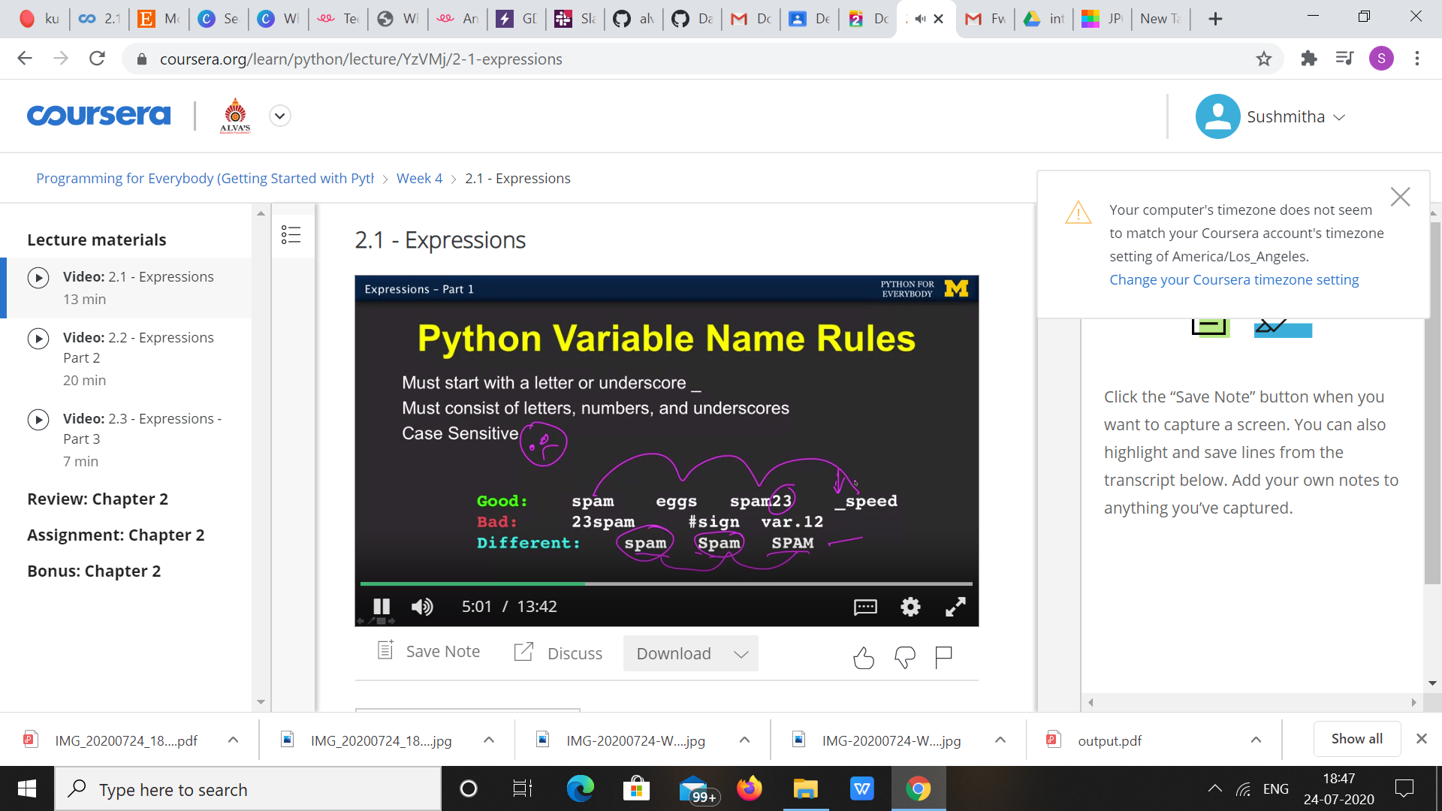

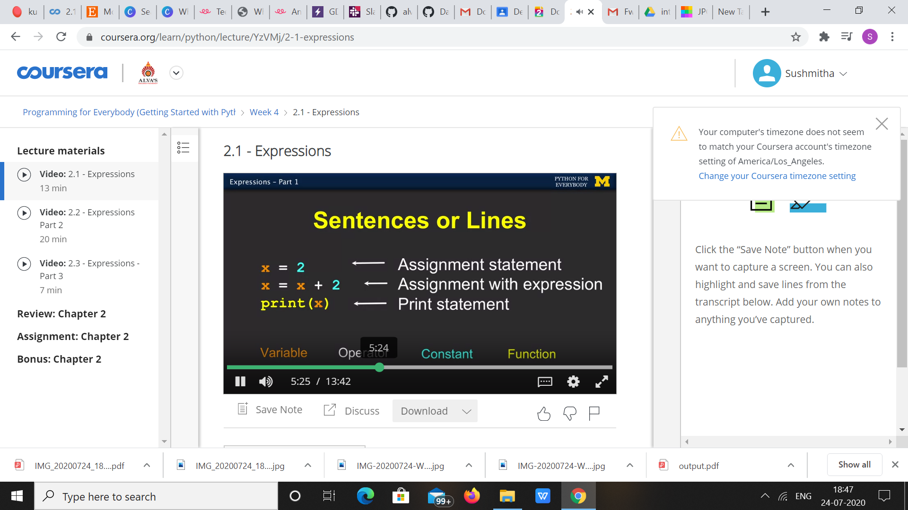

|  |  |
| --- | --- |
| **Coding Challenges** | |
| **Problem Statement: 1**.**Python Program for Difference between sums of odd and even digits.** | |
| **Status:**  Executed | |
| **Uploaded the report both in Github & Slack** | Yes |

**Snapshots of your response to challenge.**

1. ****Python Program for Difference between sums of odd and even digits.****

**def isDiff(n):**

**return (n % 11 == 0)**

**n = 1243;**

**if (isDiff(n)):**

**print("Yes")**

**else:**

**print("No")**

****OUTPUT****

