**DAILY REPORT**

**Student Name :**SUSHMITHA.B.POOJARY

**Class and Sec :** VI B

**USN :**4AL17CS103

**DATE**:25-06-2020

|  |  |  |  |  |
| --- | --- | --- | --- | --- |
| **Online Test Details** | | | | |
| **Subject** | **-----------** | | | |
| **Semester** | **VI -B** | | **Duration** | **----------** |
| **% of marks** | | **--------------** | | |

|  |  |  |  |
| --- | --- | --- | --- |
| **PRE-PLACEMENT DETAILS** | | | |
| **Course** | **-** JAVA and J2EE(9 to 11am)  -Data structure in C(11am to 1pm) | | |
| **Certificate Provider** | Mr.Sayeesh  Me.Venkatesh.Bhatt | **Duration** | 4hours |

**Snapshots of the daily class acitivities.**

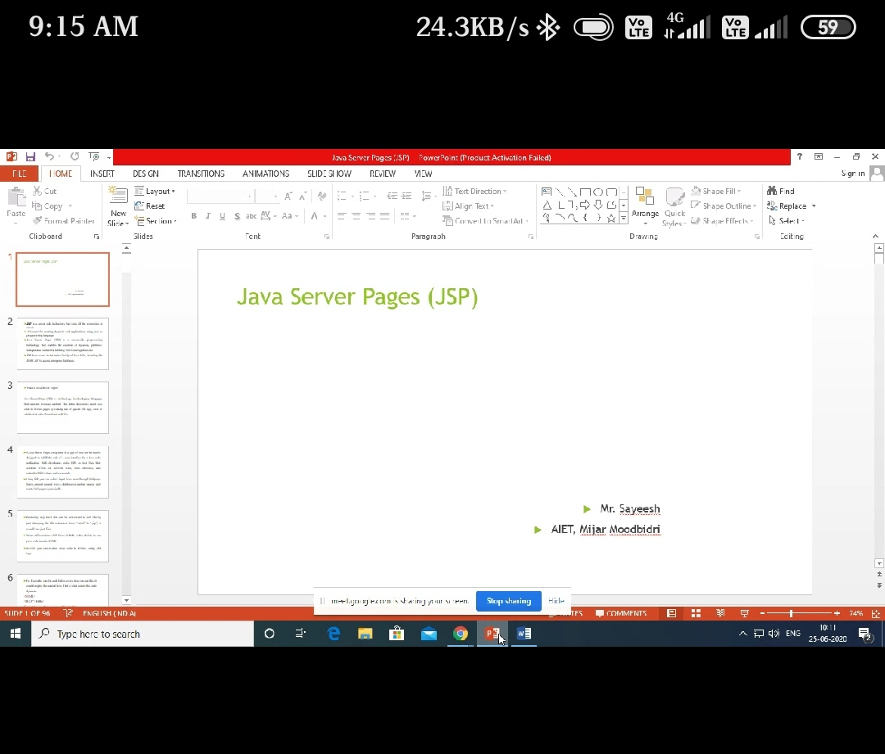

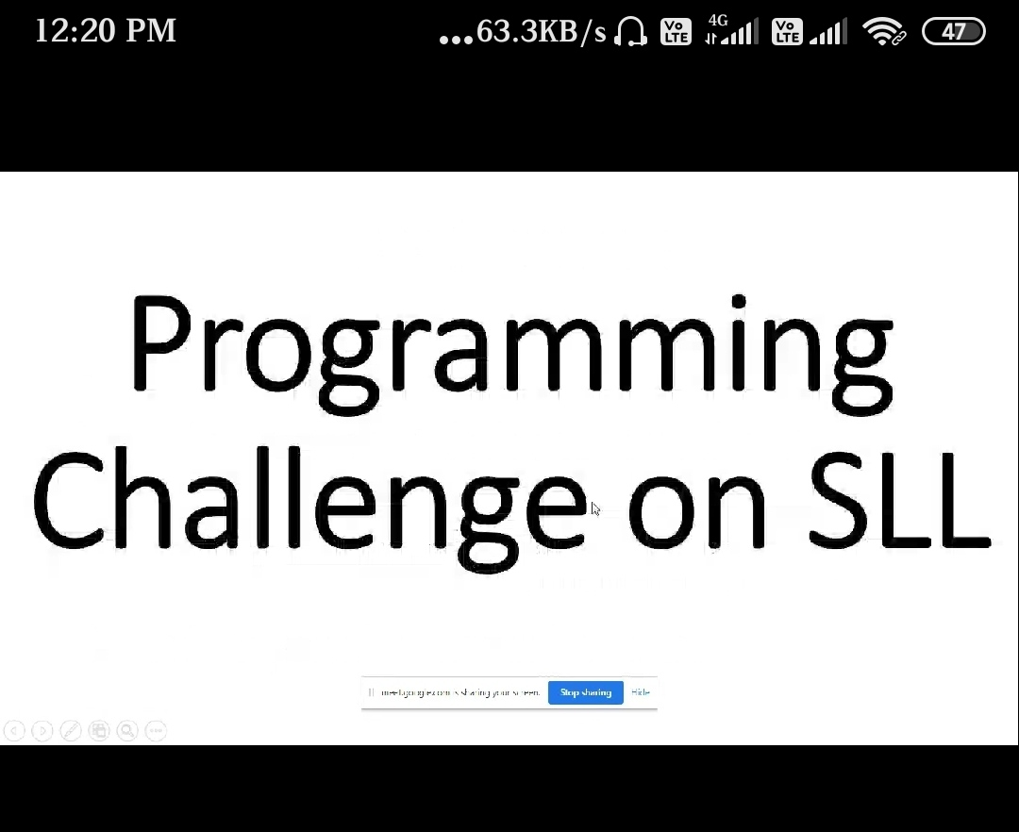

|  |  |
| --- | --- |
| **Coding Challenges** | |
| **Problem Statement: 1.**Python Program To Find Number Of Words And Number Of Characters in The string  String | |
| **Status: Executed** | |
| **Uploaded the report both in Github & Slack** | **Yes** |

**Snapshots of your response to challenge.**

**1.Python Program To Find Number Of Words And Number Of Characters In The**

**String.**

s = input("Enter The String: ")

c = 0

for i in s:

if i == " ":

c += 1

print(f'The Number Of Words In A String Is: {c + 1} \nThe Number Of Characters In A String Is: {len(s) - c}')

**OUTPUT**

