**DAILY REPORT**

**Student Name :SUSHMITHA.B.POOJARY**

**Class and Sec : VI B**

**USN :4AL17CS103**

**DATE:25-07-2020**

|  |  |  |  |  |
| --- | --- | --- | --- | --- |
| **Online Test Details** | | | | |
| **Subject** | **-----** | | | |
| **Semester** | **VI -B** | | **Duration** | **----** |
| **% of marks ----** | | **-----** | | |

|  |  |  |  |
| --- | --- | --- | --- |
| **Certification Course Details** | | | |
| **Course** | Python for Everybody | | |
| **Certificate Provider** | Coursera | **Duration** | 19hours |

**Snapshots of the daily class acitivities.**

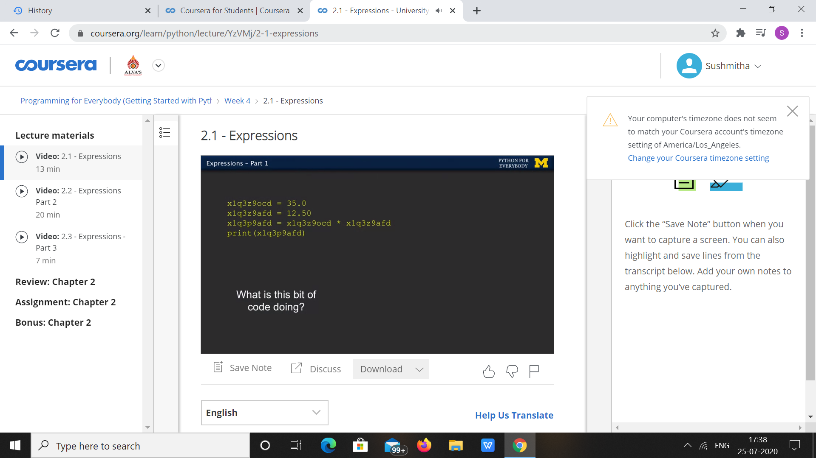

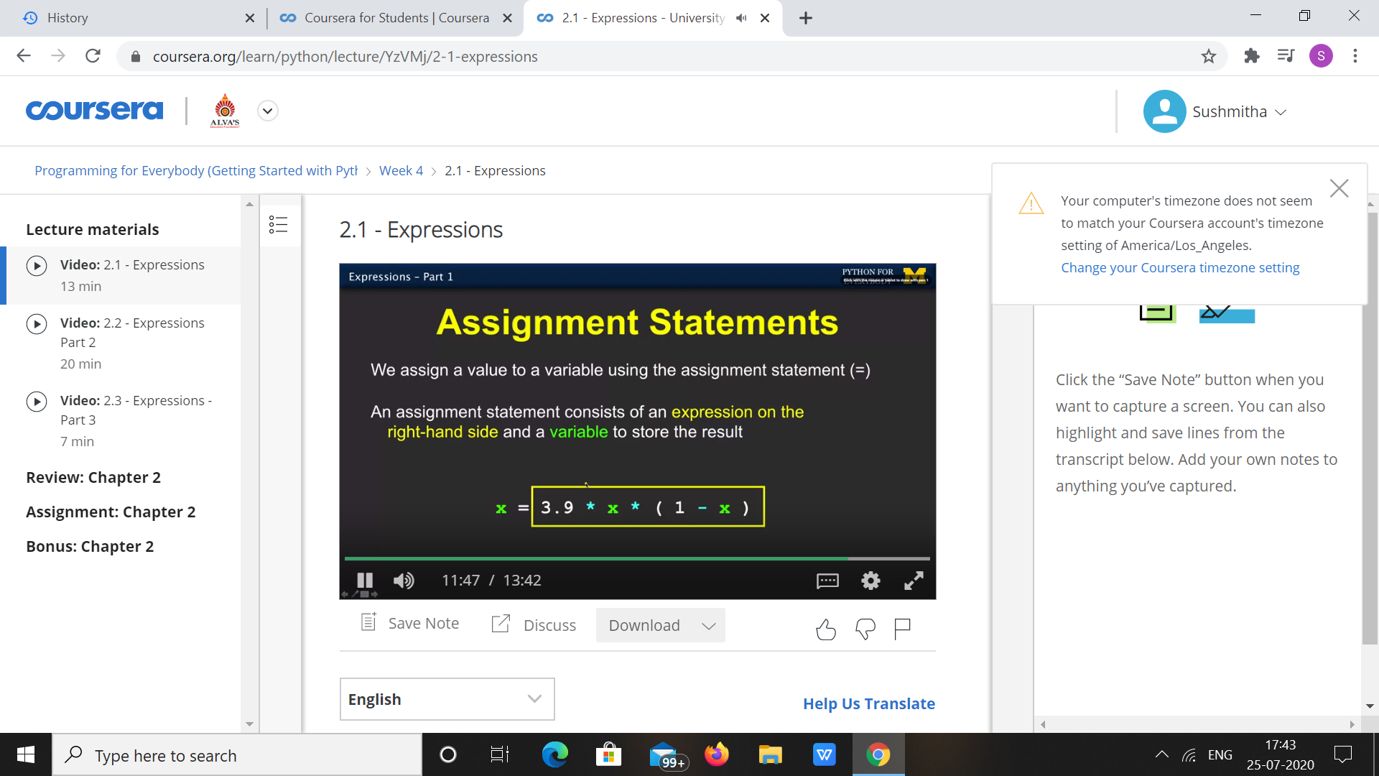

|  |  |
| --- | --- |
| **Coding Challenges** | |
| **Problem Statement:** 1.**Python Program for Program to Print Matrix in Z form.** | |
| **Status:** Executed | |
| **Uploaded the report both in Github & Slack** | Yes |

**Snapshots of your response to challenge.**

1. ****Python Program for Program to Print Matrix in Z form.****

arr = [[4, 5, 6, 8],

[1, 2, 3, 1],

[7, 8, 9, 4],

[1, 8, 7, 5]]

n = len(arr[0])

i=0

for j in range(0, n-1):

print(arr[i][j], end =" ")

k = 1

for i in range(0, n):

for j in range(n, 0, -1):

if(j==n-k):

print(arr[i][j], end = " ")

break;

k+=1

i=n-1;

for j in range(0, n):

print(arr[i][j], end = " ")

**OUTPUT**

