**DAILY REPORT**

**Student Name :SUSHMITHA.B.POOJARY**

**Class and Sec : VI B**

**USN :4AL17CS103**

**DATE:26-06-2020**

|  |  |  |  |  |
| --- | --- | --- | --- | --- |
| **Online Test Details** | | | | |
| **Subject** | **--------------** | | | |
| **Semester** | **VI -B** | | **Duration** | **-----------** |
| **% of marks ----** | | **-------------** | | |

|  |  |  |  |
| --- | --- | --- | --- |
| **PRE-PLACEMENT DETAILS** | | | |
| **Course** | **-** Cyber Security(9.15 to 11am)  - Data Structure(11.15am to 1pm) | | |
| **Faculty** | Dr.Manjunath kotari  Mr.Venkatesh.Bhatt | **Duration** | 4hours |

**Snapshots of the daily class acitivities.**

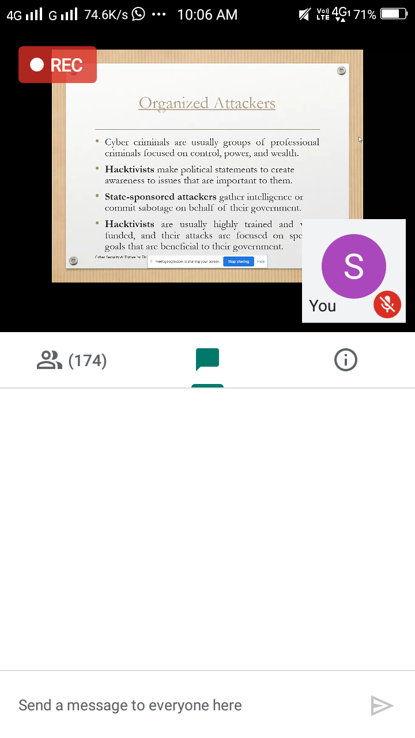

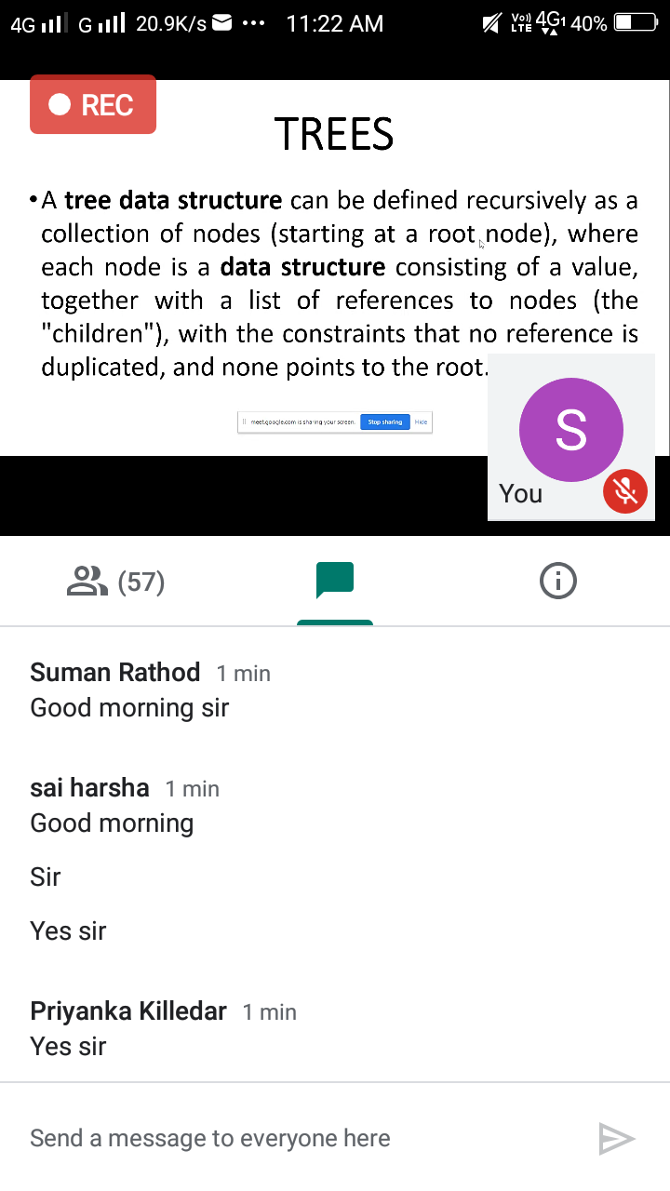

|  |  |
| --- | --- |
| **Coding Challenges** | |
| **Problem Statement: 1.**Write a java program to print all permutations of a given string. | |
| **Status: Executed** | |
| **Uploaded the report both in Github & Slack** | **Yes** |

**Snapshots of your response to challenge.**

**1. Write a java program to print all permutations of a given string.**

Description:  
Here is the steps to implement string permutations:

Take out the first char and keep it constant. And permute rest of the characters.  
User recursive method call to permute rest of the string except first character.  
While making recursive call, we accumulate each character being constant along with recursive call response.

Program

public class Permutation

{

public static void main(String[] args)

{

String str = "ABC";

int n = str.length();

Permutation permutation = new Permutation();

permutation.permute(str, 0, n-1);

}

private void permute(String str, int l, int r)

{

if (l == r)

System.out.println(str);

else

{

for (int i = l; i <= r; i++)

{

str = swap(str,l,i);

permute(str, l+1, r);

str = swap(str,l,i);

}

}

}

public String swap(String a, int i, int j)

{

char temp;

char[] charArray = a.toCharArray();

temp = charArray[i] ;

charArray[i] = charArray[j];

charArray[j] = temp;

return String.valueOf(charArray);

}

}

**Output:**

