**DAILY REPORT**

**Student Name :SUSHMITHA.B.POOJARY**

**Class and Sec : VI B**

**USN :4AL17CS103**

**DATE:27-06-2020**

|  |  |  |  |  |
| --- | --- | --- | --- | --- |
| **Online Test Details** | | | | |
| **Subject** | **---------------** | | | |
| **Semester** | **VI -B** | | **Duration** | **-----------** |
| **% of marks** | | **--------------** | | |

|  |  |  |  |
| --- | --- | --- | --- |
| PRE-PLACEMENT DETAILS | | | |
| **Course** | -DBMS(9.15 TO 11.00am)  -JDBC(11.00am to 1pm) | | |
| **Faculty** | Mr.Hemanth  Mr.Sayeesh | **Duration** | 4hours |

**Snapshots of the daily class acitivities.**

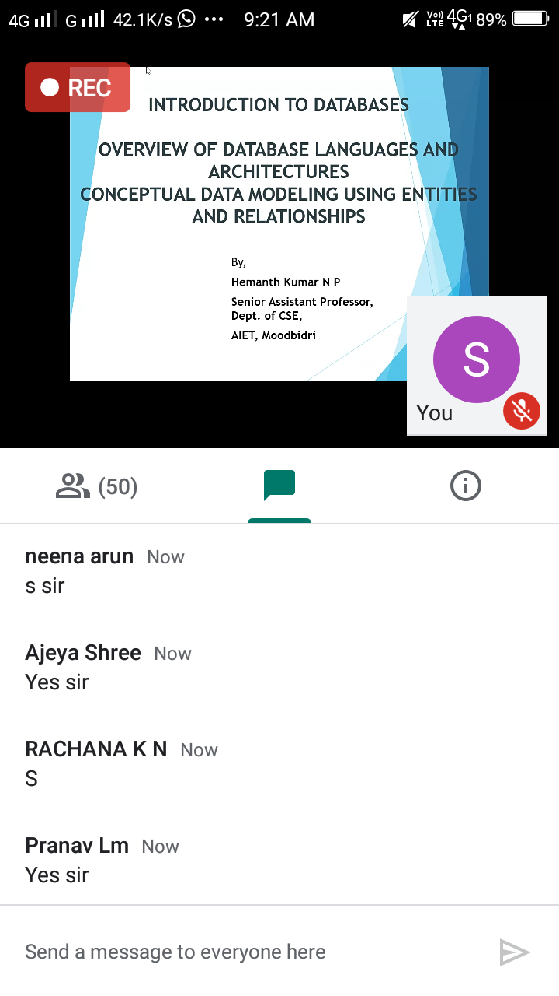

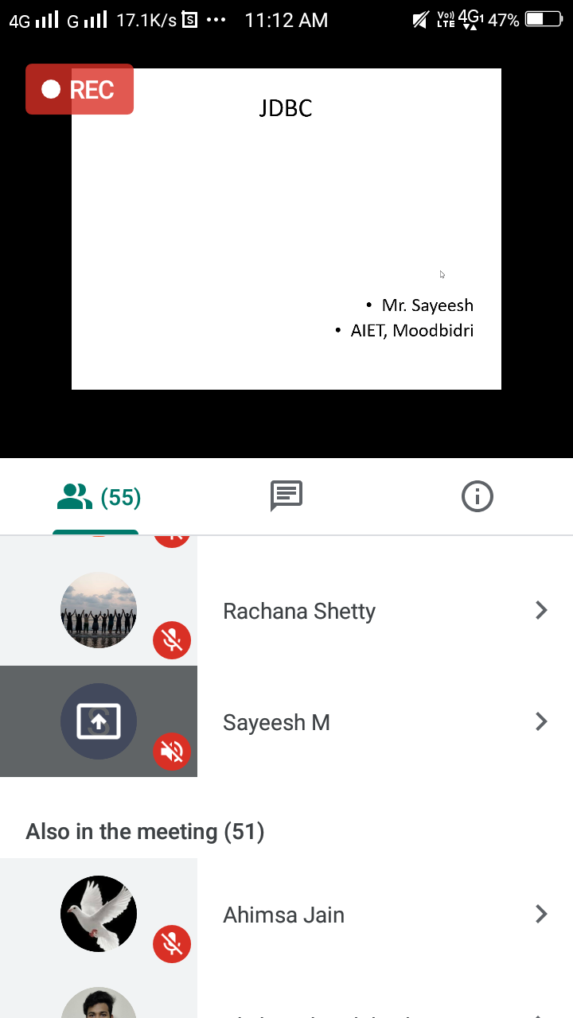

|  |  |
| --- | --- |
| **Coding Challenges** | |
| **Problem Statement: 1.**Python Program to Find the Area of a Rectangle Using Classes. | |
| **Status: Executed** | |
| **Uploaded the report both in Github & Slack** | **Yes** |

**Snapshots of your response to challenge.**

1. **Python Program to Find the Area of a Rectangle Using Classes.**

class rectangle():

def __init__(self,breadth,length):

self.breadth=breadth

self.length=length

def area(self):

return self.breadth*self.length

a=int(input("Enter length of rectangle: "))

b=int(input("Enter breadth of rectangle: "))

obj=rectangle(a,b)

print("Area of rectangle:",obj.area())

print()

