**DAILY REPORT**

**Student Name :SUSHMITHA.B.POOJARY**

**Class and Sec : VI B**

**USN :4AL17CS103**

**DATE:27-07-2020**

|  |  |  |  |  |
| --- | --- | --- | --- | --- |
| **Online Test Details** | | | | |
| **Subject** | OS | | | |
| **Semester** | **VI -B** | | **Duration** | 50Minutes |
| **% of marks** 30 | | **-----** | | |

|  |  |  |  |
| --- | --- | --- | --- |
| **Certification Course Details** | | | |
| **Course** | **Python for Everybody** | | |
| **Certificate Provider** | **Coursera** | **Duration** | **19hours** |

**Snapshots of the daily class acitivities.**

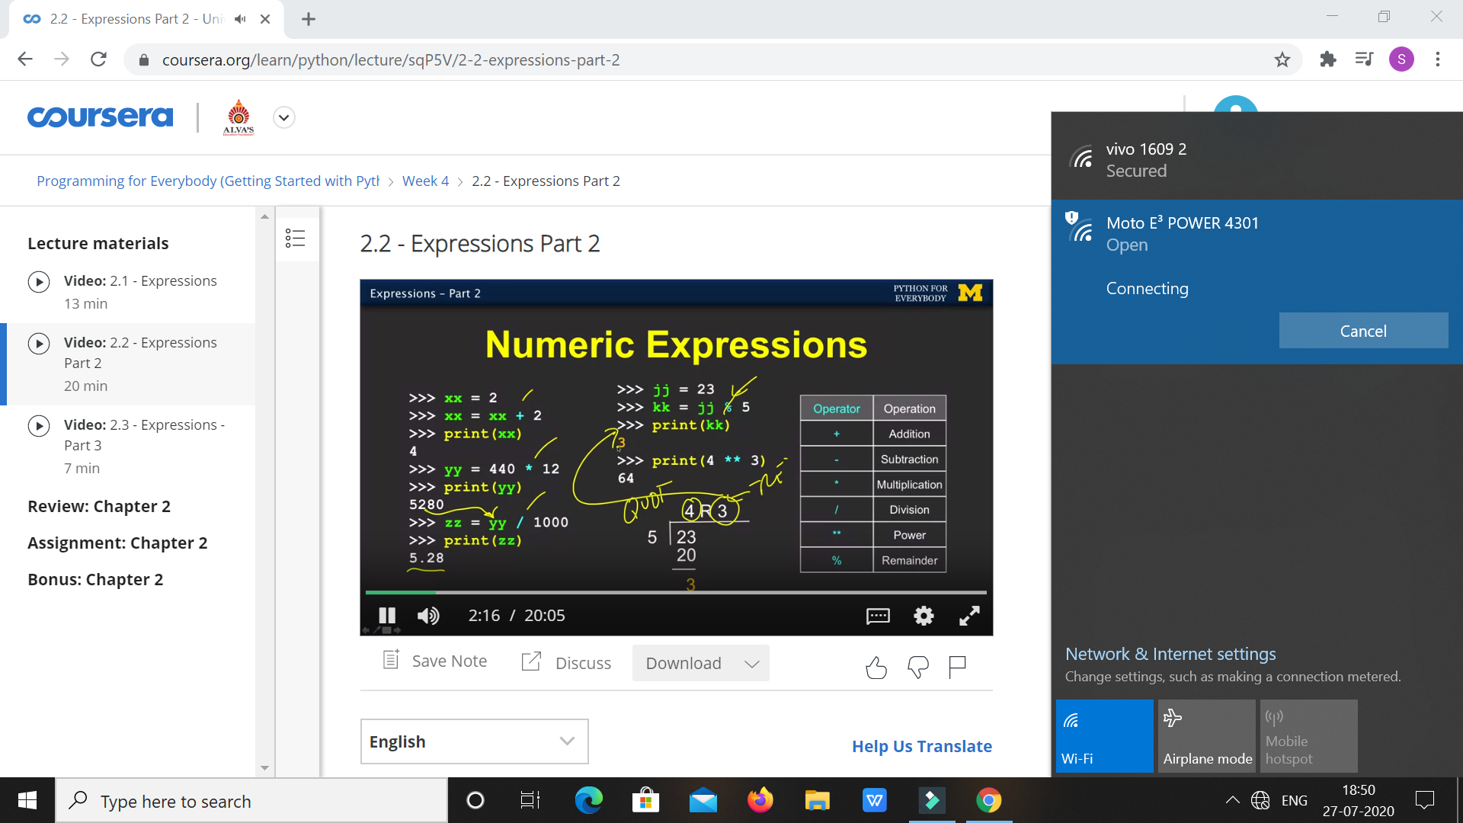

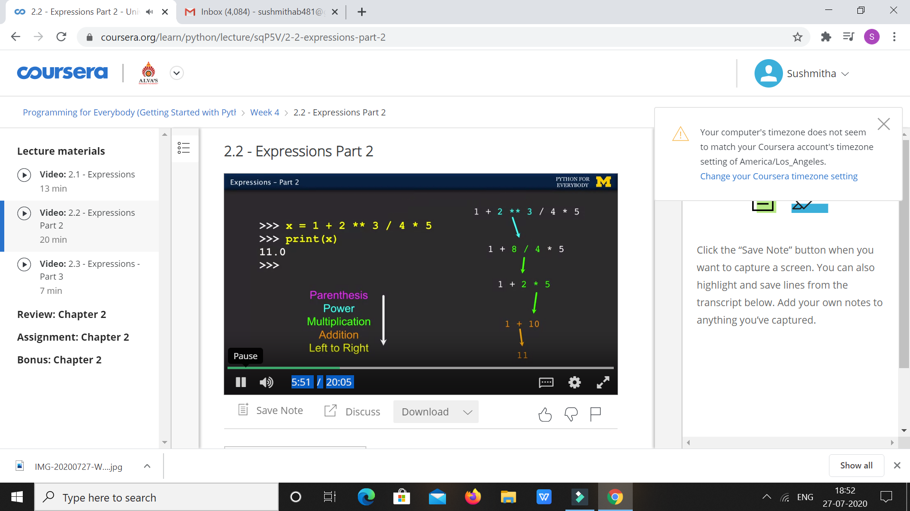

|  |  |
| --- | --- |
| **Coding Challenges** | |
| **Problem Statement:** **1.Python Program for Smallest K digit number divisible by X.** | |
| **Status:** Executed | |
| **Uploaded the report both in Github & Slack** | Yes |

**Snapshots of your response to challenge.**

1. ****Python Program for Smallest K digit number divisible by X.****

**def answer(X, K):**

**MIN = pow(10, K-1)**

**if(MIN%X == 0):**

**return (MIN)**

**else:**

**return ((MIN + X) - ((MIN + X) % X))**

**X = 83;**

**K = 5;**

**print(answer(X, K));**

****OUTPUT****

