**DAILY REPORT**

**Student Name :SUSHMITHA B POOJARY**

**Class and Sec : VI B**

**USN :4AL17CS103**

**Date:28-05-2020**

|  |  |  |  |  |
| --- | --- | --- | --- | --- |
| **Online Test Details** | | | | |
| **Subject** | **Operating system** | | | |
| **Semester** | **VI B** | | **Duration** | **35 Minutes** |
| **% of marks 30** | | **16** | | |

**snapshot of the test result**

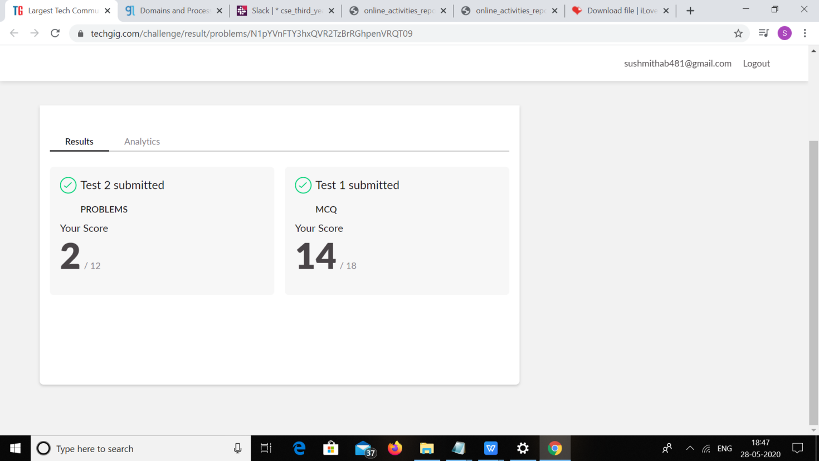

|  |  |  |  |
| --- | --- | --- | --- |
| **Certification Course Details** | | | |
| **Course** | **Ethical Hacking** | | |
| **Certificate Provider** | **Great learning** | **Duration** | **6hours** |

**snapshots of the daily class acitivities**





|  |  |
| --- | --- |
| **Coding Challenges** | |
| **1.Problem Statement:** Python program to find digital root of a number  JAVA PROGRM-BALANCED BRAKET | |
| **Status: Executed** | |
| **Uploaded the report both in Github & Slack** | **yes** |

**snapshots of response to challenge.**

**Coding Challenges Details:**

1. Python program to find digital root of a number

Description:

A digital root is the recursive sum of all the digits in a number. Given n, take the sum of the digits of n. If that value has more than one digit, continue reducing in this way until a single-digit number is produced. This is only applicable to the natural numbers.

digit_root(0)= 0

digital_root(16)

=> 1 + 6

=> 7

digital_root(132189)

=> 1 + 3 + 2 + 1 + 8 + 9

=> 24 ...

=> 2 + 4

=> 6

def DigitalRoot(number): addper=0

while number >=10:

number = sum(int(digit)for digit in str(number))

addper +=1

#I highly recommend using return instead of print, but for testing purposes I used print

print(number) DigitalRoot(132189)

**Output**

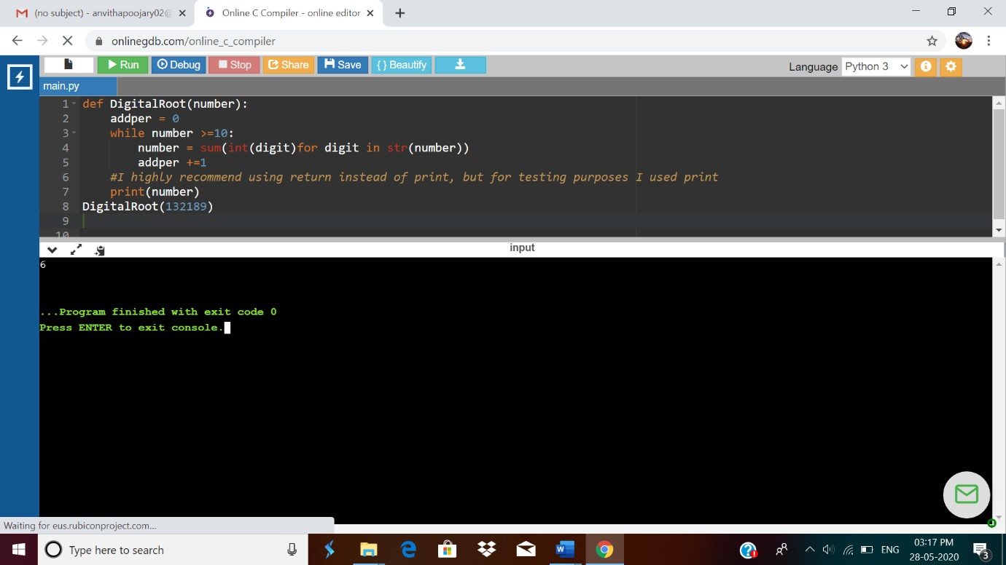

1. JAVA PROGRM-BALANCED BRAKET

Write a function that accepts a string consisting entiring of brackets ({}) and returns whether it is balanced. Every "opening" bracket must be followed by a closing bracket of the same type. There can also be nested brackets, which adhere to the same rule. f('()[]{}(([])){[()][]}') // true

f('())[]{}') // false

import java.util.Stack; public class Main {

public static void main(String[] args)

{

System.out.println(is_parentheses_balanced("()[]{}(([])){[()][]}"));

}

public static boolean matchingPeer(char open , char close){

if ( open == '(' && close == ')')

{

return true;

}

if ( open == '[' && close == ']')

{

return true;

}

else{

return false;

}

}

public static boolean is_parentheses_balanced(String equation){

char[] c = equation.toCharArray();

Stack <Character> myStack= new Stack <Character> ();

for (int i = 0; i < c.length; i++){

if(c[i]=='(' || c[i] == '[' ){

myStack.push(c[i]);

}

else if (c[i]== ')' || c[i]==']'){

if(matchingPeer(myStack.peek(),c[i])==true){

myStack.pop();

} else {

return false;

}

}

}

if(myStack.isEmpty()){

return true;

}

else {

}

return false;

}

# Output:



