**DAILY REPORT**

**Student Name :SUSHMITHA.B.POOJARY**

**Class and Sec : VI B**

**USN :4AL17CS103**

**DATE:28-06-2020**

|  |  |  |  |  |
| --- | --- | --- | --- | --- |
| **Online Test Details** | | | | |
| **Subject** | **--------------** | | | |
| **Semester** | **VI -B** | | **Duration** | **--------** |
| **% of marks** | | **-------** | | |

|  |  |  |  |
| --- | --- | --- | --- |
| **Certification Course Details** | | | |
| **Course** | **Introduction to Cloud Computing** | | |
| **Certificate Provider** | **Cognitiveclass.ai** | **Duration** | **6hours** |

**Snapshots of the daily class acitivities**

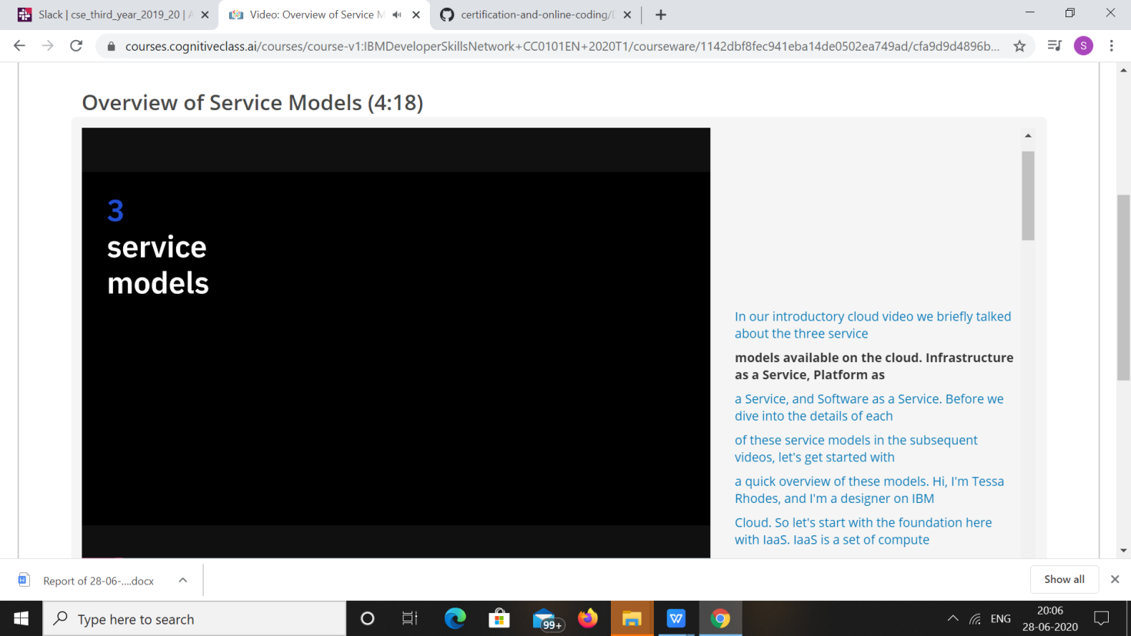

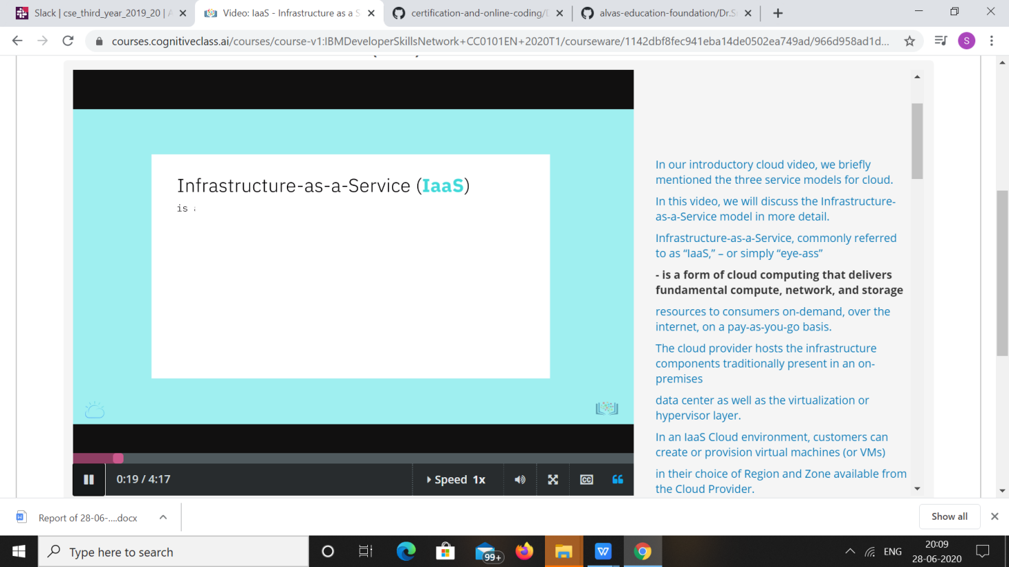

|  |  |
| --- | --- |
| **Coding Challenges** | |
| **Problem Statement: 1.**Write a C++ program to find the sum of 2 integers using Pointers. | |
| **Status: Executed** | |
| **Uploaded the report both in Github & Slack** | **Yes** |

**Snapshots of your response to challenge.**

1.**Write a C++ program to find the sum of 2 integers using Pointers.**

#include<iostream.h>

#include<conio.h>

void main()

{

clrscr();

int num1, num2, *ptr1, *ptr2, sum=0;

cout<<"Enter the two number :";

cin>>num1>>num2;

ptr1 = &num1;

ptr2 = &num2;

sum = *ptr1 + *ptr2;

cout<<"Sum of the two number is "<<sum;

getch();

}

**OUTPUT**

