**DAILY REPORT**

**Student Name :SUSHMITHA.B.POOJARY**

**Class and Sec : VI B**

**USN :4AL17CS103**

**DATE:28-07-2020**

|  |  |  |  |  |
| --- | --- | --- | --- | --- |
| **Online Test Details** | | | | |
| **Subject** | **OR** | | | |
| **Semester** | **VI -B** | | **Duration** | **75Minutes** |
| **% of marks 30** | | **-----** | | |

|  |  |  |  |
| --- | --- | --- | --- |
| **Certification Course Details** | | | |
| **Course** | **Python for Everybody** | | |
| **Certificate Provider** | **Coursera** | **Duration** | **19hours** |

**Snapshots of the daily class acitivities.**

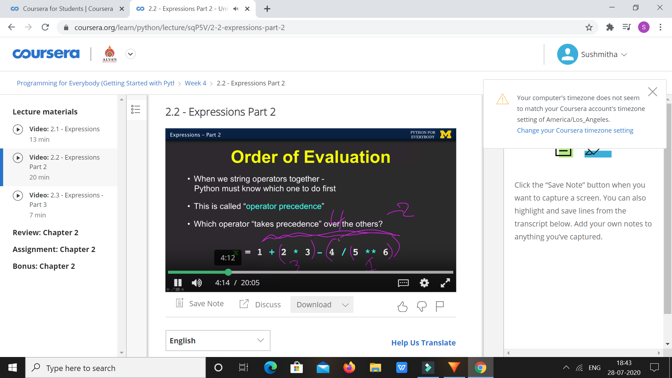

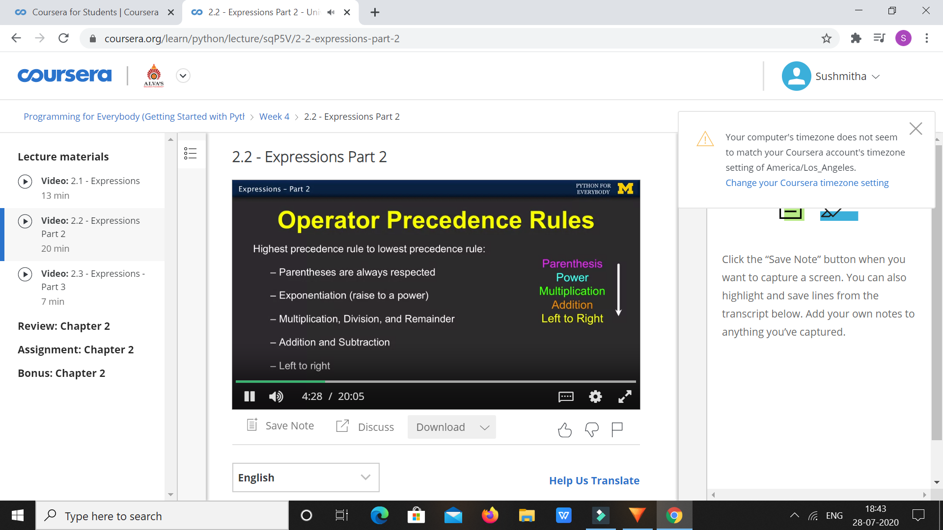

|  |  |
| --- | --- |
| **Coding Challenges** | |
| **Problem Statement:** 1.**Python Program for Print Number series without using any loop.** | |
| **Status:** Executed | |
| **Uploaded the report both in Github & Slack** | Yes |

**Snapshots of your response to challenge.**

**1.**Python Program for Print Number series without using any loop.****

def PrintNumber(N, Original, K, flag):

print(N, end = " ")

if (N <= 0):

if(flag==0):

flag = 1

else:

flag = 0

if (N == Original and (not(flag))):

return

if (flag == True):

PrintNumber(N - K, Original, K, flag)

return

if (not(flag)):

PrintNumber(N + K, Original, K, flag);

return

N = 20

K = 6

PrintNumber(N, N, K, True)

**OUTPUT**

