**DAILY REPORT**

**Student Name :Sushmitha.B.Poojary**

**Class and Sec : VI B**

**USN :4AL17CS103**

**DATE:29-05-2020**

|  |  |  |  |  |
| --- | --- | --- | --- | --- |
| **Online Test Details** | | | | |
| **Subject** | **Operation Research** | | | |
| **Semester** | **VI B** | | **Duration** | **45 Minutes** |
| **% of marks 30** | | **30** | | |

**Snapshot of the test result**

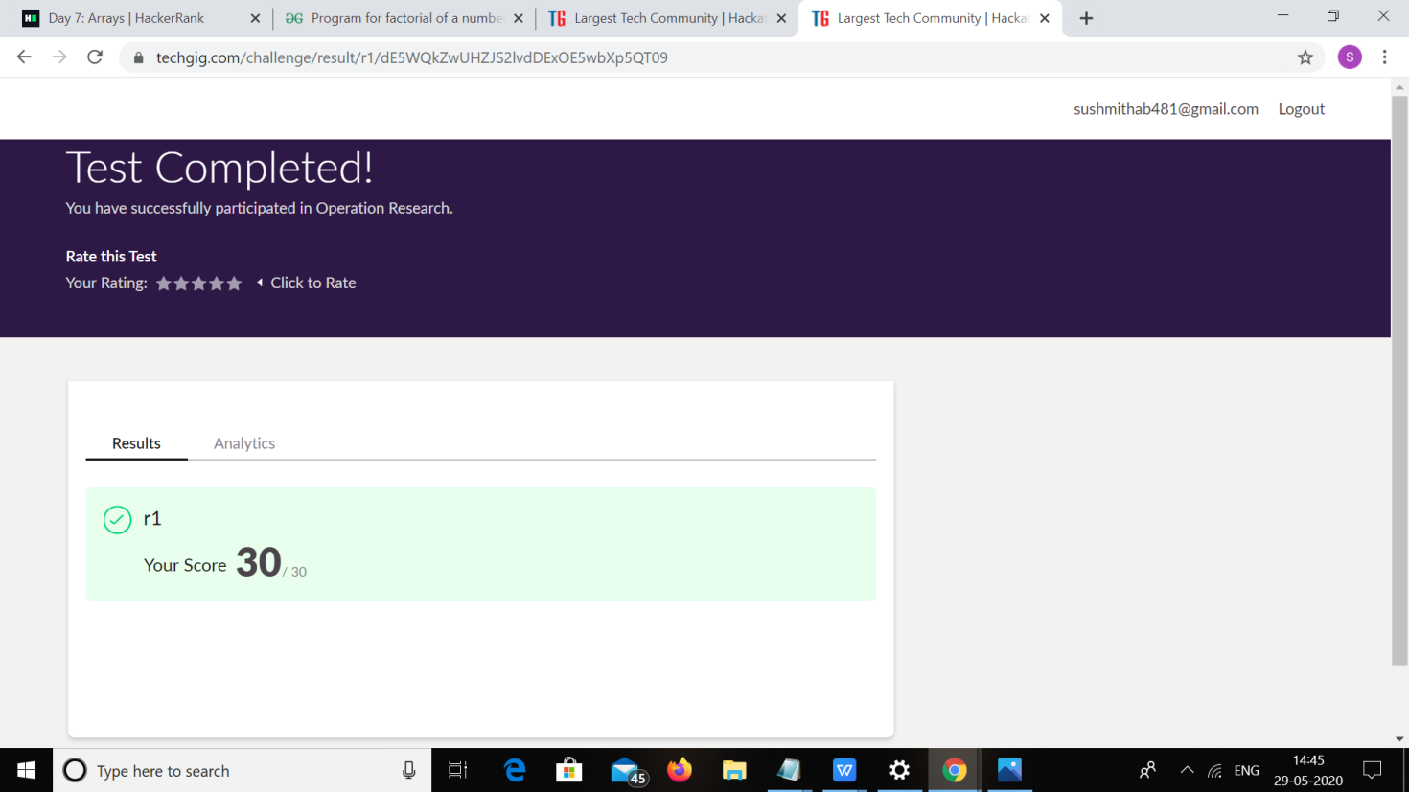

|  |  |  |  |
| --- | --- | --- | --- |
| **Certification Course Details** | | | |
| **Course** | **Ethical Hacking** | | |
| **Certificate Provider** | **Great Learning** | **Duration** | **6hours** |

**Snapshots of the daily class acitivities**



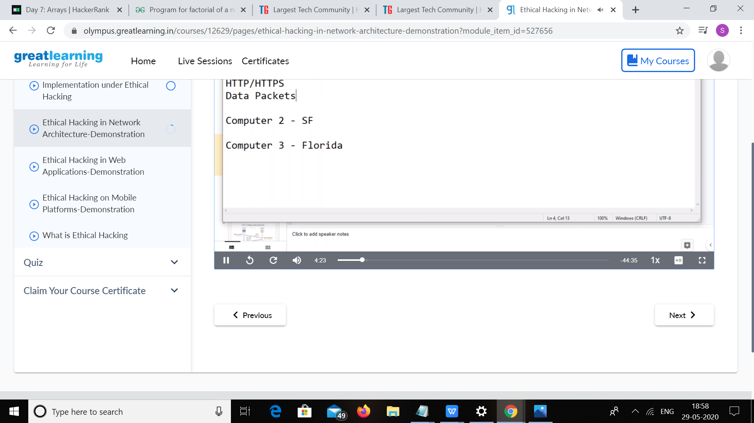

|  |  |
| --- | --- |
| **Coding Challenges** | |
| **Problem Statement:** 1. Python program to calculate the number of lowercase and uppercase letters in a string  2. We are given 3 strings: str1, str2, and str3. Str3 is said to be a shuffle of str1 and str2 if it  can be formed by interleaving the characters of str1 and str2 in a way that maintains the  left to right ordering of the characters from each string.  3.Write a c program to solve a system of linear congruences by applying the Chinese  Remainder Theorem. | |
| **Status: Executed** | |
| **Uploaded the report both in Github & Slack** | **Yes** |

**Snapshots of your response to challenge.**

**Coding Challenges Details:**

1. Python program to calculate the number of lowercase and uppercase

letters in a string

Description:

Take a string as input and find the number of uppercase and lower case letters in

the string and print the count.

Note: any spaces has to be ignored

Eg: string is : 'This is Python'

Upper case characters : 2

Lower case characters : 10

string=input("Enter string:")

count1=0

count2=0

for i in string:

if(i.islower()):

count1=count1+1elif(i.isupper()):

count2=count2+1

print("The number of lowercase characters is:")

print(count1)

print("The number of uppercase characters is:")

print(count2)

**output:**

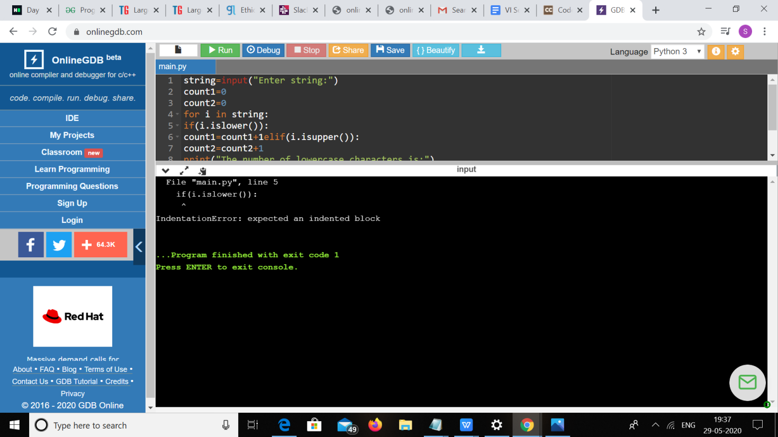

2. We are given 3 strings: str1, str2, and str3. Str3 is said to be a shuffle of str1 and str2 if it can

be formed by interleaving the characters of str1 and str2 in a way that maintains the left to right

ordering of the characters from each string. For example, given str1="abc" and str2="def",

str3="dabecf" is a valid shuffle since it preserves the character ordering of the two strings. So,

given these 3 strings write a function that detects whether str3 is a valid shuffle of str1 and str2.

public class Main{

static boolean isInterleaved (String A, String B, String C) {

int i = 0, j = 0, k = 0;

while (k != C.length())

{

if (i<A.length()&&A.charAt(i) == C.charAt(k))

i++;

else if (j<B.length()&&B.charAt(j) == C.charAt(k))

j++;

else

return false;

k++;

}

if (i < A.length() || j < B.length())

return false;

return true;

}

public static void main(String []args){

String A = "abc";

String B = "def";

String C = "dabecf";

if (isInterleaved(A, B, C) == true)

System.out.printf("%s is interleaved of %s and %s", C, A, B); else

System.out.printf("%s is not interleaved of %s and %s", C, A, B);

}

}

**Output:**

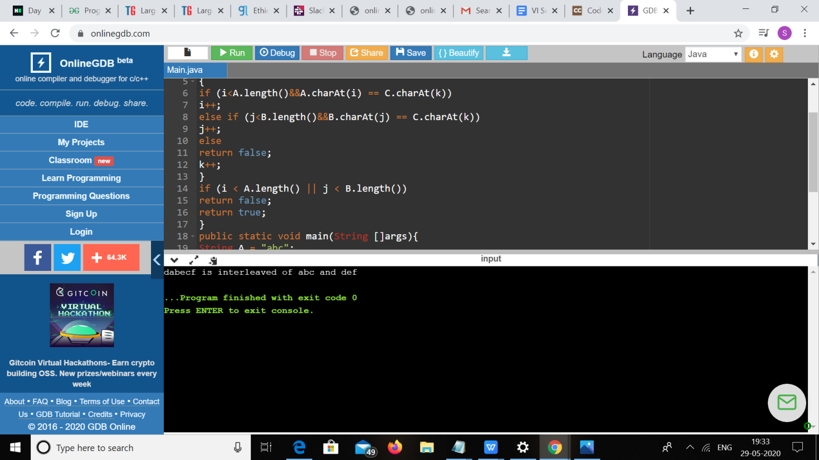

3.Write a c program to solve a system of linear congruences by applying the Chinese

Remainder Theorem.

#include <stdio.h>

int mul_inv(int a, int b)

{

int b0 = b, t, q;

int x0 = 0, x1 = 1;

if (b == 1) return 1;while (a > 1) {

q = a / b;

t = b, b = a % b, a = t;

t = x0, x0 = x1 - q * x0, x1 = t;

}

if (x1 < 0) x1 += b0;

return x1;

}

int chinese_remainder(int *n, int *a, int len)

{

int p, i, prod = 1, sum = 0;

for (i = 0; i < len; i++) prod *= n[i];

for (i = 0; i < len; i++) {

p = prod / n[i];

sum += a[i] * mul_inv(p, n[i]) * p;

}

return sum % prod;

}

int main(void)

{int n[] = { 3, 5, 7 };

int a[] = { 2, 3, 2 };

printf("%d\n", chinese_remainder(n, a, sizeof(n)/sizeof(n[0])));

return 0;

OUTPUT:

