**DAILY REPORT**

**Student Name :SUSHMITHA.B.POOJARY**

**Class and Sec : VI B**

**USN :4AL17CS103**

**DATE:29-06-2020**

|  |  |  |  |  |
| --- | --- | --- | --- | --- |
| **Online Test Details** | | | | |
| **Subject** | **----------** | | | |
| **Semester** | **VI -B** | | **Duration** | **------** |
| **% of marks** | | **-------------** | | |

|  |  |  |  |
| --- | --- | --- | --- |
| **PRE-PLACEMENT TRAINING DETAILS** | | | |
| **Course** | -DBMS(9 TO 11am)  -Cyber Security(11am to 1pm) | | |
| **Faculty** | -Mrs.Reena.Lobo  -Dr.Manjunath.Kottari | **Duration** | 4hours |

**Snapshots of the daily class activities**

**t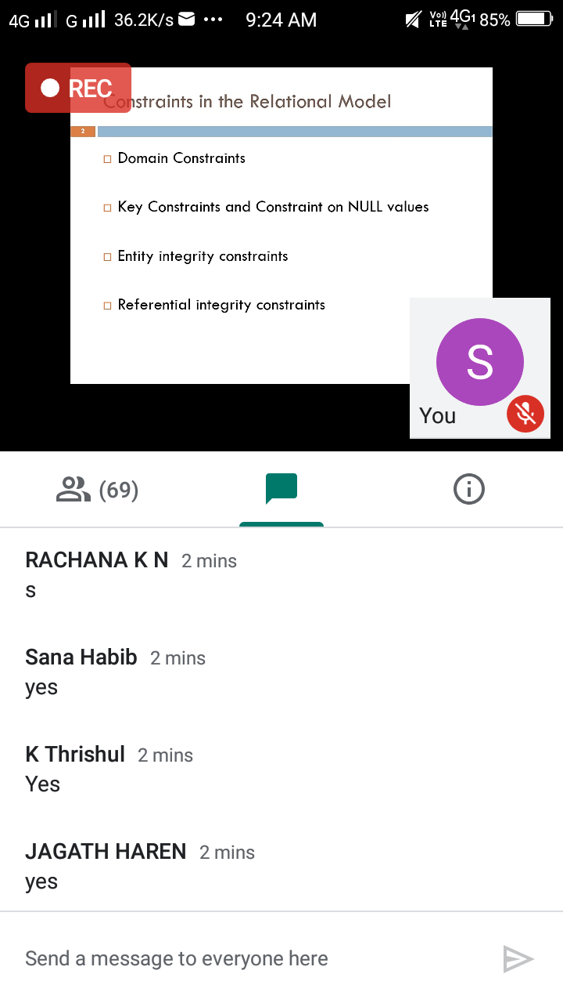ies.**

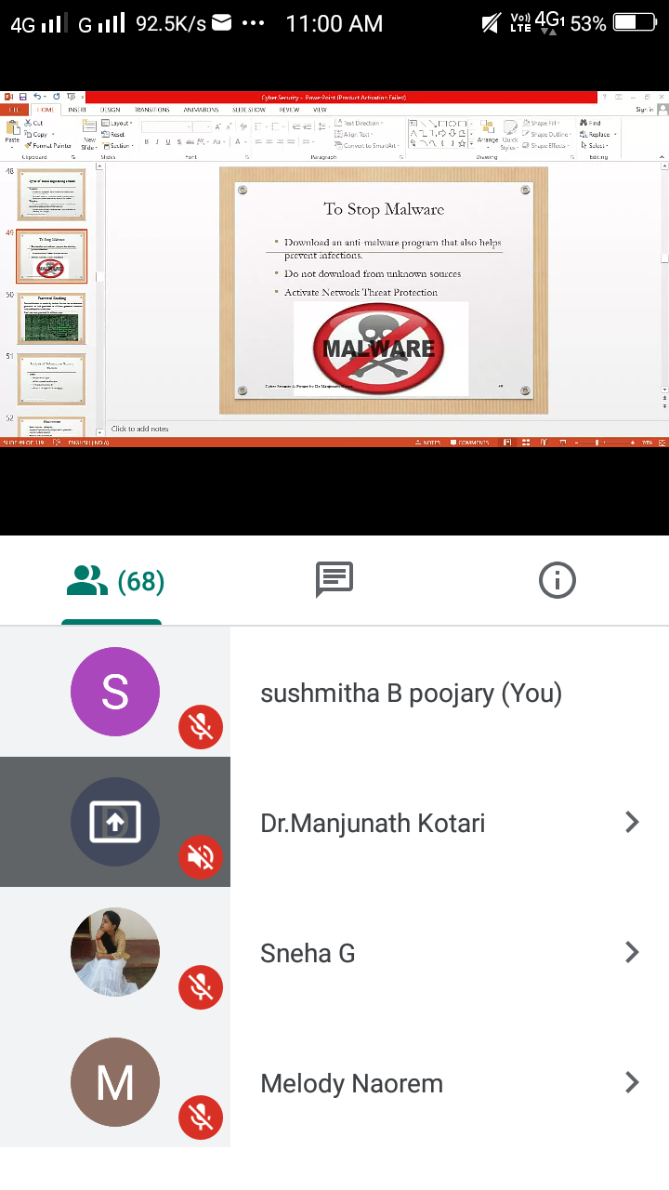

|  |  |
| --- | --- |
| **Coding Challenges** | |
| **Problem Statement: 1**.**Python Program to Count the Number of Occurrences of an Element in the Linked List with using Recursions.**  ****2.**Python Program to Count the Number of Occurrences of an Element in the Linked List without using Recursions.** | |
| **Status: Executed** | |
| **Uploaded the report both in Github & Slack** | **Yes** |

**Snapshots of your response to challenge.**

1. ****Python Program to Count the Number of Occurrences of an Element in the Linked List with using Recursions.****

**class Node:**

**def __init__(self, data):**

**self.data = data**

**self.next = None**

**class LinkedList:**

**def __init__(self):**

**self.head = None**

**self.last_node = None**

**def append(self, data):**

**if self.last_node is None:**

**self.head = Node(data)**

**self.last_node = self.head**

**else:**

**self.last_node.next = Node(data)**

**self.last_node = self.last_node.next**

**def display(self):**

**current = self.head**

**while current:**

**print(current.data, end = ' ')**

**current = current.next**

**def count(self, key):**

**return self.count_helper(self.head, key)**

**def count_helper(self, current, key):**

**if current is None:**

**return 0**

**if current.data == key:**

**return 1 + self.count_helper(current.next, key)**

**else:**

**return self.count_helper(current.next, key)**

**a_llist = LinkedList()**

**for data in [8, 5, 6, 4, 1, 9, 33, 6, 2, 11, 8, 4 ,6] :**

**a_llist.append(data)**

**print('The linked list: ', end = '')**

**a_llist.display()**

**print()**

**key = int(input('Enter the data element: '))**

**count = a_llist.count(key)**

**print('{0} occurs {1} times in the list.'.format(*key, count))***

****OUTPUT****

****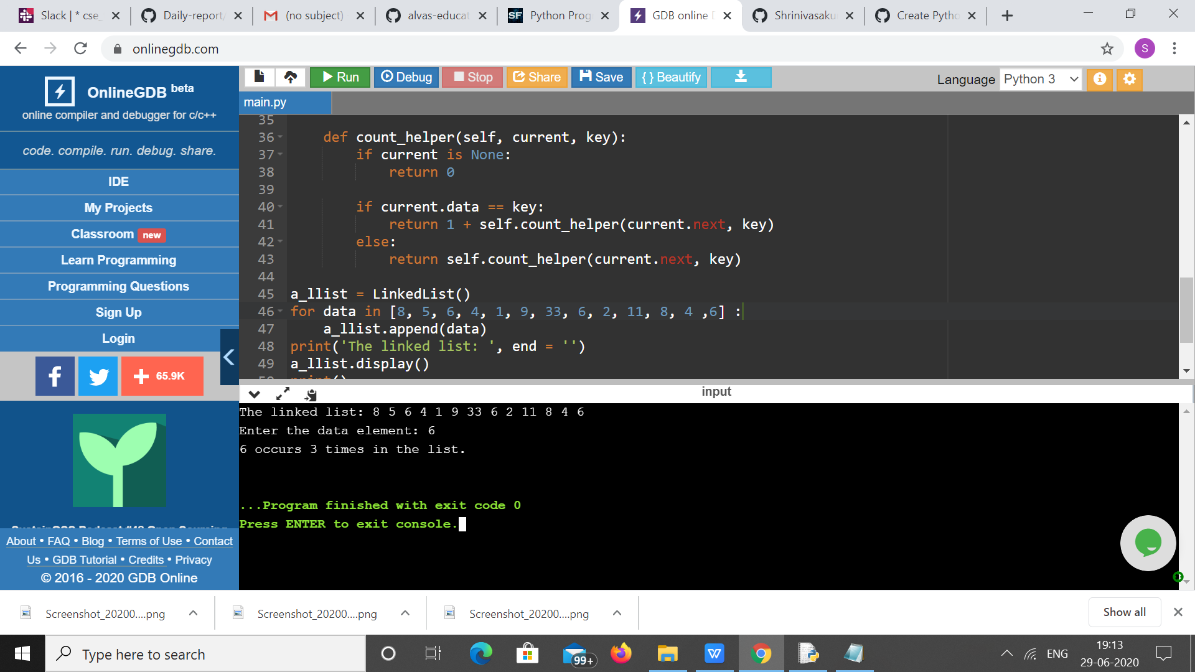****

****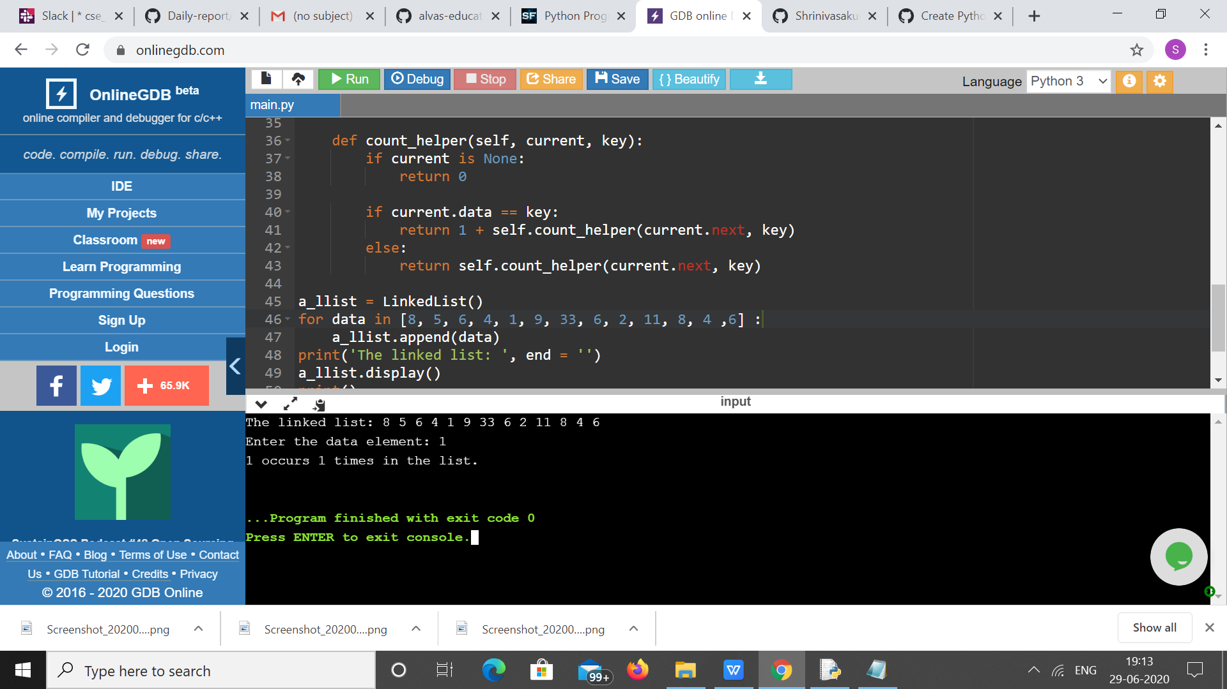****

****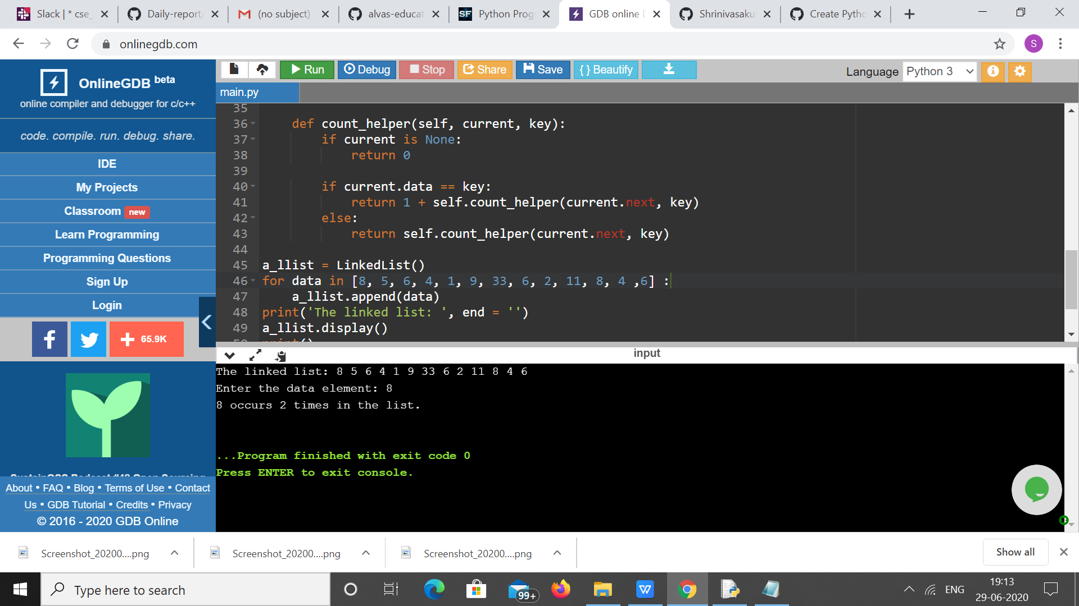****

1. ****Python Program to Count the Number of Occurrences of an Element in the Linked List without using Recursions.****

**class Node:**

**def __init__(self, data):**

**self.data = data**

**self.next = None**

**class LinkedList:**

**def __init__(self):**

**self.head = None**

**self.last_node = None**

**def append(self, data):**

**if self.last_node is None:**

**self.head = Node(data)**

**self.last_node = self.head**

**else:**

**self.last_node.next = Node(data)**

**self.last_node = self.last_node.next**

**def display(self):**

**current = self.head**

**while current:**

**print(current.data, end = ' ')**

**current = current.next**

**def count(self, key):**

**current = self.head**

**count = 0**

**while current:**

**if current.data == key:**

**count = count + 1**

**current = current.next**

**return count**

**a_llist = LinkedList()**

**for data in [ 4, 6 ,9 ,11 , 58, 4, 7, 11, 5, 11, 8 ,9 ,11 ]:**

**a_llist.append(data)**

**print('The linked list: ', end = '')**

**a_llist.display()**

**print()**

**key = int(input('Enter the data item: '))**

**count = a_llist.count(key)**

**print('{0} occurs {1} times in the list.'.format(key, count))**

**OUTPUT**

****