**DAILY REPORT**

**Student Name :SUSHMITHA.B.POOJARY**

**Class and Sec : VI B**

**USN :4AL17CS103**

**DATE:29-07-2020**

|  |  |  |  |  |
| --- | --- | --- | --- | --- |
| **Online Test Details** | | | | |
| **Subject** | **OR** | | | |
| **Semester** | **VI -B** | | **Duration** | **50Minutes** |
| **% of marks ---** | | **-----** | | |

|  |  |  |  |
| --- | --- | --- | --- |
| **Certification Course Details** | | | |
| **Course** | **Python for Everybody** | | |
| **Certificate Provider** | **Coursera** | **Duration** | **19hours** |

**Snapshots of the daily class acitivities.**

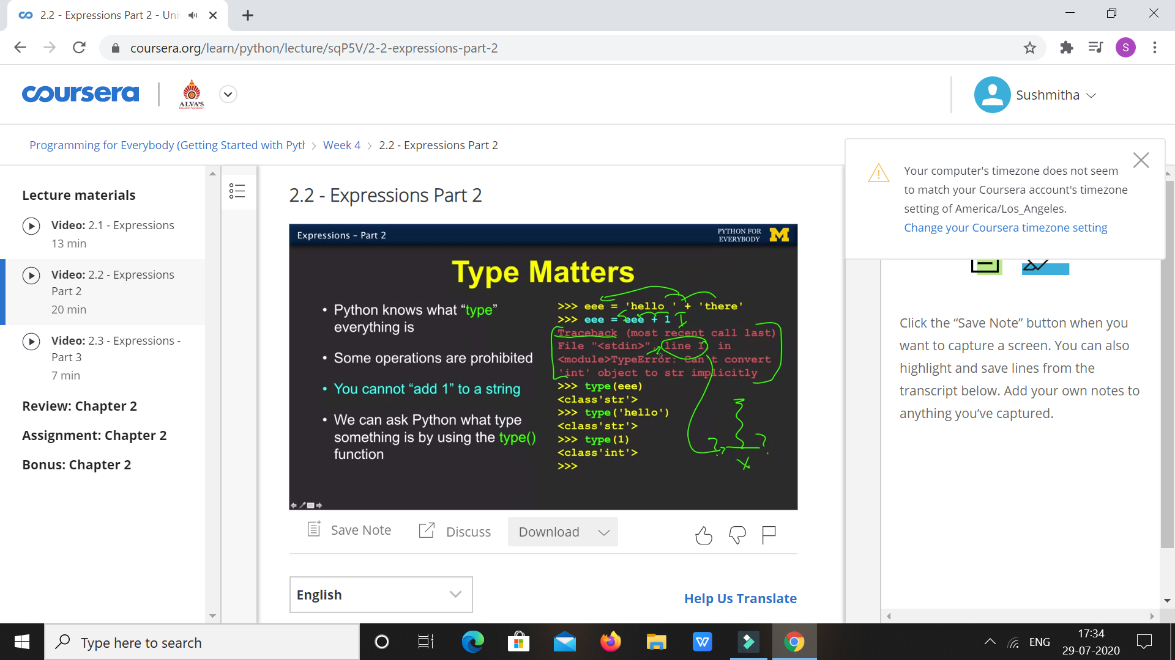

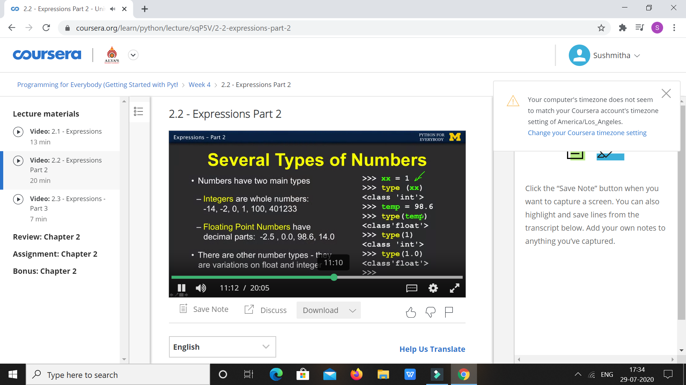

|  |  |
| --- | --- |
| **Coding Challenges** | |
| **Problem Statement: 1.Python Program for Number of stopping station problem.** | |
| **Status:** Executed | |
| **Uploaded the report both in Github & Slack** | Yes |

**Snapshots of your response to challenge.**

1. ****Python Program for Number of stopping station problem.****

**def stopping_station( p, n):**

**num = 1**

**dem = 1**

**s = p**

**while p != 1:**

**dem *= p**

**p-=1**

**t = n - s + 1**

**while t != (n-2 * s + 1):**

**num *= t**

**t-=1**

**if (n - s + 1) >= s:**

**return int(num/dem)**

**else:**

**return -1**

**num = stopping_station(4, 12)**

**if num != -1:**

**print(num)**

**else:**

**print("Not Possible")**

****OUTPUT****

