**DAILY REPORT**

**Student Name :SUSHMITHA.B.POOJARY**

**Class and Sec : VI B**

**USN :4AL17CS103**

**DATE:30-07-2020**

|  |  |  |  |  |
| --- | --- | --- | --- | --- |
| **Online Test Details** | | | | |
| **Subject** | **------** | | | |
| **Semester** | **VI -B** | | **Duration** | **----** |
| **% of marks ---** | | **-----** | | |

|  |  |  |  |
| --- | --- | --- | --- |
| **Certification Course Details** | | | |
| **Course** | **Python for Everybody** | | |
| **Certificate Provider** | **Coursera** | **Duration** | **19hours** |

**Snapshots of the daily class acitivities.**

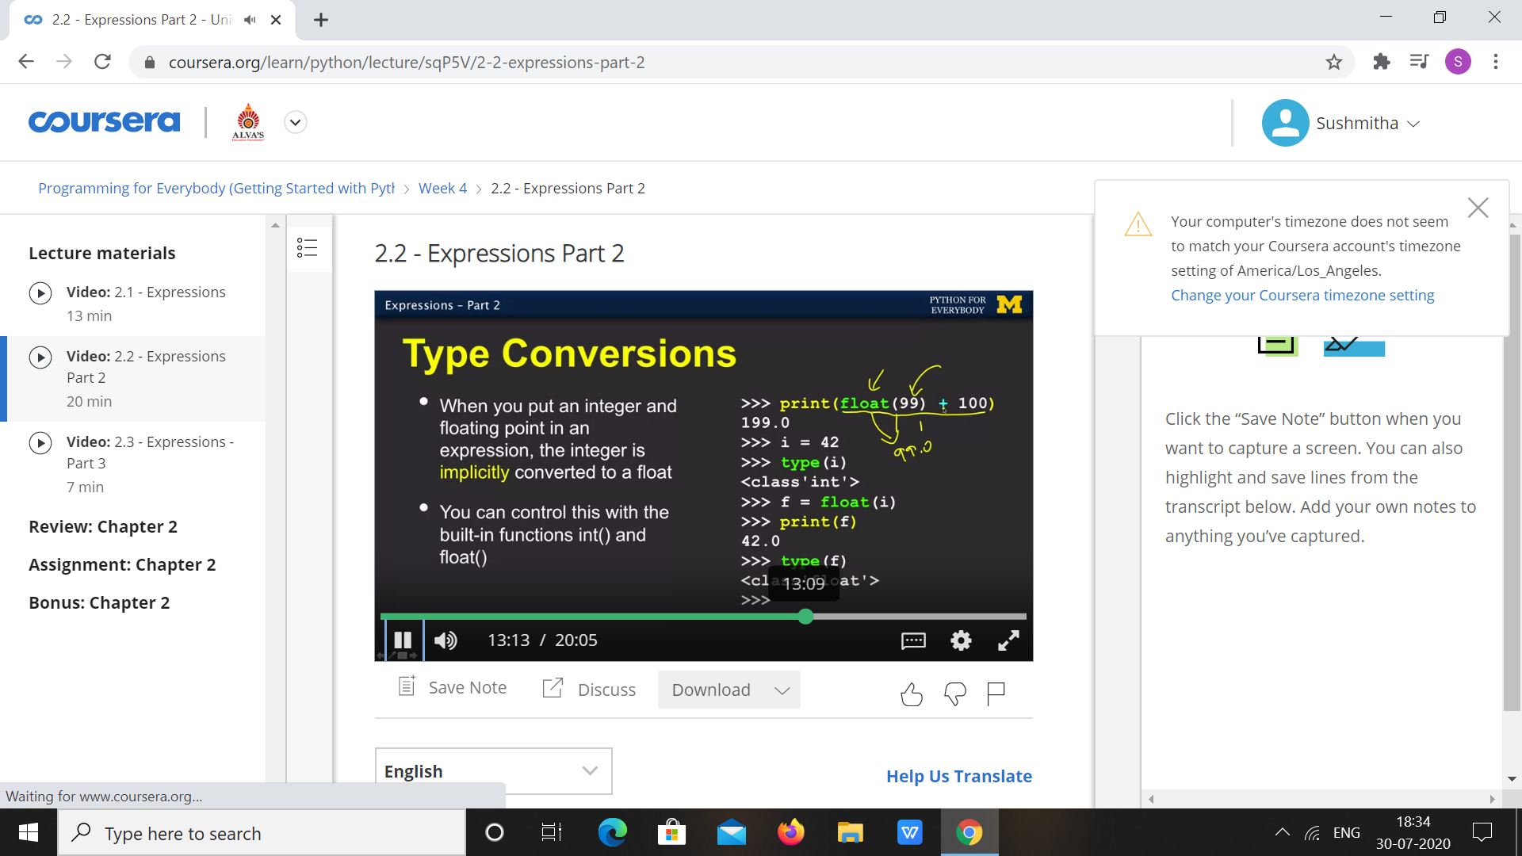

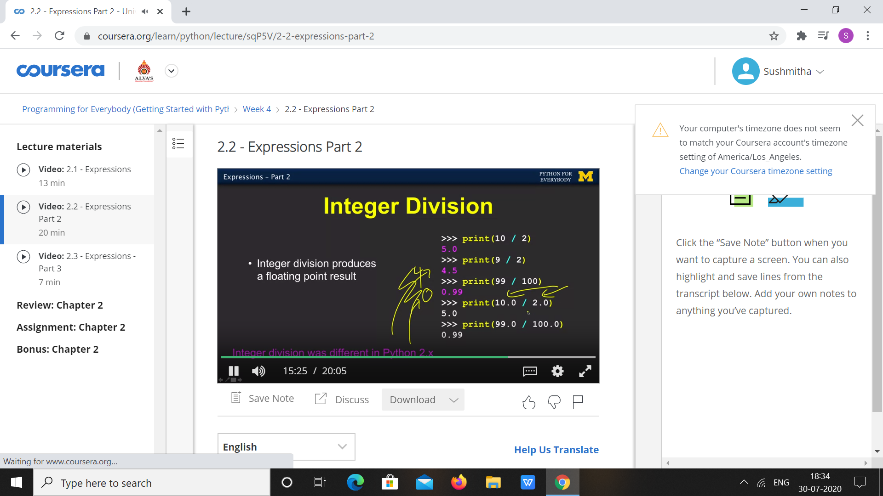

|  |  |
| --- | --- |
| **Coding Challenges** | |
| **Problem Statement: 1. Python Program for Program to calculate area of a Tetrahedron.** | |
| **Status:** Executed | |
| **Uploaded the report both in Github & Slack** | Yes |

**Snapshots of your response to challenge.**

1. ****Python Program for Program to calculate area of a Tetrahedron.****

**import math**

**def area_of_tetrahedron(side):**

**return (math.sqrt(3) * (side * side))**

**side = 3;**

**print("Area of Tetrahedron =",**

**area_of_tetrahedron(side));**

****OUTPUT****

