**DAILY REPORT**

**Student Name :SUSHMITHA.B.POOJARY**

**Class and Sec : VI B**

**USN :4AL17CS103**

**DATE:30-05-2020**

|  |  |  |  |  |
| --- | --- | --- | --- | --- |
| **Online Test Details** | | | | |
| **Subject** | **PYTHON APPLICATION PROGRAMMING** | | | |
| **Semester** | **VI -B** | | **Duration** | **30 Minutes** |
| **% of marks 30** | | **12** | | |

**Snapshot of the test result**



|  |  |  |  |
| --- | --- | --- | --- |
| **Certification Course Details** | | | |
| **Course** | **Ethical Hacking** | | |
| **Certificate Provider** | **Great Learning** | **Duration** | **6 hours** |

**Snapshots of the daily class acitivities**





|  |  |
| --- | --- |
| **Coding Challenges** | |
| **Problem Statement:** 1.Python program to read a number and print the pattern.  2.write a java program to Count number of trailing zeros in product of array. | |
| **Status: Executed** | |
| **Uploaded the report both in Github & Slack** | **Yes** |

**Snapshots of your response to challenge.**

1. Python program to read a number and print the pattern.

rows = int(input("Enter the number of rows "))

for i in range(rows + 1, 0, -1):

for j in range(0, i - 1):

print("*", end=' ')

print(" ")

**Output**

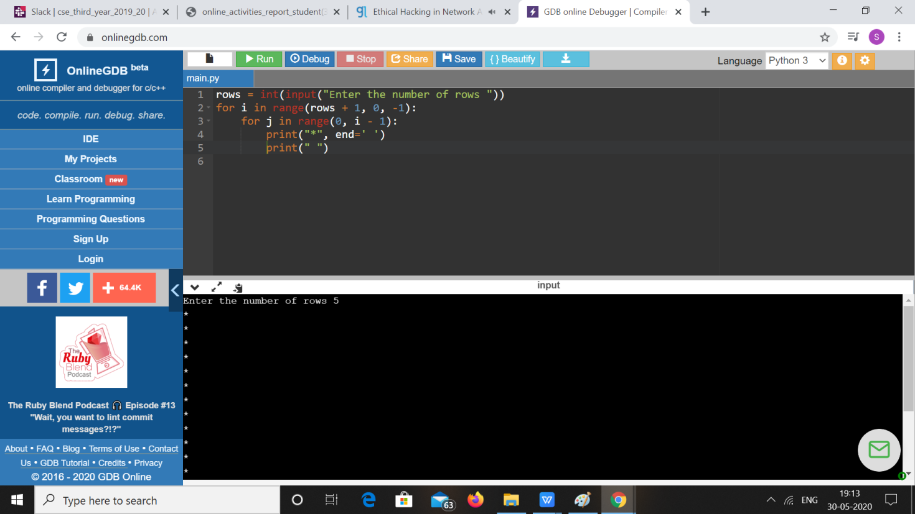

1. **write a java program to Count number of trailing zeros in product of array.**

A simple solution is simply multiply and count trailing 0s in product. This solution may cause integer overflow. A better solution is based on the fact that zeros are formed by a combination of 2 and 5. Hence the number of zeros will depend on the number of pairs of 2’s and 5’s that can be formed. Ex.: 8 * 3 * 5 * 23 * 17 * 25 * 4 * 11 23 * 31 * 51 * 231 * 171 * 52 * 22 * 111 In this example there are 5 twos and 3 fives. Hence, we shall be able to form only 3 pairs of (2*5). Hence will be 3 Zeros in the product.

import java.util.*;

import java.lang.*;

public class Main

{

public static int countZeroso(int[] a, int n)

{

int count2 = 0, count5 = 0;

for (int i = 0; i < n; i++)

{

while (a[i] % 2 == 0)

{

a[i] = a[i] / 2; count2++;

}

while (a[i] % 5 == 0)

{

a[i] = a[i] / 5; count5++;

}

}

return (count2 < count5) ? count2 : count5;

}

public static void main(String argc[])

{

int[] a = new int[]

{ 10, 100, 20, 30, 50, 91, 12, 80 };

int n = 8;

System.out.println(countZeroso(a, n));

}

}

**Output:**

