**DAILY REPORT**

**Student Name :Sushmitha.B.Pooajry**

**Class and Sec : VI B**

**USN :4al17cs103**

**DATE:31-05-2020**

|  |  |  |  |  |
| --- | --- | --- | --- | --- |
| **Online Test Details** | | | | |
| **Subject** | **-** | | | |
| **Semester** | **VI -A/B** | | **Duration** | **-** |
| **% of marks -** | | **-.** | | |

|  |  |  |  |
| --- | --- | --- | --- |
| **Certification Course Details** | | | |
| **Course** | **Ethical Hacking** | | |
| **Certificate Provider** | **Great Learning** | **Duration** | **6 hours** |

**snapshots of the daily class acitivities**

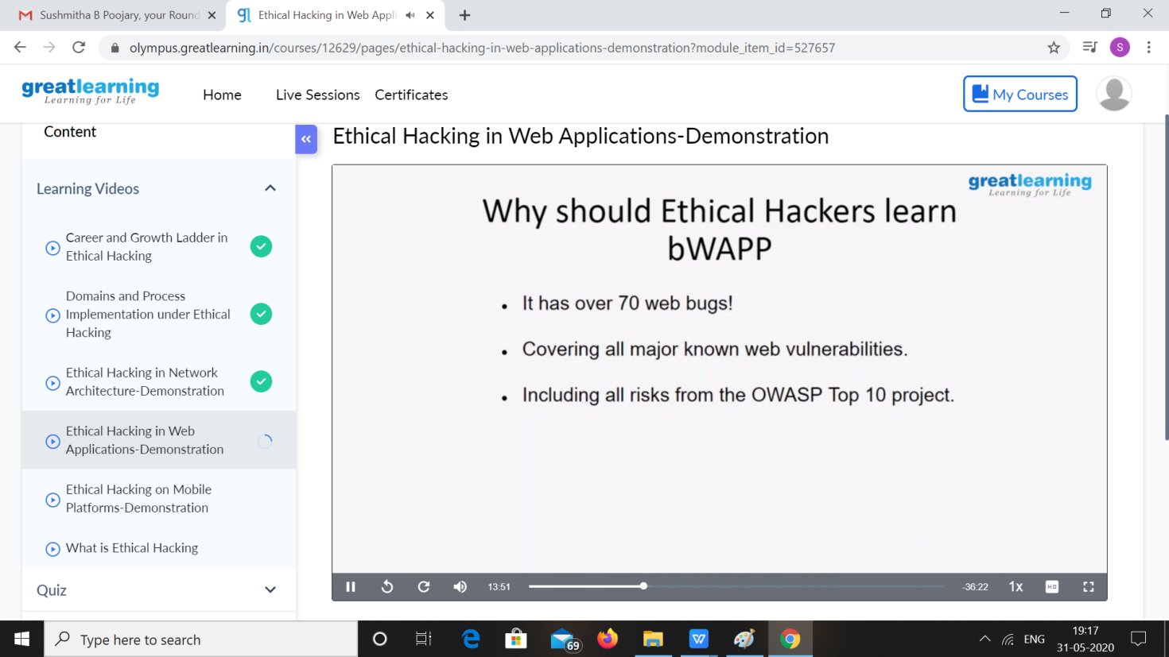

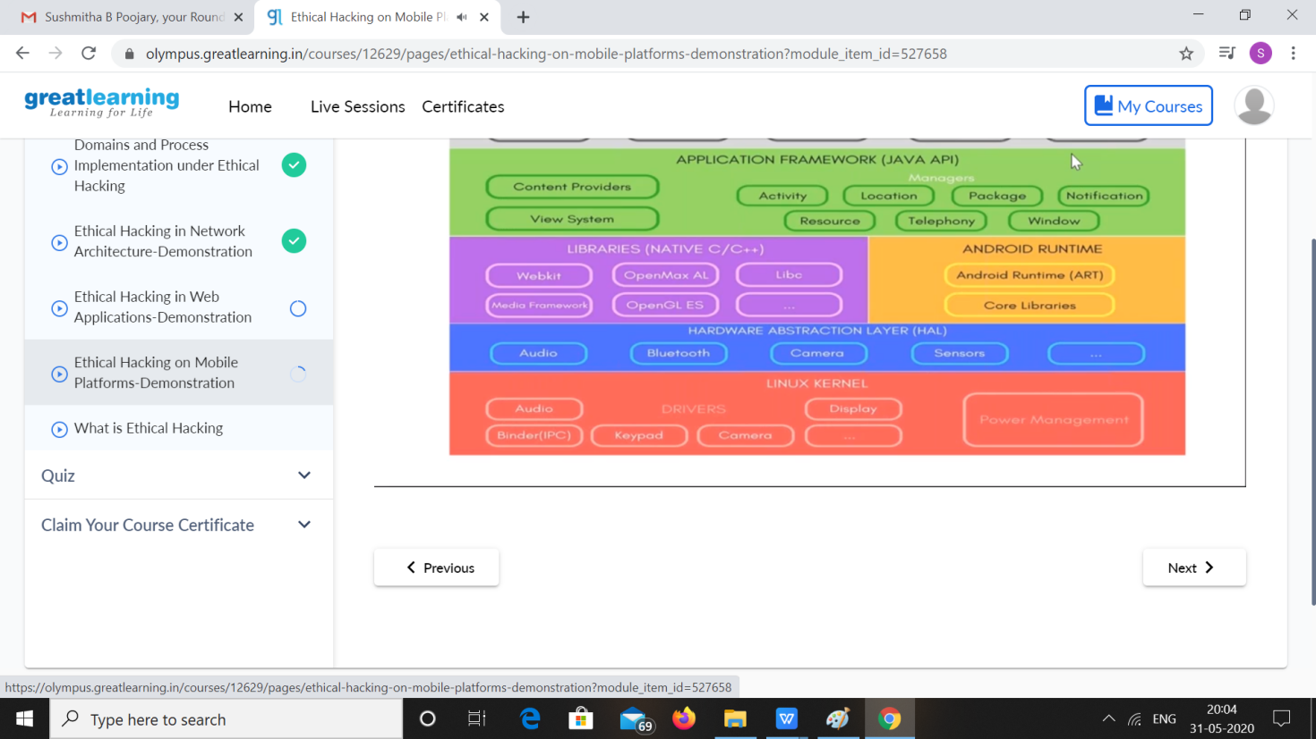

|  |  |
| --- | --- |
| **Coding Challenges** | |
| **Problem Statement: 1.**python program to print the multiplication table of number   1. C program to convert decimal number to binary. 2. C program to print alphabet triangle | |
| **Status: Executed** | |
| **Uploaded the report both in Github & Slack** | **yes** |

**snapshots of your response to challenge.**

**Program1:**

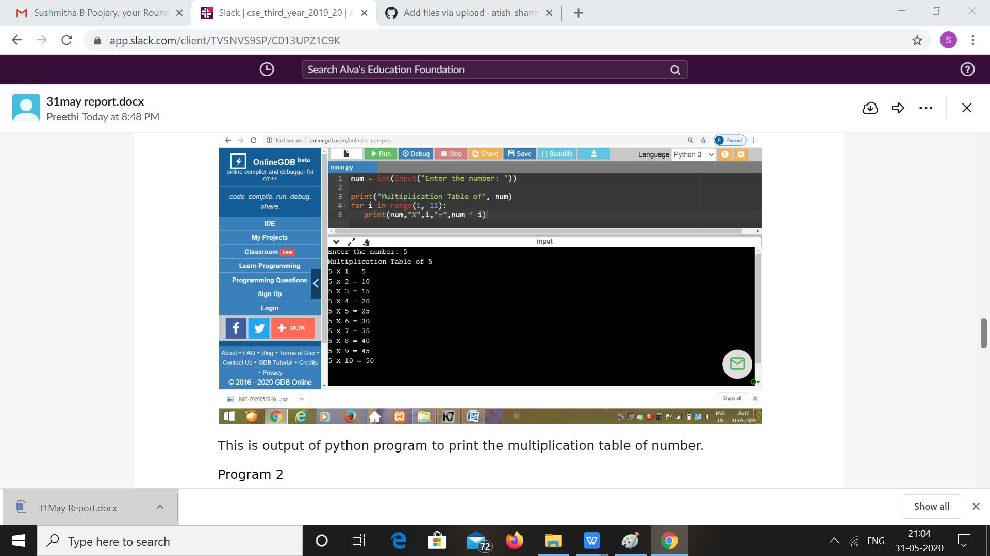

**Program2**

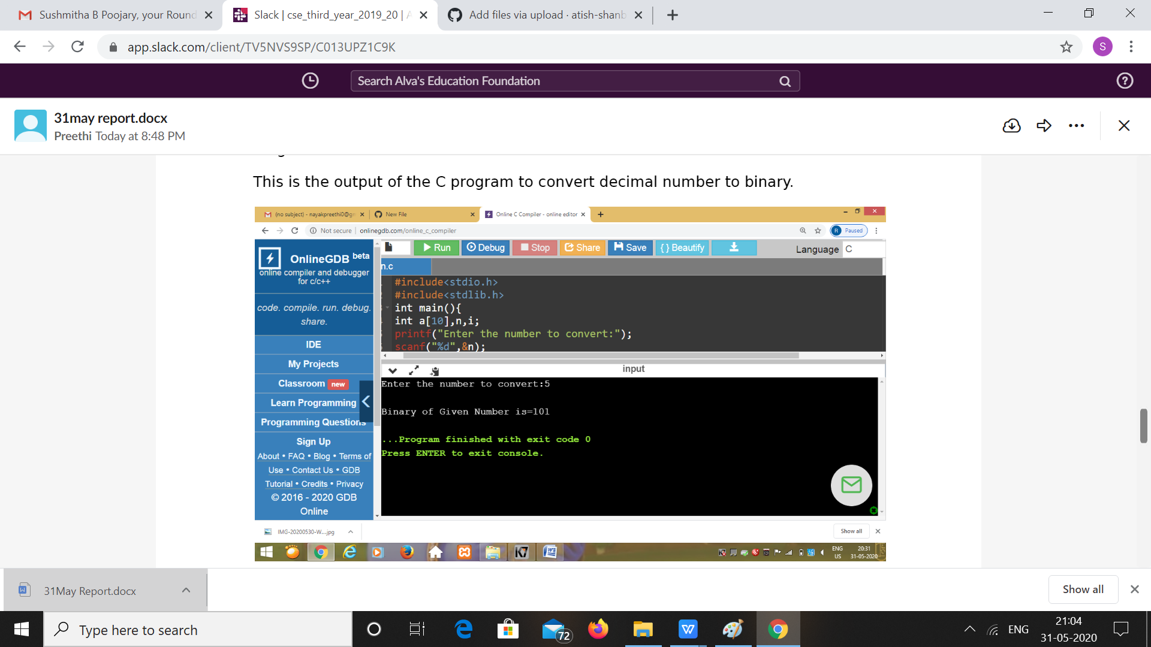

**Program3:**

