**DAILY REPORT**

**Student Name :SUSHMITHA.B.POOJARY**

**Class and Sec : VI B**

**USN :4AL17CS103**

**DATE:31-07-2020**

|  |  |  |  |  |
| --- | --- | --- | --- | --- |
| **Online Test Details** | | | | |
| **Subject** | **------** | | | |
| **Semester** | **VI -B** | | **Duration** | **----** |
| **% of marks ---** | | **-----** | | |

|  |  |  |  |
| --- | --- | --- | --- |
| **Certification Course Details** | | | |
| **Course** | **Python for Everybody** | | |
| **Certificate Provider** | **Coursera** | **Duration** | **19hours** |

**Snapshots of the daily class acitivities.**

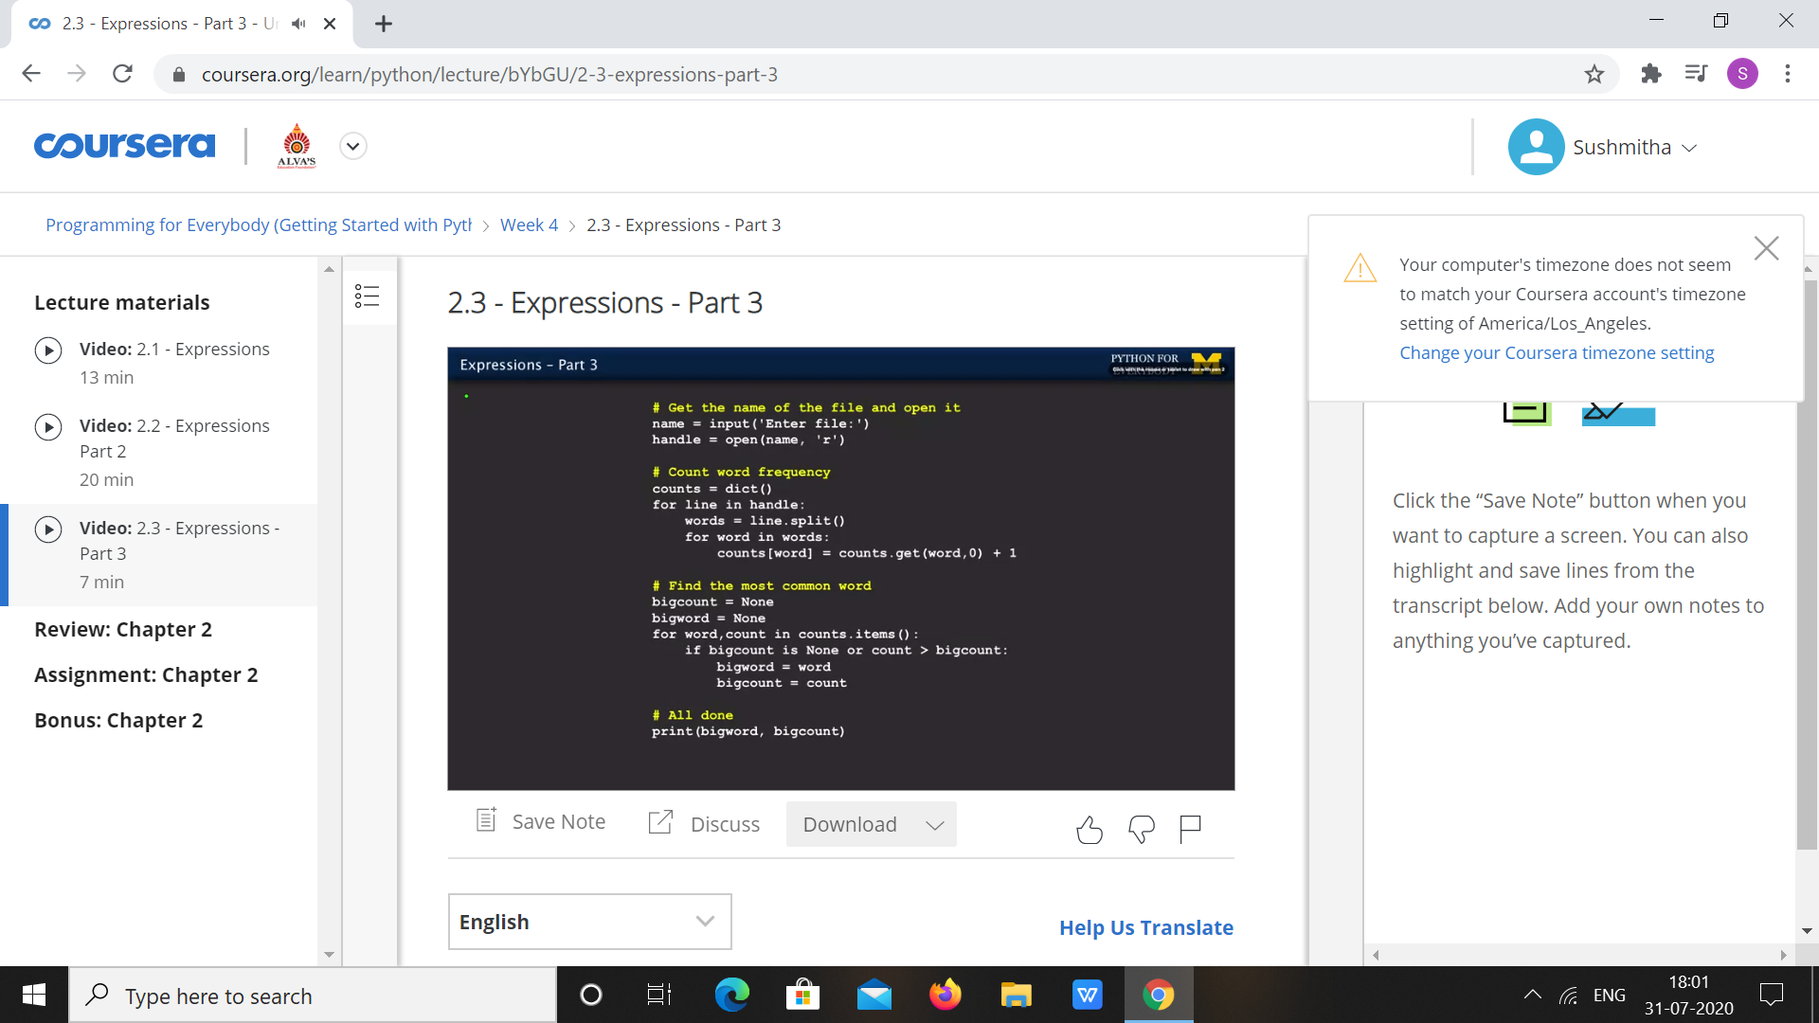

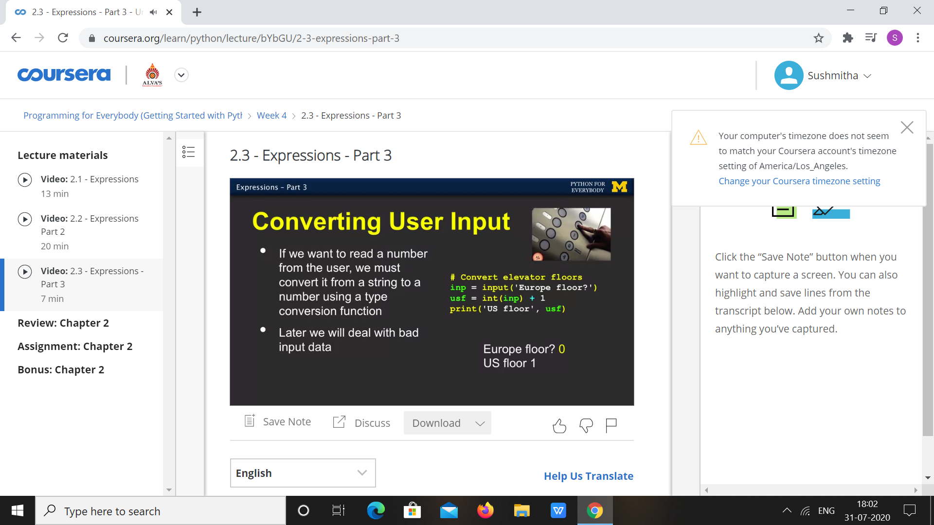

|  |  |
| --- | --- |
| **Coding Challenges** | |
| **Problem Statement:**  1.**Python Program for focal length of a spherical mirror.** | |
| **Status:** Executed | |
| **Uploaded the report both in Github & Slack** | Yes |

**Snapshots of your response to challenge.**

**1.**Python Program for focal length of a spherical mirror.****

def focal_length_concave(R):

return R / 2

def focal_length_convex(R):

return - ( R/ 2 )

R = 30 ;

print("Focal length of spherical concave mirror is :",

focal_length_concave(R)," units")

print("Focal length of spherical convex mirror is : ",

focal_length_convex(R)," units")

**OUTPUT**

