**DAILY REPORT**

**Student Name :SUSHMITHA B POOJARY**

**Class and Sec : VI B**

**USN :4AL17CS103**

|  |  |  |  |  |
| --- | --- | --- | --- | --- |
| **Online Test Details** | | | | |
| **Subject** | **Python Application Programming** | | | |
| **Semester** | **VI -B** | | **Duration** | **30 Minutes** |
| **% of marks 30** | | **18** | | |

**Encl : snapshot of the test result**

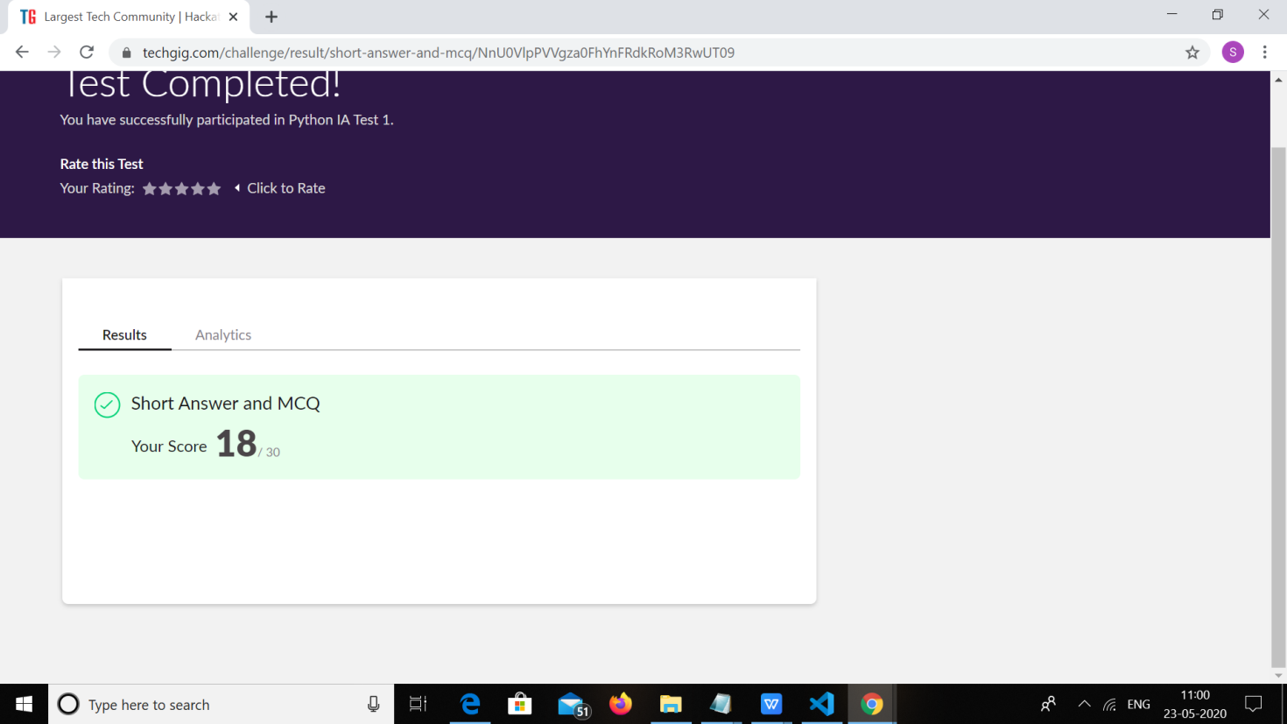

|  |  |  |  |
| --- | --- | --- | --- |
| **Certification Course Details** | | | |
| **Course** | **FRONT END HTML DEVELOPMENT** | | |
| **Certificate Provider** | **GREAT LEARNING** | **Duration** | **3.5HOURS** |

**Encl : snapshots of the daily class acitivities (atleast two snap shots)**

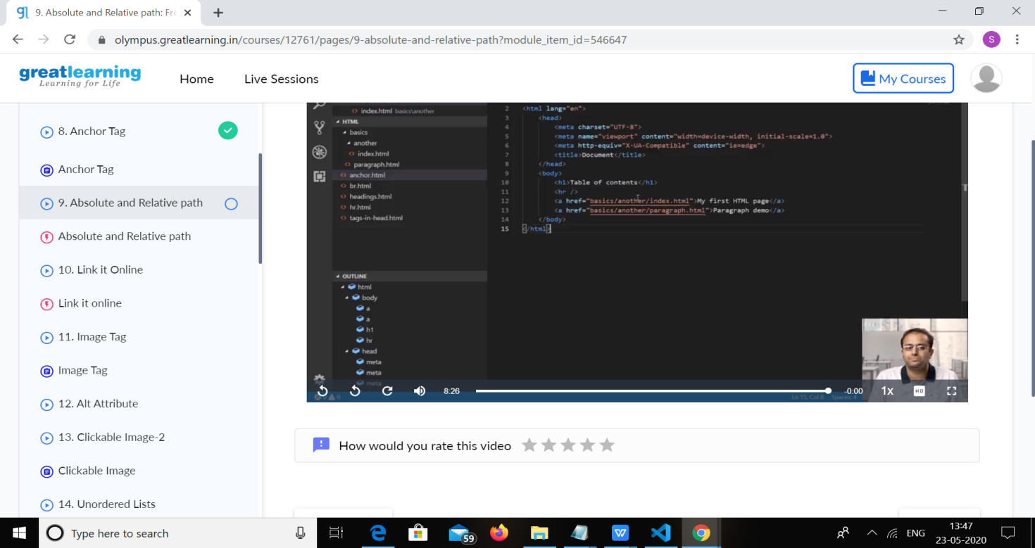



|  |  |
| --- | --- |
| **Coding Challenges** | |
| **Problem Statement:**  Write a C Program to Generate First N Triangular Numbers (Where N is read from the Keyboard) | |
| **Status: Executed** | |
| **Uploaded the report both in Github & Slack** | **yes** |

**Encl : snapshots of your response to challenge.**

Coding Challenges Details:

1.Write a C Program to Generate First N Triangular Numbers (Where N is read from the Keyboard)

#include <stdio.h>

void triangular_series(int n)

{

int i, j = 1, k = 1;

for (i = 1; i <= n; i++) {

printf(" %d ", k);

j = j + 1;

k = k + j;

}

}

int main()

{

int n ;

printf("enter n");

scanf("%d",&n);

triangular_series(n);

return 0;

}

**OUTPUT:**

