**DAILY ONLINE ACTIVITIES SUMMARY**

|  |  |  |  |  |  |  |  |  |
| --- | --- | --- | --- | --- | --- | --- | --- | --- |
| **Date:** | **18-05-2020** | | | | | **Name:** | **Sushmitha b poojary** | |
| **Sem & Sec** | **6 B** | | | | | **USN:** | **4AL17CS103** | |
| **Online Test Summary** | | | | | | | | |
| **Subject** | | **CRYPTOGRAPHY, NETWORK SECURITY AND CYBER LAW** | | | | | | |
| **Max. Marks** | | **60** | | **Score** | | | **26** | |
| **Certification Course Summary** | | | | | | | | |
| **Course** | **Python with machine learning** | | | | | | | |
| **Certificate Provider** | | | **Great learning** | | **Duration** | | | **2.5 hours** |
| **Coding Challenges** | | | | | | | | |
| **Problem Statement: Two java programs and 2 C programs** | | | | | | | | |
| **Status: Executed** | | | | | | | | |
| **Uploaded the report in Github** | | | | | **Yes** | | | |
| **If yes Repository name** | | | | | <https://github.com/Sushmithabp/report1> | | | |
| **Uploaded the report in slack** | | | | | **Yes** | | | |

Online Test Details: (Attach the snapshot and briefly write the report for the same)

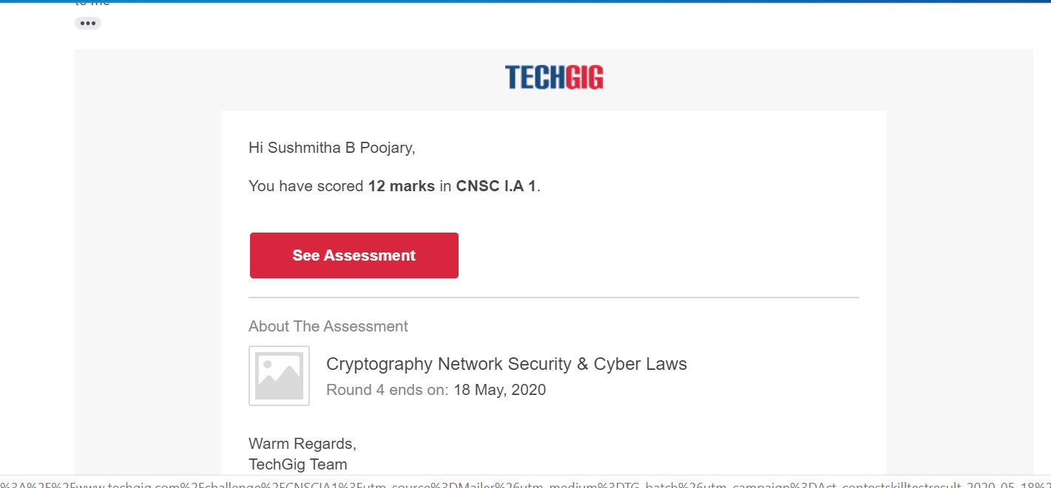

Certification Course Details: (Attach the snapshot and briefly write the report for the same)

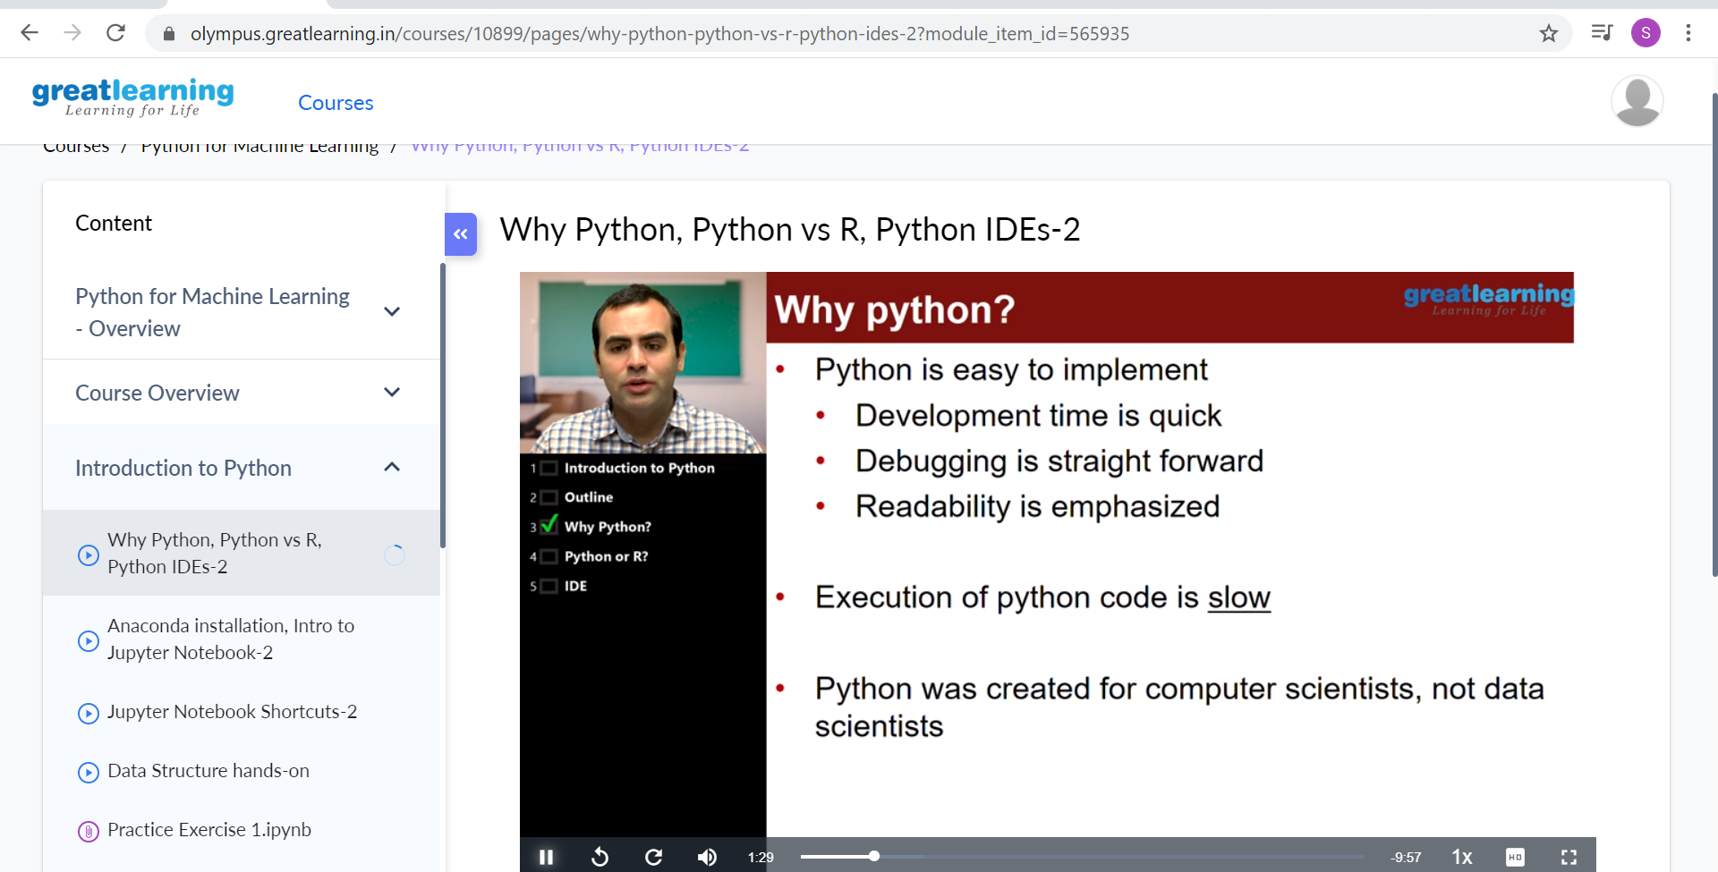

Coding Challenges Details: (Attach the snapshot and briefly write the report for the same)

Program1:

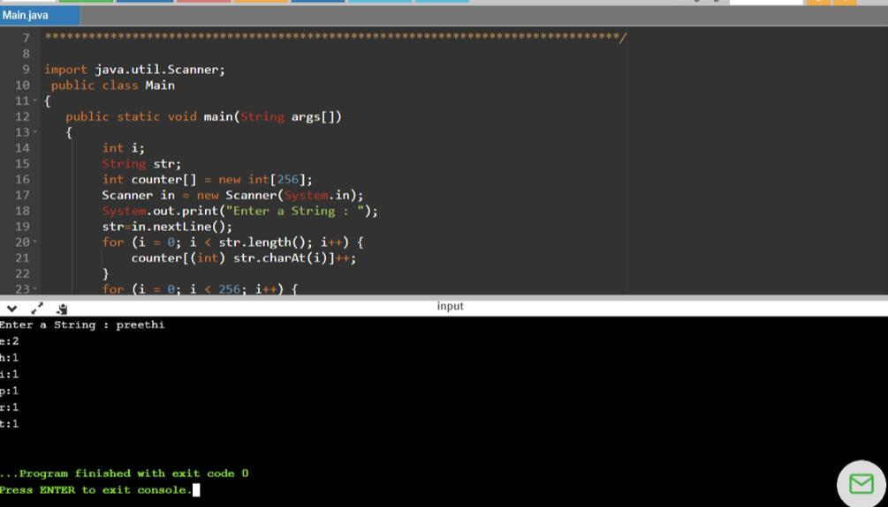

Program2:

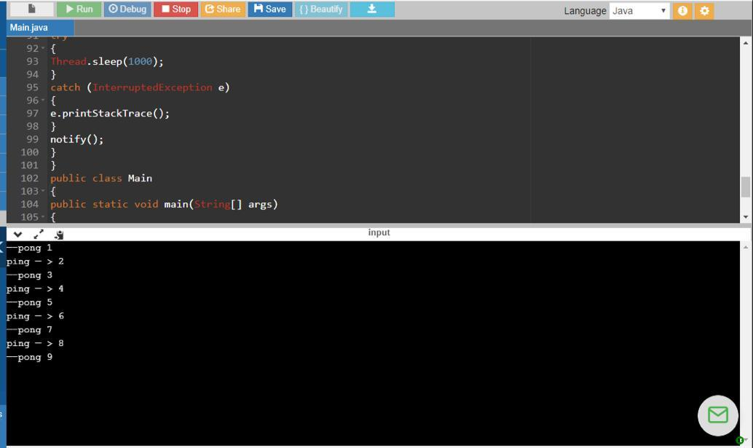

Program3:

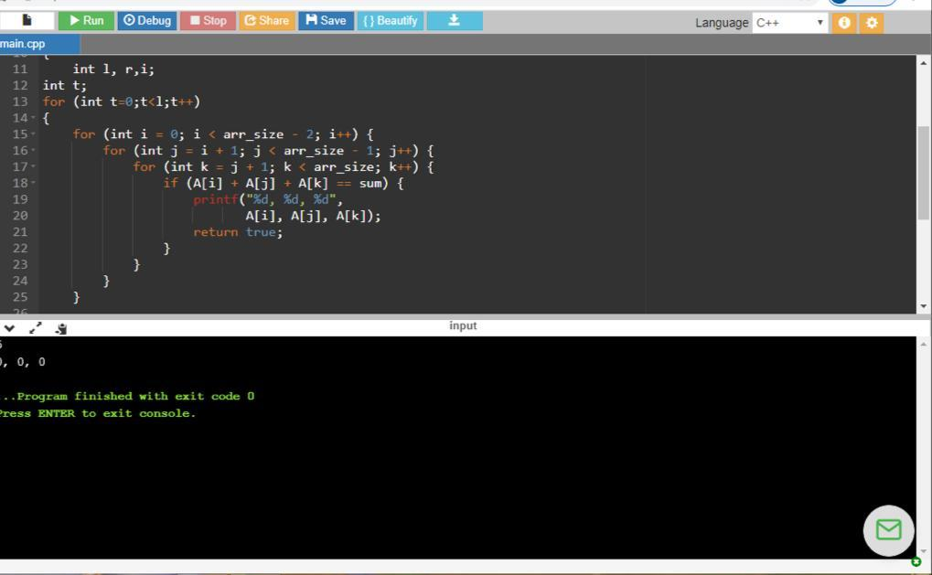

Program4:

