**DAILY ONLINE ACTIVITIES SUMMARY**

|  |  |  |  |  |  |  |  |  |
| --- | --- | --- | --- | --- | --- | --- | --- | --- |
| **Date:** | **19-05-2020** | | | | | **Name:** | **SUSHMITHA B POOJARY** | |
| **Sem & Sec** | **6 B** | | | | | **USN:** | **4AL17CS103** | |
| **Online Test Summary** | | | | | | | | |
| **Subject** | | **COMPUTER GRAPHICS AND VISUALIZATION** | | | | | | |
| **Max. Marks** | | **60** | | **Score** | | | **31** | |
| **Certification Course Summary** | | | | | | | | |
| **Course** | **PYTHON WITH MACHINE LEARNING** | | | | | | | |
| **Certificate Provider** | | | **GREAT LEARNING** | | **Duration** | | | **2.5 hours** |
| **Coding Challenges** | | | | | | | | |
| **Problem Statement: Two java programs and 1 C programs** | | | | | | | | |
| **Status: Executed** | | | | | | | | |
| **Uploaded the report in Github** | | | | | **Yes** | | | |
| **If yes Repository name** | | | | | <https://github.com/Sushmithabp/report2> | | | |
| **Uploaded the report in slack** | | | | | **Yes** | | | |

Online Test Details: (Attach the snapshot and briefly write the report for the same)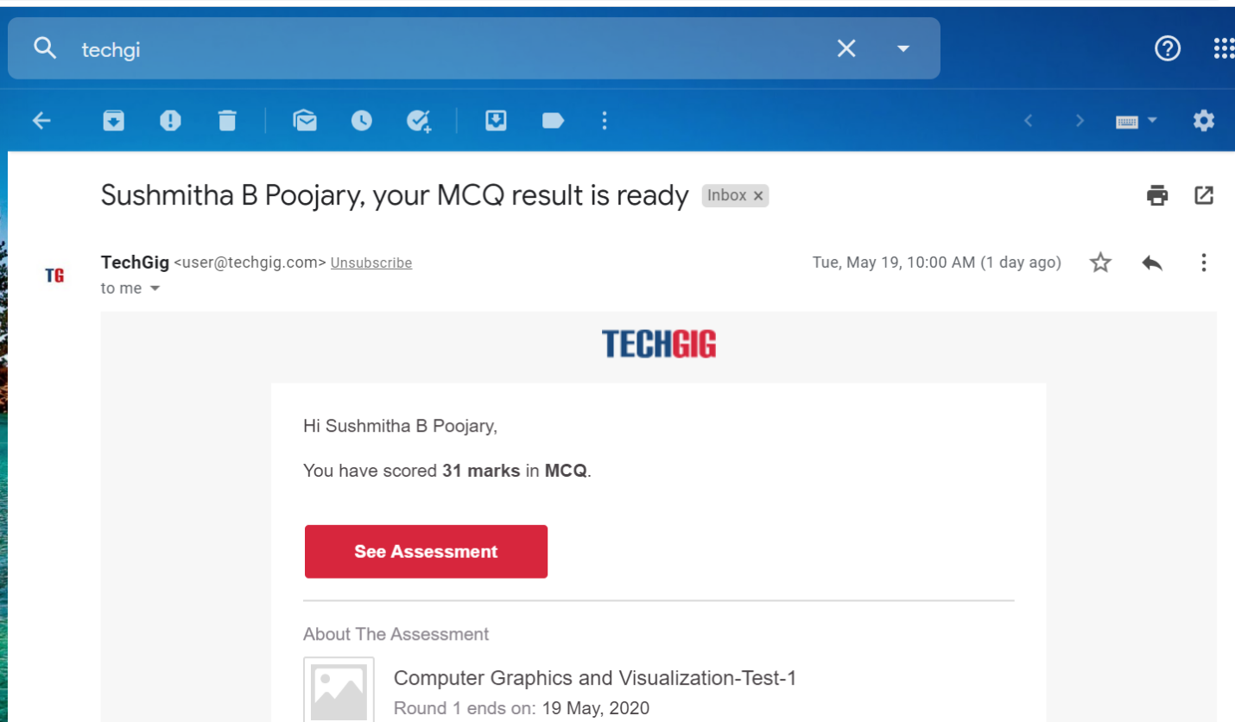

Certification Course Details: (Attach the snapshot and briefly write the report for the same)

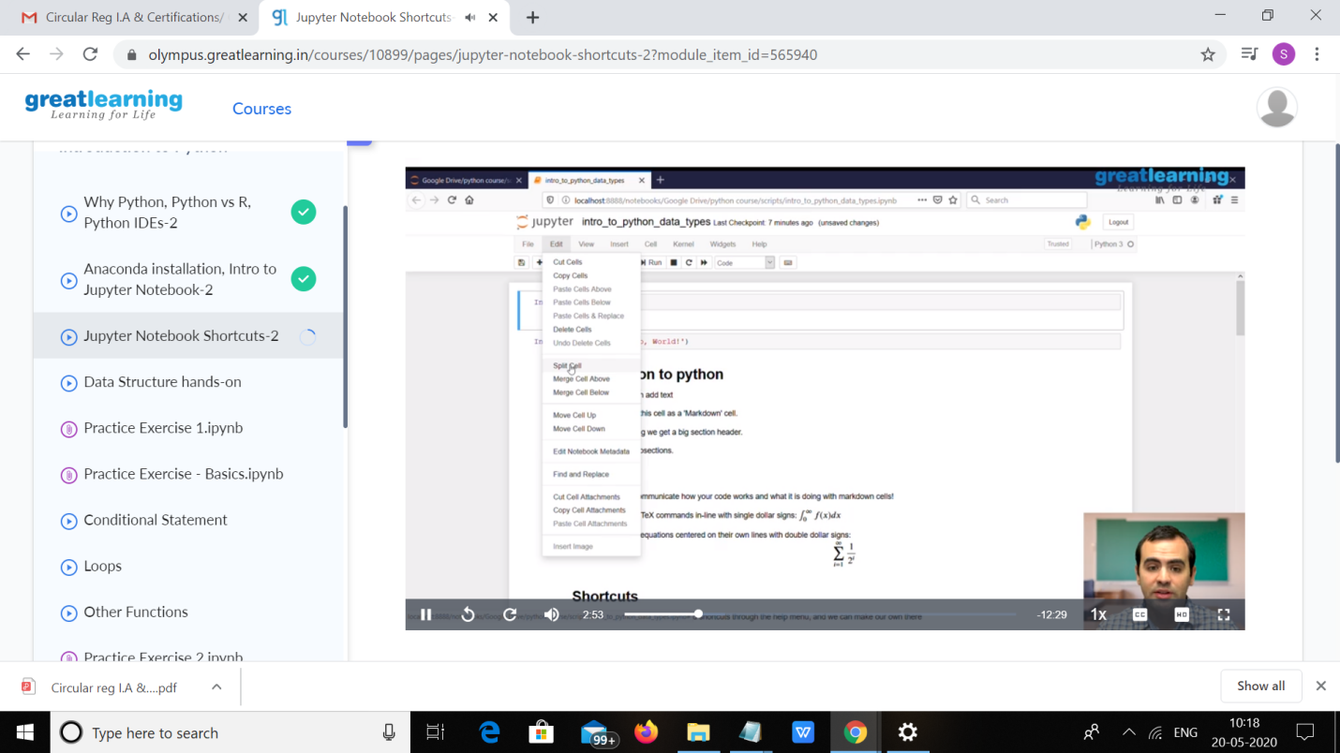

Coding Challenges Details: (Attach the snapshot and briefly write the report for the same)

Program1:

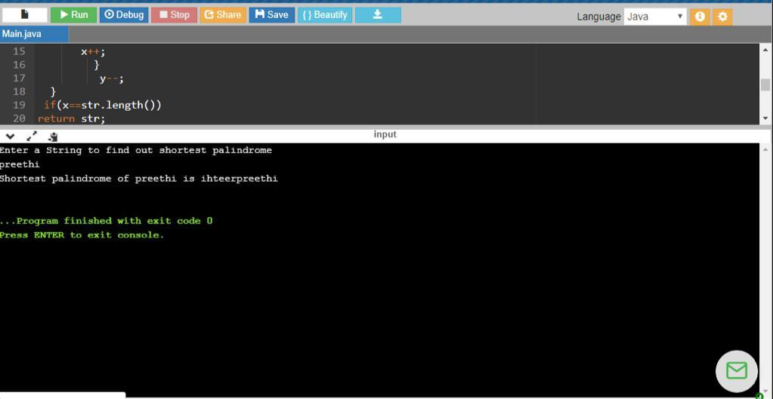

Program2:

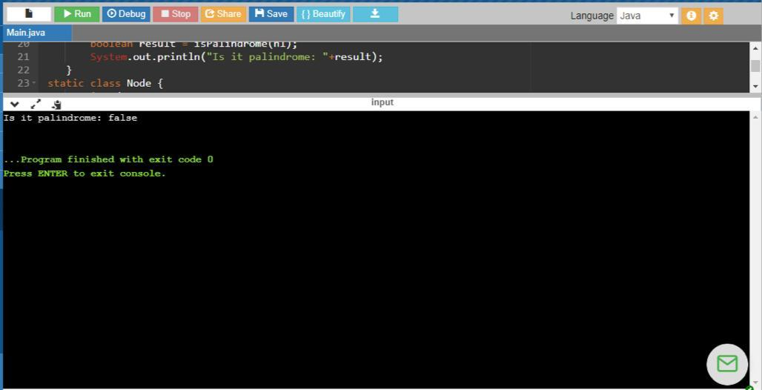

Program3:

