# Flight Reservation System

## Introduction

Flight Reservation system: This is a web application which is used to efficient management of flight reservations. It provides functionalities for customers to search, book, and cancel flights, as well as view flight details. Additionally, staff members have access to functionalities for managing flights, including adding, editing, and canceling.

* Build few screens for Flight Reservation system application.
* System needs to store all the details about registered customers, available flights, book the flight and cancel the flight.
* There will be three user roles such as
  + Flight Reservation: who can manage/control this system
  + Customer: who can book the flight, Search the flight, view flight details and cancel the flight.
  + Staff: who can add the flight, Edit the flight and cancel the flight
* Customer should be registered before accessing the system.

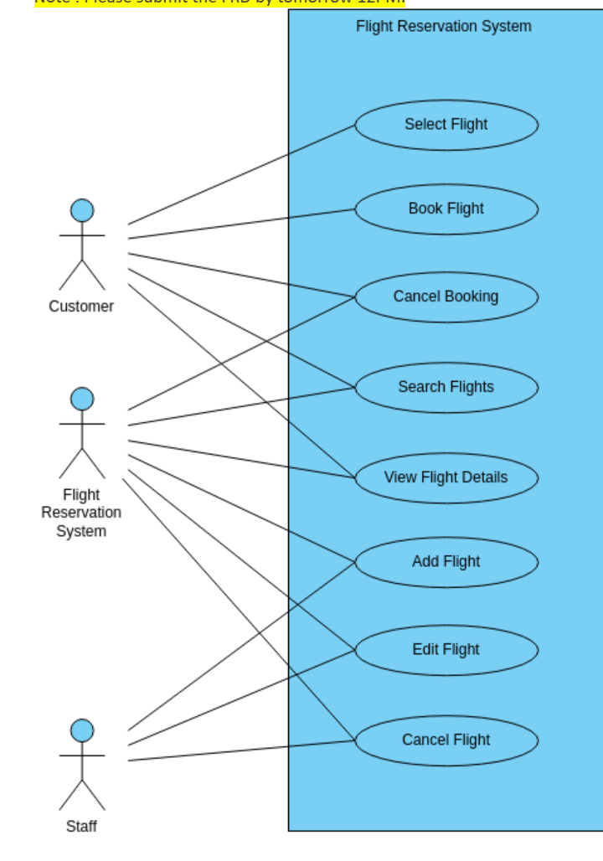

## Functional Requirements

### #1 Customer Module

* Select Flight:
* The system shall allow customers to search for available flights based on criteria such as date, time, and destination.
* Customers can view a list of available flights with relevant details.
* Book Flight:
* Customers can select a flight and book it for a specified date and time.
* Booking confirmation shall be sent to the customer via email.
* Cancel Booking:
* Customers can cancel their booked flights up to a specified cancellation deadline.
* The system shall refund the appropriate amount according to the cancellation policy.
* Search Flights:
* Customers can search for flights based on various parameters such as destination, date, and time.
* View Flight Details:
* Customers can view detailed information about a selected flight, including departure and arrival times, airline details, and available seats.

### #2 Flight Reservation Module

* Cancel Booking:
* The system shall allow staff members to cancel customer bookings in case of exceptional circumstances.
* Search Flights:
* Staff members can search for flights based on different criteria to assist customers.
* View Flight Details:
* Staff members can access detailed information about any flight in the system.
* Add Flight:
* Staff members can add new flights to the system, specifying details such as date, time, airline, and available seats.
* Edit Flight:
* Staff members can modify existing flight details, including date, time, and available seats.
* Cancel Flight:
* Staff members can cancel flights, removing them from the system.

### #3 Staff Module

* Add Flight:
* Staff members can add new flights to the system, specifying details such as date, time, airline, and available seats.
* Edit Flight:
* Staff members can modify existing flight details, including date, time, and available seats.
* Cancel Flight:
* Staff members can cancel flights, removing them from the system.

### Technology Stack:

* Back End: ASP.NET CORE WEB API
* Front End: ANGULAR
* Database: SQL SERVER
* Framework: ENTITY RELATIONSHIP FRAMEWORK

### Requirements Phase

* Provide a description not exceeding 10 lines about the functionality present/being built, call out error scenarios.

### Design Phase

* Create an ERD
* Determine what values need to be stored for each entity and determine suitable

1. primary keys
2. foreign keys
3. indexes

* Decide what entities we need to consider in a data model
* List down the assumptions does your model make?
* List down the information in the text was irrelevant to your design?
* List down any further restrictions might you want to apply to the data?
* Identify Business Functions
* List down all the queries that you need for queries/stored procedures etc., as per your need.

### Coding

* You need to make the 5 pages mentioned in Functional requirements section.
* You need to build all services required to handle the functionality and error scenarios.
* Write search, add, edit, delete Stored Procedures for each of the business function.

### Testing

* Set-up Test Data (manual or script or bulk upload thru excel)
* Perform full end to end testing with different scenarios.
* We will do Acceptance Testing based on this document.
* Discuss among yourselves on the requirements and prepare manual Test cases.

## Solution submission

1. Project Code Folder (entire .NET code + SQL Code)
2. Functional Requirements Document
3. ER Diagram
4. A screen share/video to show the working prototype

Note – all the deliverables can be uploaded (without zipping) to their personal GitHub and can share the links with us.