# Library Management System

## Introduction

Library Management system: This is a web application which is used to manage the Books and Borrowing/Returning the books in a particular Library.

* Build few screens for Library Management system application.
* System needs to store all the details about registered borrowers, available books, borrow the books and returning the books.
* There will be two user roles such as
  + Librarian: who can manage/control this system
  + Borrower: who can borrow the book, Search the book, View book details and returning the book.
* Borrower should be registered before accessing the system.

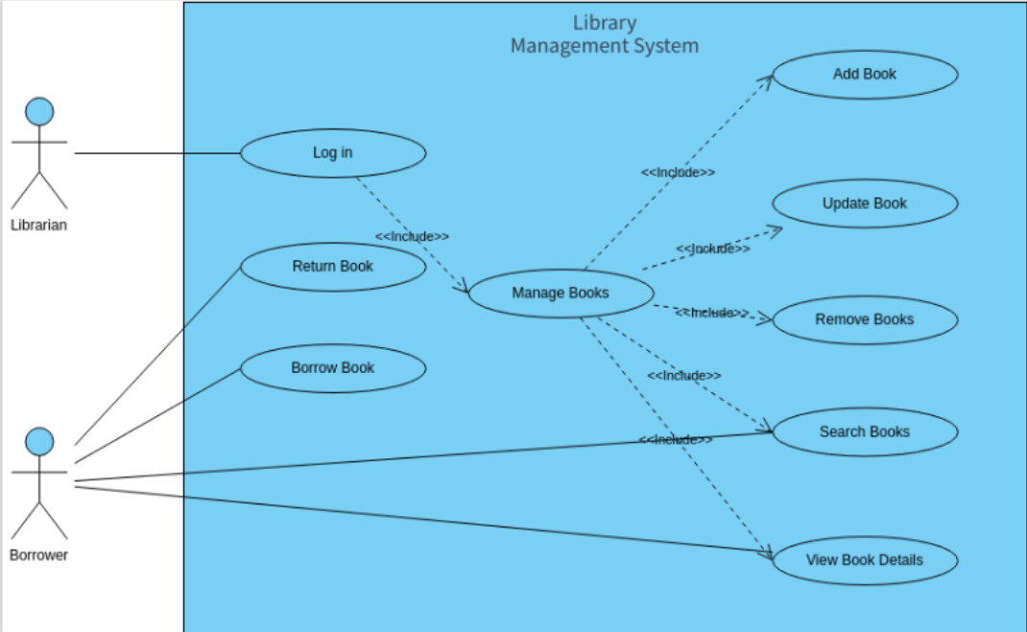

## Functional Requirements

### #1 Librarian Function

* Add Book:
  + The Librarian should be able to add a new book to the system.
  + Required book details include title, author, ISBN, genre, and quantity.
* Update Book:
  + The Librarian should be able to update the details of an existing book.
  + Modification of information such as title, author, genre, and quantity should be supported.
* Remove Book:
  + The Librarian should be able to remove a book from the system.
  + Removing a book should update the book catalog and availability status.
* Search Book Details:
  + The Librarian should be able to search for books based on title, author, or ISBN.
  + The search results should display relevant book details.
* View Book Details:
  + The Librarian should have the ability to view detailed information about a specific book.

### #2 Borrower Function

* Borrow Book:
  + Borrowers should be able to borrow available books by providing their user ID and selecting the desired books.
  + The system should update the availability status of the borrowed books.
* Return Book:
  + Borrowers should be able to return books, and the system should update the availability status accordingly.
* Search Book:
  + Borrowers should be able to search for books based on title, author, or genre.
  + The search results should display available books that match the search criteria.
* View Book Details:
  + Borrowers should be able to view detailed information about a specific book.

### #3 Authentication

* Both Librarians and Borrowers should be required to log in with a unique username and password.

### Technology Stack:

* Back End: ASP.NET MVC
* Front End: ANGULAR
* Database: SQL SERVER

### Requirements Phase

* Provide a description not exceeding 10 lines about the functionality present/being built, call out error scenarios.

### Design Phase

* Create an ERD
* Determine what values need to be stored for each entity and determine suitable

1. primary keys
2. foreign keys
3. indexes

* Decide what entities we need to consider in a data model
* List down the assumptions does your model make?
* List down the information in the text was irrelevant to your design?
* List down any further restrictions might you want to apply to the data?
* Identify Business Functions
* List down all the queries that you need for queries/stored procedures etc., as per your need.

### Coding

* You need to make the 5 pages mentioned in Functional requirements section.
* You need to build all services required to handle the functionality and error scenarios.
* Write search, add, edit, delete Stored Procedures for each of the business function.

### Testing

* Set-up Test Data (manual or script or bulk upload thru excel)
* Perform full end to end testing with different scenarios.
* We will do Acceptance Testing based on this document.
* Discuss among yourselves on the requirements and prepare manual Test cases.

## Solution submission

1. Project Code Folder (entire .NET code + SQL Code)
2. Functional Requirements Document
3. ER Diagram
4. A screen share/video to show the working prototype

Note – all the deliverables can be uploaded (without zipping) to their personal github and can share the links with us.