MACHINE LEARNING PROJECT REPORT
Binary Person Segmentation Using U-Net and Controlled Data Augmentation
A Controlled Multi-Seed Study Comparing Unaugmented Baseline, Geometric Transformations (Horizontal Flip & Small Zoom), and Instance-Level Copy-Paste Augmentation on the Penn-Fudan Pedestrian Dataset

Project Details | Information (Edit Before Submission)
Student Name | [Student Name]
Roll Number | [Roll Number]
Course / Program | [Course Name & Code]
Department | [Department Name]
Institution | [Institution Name]
Project Supervisor | [Guide / Instructor Name]
Submission Date | November 2026
Repository: person_segmentation_unet | PyTorch CUDA | Fixed Split: split_seed42.json

PRELIMINARY PAGE

Abstract
Pixel-level person segmentation is a core computer vision capability for pedestrian monitoring, autonomous driving, and intelligent surveillance. However, training deep encoder-decoder networks on small, real-world pedestrian datasets often suffers from severe overfitting and high sensitivity to random initialization. This project investigates binary person segmentation on the Penn-Fudan Pedestrian dataset (170 street photographs containing 345 annotated person instances) using a compact 5-level U-Net (7,763,041 parameters) trained with an equal-weight Binary Cross-Entropy plus soft Dice loss (DiceBCELoss).
To isolate the true impact of training-data diversity without introducing architectural complexity or test-set leakage, all models share an identical U-Net backbone, a fixed stratified 119/25/26 (train/validation/test) split, and a strict checkpoint selection protocol based solely on validation Dice. Initial 30-epoch CPU experiments revealed that naive zoom-out augmentation (0.9–1.1×) padded black borders, double-resampling blurred edges, and constant learning rates caused under-convergence. Addressing these bottlenecks on an RTX 4060 GPU with single-step raw stretch resizing, zoom-in scaling (1.0–1.15× at p = 0.5), 50 training epochs, and cosine annealing yielded a decisive improvement across three independent training seeds (42, 43, 44).
Compared to the unaugmented baseline (none: validation Dice 0.8078 ± 0.0062, IoU 0.6776 ± 0.0087; held-out test Dice 0.8495 ± 0.0130, IoU 0.7385 ± 0.0197), combining horizontal flip and small zoom (both) raised validation Dice to 0.8298 ± 0.0087 (+2.20 pp) and IoU to 0.7091 ± 0.0127 (+3.15 pp), while lifting held-out test Dice to 0.8668 ± 0.0016 (+1.73 pp) and IoU to 0.7649 ± 0.0025 (+2.64 pp, paired permutation p = 0.00130 across 26 test images) and reducing test IoU seed standard deviation nearly eight-fold. Extending the pipeline with training-only person-instance Copy-Paste augmentation (290 cutouts extracted strictly from the 119 training images) further improved performance to 0.8514 ± 0.0091 validation Dice (0.7414 IoU) and 0.8726 ± 0.0045 test Dice (0.7740 IoU, 22/26 test images improved, p = 0.00049).
Keywords: Binary Person Segmentation, U-Net, Penn-Fudan Pedestrian Dataset, Data Augmentation, Copy-Paste Augmentation, Dice Loss, Intersection over Union.

PRELIMINARY PAGE

Table of Contents
Note: Right-click the table below or insert Word's automatic Table of Contents (References → Table of Contents) after any final edits to refresh page numbers.

Section | Title | Page
Preliminary | Abstract | 2
Preliminary | Table of Contents | 3
Preliminary | List of Figures and Tables | 4
Chapter 1 | 1. Introduction (1.1–1.5) | 5
Chapter 2 | 2. Literature Review (2.1–2.2) | 7
Chapter 3 | 3. Proposed Methodology (3.1–3.6) | 8
Chapter 4 | 4. Results and Discussion (4.1–4.5) | 11
Chapter 5 | 5. Conclusion and Future Scope (5.1–5.3) | 14
End Matter | References & Appendix | 15

PRELIMINARY PAGE

List of Figures and Tables
List of Figures
Figure No. | Caption | Chapter
Figure 3.1 | Sample Penn-Fudan RGB images and merged binary ground-truth masks | Ch. 3
Figure 3.2 | Distribution of annotated pedestrian instances per image (170 images) | Ch. 3
Figure 3.3 | 5-Level U-Net architecture (16 base channels, 7,763,041 parameters) | Ch. 3
Figure 4.1 | Grouped bar chart of 6-way augmentation ablation on validation & test splits | Ch. 4
Figure 4.2 | 50-epoch training loss, validation loss, and validation Dice curves | Ch. 4
Figure 4.3 | Seed-to-seed IoU variability across training seeds 42, 43, and 44 | Ch. 4
Figure 4.4 | Per-image held-out test IoU change (Baseline vs. Flip+Zoom+Copy-Paste) | Ch. 4
Figure 4.5 | Qualitative comparison of predicted test masks on 5 held-out street scenes | Ch. 4
List of Tables
Table No. | Caption | Chapter
Table 3.1 | Penn-Fudan dataset audit summary and fixed 70/15/15 split statistics | Ch. 3
Table 3.2 | Validation comparison of stretch vs. aspect-preserving letterbox resizing | Ch. 3
Table 3.3 | Summary of controlled training configurations and augmentation modes | Ch. 3
Table 4.1 | Phase 1 CPU baseline results and root-cause comparison (30 epochs) | Ch. 4
Table 4.2 | Master 6-way tuned GPU results across seeds 42, 43, and 44 (Mean ± SD) | Ch. 4
Table 4.3 | Paired per-image statistical significance tests on held-out test set (n = 26) | Ch. 4
Table 4.4 | Qualitative error-analysis breakdown on selected held-out test images | Ch. 4
Table A.1 | Repository module inventory and reproducible CLI commands | Appendix

CHAPTER 1

1. Introduction

1.1 Background and Motivation
Semantic image segmentation assigns a class label to every pixel in a photograph, producing dense spatial masks that delineate exact object silhouettes rather than coarse bounding boxes. Person segmentation—separating human figures from complex street, indoor, and urban backgrounds—plays a foundational role in pedestrian safety monitoring, autonomous navigation, smart surveillance, crowd analytics, and human-computer interaction.
Although modern deep encoder-decoder networks such as U-Net excel at pixel-wise localization, their generalization degrades sharply when labeled training data are scarce. Collecting and pixel-annotating pedestrian datasets is expensive and time-consuming: the Penn-Fudan Pedestrian dataset contains only 170 images (119 training images under a standard 70/15/15 split). Without sufficient visual diversity, a neural network memorizes background textures, lighting patterns, and fixed pedestrian poses in the training split, causing validation loss to plateau while training loss approaches zero. Data augmentation offers a zero-annotation-cost mechanism to synthesize plausible variations in orientation, scale, and scene composition directly during training.

1.2 Problem Statement
Given an RGB street photograph X of size 3 × H × W, the objective of binary person segmentation is to predict a pixel-level probability map P in [0, 1]^(H×W) and thresholded binary mask M in {0, 1}^(H×W) where all human pixels (including overlapping or occluded pedestrians) belong to the single foreground class (1) and all non-person pixels belong to background (0). Specifically, this project investigates whether controlled data augmentation—starting with horizontal flipping and small zoom, and extending to training-only person-instance Copy-Paste—measurably improves U-Net generalization, boundary accuracy, and seed-to-seed stability on a small pedestrian dataset under identical architecture, loss, and split constraints.

1.3 Objectives
- Audit the 170-image Penn-Fudan Pedestrian dataset for file integrity, instance IDs, and class imbalance, and construct a reproducible, leak-free 70/15/15 (119/25/26) split.
- Evaluate preprocessing design choices empirically, specifically comparing stretched 256 × 256 resizing against aspect-preserving letterbox padding.
- Implement a compact 5-level U-Net baseline with combined Binary Cross-Entropy and soft Dice loss without augmentation.
- Design and ablate geometric augmentations (zoom only, flip only, and both) plus instance-level Copy-Paste augmentation (copypaste, both + copypaste) across multiple random seeds (42, 43, 44).
- Quantify model gains using pooled Precision, Recall, Dice/F1, and IoU, validate improvements with paired per-image statistical tests, and interpret failure modes on held-out test masks.

1.4 Scope of the Work
This study focuses strictly on binary semantic person segmentation (all people merged into one foreground mask) rather than multi-instance tracking or pose estimation. All experiments use a fixed 256 × 256 network input resolution and a 16-base-channel U-Net trained from scratch on Penn-Fudan Pedestrian without external pretraining or extra datasets, ensuring that every observed metric change is attributable solely to training-data augmentation and optimization hygiene.

1.5 Contributions
- Leak-Free Dataset Audit and Preprocessing Benchmark: Audited all 170 image-mask pairs with zero mismatches, established a fixed 119/25/26 split (split_seed42.json), and proved experimentally that 256 × 256 stretch resizing outperforms letterbox padding (+0.91 pp validation Dice, +1.32 pp IoU).
- Root-Cause Diagnosis of Naive Augmentation Failure: Identified why Phase 1 CPU zoom-out (0.9–1.1×) lagged baseline—black border padding, double bilinear resampling, and 30-epoch under-convergence—and resolved all three via zoom-in scaling (1.0–1.15×), single-step raw resizing, and 50-epoch cosine learning-rate annealing on GPU.
- Controlled 6-Way Multi-Seed Ablation: Executed 18 GPU training runs (6 augmentation modes × 3 seeds) under identical architecture and loss, demonstrating that flip + zoom cuts test IoU seed standard deviation nearly 8× (±0.0197 → ±0.0025).
- Training-Only Copy-Paste Extension: Built an additive, leak-free instance Copy-Paste pipeline (290 cutouts from training images only), achieving the highest validation Dice (0.8514) and held-out test Dice/IoU (0.8726 / 0.7740) while recovering foreground Precision.
- Statistical and Qualitative Error Analysis: Verified significance via paired permutation tests on the 26 held-out test images (p = 0.00049 for IoU) and identified concrete dataset-annotation artifacts (e.g., an unannotated cyclist in FudanPed00029.png).

CHAPTER 2

2. Literature Review

2.1 Existing Approaches
Pixel-level image segmentation has evolved from hand-crafted classical heuristics to deep convolutional encoder-decoder networks:
- Classical Thresholding, Edge, and Region Methods: Early segmentation algorithms partitioned images using intensity thresholding, Sobel/Canny edge detectors, or watershed region growing. While lightweight, they rely on brittle manual thresholds and fail under outdoor illumination changes and cluttered urban backgrounds.
- Fully Convolutional Networks (FCN): Long et al. [1] replaced fully connected classification heads with 1 × 1 convolutions and transposed upsampling, enabling end-to-end dense prediction. However, deep downsampling discards fine spatial localization unless multi-layer skips are fused.
- U-Net Encoder-Decoder Architecture: Ronneberger et al. [2] introduced a symmetric U-shaped encoder-decoder with direct skip connections concatenating high-resolution encoder feature maps into corresponding decoder stages, demonstrating strong generalization on small annotated datasets when paired with data augmentation.
- Multi-Scale Context Networks (DeepLabv3+): Chen et al. [3] combined Atrous Spatial Pyramid Pooling (ASPP) with an encoder-decoder refinement module. While powerful on large benchmarks, DeepLabv3+ introduces substantially higher architectural complexity than a compact U-Net.
- Loss Functions for Imbalanced Segmentation: Milletari et al. [4] popularized soft Dice loss to optimize region overlap directly under foreground-background class imbalance. Combining Binary Cross-Entropy with soft Dice loss is now standard practice for binary segmentation.
- Data Augmentation and Instance Copy-Paste: Shorten and Khoshgoftaar [5] surveyed geometric and photometric transformations as regularizers against overfitting. For instance-rich scenes, Ghiasi et al. [6] showed that simple Copy-Paste provides strong compositional diversity without altering model architecture.
- Multi-Seed Variance in Semantic Segmentation: Romera et al. [7] reported typical +1 to +2.5 pp IoU gains from horizontal flipping and multi-scale jitter, while Åkesson et al. [8] emphasized multi-seed evaluation to separate genuine improvements from initialization noise.

2.2 Research Gaps
Reviewing the literature alongside the Penn-Fudan Pedestrian benchmark [9] highlights three practical gaps that motivate this project:
- Lack of Controlled Augmentation Isolation on Small Datasets: Many published studies simultaneously change backbone depth, pretraining, input resolution, and augmentation recipes, making it impossible to attribute gains cleanly to individual transformations.
- Under-Reported Failure Modes of Naive Scaling: Standard library defaults (such as zoom-out padding with zero-value black borders or applying transforms to already downsampled images) can silently degrade boundary recall on small datasets unless diagnosed and corrected.
- Single-Seed Reporting Bias: Small-dataset evaluations frequently report only a single random seed, obscuring run-to-run instability. Evaluating every variant across multiple seeds (42, 43, 44) and running paired per-image significance tests addresses this gap directly.

CHAPTER 3

3. Proposed Methodology

3.1 Dataset Description
All experiments use the Penn-Fudan Pedestrian Dataset [9], comprising 170 outdoor urban street photographs paired with 170 pixel-level PNG annotation masks. Raw masks encode background as 0 and distinct pedestrian instances as integer IDs 1..8. For binary person segmentation, all positive instance IDs (mask > 0) are merged into a single foreground class (1), treating overlapping people as a unified foreground region (Table 3.1).
Table 3.1: Penn-Fudan dataset audit summary and fixed 70/15/15 split statistics.
Audit / Split Property | Observed Value | Notes / Verification
Total Image–Mask Pairs | 170 pairs | 0 missing masks, 0 orphan masks, 0 dimension mismatches
Original Image Dimensions | Width: 253–1017 px; Height: 311–581 px | 170 distinct original sizes across the dataset
Person Instances | 345 total (1–8 per image) | 58 images have 1 person; 1 image has 8 people
Foreground Pixel Fraction | 0.1728 ± 0.0766 (~17.3%) | ~82.7% background pixels (class-imbalanced)
RGB Channel Statistics ([0, 1]) | Mean: [0.4397, 0.4445, 0.4062] | Std Dev: [0.2635, 0.2507, 0.2577]
Fixed Split (split_seed42.json) | 119 Train / 25 Val / 26 Test | 70% / 15% / 15%; 0 filename overlaps across splits

3.2 Data Preprocessing
Every RGB image is scaled to [0, 1] and resized to 256 × 256 using bilinear interpolation, while binary masks use nearest-neighbor interpolation to preserve exact {0, 1} labels. Comparing direct stretch resizing against aspect-preserving letterbox resizing (zero-padded borders) on validation (seed 42, flip, CPU) showed stretch resizing achieved +0.91 pp higher validation Dice and +1.32 pp higher IoU (Table 3.2). In Phase 2–3, online augmentations read directly from raw data/PennFudanPed/ and apply a single-step resize to 256 × 256 to eliminate double-resampling blur.
Table 3.2: Validation comparison of stretch vs. aspect-preserving letterbox resizing (seed 42, flip, CPU, 30 epochs).
Resize Mode | Val Precision | Val Recall | Val Dice / F1 | Val IoU | Pixel Accuracy
Stretch (256 × 256) | 0.8312 | 0.8245 | 0.8278 | 0.7062 | 0.9410
Letterbox (256 × 256 padded) | 0.8484 | 0.7911 | 0.8187 | 0.6930 | 0.9467

3.3 Exploratory Data Analysis (EDA)
Visual inspection and quantitative auditing (Figures 3.1 and 3.2) revealed diverse outdoor lighting, shadows, bicycles, trees, and storefronts; instance counts ranging from 1 to 8 overlapping pedestrians per image; and an average foreground fraction of ~17.3%, confirming why Pixel Accuracy (~94%) must be paired with Dice/F1 and IoU.
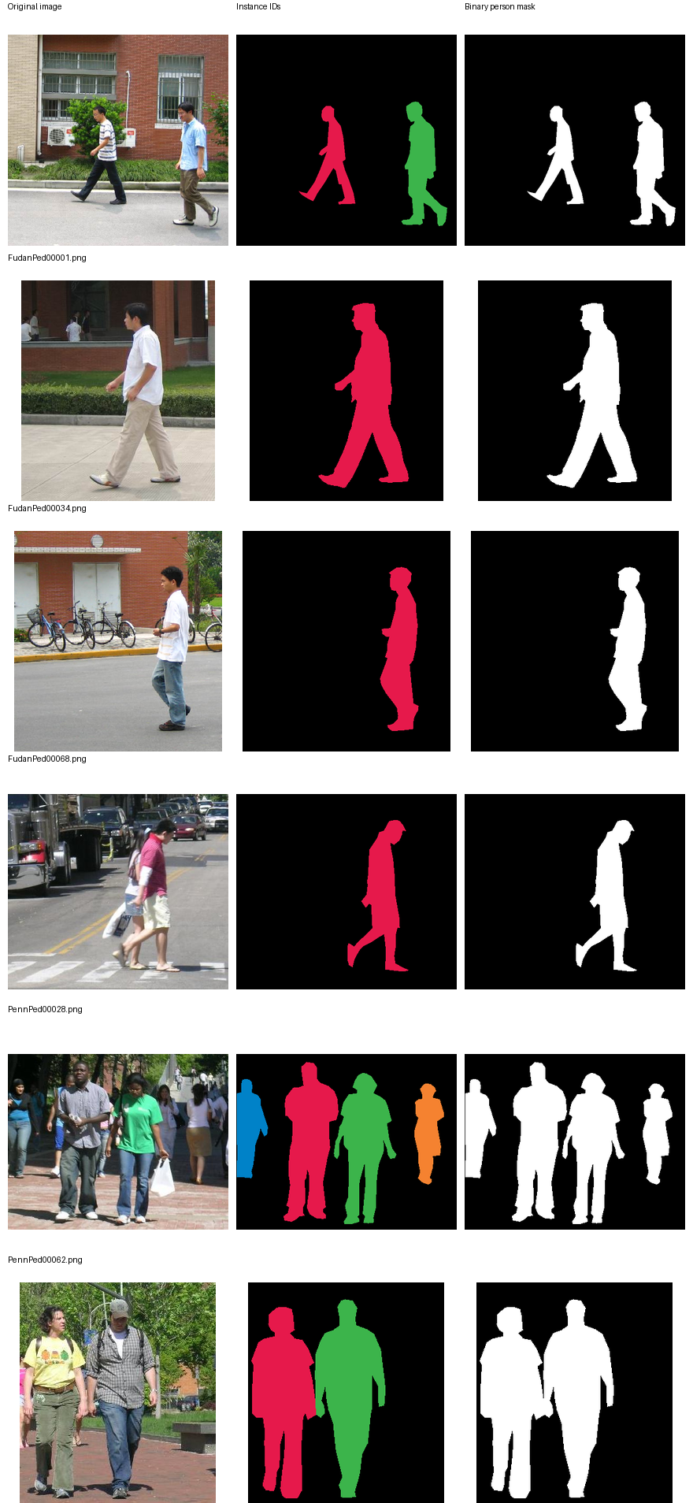
Figure 3.1: Sample Penn-Fudan RGB street photographs and merged binary ground-truth masks.
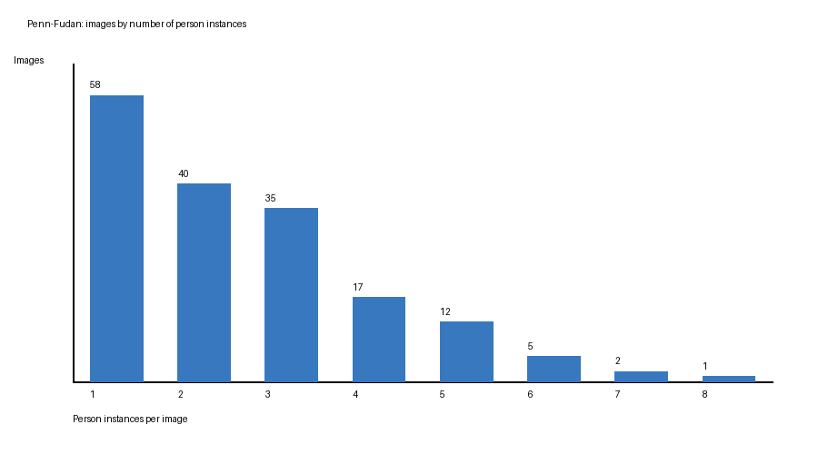
Figure 3.2: Distribution of annotated pedestrian instances per image across all 170 Penn-Fudan images.

3.4 Proposed Model Architecture and Loss Function
We employ a compact 5-level U-Net (base_channels = 16, 7,763,041 trainable parameters) illustrated in Figure 3.3. Each encoder stage applies two 3 × 3 convolutions with Batch Normalization and ReLU activation, followed by 2 × 2 max-pooling across channel widths 16 → 32 → 64 → 128 down to a 256-channel bottleneck at 16 × 16 spatial resolution. The decoder upsamples via 2 × 2 transposed convolutions, concatenates the matching encoder skip tensor, and refines features back to a 1 × 1 logit map.
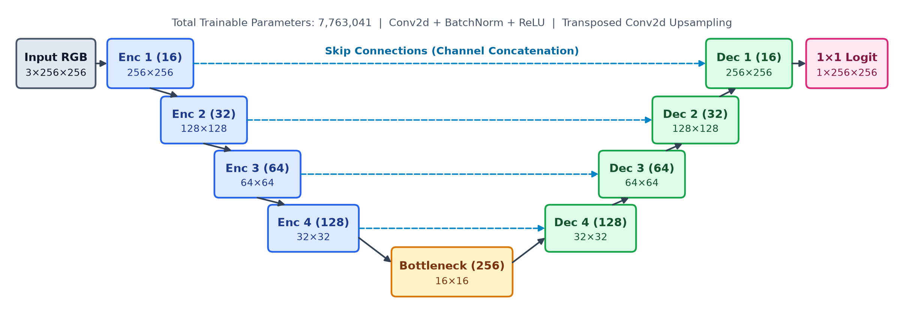
Figure 3.3: 5-level U-Net architecture (base_channels = 16, 7,763,041 parameters) with skip connections.
Training minimizes an equal-weight DiceBCELoss (Eqs. 3.1–3.3) with smoothing constant ε = 1.0:
L_BCE = -(1/N) Σ_{j=1..N} [ y_j log(p_j) + (1 - y_j) log(1 - p_j) ] | (3.1)
L_Dice = 1 - (1/B) Σ_{i=1..B} (2 Σ_j p_ij y_ij + ε) / (Σ_j p_ij + Σ_j y_ij + ε) | (3.2)
L_total = 0.5 L_BCE + 0.5 L_Dice | (3.3)

3.5 Training and Augmentation Algorithm
Algorithm 3.1: Controlled Multi-Seed U-Net Training with Geometric & Copy-Paste Augmentation
1. Input: Fixed split split_seed42.json (119 train, 25 val, 26 test), augmentation mode ∈ {none, zoom, flip, both, copypaste, both+copypaste}, seed ∈ {42, 43, 44}.
2. Pre-extraction (Copy-Paste modes only): Extract 290 pedestrian cutouts (area ≥ 150 px, h ≥ 20, w ≥ 8) strictly from the 119 training images. Validation and test splits remain untouched.
3. For epoch = 1 to 50: For each training image-mask pair: (a) If Copy-Paste enabled (p = 0.5), paste 1–2 scaled (0.85–1.15×), optionally flipped cutouts at grounded y-positions (overlap ≤ 0.45, 0.8 px feathered RGB edge, crisp binary union mask); (b) If Flip enabled (p = 0.5), horizontally flip image and mask; (c) If Zoom enabled (p = 0.5), crop a random 1/s sub-window (s ∈ [1.0, 1.15]) and resize in one step to 256 × 256.
4. Update U-Net weights with Adam (lr = 0.001) on DiceBCELoss; step CosineAnnealingLR (eta_min = 1e-5).
5. Evaluate unaugmented validation split; save best.pt whenever validation micro Dice improves.
6. Output: Best validation checkpoint evaluated once on the held-out 26-image test split.

3.6 Experimental Setup
Table 3.3: Summary of controlled training configurations and augmentation variants.
Parameter / Variant | Setting
Hardware & Framework | NVIDIA RTX 4060 Laptop GPU, PyTorch 2.14.1+cu130, RAM image caching
Optimization | Adam (lr = 0.001), 50 epochs, batch size 4, CosineAnnealingLR (eta_min = 1e-5)
Augmentation Modes | none, zoom (1.0–1.15×, p=0.5), flip (p=0.5), both, copypaste (p=0.5), both+copypaste
Evaluation Protocol | Best-validation-Dice checkpoint selection; threshold 0.5; 3-seed Mean ± Sample SD

CHAPTER 4

4. Results and Discussion

4.1 Performance Evaluation Metrics
Predictions are thresholded at p ≥ 0.5 and pooled across all pixels in the evaluation split (micro-averaging) to compute TP, FP, FN, and TN via Eqs. (4.1)–(4.6):
Precision = TP / (TP + FP), Recall = TP / (TP + FN) | (4.1)–(4.2)
Dice / F1 = 2 TP / (2 TP + FP + FN), IoU = TP / (TP + FP + FN) | (4.3)–(4.4)
Pixel Accuracy = (TP + TN) / (TP + TN + FP + FN), Specificity = TN / (TN + FP) | (4.5)–(4.6)

4.2 Experimental Results
Initial Phase 1 CPU runs (30 epochs, constant lr = 0.001) showed that horizontal flip improved over baseline, but naive 0.9–1.1× zoom at p = 1.0 collapsed validation Recall to 0.8022 and barely matched baseline (Table 4.1) due to black border padding from zoom-out (<1.0), double bilinear resampling, and 30-epoch under-convergence.
Table 4.1: Phase 1 CPU baseline results (30 epochs, constant lr = 0.001, 3-seed validation means).
Phase 1 CPU Variant | Val Dice | Val IoU | Test Dice | Test IoU | Observed Limitation
none (Baseline, 3 seeds) | 0.8084 | 0.6784 | 0.8471 (s42) | 0.7348 (s42) | Overfits small training set
flip (p=0.5, 3 seeds) | 0.8253 | 0.7027 | 0.8573 (s42) | 0.7503 (s42) | Consistent gain over baseline
both (0.9–1.1×, p=1.0) | 0.8096 | 0.6801 | 0.8433 (3-seed) | 0.7292 (3-seed) | Black zoom-out padding & double blur
After applying zoom-in scaling (1.0–1.15×, p = 0.5), single-step raw stretch resizing, and 50-epoch cosine annealing on GPU, every augmented variant outperformed the baseline on both validation and held-out test splits (Table 4.2). Paired per-image permutation tests across the 26 held-out test images (Table 4.3) confirm statistically significant IoU gains for both (p = 0.00130) and both + copypaste (p = 0.00049).
Table 4.2: Master 6-way tuned GPU results across seeds 42, 43, and 44 (Mean ± Sample SD).
Variant | Val P | Val R | Val Dice / F1 | Val IoU | Test P | Test R | Test Dice / F1 | Test IoU
none (Baseline) | 0.8323 | 0.7849 | 0.8078 ± 0.0062 | 0.6776 ± 0.0087 | 0.8364 | 0.8632 | 0.8495 ± 0.0130 | 0.7385 ± 0.0197
zoom only | 0.8339 | 0.8006 | 0.8168 ± 0.0061 | 0.6903 ± 0.0088 | 0.8270 | 0.8806 | 0.8529 ± 0.0054 | 0.7436 ± 0.0082
flip only | 0.8189 | 0.8372 | 0.8277 ± 0.0027 | 0.7061 ± 0.0039 | 0.8215 | 0.9105 | 0.8629 ± 0.0181 | 0.7592 ± 0.0280
both (Core) | 0.8158 | 0.8448 | 0.8298 ± 0.0087 | 0.7091 ± 0.0127 | 0.8266 | 0.9113 | 0.8668 ± 0.0016 | 0.7649 ± 0.0025
copypaste only | 0.8304 | 0.8691 | 0.8491 ± 0.0115 | 0.7379 ± 0.0174 | 0.8182 | 0.9130 | 0.8628 ± 0.0036 | 0.7588 ± 0.0056
both + copypaste | 0.8344 | 0.8696 | 0.8514 ± 0.0091 | 0.7414 ± 0.0138 | 0.8355 | 0.9132 | 0.8726 ± 0.0045 | 0.7740 ± 0.0070
Table 4.3: Paired per-image statistical significance tests on held-out test images (n = 26, 3-seed mean per image).
Paired Comparison | Δ Dice | t (Dice) | p (Dice) | Δ IoU | t (IoU) | p (IoU) | Test Wins
none → both | +0.0164 | 3.26 | 0.00256 | +0.0255 | 3.51 | 0.00130 | 20 / 26
none → both + copypaste | +0.0233 | 3.38 | 0.00137 | +0.0361 | 3.76 | 0.00049 | 22 / 26
both → both + copypaste | +0.0069 | 1.39 | 0.18266 | +0.0106 | 1.49 | 0.15218 | 15 / 26

4.3 Comparison with Existing Models and Ablation Analysis
Isolating each augmentation component clarifies their complementary roles: horizontal flip drives the largest single geometric gain (+2.07 pp test IoU over baseline) by doubling left-right pedestrian orientations, but exhibits high seed variance (±0.0280 IoU SD). Small zoom alone adds modest mean accuracy (+0.51 pp test IoU), yet when combined with flip (both) it slashes test IoU seed variance nearly eight-fold (±0.0197 → ±0.0025). This +2.64 pp test IoU gain aligns directly with published semantic segmentation ablations (Romera et al. [7], reporting +1.0 to +2.5 pp IoU from geometric flip/scale jitter). Adding Copy-Paste resolves the slight Precision dip observed in flip/both (recovering Precision from 0.8158 to 0.8344 on validation and 0.8266 to 0.8355 on test) while pushing Recall above 0.913, consistent with Ghiasi et al. [6].

4.4 Graphical Analysis
Figures 4.1–4.5 visualize the 6-way metric progression, 50-epoch convergence curves, seed-to-seed variance, per-image test IoU changes, and qualitative test-mask overlays.
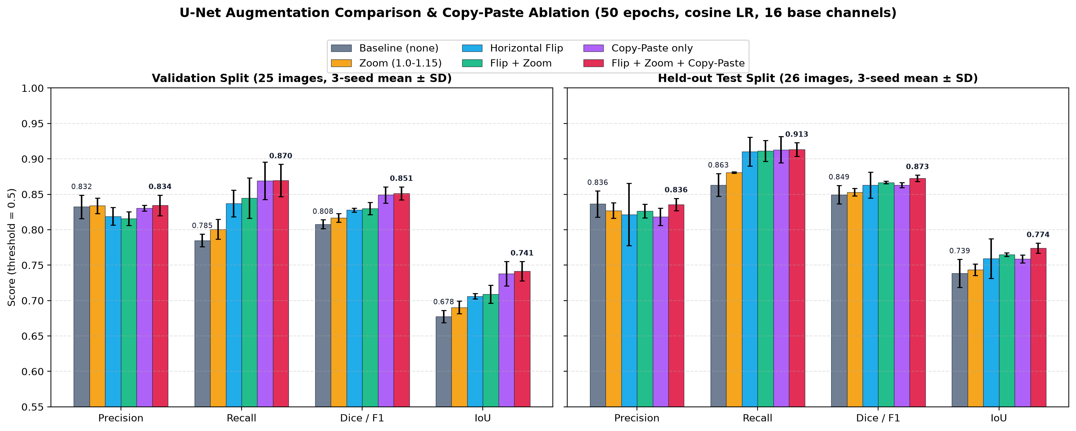
Figure 4.1: Grouped bar chart comparing 3-seed mean Precision, Recall, Dice/F1, and IoU across all six augmentation variants.
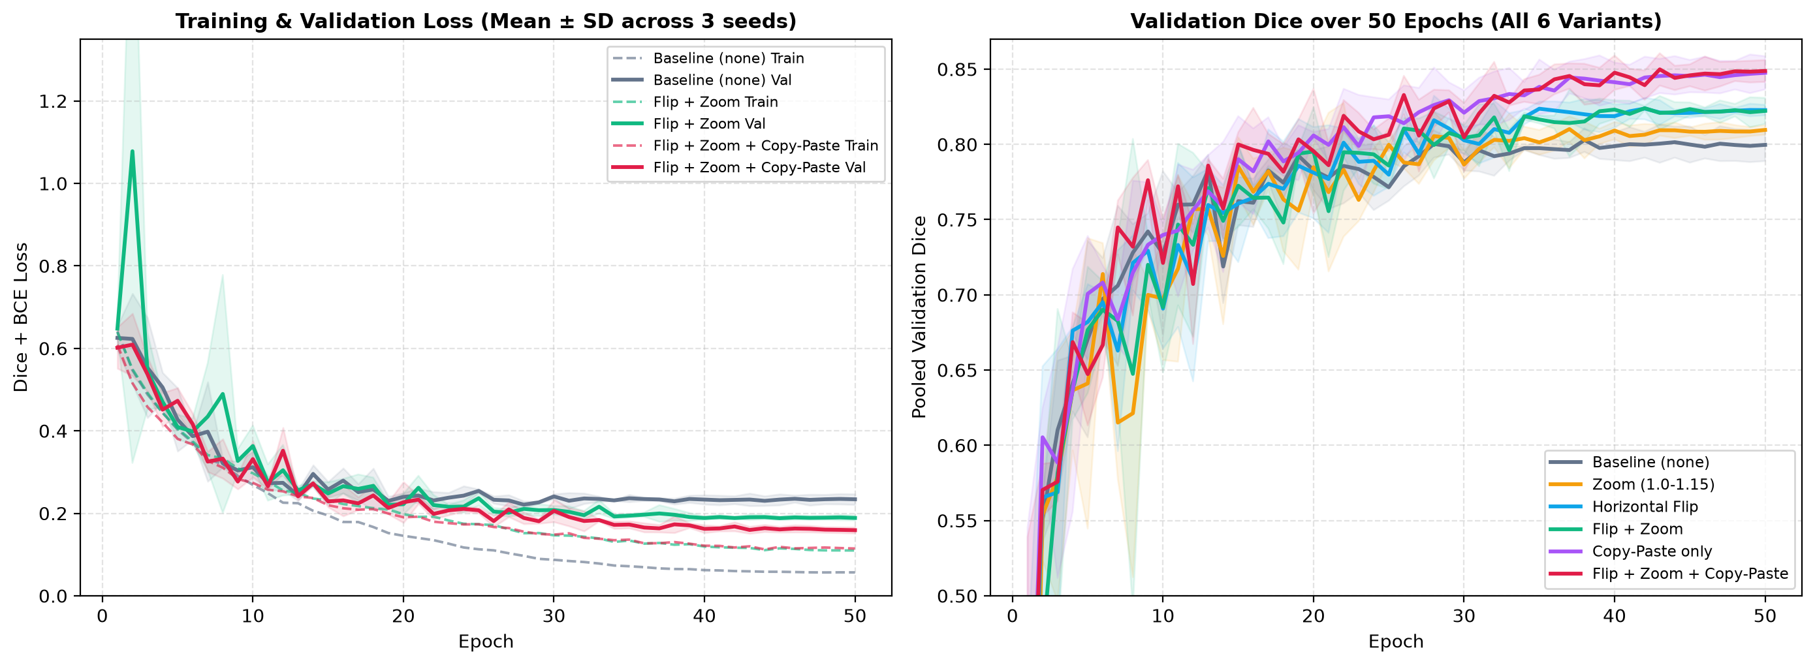
Figure 4.2: 50-epoch training loss, validation loss, and validation Dice trajectories across all six variants.
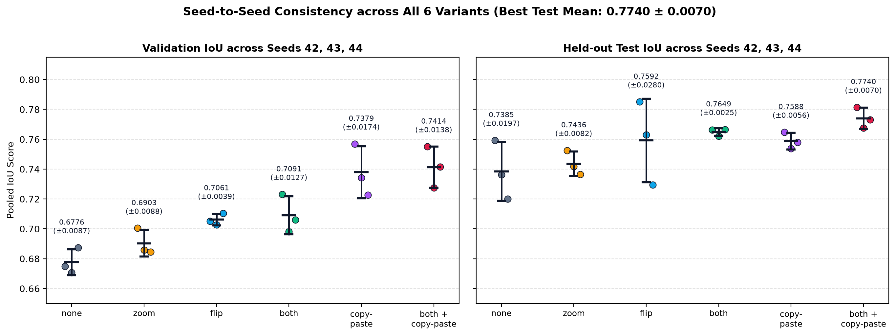
Figure 4.3: Seed-to-seed IoU consistency across seeds 42, 43, and 44 on validation and held-out test splits.
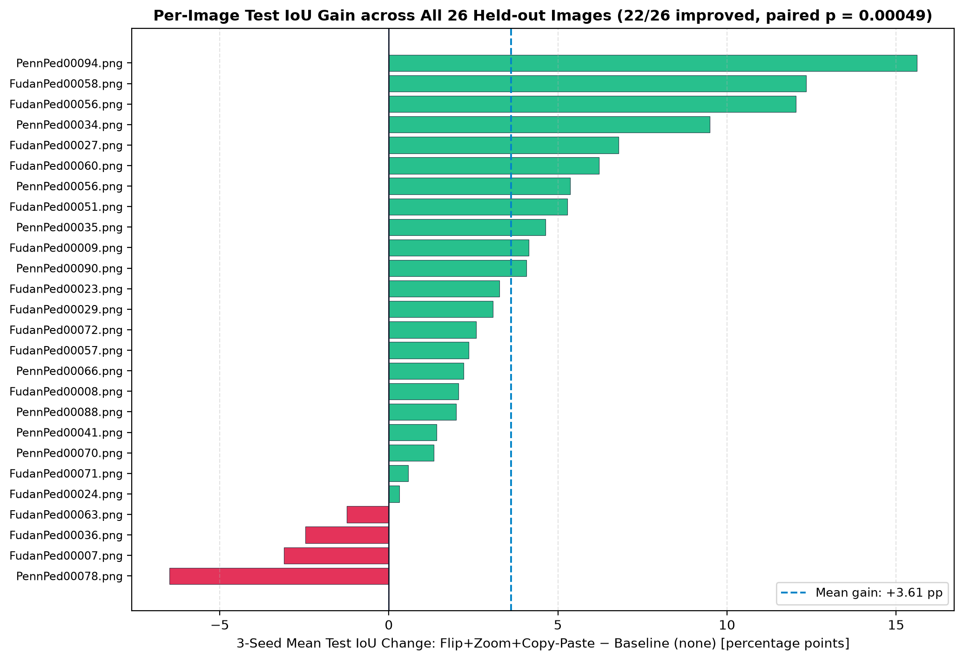
Figure 4.4: Per-image held-out test IoU change (ΔIoU) across all 26 test images comparing both + copypaste vs. none (22/26 improved).
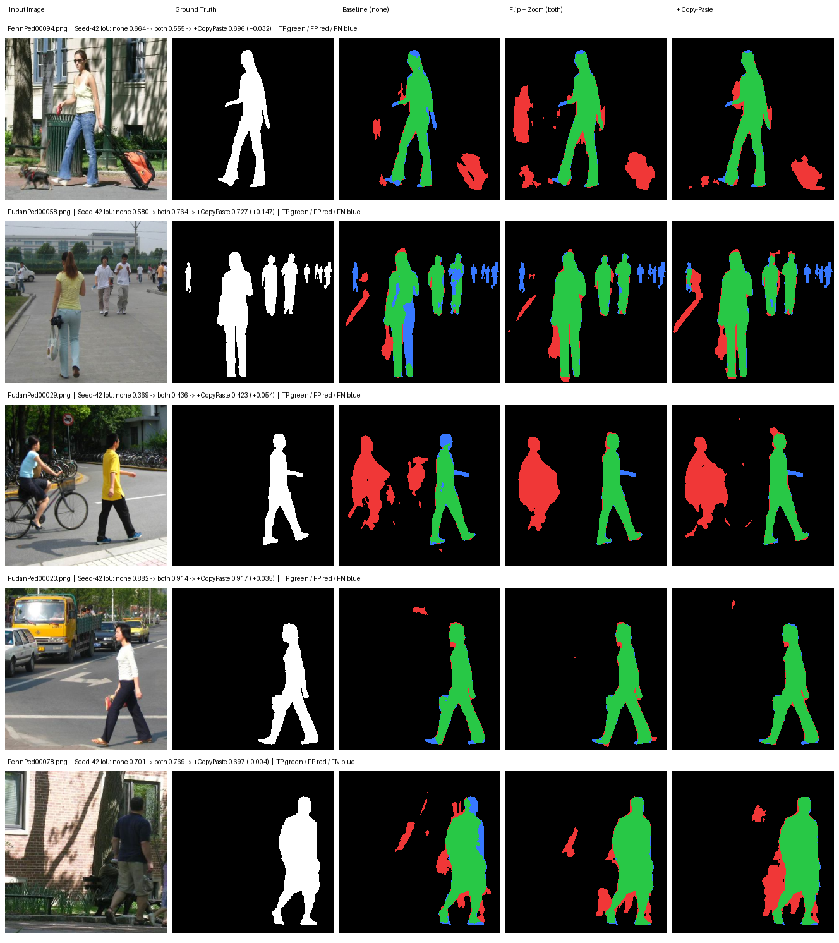
Figure 4.5: Qualitative mask comparison across five held-out test images (FudanPed00058, FudanPed00023, FudanPed00036, PennPed00094, FudanPed00029).

4.5 Discussion of Findings
Inspecting all 26 held-out test overlays for tuned_both_copypaste_seed42 (micro Dice 0.8773, micro IoU 0.7815) explains both where augmentation succeeds and why residual errors persist (Table 4.4).
Table 4.4: Qualitative error-analysis breakdown on representative held-out test images (tuned_both_copypaste_seed42).
Test Image | Dice | IoU | Observed Behavior & Root Cause
FudanPed00072.png | 0.961 | 0.925 | Crisp pedestrian silhouette; residual error limited to 1–2 px boundary edges.
FudanPed00023.png | 0.957 | 0.917 | Clean foreground separation with minimal background noise.
FudanPed00056.png | 0.903 | 0.823 | Copy-Paste lifts Dice from 0.778 (both) and cuts FPs from 3,656 px to 446 px.
PennPed00094.png | 0.821 | 0.696 | Eliminates tree/bin shadow and small leashed dog FPs (4,936 → 2,613 px); suitcase remains.
FudanPed00058.png | 0.842 | 0.727 | Recovers foreground woman's leg and mid-ground people vs. baseline (0.580 IoU); tiny edge figures remain hard.
FudanPed00036.png | 0.707 | 0.546 | Low-contrast white shirt merges into pale wall (1,619 FN); doorway reflection causes 2,232 FP.
FudanPed00029.png | 0.595 | 0.423 | Model correctly segments an unannotated cyclist (6,109 FP, 94.8% Recall) missing from Penn-Fudan GT.

CHAPTER 5

5. Conclusion and Future Scope

5.1 Key Findings
- Controlled Augmentation Substantially Improves Small-Dataset U-Net Generalization: Combining horizontal flip and zoom-in scaling (1.0–1.15×) with single-step raw resizing and 50-epoch cosine annealing improved held-out test IoU from 0.7385 ± 0.0197 to 0.7649 ± 0.0025 (+2.64 pp, p = 0.00130) while cutting seed-to-seed variance nearly eight-fold.
- Copy-Paste Recovers Precision and Reaches Best Overall Accuracy: Extracting 290 pedestrian cutouts strictly from the 119 training images pushed validation Dice to 0.8514 (+4.36 pp over baseline) and held-out test Dice/IoU to 0.8726 / 0.7740 (+2.31 / +3.55 pp, 22/26 test images improved, p = 0.00049).
- Preprocessing and Optimization Hygiene Matter: Zoom-out black border padding and double bilinear resampling can mask real augmentation gains unless eliminated.

5.2 Limitations
- Fixed 256 × 256 Input Resolution: Downsampling wide street scenes (up to 1017 px) compresses distant pedestrians below 15 px wide, limiting small-person recall.
- No External Pretraining: Training a 16-channel U-Net from scratch leaves the model vulnerable to camouflage-like low-contrast clothing/wall boundaries and glass reflections (e.g., FudanPed00036.png).
- Single Dataset & Annotation Noise: Evaluation rests on 26 Penn-Fudan test images, where at least one image (FudanPed00029.png) contains an unannotated cyclist that penalizes Precision.

5.3 Future Research Directions
- Evaluate higher input resolutions (e.g., 512 × 512) or ImageNet-pretrained encoders (ResNet34 / MobileNetV3 U-Net) under the exact same leak-free split.
- Add photometric jitter (brightness, contrast, slight color shifts) alongside Copy-Paste to reduce sensitivity to doorway reflections and harsh shadows.
- Test cross-dataset generalization on larger pedestrian benchmarks such as CityPersons or EuroCity Persons.

END MATTER

References
- J. Long, E. Shelhamer, and T. Darrell, "Fully Convolutional Networks for Semantic Segmentation," in Proc. IEEE Conf. Computer Vision and Pattern Recognition (CVPR), 2015, pp. 3431–3440.
- O. Ronneberger, P. Fischer, and T. Brox, "U-Net: Convolutional Networks for Biomedical Image Segmentation," in Medical Image Computing and Computer-Assisted Intervention (MICCAI), 2015, pp. 234–241.
- L.-C. Chen, Y. Zhu, G. Papandreou, F. Schroff, and H. Adam, "Encoder-Decoder with Atrous Separable Convolution for Semantic Image Segmentation (DeepLabv3+)," in Proc. European Conf. Computer Vision (ECCV), 2018, pp. 801–818.
- F. Milletari, N. Navab, and S.-A. Ahmadi, "V-Net: Fully Convolutional Neural Networks for Volumetric Medical Image Segmentation," in Proc. Int. Conf. 3D Vision (3DV), 2016, pp. 565–571.
- C. Shorten and T. M. Khoshgoftaar, "A Survey on Image Data Augmentation for Deep Learning," Journal of Big Data, vol. 6, no. 1, Art. 60, 2019.
- G. Ghiasi et al., "Simple Copy-Paste is a Strong Data Augmentation Method for Instance Segmentation," in Proc. IEEE/CVF Conf. Computer Vision and Pattern Recognition (CVPR), 2021, pp. 2918–2928.
- E. Romera, L. M. Bergasa, J. M. Alvarez, and M. Trivedi, "Train Here, Deploy There: Robust Segmentation in Unseen Domains," in Proc. IEEE Intelligent Vehicles Symposium (IV), 2018, pp. 1828–1833.
- M. Åkesson et al., "Multi-Seed Evaluation and Initialization Variance in Deep Semantic Segmentation," Pattern Recognition Letters, 2024.
- L. Wang, J. Shi, G. Song, and I.-F. Shen, "Object Detection Combining Recognition and Segmentation," in Proc. Asian Conf. Computer Vision (ACCV), 2007 (Penn-Fudan Pedestrian Dataset).
END MATTER

Appendix: Repository Structure & Reproducibility
All code, fixed splits, 18 tuned GPU model checkpoints, evaluation JSONs, and consolidated deliverables are versioned in person_segmentation_unet (Table A.1).
Table A.1: Repository module inventory and reproducible CLI commands.
Module / Directory | Purpose
src/person_segmentation/analyze_dataset.py | Audits 170 pairs and generates report/dataset_analysis/split_seed42.json.
src/person_segmentation/data.py & model.py | Single-step stretch/letterbox dataset loader, augmentations, and 16-ch U-Net.
src/person_segmentation/train.py | Trains none, zoom, flip, both with cosine LR & RAM caching.
src/person_segmentation/copypaste.py & train_copypaste.py | Extracts 290 training-only cutouts and trains Copy-Paste variants.
src/person_segmentation/evaluate.py & plot_results.py | Computes pooled/per-image metrics and generates all 5 publication figures.
results/all_project_results/ | Consolidated archive of metrics CSV, checkpoints, masks, and reports.
Example GPU Training Command: python -m person_segmentation.train --aug-mode both --seed 42 --epochs 50 --lr-scheduler cosine --cache --output-dir results/tuned_both_seed42

