**Sign into the Azure portal**

Sign in to the Azure portal with your Azure account.

**Create an application gateway**

You'll create the application gateway using the tabs on the **Create an application gateway** page.

1. On the Azure portal menu or from the **Home** page, select **Create a resource**. The **New** window appears.
2. Select **Networking** and then select **Application Gateway** in the **Featured** list.

**Basics tab**

1. On the **Basics** tab, enter these values for the following application gateway settings:
   * **Resource group**: Select **myResourceGroupAG** for the resource group. If it doesn't exist, select **Create new** to create it.
   * **Application gateway name**: Enter *myAppGateway* for the name of the application gateway.

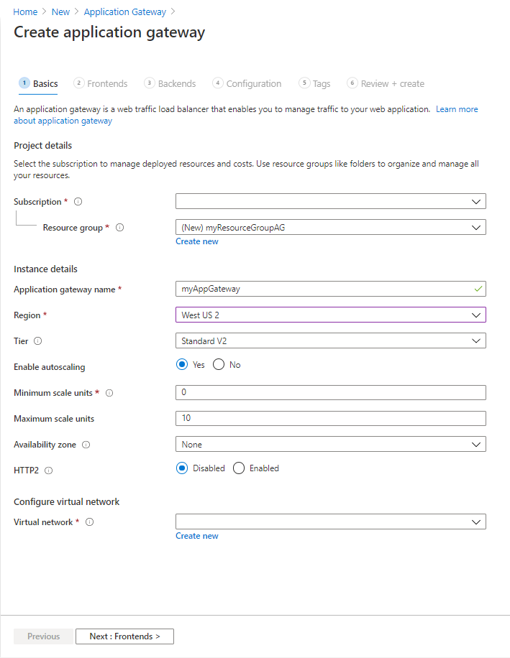

1. For Azure to communicate between the resources that you create, it needs a virtual network. You can either create a new virtual network or use an existing one. In this example, you'll create a new virtual network at the same time that you create the application gateway. Application Gateway instances are created in separate subnets. You create two subnets in this example: one for the application gateway, and another for the backend servers.

**Note**

[**Virtual network service endpoint policies**](https://docs.microsoft.com/en-us/azure/virtual-network/virtual-network-service-endpoint-policies-overview) are currently not supported in an Application Gateway subnet.

Under **Configure virtual network**, create a new virtual network by selecting **Create new**. In the **Create virtual network** window that opens, enter the following values to create the virtual network and two subnets:

* + **Name**: Enter *myVNet* for the name of the virtual network.
  + **Subnet name** (Application Gateway subnet): The **Subnets** grid will show a subnet named *Default*. Change the name of this subnet to *myAGSubnet*.  
    The application gateway subnet can contain only application gateways. No other resources are allowed.
  + **Subnet name** (backend server subnet): In the second row of the **Subnets** grid, enter *myBackendSubnet* in the **Subnet name** column.
  + **Address range** (backend server subnet): In the second row of the **Subnets** Grid, enter an address range that doesn't overlap with the address range of *myAGSubnet*. For example, if the address range of *myAGSubnet* is 10.0.0.0/24, enter *10.0.1.0/24* for the address range of *myBackendSubnet*.

Select **OK** to close the **Create virtual network** window and save the virtual network settings.

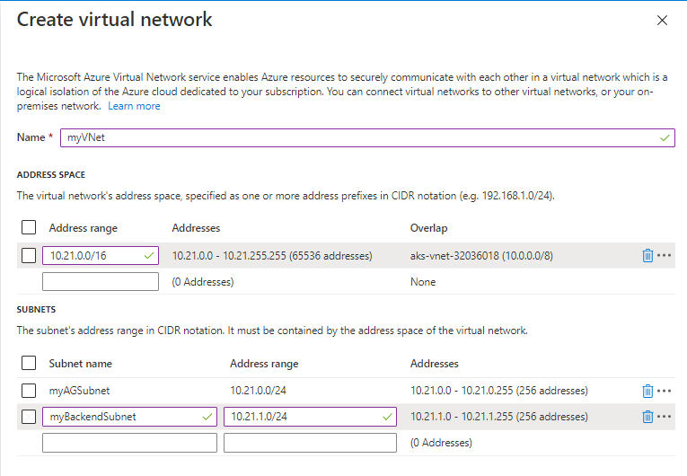

1. On the **Basics** tab, accept the default values for the other settings and then select **Next: Frontends**.

**Frontends tab**

1. On the **Frontends** tab, verify **Frontend IP address type** is set to **Public**.  
   You can configure the Frontend IP to be Public or Private as per your use case. In this example, you'll choose a Public Frontend IP.

**Note**

For the Application Gateway v2 SKU, there must be a **Public** frontend IP configuration. You can still have both a Public and a Private frontend IP configuration, but Private only frontend IP configuration (Only ILB mode) is currently not enabled for the v2 SKU.

1. Select **Add new** for the **Public IP address** and enter *myAGPublicIPAddress* for the public IP address name, and then select **OK**.

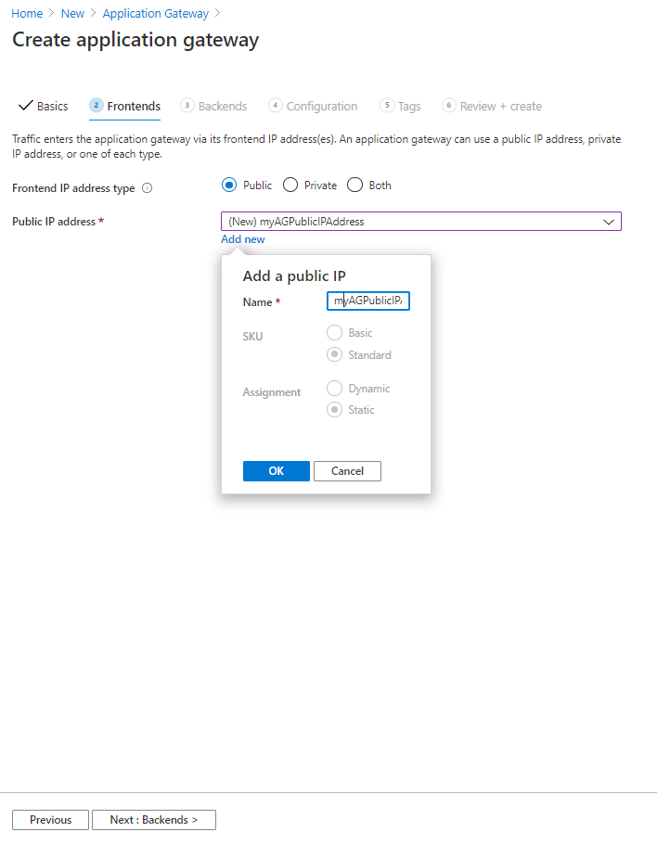

1. Select **Next: Backends**.

**Backends tab**

The backend pool is used to route requests to the backend servers that serve the request. Backend pools can be composed of NICs, virtual machine scale sets, public IP addresses, internal IP addresses, fully qualified domain names (FQDN), and multi-tenant back-ends like Azure App Service. In this example, you'll create an empty backend pool with your application gateway and then add backend targets to the backend pool.

1. On the **Backends** tab, select **Add a backend pool**.
2. In the **Add a backend pool** window that opens, enter the following values to create an empty backend pool:
   * **Name**: Enter *myBackendPool* for the name of the backend pool.
   * **Add backend pool without targets**: Select **Yes** to create a backend pool with no targets. You'll add backend targets after creating the application gateway.
3. In the **Add a backend pool** window, select **Add** to save the backend pool configuration and return to the **Backends** tab.

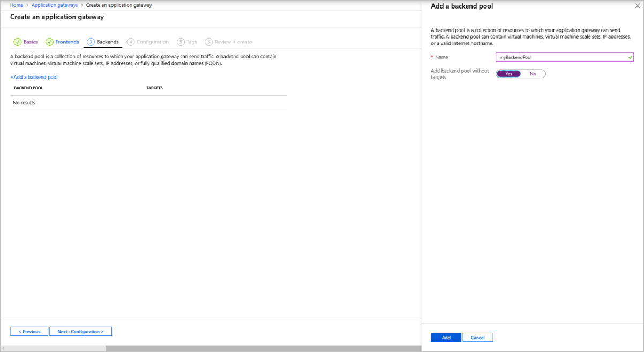

1. On the **Backends** tab, select **Next: Configuration**.

**Configuration tab**

On the **Configuration** tab, you'll connect the frontend and backend pool you created using a routing rule.

1. Select **Add a routing rule** in the **Routing rules** column.
2. In the **Add a routing rule** window that opens, enter *myRoutingRule* for the **Rule name**.
3. A routing rule requires a listener. On the **Listener** tab within the **Add a routing rule** window, enter the following values for the listener:
   * **Listener name**: Enter *myListener* for the name of the listener.
   * **Frontend IP**: Select **Public** to choose the public IP you created for the frontend.

Accept the default values for the other settings on the **Listener** tab, then select the **Backend targets** tab to configure the rest of the routing rule.

1. 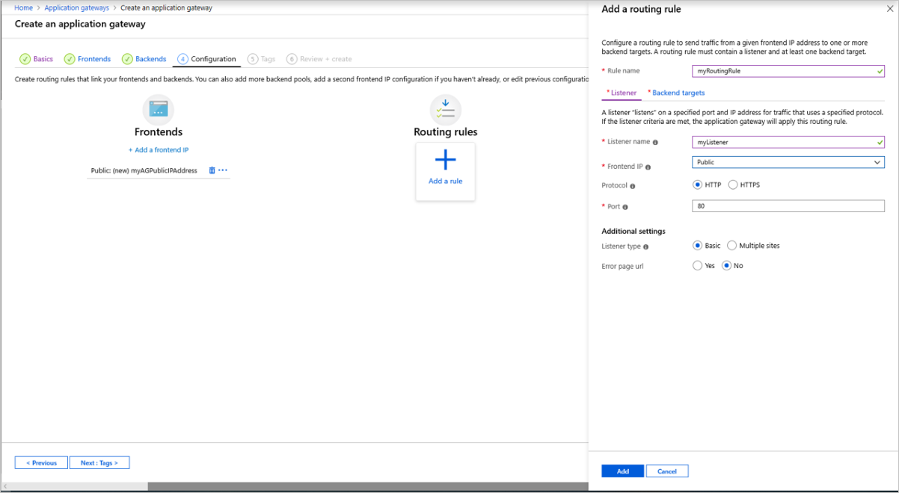
2. On the **Backend targets** tab, select **myBackendPool** for the **Backend target**.
3. For the **HTTP setting**, select **Add new** to add a new HTTP setting. The HTTP setting will determine the behavior of the routing rule. In the **Add an HTTP setting** window that opens, enter *myHTTPSetting* for the **HTTP setting name** and *80* for the **Backend port**. Accept the default values for the other settings in the **Add an HTTP setting** window, then select **Add** to return to the **Add a routing rule** window.

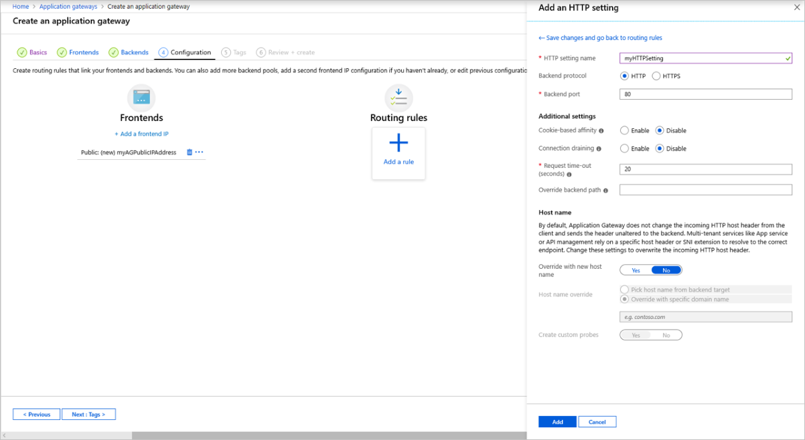

1. On the **Add a routing rule** window, select **Add** to save the routing rule and return to the **Configuration** tab.

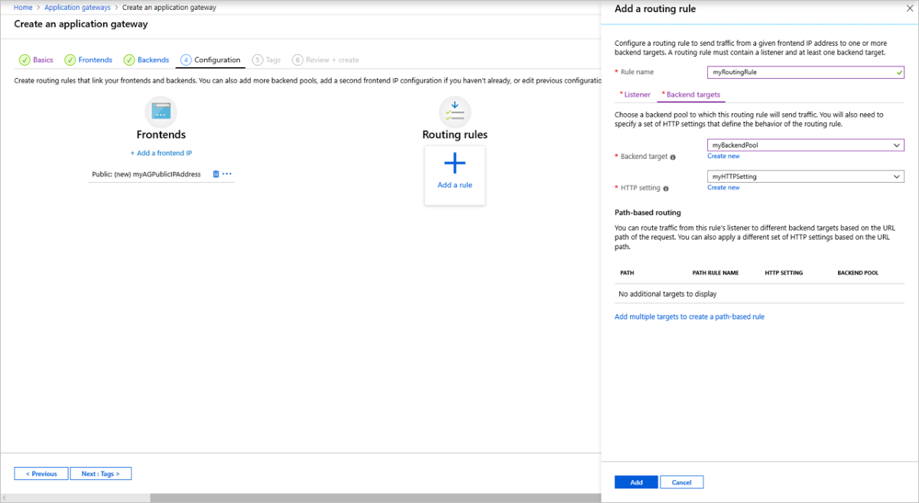

1. Select **Next: Tags** and then **Next: Review + create**.

**Review + create tab**

Review the settings on the **Review + create** tab, and then select **Create** to create the virtual network, the public IP address, and the application gateway. It may take several minutes for Azure to create the application gateway. Wait until the deployment finishes successfully before moving on to the next section.

**Add backend targets**

In this example, you'll use virtual machines as the target backend. You can either use existing virtual machines or create new ones. You'll create two virtual machines as backend servers for the application gateway.

To do this, you'll:

1. Create two new VMs, *myVM* and *myVM2*, to be used as backend servers.
2. Install IIS on the virtual machines to verify that the application gateway was created successfully.
3. Add the backend servers to the backend pool.