Assignment 1
Regression Models
SUSHRUTA GANGADHAR PATIL
Student ID: 26273312
2026 Autumn

36106 - Machine Learning Algorithms and Applications
Master of Data Science and Innovation
University of Technology of Sydney

Table of Contents

Contents
List of Figures ………………………………………………………………………………………………………………………………………. 2
List of Tables ……………………………………………………………………………………………………………………………….…….…. 3
1. Business Understanding 4
a. Business Use Cases 4
b. Key Objectives 4
2. Data Understanding 5
a. Data Limitations 5
b. Key Findings from Exploratory Data Analysis: 5
3. Data Preparation 7
4. Modeling 9
5. Evaluation 12
a. Results and Analysis 12
6. Conclusion 15
7. References 16

List of Figures
Figure 1: Histogram showing distribution of price ……………………………………………………………………………… 6
Figure 2: Scatter plot of kilometres driven vs price …………………………………………………………………………… 6
Figure 3: Median price by body type ………………………………………………………………………………………………… 7
Figure 4: KNN training and validation RMSE by number of neighbours ………………………………………….. 11
Figure 5: Training and Validation RMSE comparison across all models ……………………………………….… 12

List of Tables
Table 1: Model and their RMSE comparison against Baseline ………………………………………………………… 12
Table 2: Segment-wise RMSE comparison across models ……………………………….…………………………….. 13
Table 3: Segment wise RMSE for test dataset ………………………………………………………………………………….. 13

Business Understanding

Business Use Cases
In the Australian used car market, there is a clear gap in what buyers and sellers know about the vehicle that is listed and buyers when scrolling through platforms like Gumtree or Facebook Marketplace have no reliable way to determine whether the listed price is fair, marked up or a bargain. Podkalicka (2022) highlights that Gumtree has become the most used platform for used goods in Australia, with a focus on local and sustainable use, which makes it the right tool for this kind of price validation.
This report attempts to address that gap by developing a machine learning model that can predict the fair market price of the car listed based on its specifications such as manufacturing year, brand, body type, kilometres run, number of engine cylinders, drive and transmission type. The buyer can use the predicted price to make informed decisions and leverage in negotiations.

Key Objectives
The main objective is to build a model that is accurate enough for the buyers to rely on for their decision making. Root Mean Squared Error (RMSE) will be used as the evaluation metric across all three experiments, as it measures in Australian dollars making it much easier and more interpretable to buyers with non-technical background.
The primary stakeholder would be the buyer of the used car that is listed. They would want a fast and reliable price estimating model based on a standard listing without needing to consult a specialist.
Secondary stakeholders include platform operators like Gumtree, Facebook Marketplace who could integrate the tool directly into their portal listings. This benefits them by increasing engagement, interaction and giving buyers confidence with its accuracy.
Third stakeholders would be Customer Advocacy groups, which would want to reduce information gaps between buyers and sellers. Their requirement would be transparency about its limitations, so that vulnerable buyers are not disadvantaged.
Ultimately all these requirements should be satisfied by the final deployable model. To summarise it should be easy to use, understand and rely on, benefit the online platforms which can be done by integrating the model into the platform and integrating the model into their platforms to increase buyer engagement and confidence, which would bring in engagement and people retention, in turn give confidence to people to decide. This model also would introduce the required transparency about the listing and attempt on closing the gap on limitations.

Data Understanding
The dataset contains Australian used car listings provided across three pre-split CSV files, divided by manufacturing year. Training covers cars up to 2017, validation covers 2019 to 2020, and the test set covers 2022 to 2023.
Of the 29 columns, 12 contained personal information of seller such as name, phone number and addresses, which were irrelevant for the model and to adhere to privacy concerns, they were dropped. The remaining 17 columns covering vehicle specifications, including the target variable price, were kept for modelling.
Dataset sizes after cleaning:
- Training: 8755 records, 17 columns
- Validation: 2608 records, 17 columns
- Testing: 2038 records, 17 columns

Data Limitations
Three key limitations were identified. First, training only covered cars manufactured up to 2017, meaning the model has no exposure to more recent pricing patterns driven by inflation, post-covid price surge, or the growing shift toward EV’s and hybrids. Second, the test set's car condition distribution is totally different from training, with 47% NEW and 19% DEMO cars compared to 99.9% USED in training, making test performance an unreliable measure of real-world accuracy for our use case. Third, location data had 449 missing values in the test set, making it unusable as a feature and preventing the model from capturing state-based price variation across Australia.

Key Findings from Exploratory Data Analysis:
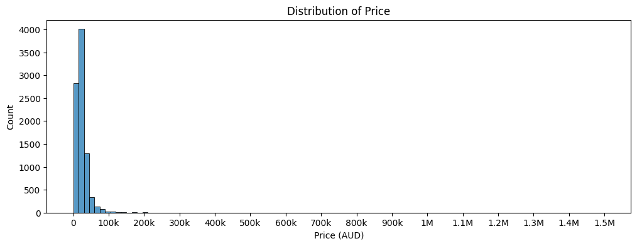
Price, the target variable was heavily right skewed at 24.5, with most cars falling between $10k and $50k but a small number of luxury cars stretching to $1.5M as displayed in Figure 1. An Alfa Romeo listed at $88 was removed as a clear data entry error, while the $1.5M Ferrari 250 (1959) was verified as a legitimate collectible and retained. The mean training price was $24,734.
Figure 1: Histogram showing distribution of price
Kilometres driven had the strongest correlation with price at -0.27. As shown in Figure 2, the scatter plot reveals a cone shape where less driven cars span over a wide price range that converges as mileage increases, confirming mileage as a strong downward signal. This is consistent with Agokei and Afa (2019), who examined over 55,900 used car listings across Australia and found that mileage and manufacturing year are the two strongest predictors of used car prices. The 14 missing values in training and 564 in the test set were all dash placeholders invisible to isnull().sum() and were dropped, as mileage cannot be accurately imputed and doing so would hinder the model’s performance.
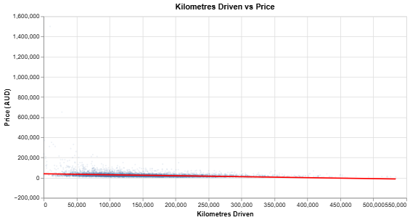
Figure 2: Scatter plot of kilometres driven vs price
Body type showed the largest categorical price disparity (Figure 3), with Coupes at a median of $33,500 versus Hatchbacks at $14,990, an $18,000 gap on body type alone. Vehicle brand ranged from Daewoo at the bottom to Lamborghini at the top. Engine cylinders showed a consistent step-up pattern from 3-cylinder to 12-cylinder, with medians exceeding $120,000 at the top end. Drive type also showed clear differentiation, with 4WD and AWD vehicles at a median of around $25,000 compared to $16,000 for FWD, reflecting the SUV and Ute are popular choices in the Australian market.
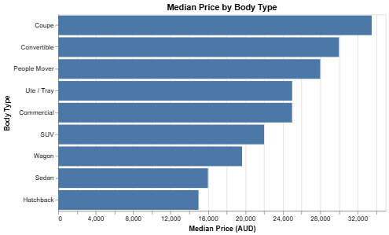
Figure 3: Median price by body type

Data Preparation
Feature Selection
Features were selected through three independent approaches, all pointing to the same seven variables:
- kilometres_driven,
- manufacturing_year,
- body_type,
- vehicle_brand,
- transmission_type,
- drive_type and
- engine_cylinders.
Three approaches were used to select features. The first focused on data quality; seats (12.6% missing), doors (11.8% missing, with seat values mixed in), fuel consumption (12.6% missing, weak correlation of +0.08), and model name (595 unique values, too granular to encode reliably) were all excluded. The second was based on correlation with price. Kilometres driven at -0.27 was the strongest numeric predictor, and box plots of body type, vehicle brand, engine cylinders and drive type all showed distinct price differentiation as can be observed. The third assessed business use case alignment. Every feature had to be readily available on platforms like Gumtree and Facebook Marketplace. Seller details were excluded for relevance and privacy, and location was excluded despite being a potential signal due to missing values in the test set that could not be reliably imputed.
Data Cleaning
Price was stored as a string and parsed to float, revealing 7 missing values in training (1 null and 6 POA) and 41 in testing (all POA). As the target variable cannot be imputed, these were dropped. The 2006 Alfa Romeo at $88 was dropped as a data entry error, while the $900 Daewoo Lanos (1998, 310,000km) was retained as reasonable given its age and mileage. Kilometres driven was similarly in string format, with 564 dash placeholders in the test set invisible to isnull().sum(). As mileage cannot be accurately imputed, these rows were dropped. Body type missing values were imputed with the training mode "SUV", and "Other" body type records from testing were dropped as the category never appeared in training. Transmission dash placeholders were replaced with training mode, "Automatic" and cylinder dashes with "4 cylinders", zero cylinders were carefully observed and retained as they were linked to electric cars. Only the numeric cylinder value was kept for modelling. All imputation parameters were fitted on training data only and applied across validation and test to prevent data leakage.
Feature Engineering
      - brand_bodytype_encoded: Vehicle brand alone was misleading as a feature because a Toyota SUV and a Toyota Hatchback are priced completely differently and taking a group average would not do justice. So, to strengthen the feature, brand and body type were encoded into 230 unique combinations using smoothed mean encoding with the formula:
smoothed = (n × combo_mean + k × global_mean) / (n + k), where n is the number of records in that category and k is the smoothing factor.
This avoids overfitting when compared to target encoding where less records values could be encoded to its own cost. Unseen combinations in validation and test were mapped to the global mean of $24,734. The original vehicle_brand column was then dropped.
      - body_drive_encoded: The same method was also used on Body type and drive type to create 37 unique combinations as an SUV 4WD and SUV Front had different prices and these insights would have been missed without the encoding.
Several other feature engineering ideas were explored and rejected:
- vehicle_age, as the name suggests the period from when the car was bought to when it was put on listing was rejected because the listing and year of purchase is unknown.
- km_per_year again which again could have been a good feature was rejected as it depends on vehicle_age.
- is_luxury was rejected because only 18 luxury records existed in training.
Data Transformation
Transmission type was one-hot encoded with drop_first=True, producing a single binary column where 1 = Manual and 0 = Automatic. StandardScaler was fitted on training only and applied across all sets to ensure no feature dominated due to scale differences (Géron, 2022). Log transformation was explored during EDA, reducing price skewness from 24.5 to 0.25, but original price values were used for model training.
Final feature set (6 features) use in the model are listed below;
- kilometres_driven
- manufacturing_year
- engine_cylinders
- brand_bodytype_encoded
- body_drive_encoded
- transmission_type_Manual

Modeling
Three experiments were conducted using the same 6 features and the same train/ validation/ test splits to ensure fair comparison of their performances.
Experiment 0 : Baseline Model
A Dummy Regressor predicting on the training mean was served as the baseline.
Baseline model: Predicts $24,734 for every car regardless of the features.
Outcome: Training RMSE: $26,155.62 | Validation RMSE: $37,291.73
The experiments conducted are expected to perform better than the baseline RMSE of $37,291.73. Since the baseline ignores all features and simply predicts the training mean for every car, it represents the worst possible performance. Any model that cannot beat this threshold has effectively failed to learn meaningful patterns from the features, making the baseline a critical reference point for evaluating each experiment.

Experiment 1 : Multivariate Linear Regression
Linear regression was selected for the first experiment for to its simplicity and interpretability (James et al., 2021). The hypothesis was that the model would outperform the baseline given its linear relationship between the features chosen and the target variable that were observed during EDA and the model would have a better accuracy with an intercept. The hyperparameter, fit_intercept was tested during this experiment. Without an intercept (fit_intercept = False) the model is forced through the origin, which makes no practical sense for car pricing and was also confirmed through the results obtained.
Results:
fit_intercept = True: Training RMSE: $20,071.20 | Validation RMSE: $27,162.40
fit_intercept = False: Training RMSE: $29,715.99 | Validation RMSE: $40,393.94
Hypothesis Confirmed : fit_intercept = True beat the baseline by $10,129.
Experiment 2 : ElasticNet Regression
ElasticNet was selected for the second experiment as it is a step up to linear regression by introducing L1 and L2 regularisation penalties (James et al., 2021). The hypothesis was that constraining large coefficients such as brand_bodytype_encoded at 13,040 would reduce overfitting and improve on experiment 1's validation RMSE. RandomizedSearchCV was run across 50 to 200 iterations, found converging at n = 110 with best hyperparameters of alpha = 0.5542 and l1_ratio = 0.6919, where alpha controls penalty strength and l1_ratio balances lasso and ridge (Pedregosa et al., 2011).
Results:
Training RMSE: $20,204.74 | Validation RMSE: $27,872.71
Hypothesis Partially Confirmed: ElasticNet was overall $710.31 worse than the Linear Regression RMSE but outperformed it within the $15k - $50k deployment scope, suggesting that the features were already well engineered and just needed minimal regularisation.
Experiment 3 : K - Nearest Neighbours Regression
KNN was chosen for the third experiment to introduce a non-parametric perspective into the experiment as it makes no assumptions about the relationship between features and price (Géron, 2022). The hypothesis was that it would outperform both linear models by capturing non-linear pricing patterns.
RandomizedSearchCV suggested n = 6 as optimal, however on plotting train and validation RMSE across n = 1 to n = 20 (Figure 4) showed that n = 7 offered a more balanced train-validation gap, making it a more stable and generalisable choice. The difference was only $1.51 in validation RMSE, so n = 7 was picked as a safer option. At the other extreme, n = 1 produced a training RMSE of $18, a clear case of overfitting. The distance metric p = 2 (Euclidean) was retained from the search results.
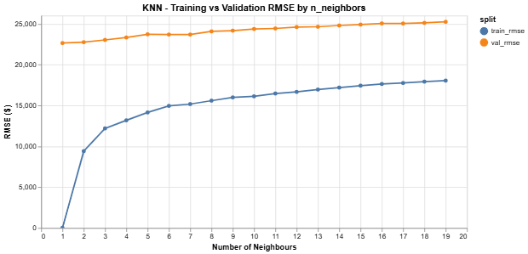
Figure 4: KNN training and validation RMSE by number of neighbours
Best hyperparameters: n_neighbors = 7, p = 2 (Euclidean distance)
Results:
Training RMSE: $15,166.79 | Validation RMSE: $23,676.16
Hypothesis Confirmed: KNN outperformed both models on overall validation RMSE and won in 4 out of 5 price segments, under $15k range being considered negligible because of very less samples.
Final Model Selection for test data:
The final model was selected based on the validation RMSE as the primary criterion. KNN with n=7, p=2 achieved the lowest validation RMSE of $23,676.16 across all three experiments, outperforming Linear Regression at $27,162.40 and ElasticNet at $27,872.71 and a $13,616 improvement over the baseline.

Evaluation

Results and Analysis
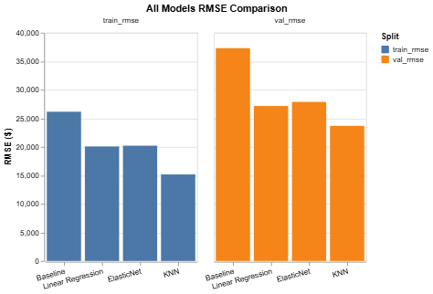
Figure 5: Training and Validation RMSE comparison across all models

Model | Train RMSE | Val RMSE | vs Baseline
Baseline | $26,155.62 | $37,291.73 | -
Linear Regression with_intercept = True | $20,071.20 | $27,162.40 | - $10,129
ElasticNet  alpha = 0.5542, l1_ratio = 0.6919 | $20,204.74 | $27,872.71 | - $9,419
KNN  n=7, p=2 | $15,166.79 | $23,676.16 | - $13,616
Table 1: Model and their RMSE comparison against Baseline
As shown in Figure 5, each successive experiment improved on the baseline. KNN is the best performing model, beating the baseline by $13,616 on validation and outperforming all models across every price segment within the $15k–$50k deployment scope.

Consistency by price segment (validation):

Segment | Count | Linear Regression | ElasticNet | KNN
< $15k | 4 | $11,545 | $10,788 | $15,661
$15k-$30k | 892 | $6,279 | $5,572 | $4,361
$30k-$50k | 1,131 | $11,634 | $11,403 | $8,589
$50k-$100k | 498 | $25,639 | $26,881 | $22,668
>$100k | 83 | $130,247 | $134,814 | $116,057
Table 2: Segment-wise RMSE comparison across models
KNN outperforms the other models in every segment except below $15k, where only 4 records made meaningful conclusions impossible. Above $50k, all three models struggle due to insufficient luxury car training data rather than model failure.
Performance is strongest in the $15k to $30k range where training data is densest. The $30k to $50k range holds reasonably, though with higher error.
Predictions break down in two areas. Luxury vehicles above $50k are underestimated due to limited training exposure, and 2022 to 2023 vehicles are systematically underestimated as the model never accounted for post-COVID price hikes driven by inflation and supply shortages. This aligns with Agokei and Afa (2019), who noted that used car price models require regular retraining as market conditions shift.
Test set evaluation (KNN only):
KNN being the better model overall, was evaluated on the test set. Overall test RMSE was $40,439.59. By segment;
Segment | Records | Test RMSE
$15k–$30k | 191 | $5,242
$30k–$50k | 841 | $11,783
$50k–$100k | 850 | $30,632
>$100k | 156 | $124,377
Table 3: Segment wise RMSE for test dataset
The high overall test RMSE can be clearly explained by the vehicle condition distribution shift in the set. The test set contains 850 records in the $50k–$100k range and 156 above $100k which are mainly “NEW” and “DEMO” vehicles that the model was never trained on. Within the intended $15k–$50k USED car scope, performance is acceptable.
Business Impact and Benefits
The model offers reliable price estimates within the $15k to $50k range, covering the majority of the everyday used car market, and is sufficient to identify an overpriced listing or a legitimate offer.This means that a buyer looking at a $22,000 car may anticipate an estimate within about $5,000, which is sufficient to identify an overpriced listing or a legitimate offer.
Beyond $50k, the model becomes unreliable and should not be used without an explicit disclaimer.
Data Privacy and Ethical Concerns
Privacy: The dataset contained several sensitive personal information including full names, phone numbers, email and home addresses of the sellers. None of those data were used as model features due to its irrelevance for model training and were excluded during data preparation. This step was also followed and processed according to responsible data practice and aligns with the Australian Privacy Act 1988 and its subsequent review of privacy obligations in automated and data-driven systems (Attorney-General's Department, 2021).
Bias and fairness: The data used to train the model included cars manufactured before to 2017. Due to inflation and post-COVID supply problems, car prices have increased dramatically since then, hence the model might underestimate the cost of the more recent models. Without being aware of this restriction, buyers who depend on the tool would reject offers that were reasonable given the state of the market.
Indigenous communities: Australia's remote and regional areas, including many Indigenous communities, frequently have limited access to large vehicle markets and mostly rely on websites like Facebook Marketplace and Gumtree for their purchases. The current model is unable to differentiate between the market circumstances in rural areas and well-developed cities due to the lack of location as a characteristic. Cars or vehicles in such location might be a bit costly than other areas due to additional transport costs, so a model that lacks such features to measure should clearly mention such disclaimers so that the communities that already face barriers to equitable market participation will not be even more disadvantaged.
Model limitations and responsible deployment: The model is not very appropriate for “NEW” or “DEMO” type of cars as it was mainly trained on “USED” cars. Any production deployment of this model should include a notice highlighting that the tool is exclusively meant for USED cars in the $15k–$50k range and in the meantime, the model should be trained with more of recent, luxury cars and locations so that it can become reliable across the price range and locations.

Conclusion
This project aimed to build a fair market price predictor for used vehicles, to help buyers on platforms like Gumtree and Facebook Marketplace to compare if the selling price is right. Three models were tested: Multivariate Linear Regression, ElasticNet, and K-Nearest Neighbours, all trained on the same features so that performance differences came down to the model, not the data fed into it.
KNN (n=7, p=2) performed the best with a validation RMSE of $23,676 and a test RMSE of $40,440. Within the target range of $15k to $50k used cars, it performed much more reliably, achieving a validation RMSE of $4,361 for the $15k to $30k segment and $8,589 for $30k to $50k, making it a useful tool for spotting overpriced listings in that price range.
The model partially meets stakeholder needs. Everyday buyers shopping in the $15k to $50k range benefit most from the model's predictions but platform operators and consumer advocacy groups want a more robust and recently retrained model before it could be deployed at a larger scale.
Despite performing well within the $15k to $50k scope deployment is not recommended yet. The model was trained on vehicles up to 2017 but tested against 2022 to 2023 listings, causing it to systematically underestimate prices. The test set also skewed heavily toward new and demo vehicles (47% and 19% respectively), confirming it does not generalise well beyond used cars.
Future work should focus on retraining with listings from 2020 onwards, adding more luxury and new/demo records, and incorporating location as a feature, to better serve regional and remote communities.

References
Agokei, C. G., & Afa, B. J. (2019). Statistical Analysis and Forecasting of Price and Mileage Correlation for Second-hand Cars in Australia.
https://doi.org/10.20944/preprints201911.0119.v1
Géron, A. (2022). Hands-on machine learning with Scikit-Learn, Keras and TensorFlow: concepts, tools, and techniques to build intelligent systems. O’Reilly. https://doi.org/10.1021/acs.est.3c00026
James, G. (Gareth M., Witten, D., Hastie, T. J., & Tibshirani, R. J. (2021). An introduction to statistical learning : with applications in R (Second edition.). Springer. https://doi.org/10.1007/978-1-0716-1418-1
Burdon, M., & Cohen, T. (2021). Issues Paper Submission-Attorney General's Department Review of The Privacy Act 1988 (Cth).
https://eprints.qut.edu.au/230239/
https://www.ag.gov.au/rights-and-protections/privacy
Pedregosa, F., Varoquaux, G., Gramfort, A., Michel, V., Thirion, B., Grisel, O., Blondel, M., Prettenhofer, P., Weiss, R., Dubourg, V., Vanderplas, J., Passos, A., Cournapeau, D., Brucher, M., Perrot, M., & Duchesnay, E. (2011). Scikit-learn: Machine Learning in Python. Journal of Machine Learning Research.
https://doi.org/10.5555/1953048.2078195
Podkalicka, A. (2022). At home with Gumtree: A cultural analysis of Australia’s popular secondhand online marketplace. European Journal of Cultural Studies, 25(5), 1410–1432.
https://doi.org/10.1177/13675494221079856

