Assignment 2
Classification Models
Sushruta Gangadhar Patil
Student ID: 26273312
2026 Autumn

36106 - Machine Learning Algorithms and Applications
Master of Data Science and Innovation
University of Technology of Sydney

Table of Contents
0. List of Tables 2
1. Business Understanding 3
a) Business Use Cases 3
b) Key Objectives 3
2. Data Understanding 4
3. Data Preparation 7
a) Data Cleaning 7
b) Feature Selection 7
c) Feature Engineering 8
d) Data Splitting, Preprocessing and Imbalance handling 9
4. Modelling 9
a) Algorithm Selection and Rationale 9
b) Parameter Tuning and Model Selection 11
c) Implementation Considerations 11
5. Evaluation 12
a. Results and Analysis 12
b. Business Impact and Benefits 14
c. Data Privacy and Ethical Concerns 15
6. Conclusion 16
7. References 18
8. Appendices 20
a. Appendix A - Hyperparameter Search Results 20
b. Appendix B - Feature Sets per Experiment 20
c. Appendix C - Full Classification Reports 21
d. Appendix D - Normalised Misclassification Heatmaps (All Experiments) 24
e. Appendix E - Learning Curves (All Experiments) 26
f. Appendix F - Precision-Recall Curves (All Experiments) 27

List of Tables
- Figure 1: Target variable distribution ………………………………………….…………………………………………………………………………… 4
- Figure 2: Correlation heatmap of numerical features …………………………………………………………………………………………… 5
- Figure 3: Symptom prevalence heatmap by class ………………………………………………………………………………………………… 6
- Figure 4: Boxplots for age and BMI by class …………………………………………………………………………………………………………. 6
- Figure 5: ANOVA F-score bar chart showing numerical feature rankings ………………………………………………………….. 8
- Figure 6: Chi-square score bar chart showing categorical feature rankings ………………………………………………………. 8
- Figure 7: Per class F1 comparison across all experiments …………………………………………………………………………………… 11
- Figure 8: Learning curve from Experiment 3 HistGradientBoosting …………………………………………………………………… 12
- Figure 9: Normalised Misclassification Heatmap from Experiment 3 HistGradientBoosting ……………………………. 12
- Figure 10: Precision-Recall curve from Experiment 3 HistGradientBoosting ……………………………………………………… 14
- Figure 11: Test set Normalised Misclassification Heatmap from best model HGB …………………………………………….. 14

Business Understanding

Business Use Cases
Nutritional deficiency diseases are preventable. That is what makes missed diagnoses so frustrating - conditions like Scurvy, Rickets and Night Blindness are not medical mysteries. They have known causes and straightforward treatments. The problem is detection. Blood tests take time, specialist referrals are expensive, and in most situations neither option is easily available. By the time a deficiency is formally confirmed, a patient has often been symptomatic for weeks.
Micronutrient deficiencies remain a significant global health burden. In 2021, anemia affected around 1.92 billion people worldwide, with women, children, and residents of low-income regions suffering the most (Gardner et al., 2023). Deficits in dietary iron, vitamin A, and other micronutrients continue to cause preventable disabilities in about 204 countries (Han et al., 2022). Vitamin deficiency illnesses, including as rickets, scurvy, and night blindness, have distinct clinical profiles, but they all have the trait of being far easier to treat early rather than late (Mays, 2018).
This project builds a machine learning classification model that predicts which of five diagnostic categories a patient falls into, namely, Healthy, Anaemia, Rickets/Osteomalacia, Night Blindness or Scurvy based on their dietary intake, serum levels, lifestyle factors and reported symptoms. The model is intended as a preliminary screening tool, not a replacement for clinical judgment. A patient fills in their data, the model produces a prediction, and the care team uses that prediction to decide whether further investigation or a targeted nutritional intervention is warranted. Similar problems have already been solved by machine learning: classifying vitamin A deficiency in schoolchildren without blood tests (Ramesh et al., 2022), predicting vitamin D deficiency from demographic and lifestyle data (Guo et al., 2024; Garcia Carretero et al., 2021), and identifying vitamin C deficiency risk in surgical patients (Parrott et al., 2023). This study extends previous work to a five-class configuration that simultaneously tackles many deficiencies.

Key Objectives
The primary objective is to produce a model that classifies all five conditions reliably, with particular attention to minority classes. With only 176 Scurvy cases and 269 Night Blindness cases in the original dataset of 5,800 patients, the class imbalance ratio is 12.1x. A model that ignores minority classes has no clinical value regardless of its overall accuracy.
The main stakeholders are clinical care teams who need to prioritise patients for further assessment, and the patients themselves, particularly those with rarer conditions whose diagnoses are most likely to be missed. To ensure that Scurvy and Night Blindness performance contributes as much to the final score as Healthy and Anaemia, the model uses macro average F1 as its major assessment measure, which weights every class equally regardless of size (Grandini et al., 2020). A false negative predicting Healthy when the patient is actually sick is the worst outcome in this context. A patient with undetected Scurvy continues to deteriorate from something that vitamin C supplementation could have corrected. That asymmetry shaped every modelling decision made in this project.

Data Understanding
The dataset contains 5,800 patient records across 45 columns covering five diagnostic categories: Healthy (2,121), Anaemia (1,805), Rickets/Osteomalacia (1,429), Night Blindness (269) and Scurvy (176). The class imbalance between the largest and smallest class sits at 12.1x, (as illustrated in Figure 1) which immediately ruled out accuracy as a meaningful evaluation metric and shaped every subsequent modelling decision.
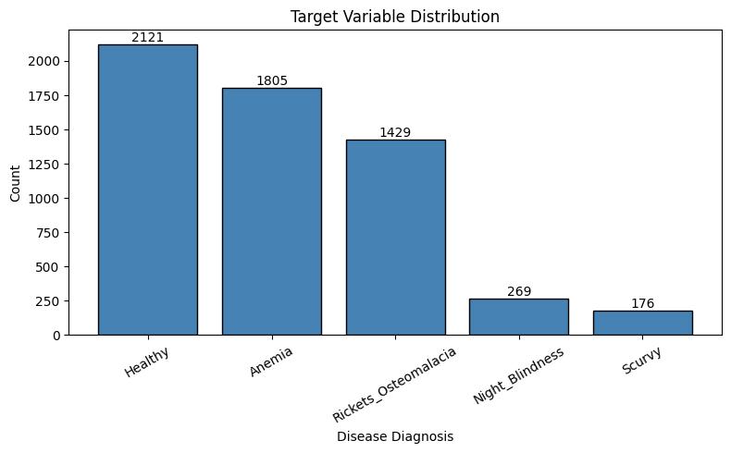

Figure 1: Target variable distribution
The 45 columns span four broad categories: serum biomarker levels, dietary vitamin and mineral intake, lifestyle and demographic information, and binary symptom indicators. No single feature on its own is sufficient to distinguish between all five classes. The diagnostic signal is distributed across combinations of variables, which is precisely what makes this a machine learning problem rather than a rules-based one.
The serum biomarker columns showed the clearest class separation. Vitamin D serum levels were substantially lower in Rickets patients compared to all other groups, and Vitamin B12 serum levels showed strong separation for Anaemia. The dietary intake columns followed a similar pattern, vitamin C intake was the strongest individual predictor for Scurvy, and vitamin A intake was the most informative feature for Night Blindness. Correlation analysis confirmed that intake and serum levels carry related but independent signal as shown in Figure 2, vitamin D intake and serum vitamin D correlated at 0.79, vitamin B12 intake and serum B12 at 0.76, and folate intake and serum folate at 0.75, meaning both sets of features were worth retaining.
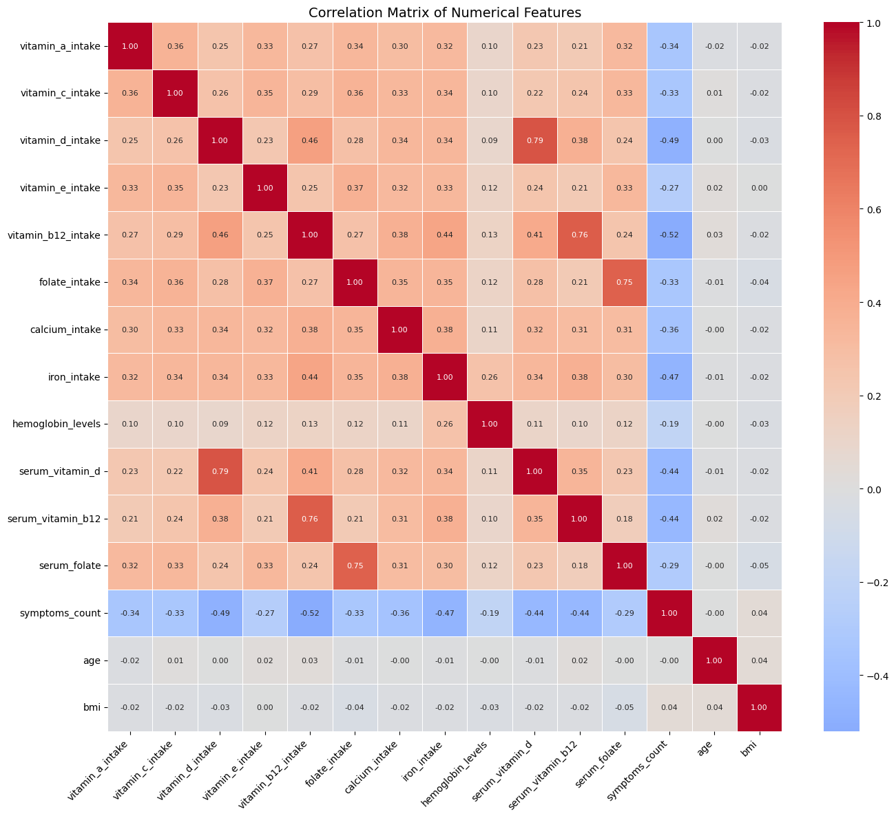
Figure 2: Correlation heatmap of numerical features

The binary symptom columns were highly class specific. Bleeding gums appeared in 54% of Scurvy patients but below 4% in all other classes. Bone pain appeared in 67% of Rickets patients but only 13% of Healthy patients. Peripheral neuropathy and memory problems were both strongly associated with Anaemia. These columns turned out to be among the most discriminative features in the entire dataset as shown in Figure 3.
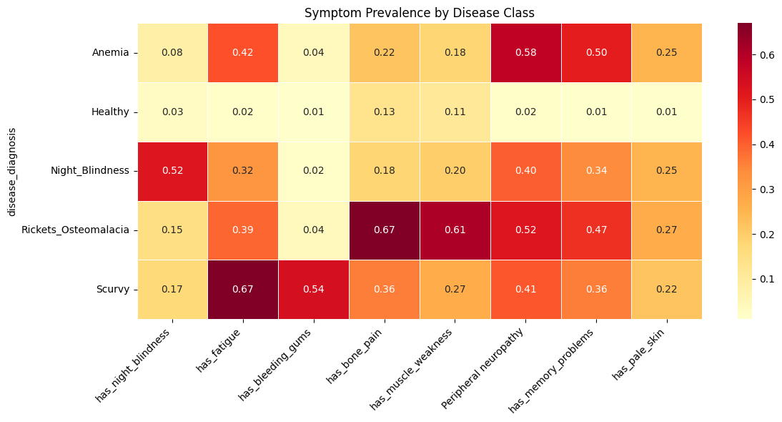
Figure 3: Symptom prevalence heatmap by class

Features with no meaningful signal were identified early. Age and BMI showed near-zero correlation with the target and no class separation in boxplot analysis displayed in Figure 4. Exercise level was investigated specifically, the difference in class distribution between Active and Sedentary patients was under 2% across all five classes, confirming it contributes nothing to prediction. Alcohol consumption was excluded due to 34% missing values combined with a flat class distribution.
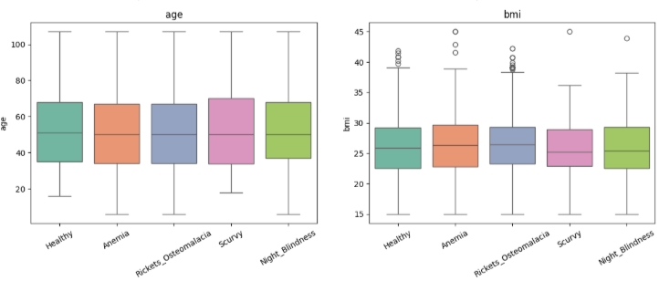
Figure 4: Boxplots for age and BMI by class

Data Preparation

Data Cleaning
The raw dataset required careful cleaning before any modelling could begin. A total of 721 rows were removed from the original 5,800, leaving 5,079 clean records across two categories of issues.
The first was biologically impossible negative values. Nine numerical columns including serum vitamin D, serum vitamin B12, serum folate and several dietary intake columns contained negative entries that cannot exist in a clinical context. A value of negative 40 for vitamin D intake is not a data quirk to be imputed around; it is a data entry error. These 271 rows were dropped entirely rather than imputed, because zero is also not a valid lower bound for these measurements and no meaningful substitution value exists.
The second issue was low quality categorical records. Rows where diet_type was NaN or Unknown were dropped after investigation confirmed they had missing values across multiple other columns simultaneously. These were not single field gaps but wholesale low quality records. The same investigation was applied to sun_exposure_type and income_band, but those columns retained their missing values for post-split imputation, because their missing rows did not show the same pattern of widespread data quality failure. 800 duplicate rows were found and they were dropped as it would introduce bias to the dataset and result in overfitting. Outliers in numerical columns were examined through boxplot analysis but were not removed, as extreme values in clinical data often reflect genuine disease severity rather than recording errors.

Feature Selection
From the original 45 columns, 22 base features were selected. All PII columns were removed as they are personal identifiers that do not aid in model performance and must be excluded to maintain privacy standards. Remaining features were evaluated using five approaches: visual analysis of class separation, correlation analysis, ANOVA F-statistic ranking for numerical features, chi-square testing for categorical features, and business relevance. Figures 5 and 6 show the ANOVA and chi-square rankings respectively, confirming which features carried the strongest signal.
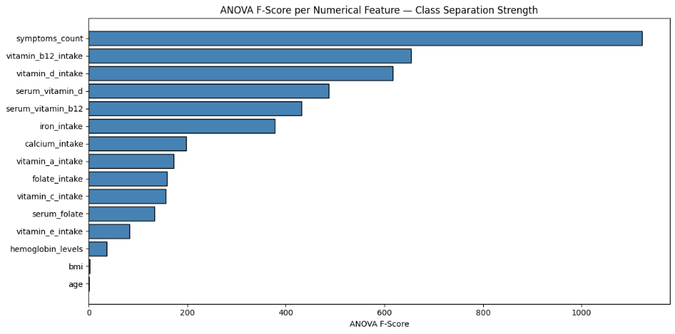
Figure 5: ANOVA F-score bar chart showing numerical feature rankings
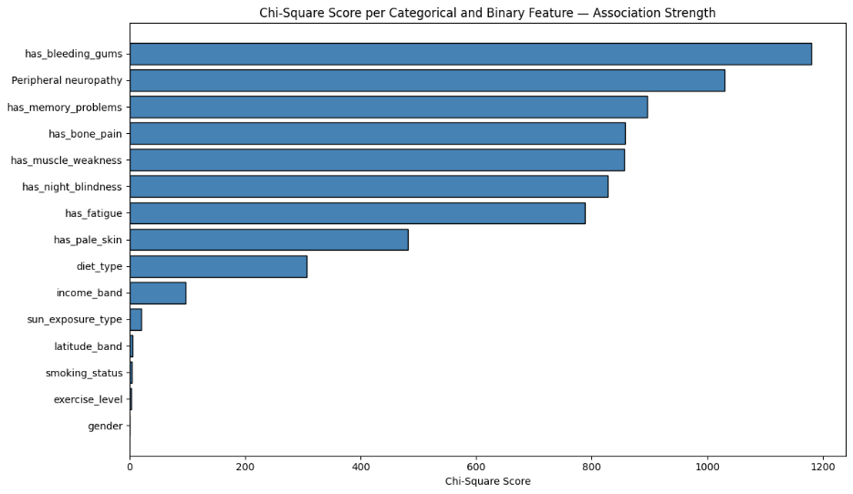
Figure 6: Chi-square score bar chart showing categorical feature rankings
Eleven numerical features were retained across serum biomarker and dietary intake columns. Age, BMI and haemoglobin levels were dropped due to near-zero correlation with the target and no class separation in boxplot analysis. Three categorical features were kept: diet type, sun exposure type and income band, each showing meaningful class separation in crosstab analysis. Exercise level, smoking status, gender, latitude band and alcohol consumption were dropped for showing flat distributions across all five classes. All eight binary symptom columns were retained given their strong class-specific signal.

Feature Engineering
Seven engineered features were created to capture interactions and composite signals that individual columns could not express alone. Rickets symptom score combined bone pain and muscle weakness, averaging 1.30 in Rickets patients versus 0.23 in Healthy. Scurvy symptom score combined bleeding gums and fatigue, averaging 1.28 in Scurvy versus 0.03 in Healthy. Anaemia symptom score combined peripheral neuropathy and memory problems. Diet-sun risk combined dietary pattern and sun exposure into a single interaction feature. Vitamin D calcium product captured the joint deficiency signal between vitamin D intake and calcium intake. Additional disease-specific risk scores were created in individual experiment notebooks as hypotheses evolved across experiments.

Data Splitting, Preprocessing and Imbalance handling
The cleaned dataset was split 70/15/15 into training, validation and test sets. Stratified splitting was used rather than random splitting because the dataset has a 12.1x class imbalance. A random split risks concentrating minority class samples unevenly across sets, producing a validation set that does not reflect the true class distribution and making experiment comparisons unreliable (Pedregosa et al., 2011). Stratification guarantees that Scurvy and Night Blindness cases are proportionally represented in every set. The validation set was used exclusively for comparing experiments. The test set was held back and touched only once at the very end on the best performing model.
Post-split imputation was applied using training set statistics only to prevent data leakage. Sun exposure type was imputed with High, the training set mode, and income band was imputed with Middle as a clinically neutral value. Label encoding and standard scaling were also fitted on the training set and applied to validation and test sets separately. Class imbalance was not addressed through resampling at the preparation stage. SMOTE oversampling was instead tested as part of Experiments 5 and 6 to directly evaluate its effect on minority class performance (Chawla et al., 2002).

Modelling

Algorithm Selection and Rationale
Six experiments were conducted across five algorithm families, each building on the findings of the previous one. Tree-based models were prioritised because existing research consistently shows they outperform linear and kernel methods on tabular clinical data with mixed feature types (Grinsztajn et al., 2022). As shown in Figure 7, the per class F1 comparison across all models clearly illustrates this pattern, tree-based approaches consistently outperform linear and kernel methods across every diagnostic class.
A DummyClassifier baseline always predicting the majority class produced a macro F1 of 0.1073 and zero recall on all disease classes, establishing the lower bound every subsequent model needed to beat.
Experiment 1 hypothesised that a Decision Tree with tuned hyperparameters should classify all five conditions well above the dummy baseline, given that vitamin deficiency diagnosis follows logical if-then rules, low serum vitamin D combined with bone pain points to Rickets, low vitamin A intake combined with night blindness points to Night Blindness. It produced a validation macro F1 of 0.6809, confirming the hypothesis. Vitamin A intake and vitamin C intake emerged as the two most important features, pushing Scurvy F1 from 0.231 to 0.513. Overfitting was evident however, with a clear gap between cross-validation and validation performance.
Experiment 2 postulated that Random Forest would outperform the Decision Tree by reducing overfitting through ensemble averaging across many decorrelated trees (Grinsztajn et al., 2022). Validation macro F1 improved to 0.7329, partially confirming the hypothesis. Two new interaction features; vitamin A night risk and vitamin C Scurvy risk improved Night Blindness F1 from 0.50 to 0.67. Training F1 remained at 1.0 however, indicating overfitting persisted despite the ensemble approach.
The premise of Experiment 3 was that HistGradientBoosting would outperform Random Forest by concentrating learning effort on the hardest to classify samples through sequential error correction. Unlike Random Forest which treats all misclassifications equally, boosting iteratively focuses on where the previous model failed. Regularisation parameters were explicitly tuned to constrain model complexity (Lyashevska et al., 2021). This produced the best validation macro F1 of 0.7647 and the smallest cross-validation to validation gap of 0.046 across all experiments, confirming the hypothesis.
Experiment 4 hypothesised that XGBoost would outperform HistGradientBoosting through more granular class imbalance control via the scale_pos_weight parameter set to 15, allowing more targeted minority class weighting than a global class weight correction (Chen & Guestrin, 2016). It achieved a validation macro F1 of 0.7638, marginally below HistGradientBoosting, partially confirming the hypothesis. Scurvy precision reached 1.00 but recall stayed at 0.40, too conservative for a clinical screening tool where missing a sick patient is far more harmful than a false positive.
In order to increase minority class recall beyond what algorithm-level weighting could do, experiments 5 and 6 addressed the class imbalance from the data side using SMOTE oversampling (Chawla et al., 2002). Both hypotheses were not confirmed. Logistic Regression produced a macro F1 of 0.5770 and SVM produced 0.5990, both substantially below the tree-based approaches and confirming the class boundaries are fundamentally non-linear. SMOTE caused severe cross-validation inflation in both experiments, with the SVM showing a gap of 0.308 between cross-validation and validation F1.

Parameter Tuning and Model Selection
All experiments used GridSearchCV with five-fold stratified cross-validation to identify the best hyperparameters. Stratified folds were used to ensure minority classes appeared in every fold given the 12.1x class imbalance. The search was fitted exclusively on the training set to prevent data leakage into the validation or test sets. Macro F1 was used as the scoring metric throughout tuning, consistent with the primary evaluation metric, ensuring hyperparameter selection prioritised minority class performance rather than overall accuracy. The validation set was then used to compare experiments against each other. The test set was touched only once at the very end on the best performing model. Full hyperparameter search results for all experiments are provided in Appendix A.

Implementation Considerations
All models were implemented using scikit-learn (Pedregosa et al., 2011), with XGBoost using the XGBoost library directly (Chen & Guestrin, 2016). Feature sets evolved across experiments as hypotheses developed, full details are provided in Appendix B. SMOTE in Experiments 5 and 6 was applied only to the training set after splitting. Figure 7 shows the per class F1 comparison across all six models, Figure 8 shows the learning curve for the best model HistGradientBoosting illustrating the persistent training to validation gap, and Figure 9 shows the normalised misclassification heatmap highlighting where the model succeeds and where Scurvy and Night Blindness remain challenging.
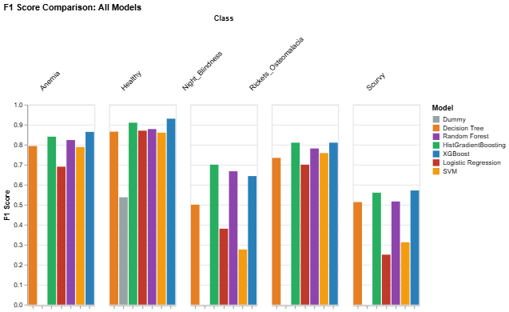
Figure 7: Per class F1 comparison across all experiments
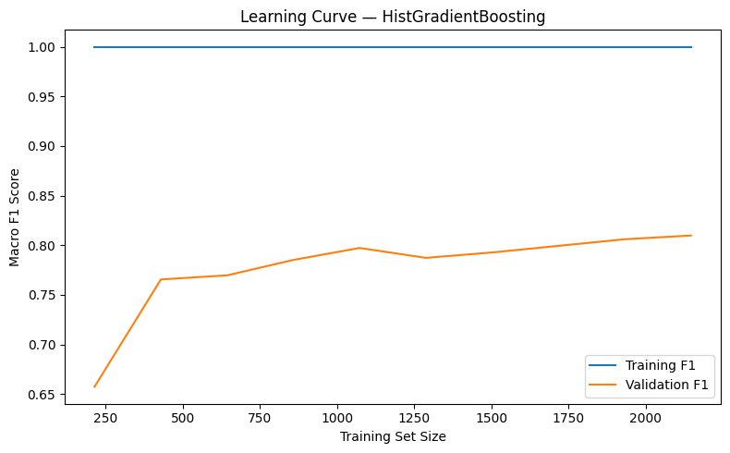
Figure 8: Learning curve from Experiment 3 HistGradientBoosting
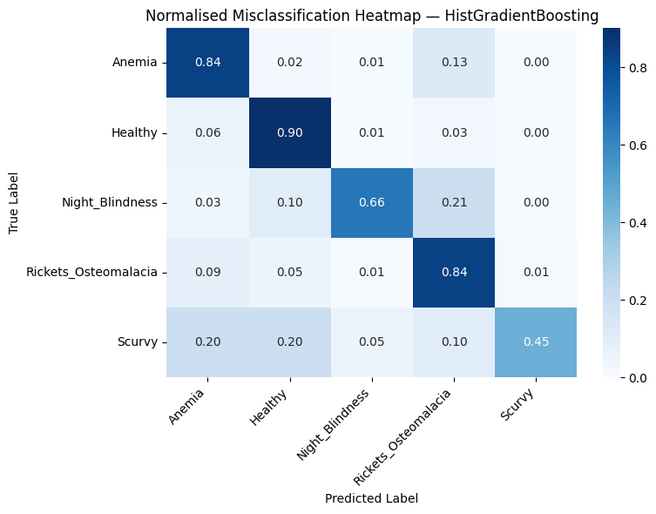
Figure 9: Normalised Misclassification Heatmap from Experiment 3 HistGradientBoosting

Evaluation

Results and Analysis
Across six experiments the results tell a consistent story, tree-based models outperform linear and kernel approaches, and boosting outperforms bagging. Accuracy was not used as the primary metric because the 12.1x class imbalance makes it misleading. A model predicting only Healthy would achieve 36.6% accuracy while failing every disease class completely. Macro F1 was used instead, weighting every class equally regardless of size (Grandini et al., 2020). Full classification reports including per class precision, recall and F1 for all six experiments are provided in appendix C and D respectively.
Key results across all models:
- Dummy Baseline: Macro F1 0.1073, zero recall on all disease classes
- Decision Tree: Macro F1 0.6809, Scurvy F1 improved from 0.231 to 0.513 after adding vitamin A and C intake features
- Random Forest: Macro F1 0.7329, Night Blindness F1 improved to 0.67 with new interaction features
- HistGradientBoosting: Macro F1 0.7647, best validation result, smallest cross-val to validation gap of 0.046
- XGBoost: Macro F1 0.7638, Scurvy precision 1.00 but recall only 0.40, too conservative for clinical use
- Logistic Regression with SMOTE: Macro F1 0.5770, confirmed non-linear problem
- SVM with SMOTE: Macro F1 0.5990, cross-val to validation gap of 0.308, severe SMOTE inflation
The test set evaluation on HistGradientBoosting confirmed generalisation with a test macro F1 of 0.7625 against validation of 0.7647, a gap of just 0.002.
Per class test results:
- Healthy: F1 0.92, recall 0.95
- Anaemia: F1 0.83, recall 0.84
- Rickets: F1 0.82, recall 0.80
- Scurvy: F1 0.72, recall 0.40
- Night Blindness: F1 0.52, recall 0.41
Scurvy and Night Blindness remain the hardest classes due to limited training samples; 95 and 134 respectively after cleaning. Learning and precision-recall curves across all experiments (refer appendix E and F) show performance has not plateaued, meaning more real training data would directly improve minority class recall (Grinsztajn et al., 2022). The results for experiment 3 are displayed below in Figure 10 and 11.
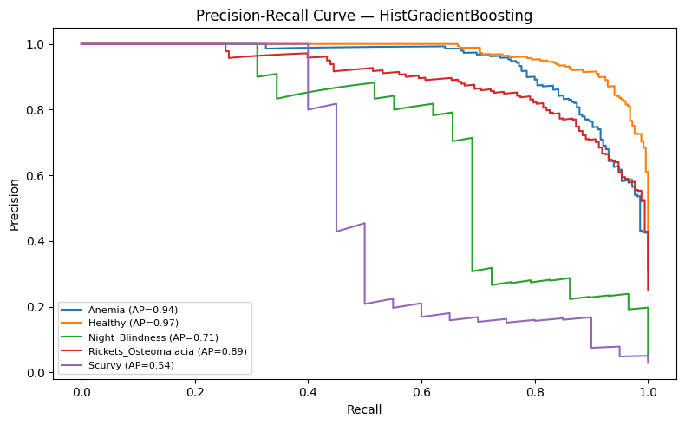
Figure 10: Precision-Recall curve from Experiment 3 HistGradientBoosting
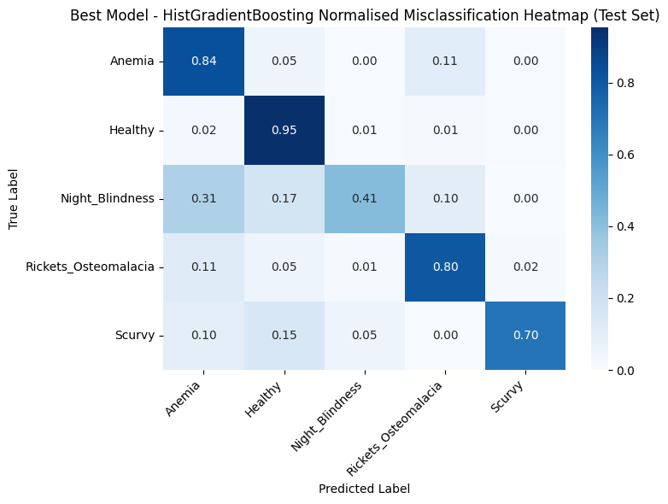
Figure 11: Test set Normalised Misclassification Heatmap from best model HGB

Business Impact and Benefits
HistGradientBoosting is the recommended model for deployment as a first line nutritional deficiency screening tool. Starting from a dummy baseline macro F1 of 0.1073, the final model achieves a test macro F1 of 0.7625, an improvement of 610% without requiring blood tests or specialist referrals. This directly addresses the detection gap between symptom onset and formal clinical diagnosis identified in Section 1.
Key clinical benefits:
- Healthy recall of 0.95 correctly clears 95 in every 100 genuinely healthy patients, avoiding unnecessary follow-up
- Anaemia recall of 0.84 and Rickets recall of 0.80 enable earlier targeted intervention for the two most common disease classes
- The model covers five diagnostic categories simultaneously from a single patient input, reducing the need for multiple specialist referrals
Instead of being a stand-alone diagnostic system, the model should serve as a triage assistance tool. For symptomatic patients, a negative prediction should not preclude additional clinical evaluation, especially in cases of Scurvy and Night Blindness where recall is less than 0.45 (Ramesh et al., 2022; Bhimavarapu et al., 2025).

Data Privacy and Ethical Concerns
Patient health data carries significant privacy obligations given the sensitive nature of dietary, clinical and lifestyle information involved. Steps taken in this project to protect privacy include:
- All personally identifiable information including patient names, identification numbers and addresses was removed before any modelling took place
- Label encoding and scaling were fitted on the training set only, preventing any test or validation data from influencing preprocessing decisions
- No patient level data is stored or output by the model, it receives inputs and returns a prediction only
Any real-world deployment would additionally require informed consent, compliance with health data privacy legislation, and strict access controls (Murdoch, 2021; Price & Cohen, 2019).
Algorithmic bias is a genuine concern. Models trained on non-representative data perform differently across demographic groups, often disadvantaging already underserved communities (Obermeyer et al., 2019; Ntoutsi et al., 2020). This is particularly critical for Indigenous populations. Research has documented health AI systems exhibiting measurable bias against Aboriginal peoples in Australia and Māori populations in New Zealand (Perera et al., 2025). This dataset contains no Indigenous demographic identifier, meaning model performance cannot be validated across Indigenous versus non-Indigenous patient groups, a meaningful gap for any Australian clinical deployment. Before deployment in settings serving Indigenous communities, the model must be validated on representative Indigenous patient data with Indigenous health experts and communities involved throughout that process (Perera et al., 2025; Anand et al., 2025).
Income band and diet type were retained as predictive features, both correlating with socioeconomic status. Ongoing monitoring of model performance across demographic subgroups after deployment is essential to detect and address differential performance before it causes harm (Harishbhai Tilala et al., 2024; Ntoutsi et al., 2020).

Conclusion
This project set out to build a machine learning model capable of classifying five nutritional deficiency conditions - Healthy, Anaemia, Rickets/Osteomalacia, Night Blindness and Scurvy from patient dietary, lifestyle and clinical data, with the primary goal of enabling earlier detection without requiring blood tests or specialist referrals. Six experiments progressing systematically from a Decision Tree baseline through ensemble and boosting methods to linear and kernel approaches were conducted.
The central finding is clear. Tree-based boosting models are the right tool for this problem. HistGradientBoosting emerged as the best model with a test macro F1 of 0.7625, representing a 610% improvement over the dummy baseline and generalising reliably to unseen data with a validation to test gap of just 0.002. The hypothesis that sequential error correction through boosting would outperform parallel ensemble averaging was confirmed. The hypothesis that SMOTE oversampling would improve minority class recall was not confirmed due to inflated cross-validation scores without improving real held-out performance, with the SVM experiment showing a cross-validation to validation gap of 0.308.
Reflecting on the project goals and stakeholder requirements, the model partially meets its objectives. For clinical care teams the model delivers strong screening performance for the three most common conditions, Healthy recall of 0.95, Anaemia recall of 0.84 and Rickets recall of 0.80 which are clinically useful results that could genuinely support earlier triage decisions. For patients with rarer conditions however, the model falls short. Night Blindness recall of 0.41 and Scurvy recall of 0.40 on the test set mean the majority of these cases would still be missed at the screening stage. The project succeeds as a proof of concept and a strong foundation but is not yet ready for standalone clinical deployment for minority classes. The stakeholder requirement of minimising false negatives, the clinically most harmful error has been partially met for majority classes but remains an open challenge for Scurvy and Night Blindness.
Scurvy and Night Blindness performance is not a modelling failure; it is a data limitation. With only 95 Scurvy and 134 Night Blindness training samples, no algorithm can fully learn these boundaries. Learning curves across all experiments show performance has not plateaued, confirming that collecting more real patient data for these two classes is the single most impactful next step available.

For future work three directions are recommended,
- First, expanding the training dataset with more Scurvy and Night Blindness cases would directly address the primary performance bottleneck.
- Second, cost-sensitive learning approaches that explicitly penalise false negatives for disease classes could further improve minority class recall.
- Third, before any clinical deployment the model must be validated on representative Indigenous patient data with Indigenous health experts involved throughout, to ensure the tool does not replicate or worsen existing health inequities (Perera et al., 2025; Harishbhai Tilala et al., 2024).

References
Anand, P., Jin, Y., Liu, J., Lii, J., Belitkar, S., & Lin, K. J. (2025). Minimizing racial algorithmic bias when predicting electronic health record data completeness. Clinical Pharmacology and Therapeutics, 118(5), 1122–1131.
https://doi.org/10.1002/cpt.3758
Bhimavarapu, U., Battineni, G., & Chintalapudi, N. (2025). Machine learning-driven prediction of vitamin D deficiency severity with hybrid optimization. Bioengineering (Basel), 12(2), 200. https://doi.org/10.3390/bioengineering12020200
Chawla, N. V., Bowyer, K. W., Hall, L. O., & Kegelmeyer, W. P. (2002). SMOTE: Synthetic minority over-sampling technique. The Journal of Artificial Intelligence Research, 16, 321–357.
https://doi.org/10.1613/jair.953
Chen, T., & Guestrin, C. (2016). XGBoost: A scalable tree boosting system. Proceedings of the 22nd ACM SIGKDD International Conference on Knowledge Discovery and Data Mining, 785–794.
https://doi.org/10.1145/2939672.2939785
Garcia Carretero, R., Vigil-Medina, L., Barquero-Perez, O., Mora-Jimenez, I., Soguero-Ruiz, C., & Ramos-Lopez, J. (2021). Machine learning approaches to constructing predictive models of vitamin D deficiency in a hypertensive population: A comparative study. Informatics for Health & Social Care, 46(4), 355–369.
https://doi.org/10.1080/17538157.2021.1896524
Gardner, W. M., Larsson, A., & Kassebaum, N. J. (2023). Prevalence, years lived with disability, and trends in anaemia burden by severity and cause, 1990–2021: Findings from the Global Burden of Disease Study 2021. The Lancet Haematology, 10(9), e713.
https://doi.org/10.1016/S2352-3026(23)00160-6
Grandini, M., Bagli, E., & Visani, G. (2020). Metrics for multi-class classification: An overview. https://doi.org/10.48550/arxiv.2008.05756
Grinsztajn, L., Oyallon, E., & Varoquaux, G. (2022). Why do tree-based models still outperform deep learning on typical tabular data? 36th Conference on Neural Information Processing Systems (NeurIPS 2022) Track on Datasets and Benchmarks.
Guo, J., He, Q., & Li, Y. (2024). Machine learning-based prediction of vitamin D deficiency: NHANES 2001–2018. Frontiers in Endocrinology (Lausanne), 15, 1327058.
https://doi.org/10.3389/fendo.2024.1327058
Han, X., Ding, S., Lu, J., & Li, Y. (2022). Global, regional, and national burdens of common micronutrient deficiencies from 1990 to 2019: A secondary trend analysis based on the Global Burden of Disease 2019 study. EClinicalMedicine, 44, Article 101299.
https://doi.org/10.1016/j.eclinm.2022.101299
Harishbhai Tilala, M., Kumar Chenchala, P., Choppadandi, A., Kaur, J., Naguri, S., Saoji, R., & Devaguptapu, B. (2024). Ethical considerations in the use of artificial intelligence and machine learning in health care: A comprehensive review. Curēus (Palo Alto, CA), 16(6), e62443.
https://doi.org/10.7759/cureus.62443
Lyashevska, O., Malone, F., MacCarthy, E., Fiehler, J., Buhk, J.-H., & Morris, L. (2021). Class imbalance in gradient boosting classification algorithms: Application to experimental stroke data. Statistical Methods in Medical Research, 30(3), 916–925.
https://doi.org/10.1177/0962280220980484
Mays, S. (2018). Micronutrient deficiency diseases: Anemia, scurvy, and rickets. The international encyclopedia of biological anthropology, 1–5.
https://doi.org/10.1002/9781118584538.ieba0271
Murdoch, B. (2021). Privacy and artificial intelligence: Challenges for protecting health information in a new era. BMC Medical Ethics, 22(1), Article 122.
https://doi.org/10.1186/s12910-021-00687-3
Ntoutsi, E., Fafalios, P., Gadiraju, U., Iosifidis, V., Nejdl, W., Vidal, M., Ruggieri, S., Turini, F., Papadopoulos, S., Krasanakis, E., Kompatsiaris, I., Kinder-Kurlanda, K., Wagner, C., Karimi, F., Fernandez, M., Alani, H., Berendt, B., Kruegel, T., Heinze, C., … Staab, S. (2020). Bias in data-driven artificial intelligence systems — An introductory survey. Wiley Interdisciplinary Reviews: Data Mining and Knowledge Discovery, 10(3), e1356.
https://doi.org/10.1002/widm.1356
Obermeyer, Z., Powers, B., Vogeli, C., & Mullainathan, S. (2019). Dissecting racial bias in an algorithm used to manage the health of populations. Science, 366(6464), 447–453.
https://doi.org/10.1126/science.aax2342
Parrott, J. M., Parrott, A. J., Rouhi, A. D., Parrott, J. S., & Dumon, K. R. (2023). What we are missing: Using machine learning models to predict vitamin C deficiency in patients with metabolic and bariatric surgery. Obesity Surgery, 33(6), 1710–1719.
https://doi.org/10.1007/s11695-023-06571-w
Pedregosa, F., Varoquaux, G., Gramfort, A., Michel, V., Thirion, B., Grisel, O., Blondel, M., Prettenhofer, P., Weiss, R., Dubourg, V., Vanderplas, J., Passos, A., Cournapeau, D., Brucher, M., Perrot, M., & Duchesnay, E. (2011). Scikit-learn: Machine learning in Python. Journal of Machine Learning Research.
https://doi.org/10.5555/1953048.2078195
Perera, M., Vidanaarachchi, R., Chandrashekeran, S., Kennedy, M., Kennedy, B., & Halgamuge, S. (2025). Indigenous peoples and artificial intelligence: A systematic review and future directions. Big Data & Society, 12(2).
https://doi.org/10.1177/20539517251349170
Price, W. N., & Cohen, I. G. (2019). Privacy in the age of medical big data. Nature Medicine, 25(1), 37–43.
https://doi.org/10.1038/s41591-018-0272-7
Ramesh, J., Sankalpa, D., Khamis, A., Sagahyroon, A., & Aloul, F. (2022). Explainable machine learning for vitamin A deficiency classification in schoolchildren. 2022 IEEE-EMBS International Conference on Biomedical and Health Informatics (BHI), 01–04.
https://doi.org/10.1109/BHI56158.2022.9926924

use regression algorithms such as random forest regressor, SVM regressor and act as if they are are good fit for a classification problem

Appendices

Appendix A - Hyperparameter Search Results
Experiment | Best Parameters | Cross-val Macro F1
Decision Tree | criterion=gini, max_depth=10, min_samples_leaf=1, min_samples_split=2 | 0.7409
Random Forest | n_estimators=200, min_samples_split=2, min_samples_leaf=1, max_features=log2, max_depth=None | 0.8087
HistGradientBoosting | min_samples_leaf=10, max_iter=300, max_depth=5, learning_rate=0.3, l2_regularization=10.0 | 0.8109
XGBoost | n_estimators=200, max_depth=7, learning_rate=0.1, scale_pos_weight=15, lambda=10.0, alpha=0.1, subsample=0.6, colsample_bytree=1.0, min_child_weight=1 | 0.8164
Logistic Regression | solver=lbfgs, penalty=l2, max_iter=100, C=0.1 | 0.7349
SVM | kernel=rbf, gamma=scale, degree=4, class_weight=None, C=100.0 | 0.9070

Appendix B - Feature Sets per Experiment
Experiment | Model | Features (n) | Feature List
Exp 1 | Decision Tree | 16 | serum_vitamin_d, serum_vitamin_b12, serum_folate, rickets_symptom_score, scurvy_symptom_score, anemia_symptom_score, night_blindness_symptom_score, diet_sun_risk, vitamin_d_calcium_product, vegan_b12_risk, vitamin_a_intake, vitamin_c_intake, diet_type, sun_exposure_type, income_band, symptoms_count
Exp 2 | Random Forest | 14 | serum_vitamin_d, serum_vitamin_b12, serum_folate, vitamin_a_intake, vitamin_c_intake, rickets_symptom_score, anemia_symptom_score, diet_sun_risk, vitamin_d_calcium_product, vegan_b12_risk, vitamin_a_night_risk, vitamin_c_scurvy_risk, sun_exposure_type, symptoms_count
Exp 3 | HistGradientBoosting | 16 | vitamin_a_intake, serum_vitamin_d, vitamin_c_intake, symptoms_count, sun_exposure_type, vitamin_d_calcium_product, iron_intake, folate_intake, anemia_symptom_score, rickets_symptom_score, vitamin_a_night_risk, vegan_b12_risk, vitamin_c_scurvy_risk, serum_vitamin_b12, serum_folate, low_vitamin_risk_count
Exp 4 | XGBoost | 16 | vitamin_a_intake, vitamin_c_intake, serum_vitamin_d, sun_exposure_type, vitamin_d_calcium_product, vitamin_a_night_risk, symptoms_count, vitamin_b12_intake, iron_intake, folate_intake, scurvy_risk_index, anemia_symptom_score, rickets_symptom_score, serum_folate, serum_vitamin_b12, vegan_b12_risk
Exp 5 | Logistic Regression | 19 | serum_vitamin_d, serum_vitamin_b12, serum_folate, vitamin_a_intake, vitamin_c_intake, iron_intake, folate_intake, vitamin_b12_intake, rickets_symptom_score, anemia_symptom_score, vitamin_d_calcium_product, vegan_b12_risk, vitamin_a_night_risk, scurvy_risk_index, vitamin_d_ratio, vitamin_a_ratio, scurvy_linear_score, sun_exposure_type, symptoms_count
Exp 6 | SVM | 16 | symptoms_count, serum_vitamin_d, vitamin_c_intake, vitamin_a_intake, sun_exposure_type, vitamin_b12_intake, vitamin_d_calcium_product, scurvy_risk_index, folate_intake, anemia_symptom_score, iron_intake, serum_folate, serum_vitamin_b12, rickets_symptom_score, vegan_b12_risk, vitamin_a_night_risk

Appendix C - Full Classification Reports
Experiment 1 - Decision Tree (Validation)
Class | Precision | Recall | F1 | Support
Anaemia | 0.79 | 0.80 | 0.79 | 215
Healthy | 0.89 | 0.84 | 0.87 | 253
Night Blindness | 0.44 | 0.59 | 0.50 | 29
Rickets Osteomalacia | 0.73 | 0.74 | 0.73 | 173
Scurvy | 0.53 | 0.50 | 0.51 | 20
Macro avg | 0.67 | 0.69 | 0.68 | 690
Accuracy |  |  | 0.78 | 690

Experiment 2 - Random Forest (Validation)
Class | Precision | Recall | F1 | Support
Anaemia | 0.82 | 0.82 | 0.82 | 215
Healthy | 0.86 | 0.89 | 0.88 | 253
Night Blindness | 0.84 | 0.55 | 0.67 | 29
Rickets Osteomalacia | 0.76 | 0.80 | 0.78 | 173
Scurvy | 0.73 | 0.40 | 0.52 | 20
Macro avg | 0.80 | 0.69 | 0.73 | 690
Accuracy |  |  | 0.82 | 690

Experiment 3 - HistGradientBoosting (Validation)
Class | Precision | Recall | F1 | Support
Anaemia | 0.84 | 0.84 | 0.84 | 215
Healthy | 0.92 | 0.90 | 0.91 | 253
Night Blindness | 0.76 | 0.66 | 0.70 | 29
Rickets Osteomalacia | 0.78 | 0.84 | 0.81 | 173
Scurvy | 0.75 | 0.45 | 0.56 | 20
Macro avg | 0.81 | 0.74 | 0.76 | 690
Accuracy |  |  | 0.84 | 690

Experiment 4 - XGBoost (Validation)
Class | Precision | Recall | F1 | Support
Anaemia | 0.86 | 0.87 | 0.86 | 215
Healthy | 0.92 | 0.94 | 0.93 | 253
Night Blindness | 0.71 | 0.59 | 0.64 | 29
Rickets Osteomalacia | 0.80 | 0.83 | 0.81 | 173
Scurvy | 1.00 | 0.40 | 0.57 | 20
Macro avg | 0.86 | 0.73 | 0.76 | 690
Accuracy |  |  | 0.86 | 690

Experiment 5 - Logistic Regression with SMOTE (Validation)
Class | Precision | Recall | F1 | Support
Anaemia | 0.81 | 0.60 | 0.69 | 215
Healthy | 0.86 | 0.87 | 0.87 | 253
Night Blindness | 0.33 | 0.45 | 0.38 | 29
Rickets Osteomalacia | 0.67 | 0.73 | 0.70 | 173
Scurvy | 0.19 | 0.40 | 0.25 | 20
Macro avg | 0.57 | 0.61 | 0.58 | 690
Accuracy |  |  | 0.72 | 690

Experiment 6 - SVM with SMOTE (Validation)
Class | Precision | Recall | F1 | Support
Anaemia | 0.77 | 0.80 | 0.79 | 215
Healthy | 0.84 | 0.88 | 0.86 | 253
Night Blindness | 0.28 | 0.28 | 0.28 | 29
Rickets Osteomalacia | 0.78 | 0.73 | 0.76 | 173
Scurvy | 0.42 | 0.25 | 0.31 | 20
Macro avg | 0.62 | 0.59 | 0.60 | 690
Accuracy |  |  | 0.78 | 690

Best Model - HistGradientBoosting (Test Set)
Class | Precision | Recall | F1 | Support
Anaemia | 0.83 | 0.84 | 0.83 | 215
Healthy | 0.90 | 0.95 | 0.92 | 253
Night Blindness | 0.71 | 0.41 | 0.52 | 29
Rickets Osteomalacia | 0.83 | 0.80 | 0.82 | 174
Scurvy | 0.74 | 0.70 | 0.72 | 20
Macro avg | 0.80 | 0.74 | 0.76 | 691
Accuracy |  |  | 0.85 | 691

Appendix D - Normalised Misclassification Heatmaps (All Experiments)
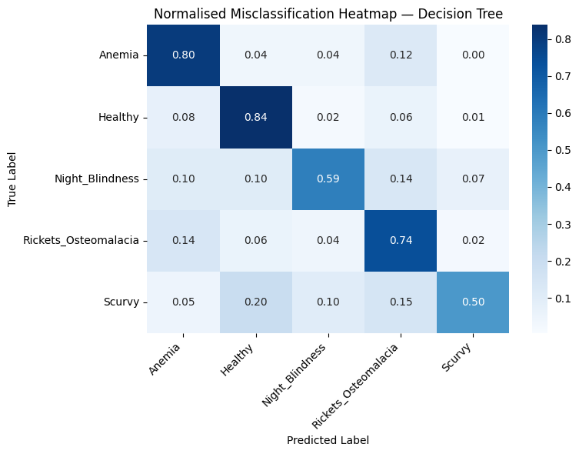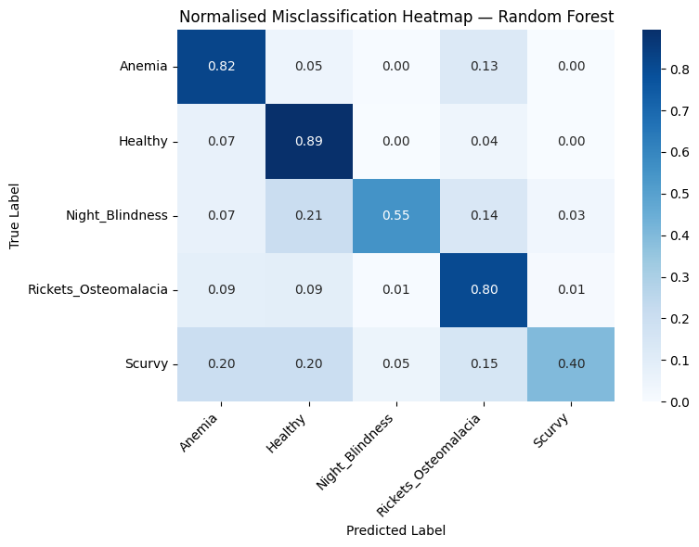
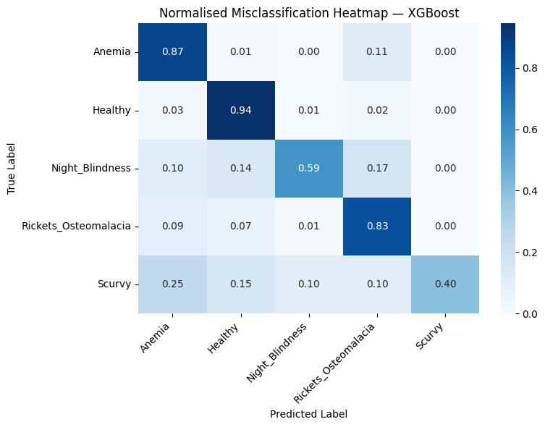
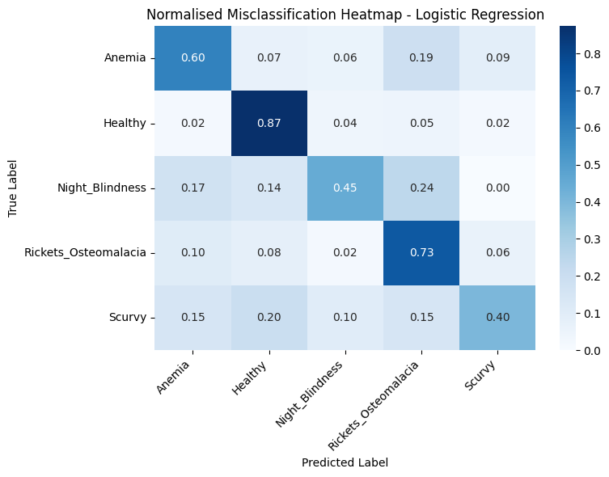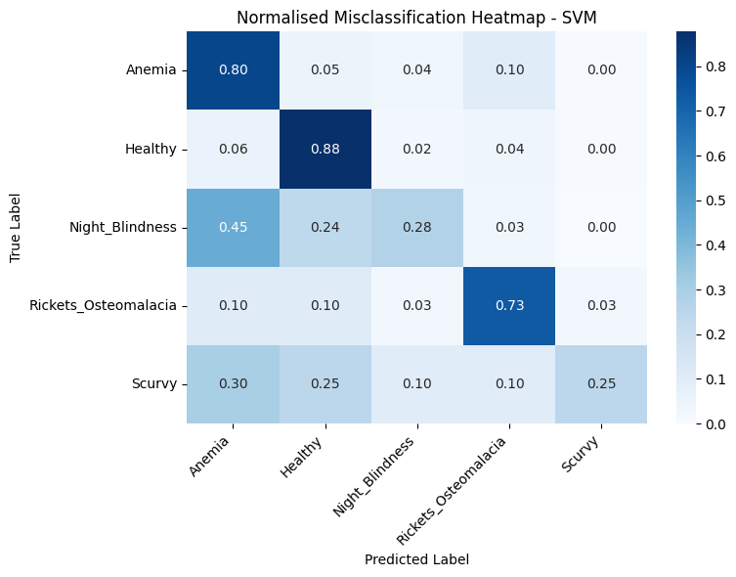

Appendix E - Learning Curves (All Experiments)
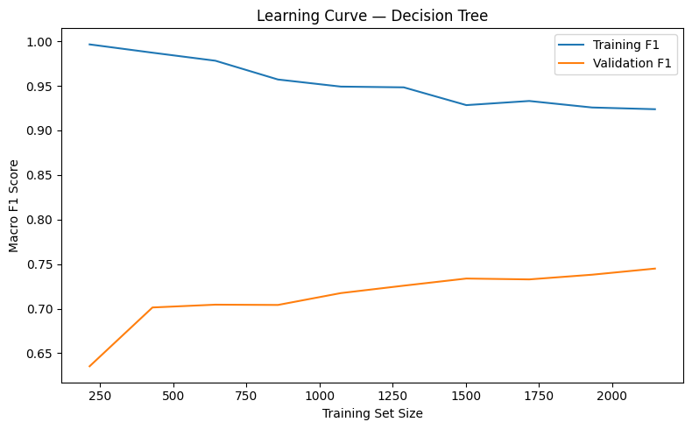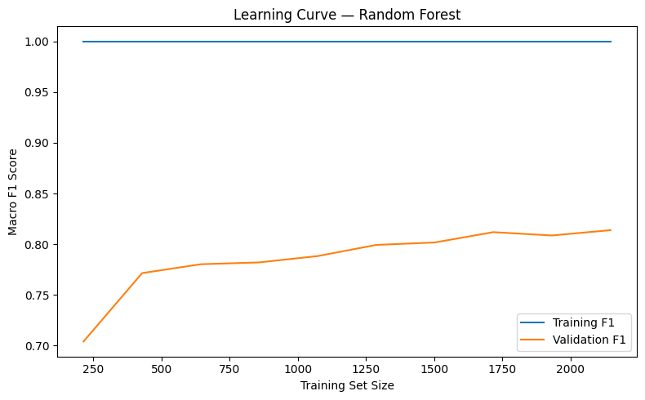
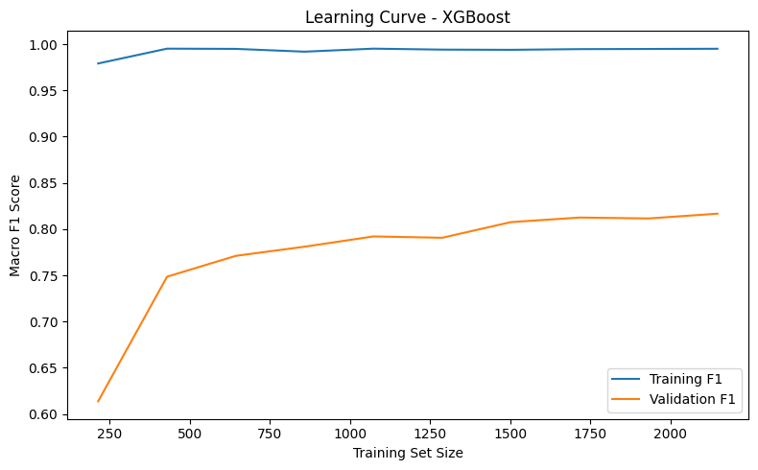
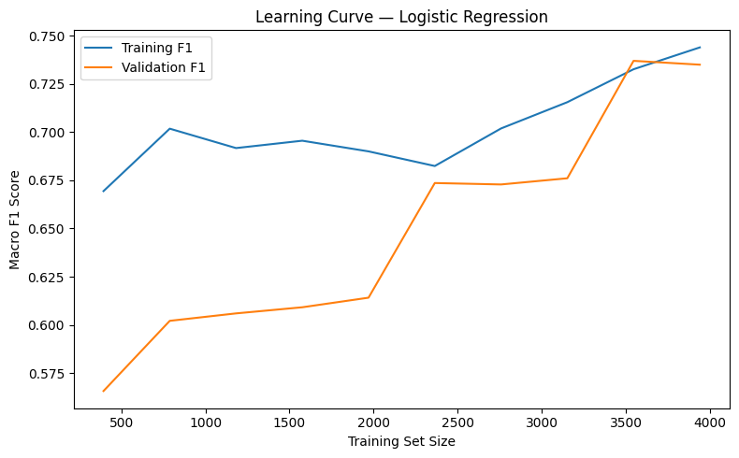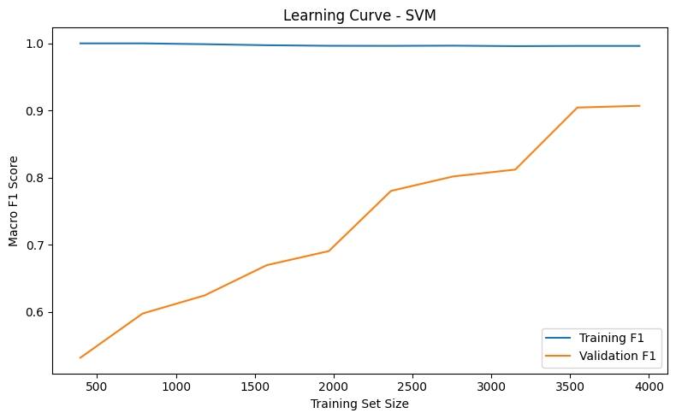

Appendix F - Precision-Recall Curves (All Experiments)
