Lab 7: Fuzz Testing Report
L6_L7_62 - Attendance Eligibility Parser
Replace each screenshot placeholder with your terminal screenshot before exporting this document to PDF.
Student name | Sushruth Sukesh
SRN | PES1UG24CS486
Course / section | CSE/ Section H
Date | 07-11-2026

SS1 - Buggy application output
Run the original buggy module before fixing it.
Command: python attendance_eligibility_parser.py
Paste the terminal screenshot below.
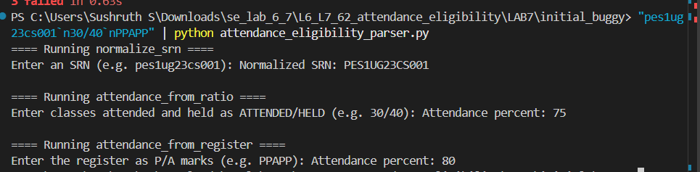

SS2 - Hypothesis tests failing on buggy module
Run the completed tests against the original buggy module.
Command: python -m pytest test_processor.py
Paste the failing-test screenshot below.
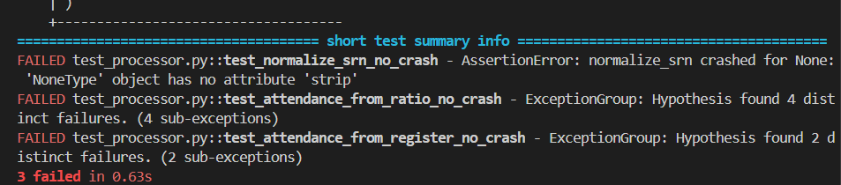

SS3 - Fixed application output
Run the hardened module with valid sample inputs.
Command: python attendance_eligibility_parser.py
Paste the terminal screenshot below.
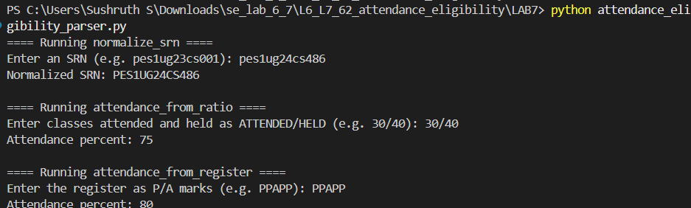

SS4 - Hypothesis tests passing on fixed module
Run the completed tests against the fixed module.
Command: python -m pytest test_processor.py
Paste the passing-test screenshot below.
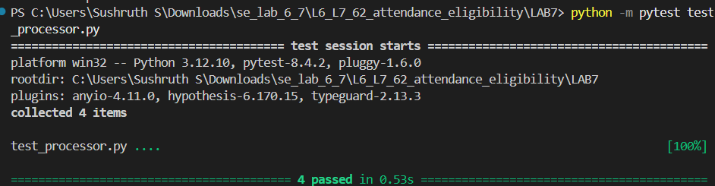

Reflection Questions
1. What input-validation bugs did Hypothesis help identify?
Answer: Hypothesis identified that the functions crashed when they received None, integers, empty strings, malformed attendance ratios, zero denominators, negative values, and invalid register characters. It also exposed division-by-zero and invalid type-conversion errors.
2. How were the three functions hardened against malformed or unexpected input?
Answer: normalize_srn now checks that the input is a string and returns an empty string for invalid input. attendance_from_ratio validates the format, numeric values, denominator, and attendance range before calculating the percentage. attendance_from_register validates that the input is a non-empty string containing only P and A, returning 0 for invalid input.
3. Why is fuzz testing useful in addition to manually written test cases?
Answer: Manual tests cover expected examples, but they may miss unusual inputs. Fuzz testing automatically generates many unexpected and malformed values, finds edge cases, and helps verify that the application does not crash. It improves robustness and input validation.

Commands Used
cd LAB7
python attendance_eligibility_parser.py
python -m pytest test_processor.py

