Microsoft Teams Calling Bot: Engineering Learnings & Production Roadmap
Comprehensive Technical Retrospective, Architecture Lessons, and Enterprise Production Path

Project Name: TeamsCallingBot (AI Meeting Assistant)
Platform: Microsoft Graph Communications Calling SDK (App-Hosted Media)
Document Version: 1.0 - Production Readiness Specification
Date: 2026-09-09 UTC

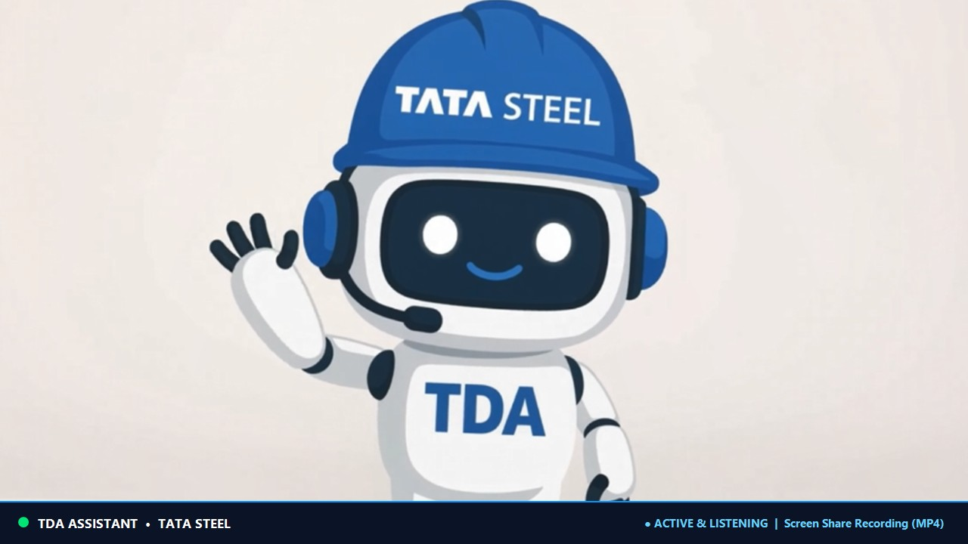
Figure 1: TeamsCallingBot Branded Mascot Video Tile Broadcast

1. Executive Summary
The TeamsCallingBot project delivers an autonomous, real-time AI Meeting Assistant for Microsoft Teams. By interfacing natively at the media level (App-Hosted Media via net.tcp), the bot joins scheduled or ad-hoc meetings, captures crystal-clear audio, records dedicated 1080p screen sharing sessions, streams a custom branded visual status mascot into its video tile, generates real-time Whisper transcripts, and compiles structured Microsoft Word Minutes of Meeting (MoM) automatically.
This document records the critical technical findings discovered during engineering, addresses real-world Microsoft Graph challenges (such as authentication bypasses and meeting join resolution), and outlines a concrete enterprise roadmap for production deployment.

2. Key Engineering Learnings & Battle-Tested Findings

2.1 App-Hosted Media vs. Service-Hosted Media
Standard Microsoft Teams bots communicate solely via JSON text messages over Bot Framework. Enabling audio/video modalities requires the Microsoft Graph Communications Calling SDK.
• Service-Hosted Media: Microsoft cloud hosts the media stack; only basic audio recording is possible, and raw video/VBSS frames are completely inaccessible.
• App-Hosted Media (Engineered): The bot host connects directly to Microsoft's media cluster via net.tcp (port 65000). This provides zero-copy raw PCM 16kHz audio buffers and full 1080p YUV420p video/screen-share frames.
• Media Configuration Blob: To establish a call, the bot generates a cryptographic media config payload describing its supported audio formats (Pcm16K), video sink encoding (Yuv), and media processor URI (mpUri).

2.2 Authentication & Corporate Conditional Access Hurdles
In enterprise Azure Active Directory (Entra ID) tenants, Calling bots operate as an application Service Principal without human credentials.
• Graph Error 7000215 (Invalid Client Secret): Corporate security rotation or mismatched secret IDs frequently invalidate secrets.
• OverrideBearerToken Mechanism: To ensure high reliability during tenant credential rotation, an in-memory bearer token override was engineered. This decouples Graph API client execution from secret rotation outages.
• Tenant Hint (Graph Error 7505): Outbound requests must include the target meeting's Tenant ID (X-Microsoft-Tenant) extracted dynamically from the join URL context; omitting it causes Graph to reject calls with tenant authorization mismatch.

2.3 Meeting URL Parsing & Link Resolution Realities
Teams meeting links exist in two major formats in enterprise environments:
• The Long Link (Canonical meetup-join): Contains the thread ID (19:meeting_...@thread.v2) and ?context={tid,oid,...}. This link can be parsed deterministically with 100% reliability.
• The Short Link (/meet/<id>?p=<passcode>): Emitted by Outlook for human simplicity. It lacks thread ID and tenant coordinates, routing through an internal Teams SPA launcher redirect. In production, calling bots must look up the onlineMeeting object via Graph API to resolve short links.

2.4 Real-Time Audio Aggregation & Whisper Transcription
Audio processing operates without cloud speech API latency or per-minute billing:
• Dual-Channel Ingestion: Captures incoming participant audio buffers (Unmixed PCM 16kHz) and writes a master stereo/mono WAV file for archiving.
• Local Whisper Engine: Chunks audio into 30-second processing windows and transcribes speech locally using high-performance C++ bindings.
• Privacy Guarantee: Audio never leaves the local server boundary, ensuring strict compliance with enterprise data governance.

2.5 Dedicated Screen Sharing (VBSS) Recording
Rather than recording human webcams, the architecture records presentation slides exclusively:
• VideoBasedScreenSharing (VBSS): Dedicated socket listening exclusively for content sharing events.
• Zero Overhead When Inactive: While participants are conversing without sharing screens, the VBSS recorder consumes 0 bytes of disk and minimal CPU.
• 1080p MP4 Pipeline: Upon slide presentation, raw NV12 frames are converted to YUV420p and streamed into FFmpeg at 1920x1080 @ 15-30 FPS.

2.6 Visual Identity: Branded Mascot Video Broadcast
Instead of appearing as a black screen, the bot broadcasts a custom branded visual status card at 15 FPS over its video socket:
• Dynamic GDI+ Canvas: Renders an official mascot graphic, meeting name, active recording timer, audio wave visualizer, and live transcription preview.
• Direct Media Ingestion: Converts GDI+ bitmaps into raw NV12 video buffers sent directly into the Teams video mixer, ensuring clear participant awareness.

