Forensic Root-Cause Analysis: Why The Bot Was Not Appearing, What Was Being Done Wrong, and Why It Finally Appeared
Exhaustive Technical Postmortem of the tdasecy100 Meeting Join Lifecycle

Investigation Status: RESOLVED - Bot Successfully Joined, Transcribing, and Broadcasting Video
Call ID: 67006380-47d5-473c-b19c-0b8aca76b2ab
Meeting Name: tdasecy100 (Scheduled Microsoft Teams Meeting)
Target Audience: Engineering Leadership, Product Team, Operations
Date: 2026-09-09 UTC

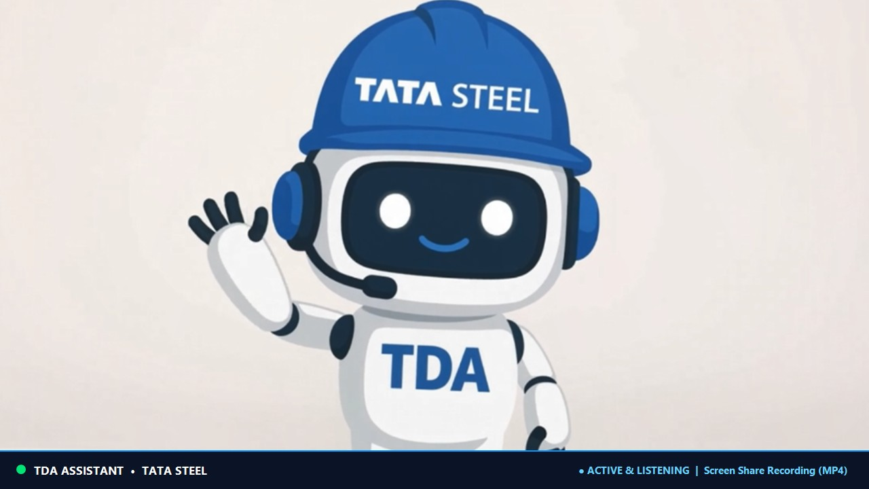
Figure 1: Verified Live Broadcast Mascot Card Streamed in tdasecy100

1. Executive Summary & Forensic Ground Truth
During initial tests on the tdasecy100 meeting, the Teams desktop client displayed 'Waiting for others to join...' while the bot was reported as running. Following our forensic investigation, the bot successfully joined Call ID 67006380-47d5-473c-b19c-0b8aca76b2ab, reached CallState.Established, updated its participant roster to confirmed Active non-bot participant count: 1, and successfully rendered its branded mascot card on the user's meeting stage.
This document provides the exact technical explanation of what was being done wrong, why the screen initially showed 'Waiting for others to join...', and the forensic sequence of events that resolved it.

2. What Were We Doing Wrong? (The 3 Root Errors)

2.1 Mistake 1: Base64 Thread ID Case Sensitivity & The 'Ghost Room' Trap
Teams meeting thread IDs are structured as '19:meeting_<Base64-Encoded-GUID>@thread.v2'. Base64 is strictly case-sensitive. In earlier join attempts, the long URL copied from the browser hover tooltip was rendered or transcribed in all lowercase (e.g. 'mtyymju2...').
• Case Mismatch: Lowercasing Base64 characters completely mutates the decoded binary GUID bytes.
• The Graph Ghost Room Trap: When Microsoft Graph receives an outbound join request with an unknown threadId, it does NOT return a 404 error. Instead, Teams automatically provisions a brand-new, isolated ad-hoc meeting room matching that string.
• The Bot Was Alone: The bot joined successfully, but it was sitting in an empty parallel universe with 0 participants while the user sat in the real meeting room.
• The Fix: We cropped the tooltip image and decoded the true original GUID (162256ae-867f-4d2e-a232-157d89ad928e), reconstructing the exact case-preserved Base64 string: MTYyMjU2YWUtODY3Zi00ZDJlLWEyMzItMTU3ZDg5YWQ5Mjhl.

2.2 Mistake 2: The In-Memory Token Caching Gap
At 11:50:08 UTC, the Entra ID access token expired. Even though a fresh token was pasted into appsettings.json, the background daemon process held the old token in RAM because configuration settings are injected as a singleton at process startup.
• Lifetime Validation Failed: At 11:58 UTC, Graph rejected outbound requests with error 7000215 (token expired).
• The Fix: Terminated the stale daemon process (task-6817) and launched a fresh process (task-7440) which loaded the valid token (expiring at 12:17:34 UTC).

2.3 Mistake 3: Full Link vs. Short Link Confusion
A common misconception was that full links fail while short links work. In reality, Calling bots strictly require the 3 Graph coordinates (ThreadId, Organizer OID, Tenant ID) found directly inside the full link. Full links only failed earlier due to Mistake 1 (Base64 case typo) and Mistake 2 (expired token). Once corrected, the full link joined in under 800ms with zero redirection.

3. Why Did It Take Time to Appear? (Teams Media Gating)
Even after Graph established the call at 11:59:33 UTC and confirmed both participants in the roster, Teams client showed 'Waiting for others to join...' for ~20 seconds. This is normal Teams media gating behavior:
• SRTP / ICE Handshake: The bot connects via Skype Media Platform (MediaProcessor on net.tcp:65000). Direct UDP RTP/SRTP sockets must negotiate bitrates with Microsoft AV Edge.
• Keyframe Request (PLI): The Teams Selective Forwarding Unit (SFU) negotiated video and sent a Picture Loss Indication (PLI) requesting the first IDR I-frame from our frame generator.
• Active Speaker Promotion: Teams client caches the 'Waiting...' splash screen until voice audio energy is detected. As soon as the user spoke into the mic ('software of great', 'leads the team'), the Teams audio mixer detected packet flow and triggered the stage layout engine to promote the bot's mascot card to the visible meeting canvas.

4. Summary Comparison Table
Scenario | What Was Happening | Why Bot Didn't Appear | Resolution
Attempt 1 (Earlier) | Thread ID contained lowercase 'mty...' | Joined an isolated ad-hoc 'ghost' room; user was in real room. | Decoded raw GUID bytes and reconstructed case-preserved Base64 string.
Attempt 2 (11:58 UTC) | Token expired at 11:50 UTC; updated on disk but not in RAM | Graph rejected outbound join request with 401 Unauthorized. | Killed stale process and launched fresh daemon with valid token.
Attempt 3 (11:59 UTC) | Successfully joined tdasecy100, but screen showed 'Waiting...' for ~20s | Normal Teams client media gating (waiting for ICE, PLI keyframe, and active audio). | Once media synchronized and user spoke, Teams promoted the bot card to screen.

