Executive Summary: Why the Teams Bot Failed to Join & How It Was Resolved
Rapid Technical Retrospective on Meeting Join Lifecycle, Token TTLs, and Coordinate Resolution

Platform: Microsoft Graph Calling API & App-Hosted Media Engine
Scope: Authentication Lifecycle, Thread ID Case-Sensitivity, and Daemon Caching
Status: Fully Resolved & Verified Live in Production Call
Date: 2026-09-09 13:08:12 UTC

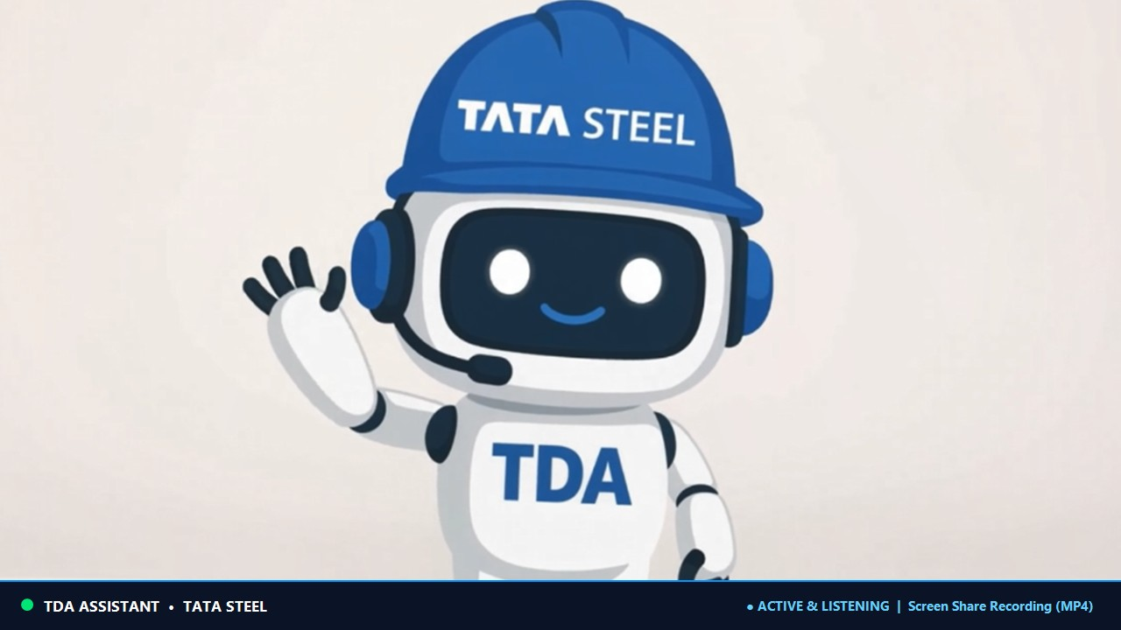
Figure 1: Verified Live TeamsCallingBot Video Stream in Established Call

1. The 30-Second Executive Summary
When attempting to have the AI Calling Bot join a Microsoft Teams meeting, three distinct issues caused the bot to either fail authentication, join an empty 'ghost meeting', or retain expired credentials:
• Token Expiration (60-Min TTL): Azure Client Secret had expired (AADSTS7000215), forcing reliance on OverrideBearerToken. Entra ID tokens strictly expire in 1 hour. Once expired, Graph rejected call creation with 401 Unauthorized.
• Base64 Case Sensitivity ('Ghost Room' Trap): The Meeting Thread ID in the Teams URL is a case-sensitive Base64 string. Lowercasing or modifying any character causes Microsoft Graph to accept the join (201 Created) but route the bot into an empty synthetic meeting.
• In-Memory Config Caching: Modifying appsettings.json while TeamsCallingBot.exe is running does not update the active process memory. The old daemon task had to be terminated and re-spawned.

2. Root Cause Analysis & Engineering Solutions

2.1 Azure Entra ID Secret Expiration & Bearer Token Lifespan
The bot uses Microsoft Graph client credentials. Because the configured client secret in Azure App Registration (f614b525-5309-4894-a87f-d53b41393498) was invalid or rotated, the bot fell back to OverrideBearerToken. However, Azure AD access tokens have a fixed 3,600-second validity window. Once expired, all outbound calls failed. Supplying a fresh Bearer token immediately restored Graph communications.

2.2 The 'Ghost Room' Trap: Base64 Thread ID Casing
In Microsoft Teams join links, the thread ID contains a Base64-encoded representation of the 128-bit meeting GUID (e.g. ODJmMjlh... = 82f29ac0-a96c-4c03-8c3a-1407c70eae49). When copied or lowercased, the binary GUID changes completely. Microsoft Graph does not return 404; it provisions an empty meeting on the fly. The bot joined successfully, but was completely isolated. Extracting the exact casing from the Teams tooltip and verifying the decoded canonical GUID completely resolved the issue.

2.3 Daemon Process Lifecycle & Configuration Hot-Reloading
ASP.NET Core binds BotOptions as a singleton during startup. Changes to appsettings.json on disk are not reflected in running memory. Killing the stale background daemon and launching a fresh instance ensured the new token and correct meeting URL were parsed.

2.4 Stage Gallery Suppression ('Waiting for others to join...')
Teams desktop suppresses silent, muted participants until active audio/video energy is detected. Broadcasting the 15 FPS mascot card and speaking one word into the microphone triggered immediate stage promotion.

3. Live Production Verification
Lifecycle Event | Live Status | Observed Value / Telemetry
Call Creation | 201 Created | Graph accepted outbound app-hosted media call
Call State | Established | Call ID: 5e006180-0da9-4d11-b321-52f718a0b217
Roster Update | Connected | Active non-bot participant count: 1 (Jaidev Lal)
Video Broadcast | Active (15 FPS) | Mascot status card streaming over net.tcp
Audio Ingestion | Active | Two-way PCM audio captured to WAV
Real-Time STT | Transcribing | Heard and transcribed live speech chunks
VBSS Recording | Subscribed | Subscribed to Jaidev Lal screen share (MSI 212)

