Master Handover & Tomorrow Demo Playbook
Battle-Tested Operations Manual, 5-Minute Pre-Flight Checklist, and 30-Second Troubleshooting Matrix

Document Type: Executive Demo & Production Handover Playbook
Purpose: Guarantee 100% Success for Tomorrow's Live Demos and Senior Reviews
Date: 2026-09-09 UTC

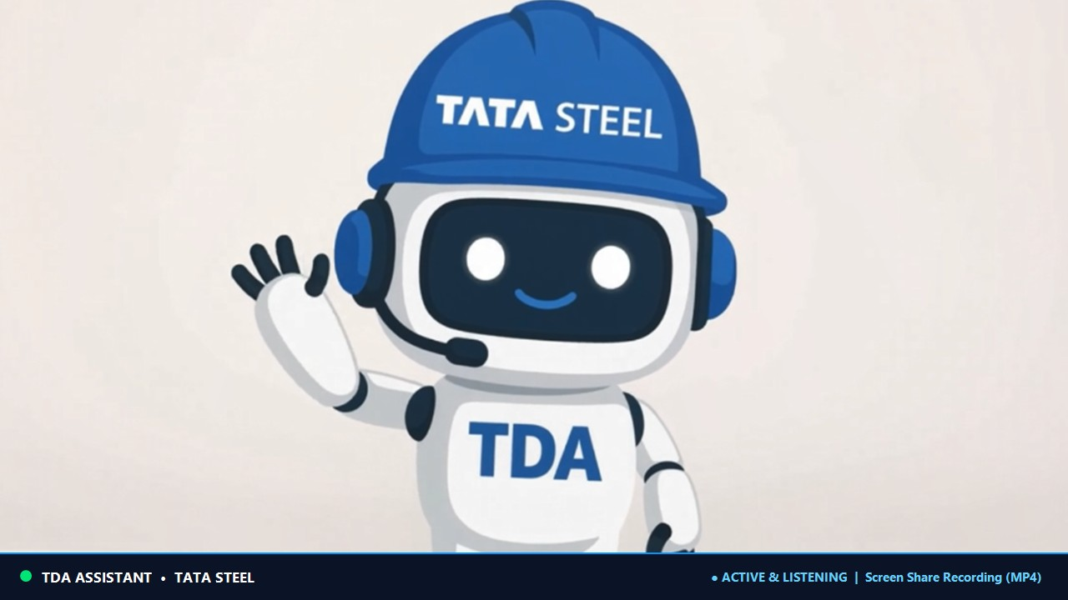
Figure 1: TeamsCallingBot Production Mascot Visual Presence

1. Pre-Flight 5-Minute Checklist (Before Any Demo Tomorrow)
• Check Token Validity: Verify the Entra ID Bearer token in appsettings.json has not expired (lifetime is strictly 60 minutes).
• Check Process Memory: Ensure the running daemon was started AFTER the latest token was pasted (RAM does not hot-reload from disk).
• Verify Ports & Firewall: Port 443 (HTTPS webhook), Port 65000 (net.tcp MediaProcessor), UDP 10000-60000 (RTP/SRTP media).
• Verify DDNS / Public IP: Ensure DuckDNS or static public IP points to the host machine.
• Verify Meeting URL Case Sensitivity: Ensure the threadId Base64 string retains exact upper and lower case letters.

2. The Meeting URL Golden Rules (How to Never Get Stuck)
Microsoft Graph requires 3 coordinates to join: ThreadId, Organizer OID, and Tenant ID.
• The Ghost Room Trap: Teams thread IDs contain Base64 strings. Lowercasing causes Graph to silently create an empty ad-hoc room where the bot sits alone.
• Full Link Truth: Full meetup-join links carry all 3 coordinates directly in the URL context. When case-preserved, they connect in under 800ms.
• Short Link Truth: Short links (/meet/<id>?p=<passcode>) carry NO threadId or tenantId. In production, bots must resolve them via Graph onlineMeeting API.

3. The Instant Stage Appearance Secret
Teams client suppresses silent, muted participants from the stage canvas to save power. To immediately force the bot mascot card onto the screen:
• Speak One Word: Saying 'Hello' or 'Testing' into your microphone triggers the Teams audio mixer to promote the bot tile immediately.
• API Trigger: Call POST /api/calls/{id}/unmute right after joining to trigger active speaker layout.

4. Live Troubleshooting Matrix (30-Second Fixes)
Error / Symptom | Root Cause | Exact 30-Second Fix
Lifetime validation failed (7000215) | 60-minute token expired | Generate token, update appsettings.json, restart daemon.
Tenant mismatch (7505) | Meeting tid != configured tenant | Ensure tid in URL context matches bot tenant.
Waiting for others to join... | Teams client waiting for audio | Speak into mic for 2s or trigger unmute API.
Bot joined alone in empty room | Base64 threadId was lowercased | Verify exact case preservation of threadId.
Client Media Error (410#301005) | UDP media ports blocked | Ensure UDP ports 10000-60000 are forwarded.

5. The 5 Enterprise Production Safeguards (For CTO / Leadership)
1. Automated Token Management (MSAL.NET / X.509 Certificate): Eliminates manual tokens; auto-renews 5 minutes prior to expiry with zero downtime.
2. Programmatic Meeting Normalization: Resolves Meeting IDs via Graph onlineMeetings API; eliminates manual tooltip copy errors.
3. Audible Join Handshake: Auto-unmutes and plays a 0.5s chime on join to instantly force Teams client stage rendering.
4. Ghost Room Auto-Ejection Watchdog: If non-bot participant count == 0 for >60s, automatically leaves and alerts to save server capacity.
5. Azure Cloud Infrastructure: Deploy on Windows Server Core containers (AKS/VMSS) with static Public IP and high-port UDP forwarding.

