**Created two EC2 instances:**

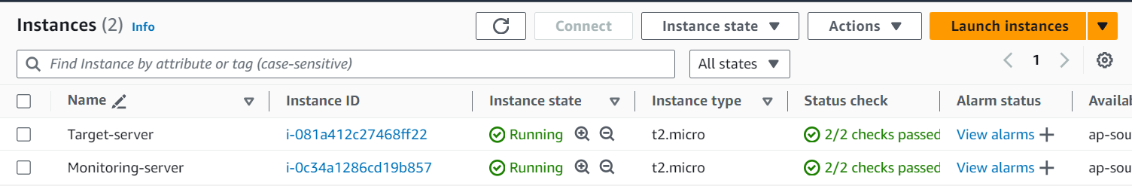

**Install Prometheus, Grafana and Node exporter in Monitoring EC2 machin:**

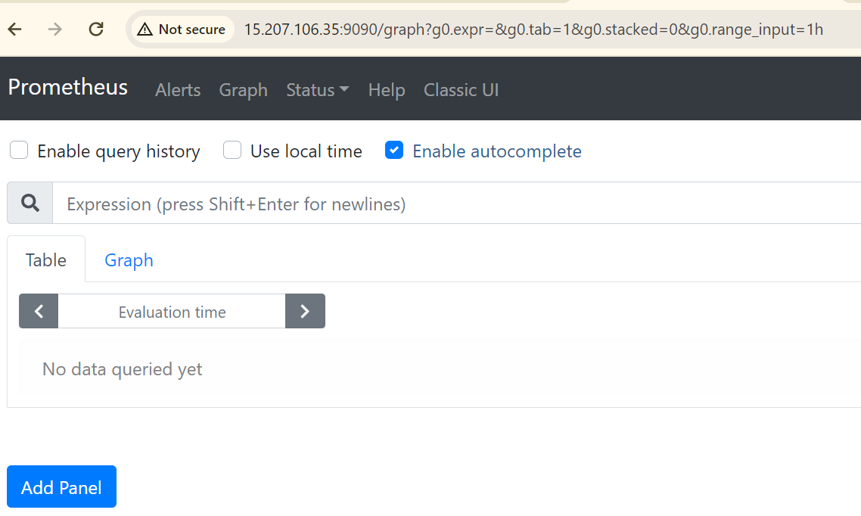

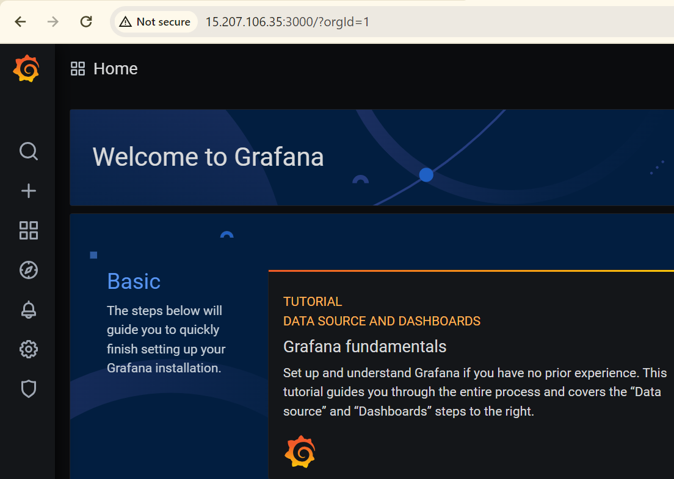

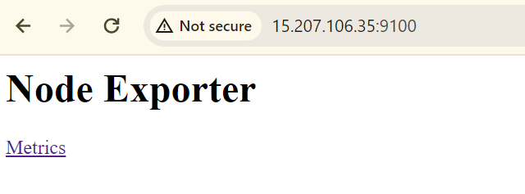

**Install Node exporter in Target EC2 machine:**

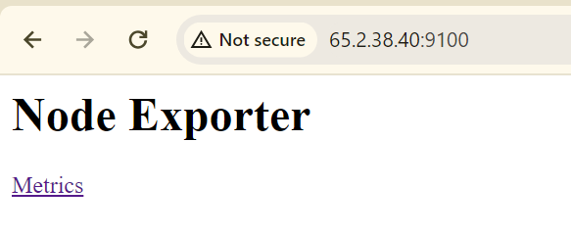

**Configure Node exporter in prometheus config file:**

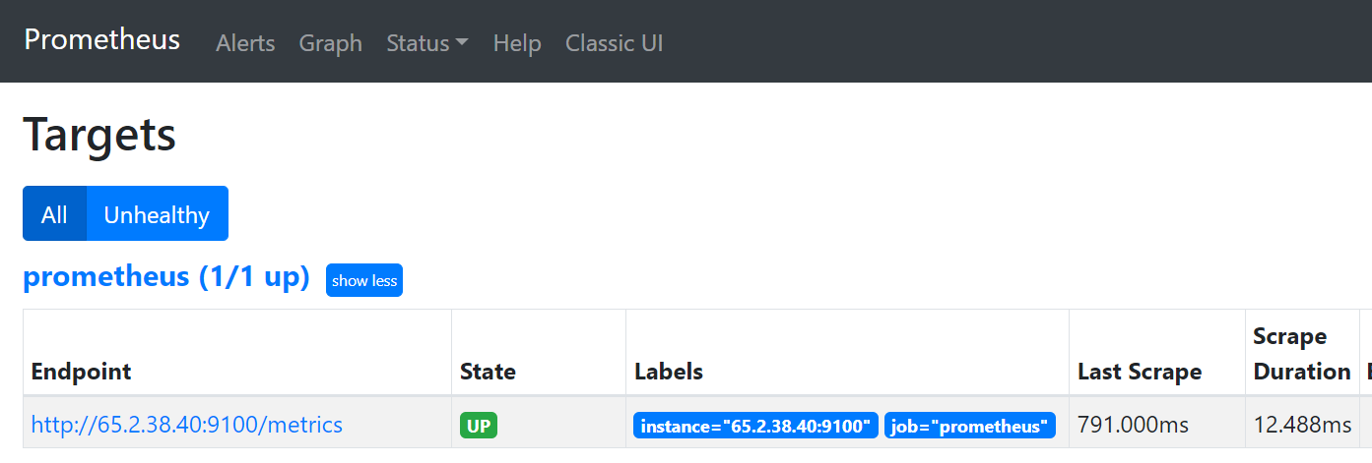

**Select metric in Grafana:**

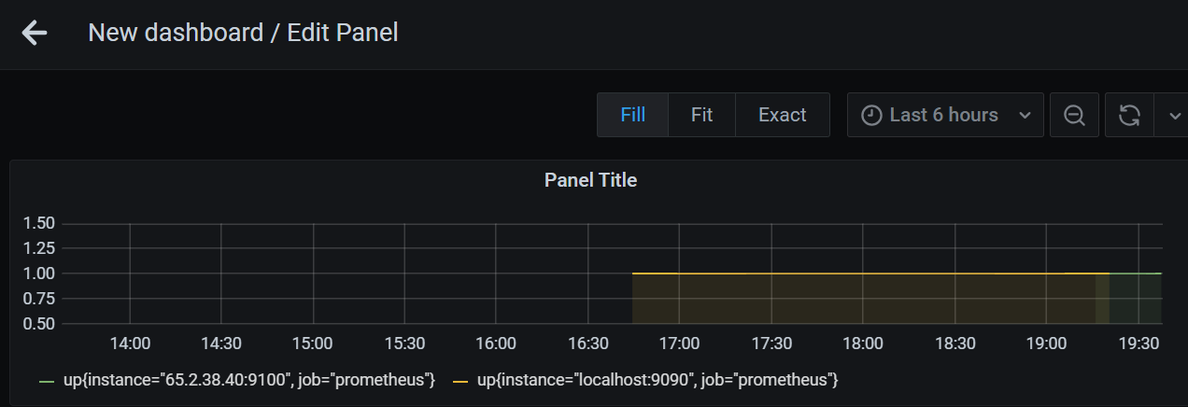

**Add multiple metrics in output:**

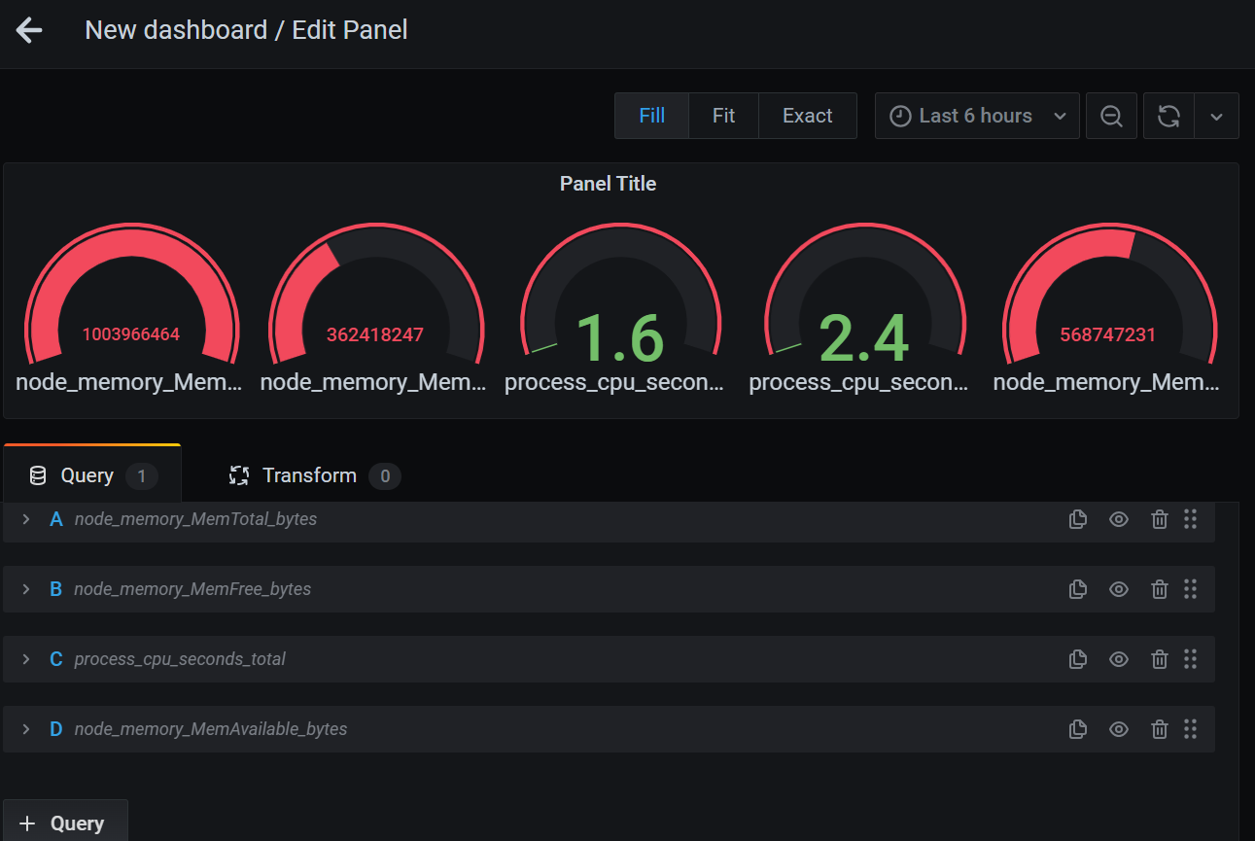

**Dashboard with metrics:**

