Create a custom docker image for nginx and deploy it using docker compose, where the volume bind mount should be at /var/opt/nginx location. Push the created custom docker image to your docker-hub.

**vi index.html**

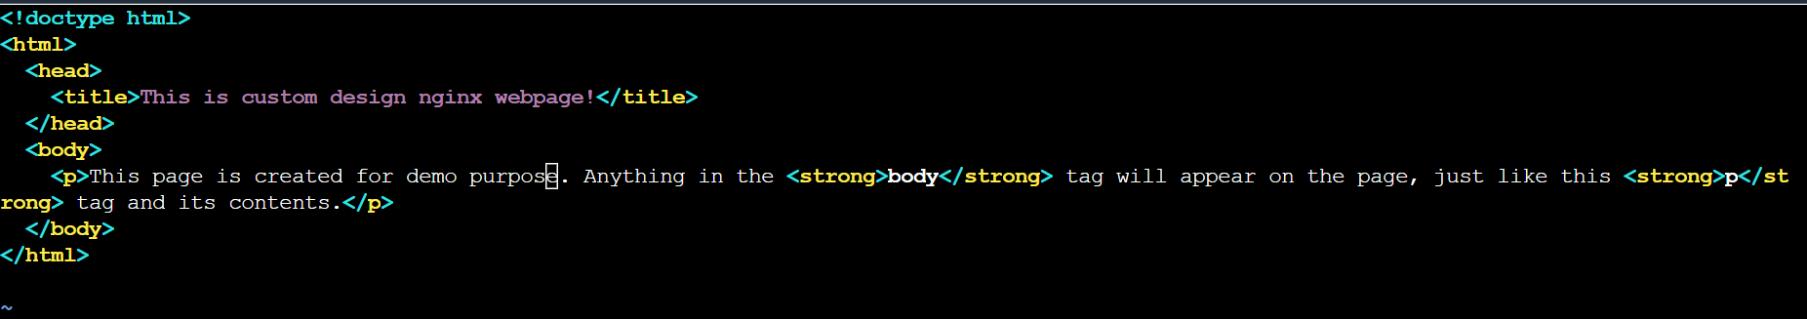

**vi dockerfile**

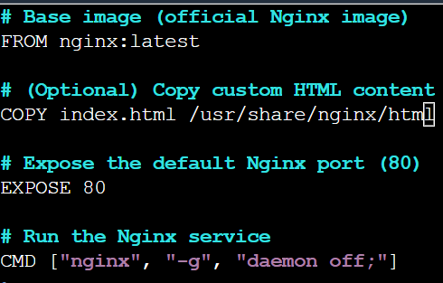

**docker build -t dock_nginx_cus .**

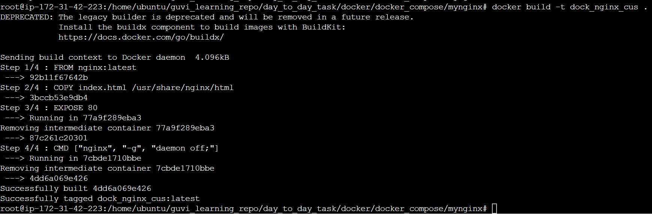

**vi docker-compose.yaml**

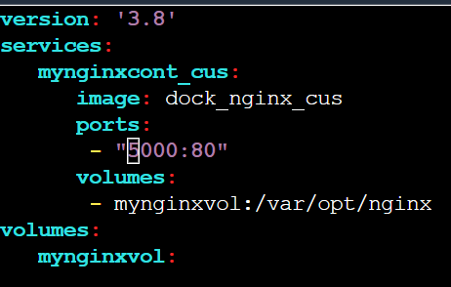

**docker-compose up -d**



**Webpage output:**



**Docker images pushed to docker hub repo:**

