Heatmaps gives a efficient visualization in present patterns, trends, and relationship within the data.

Example:

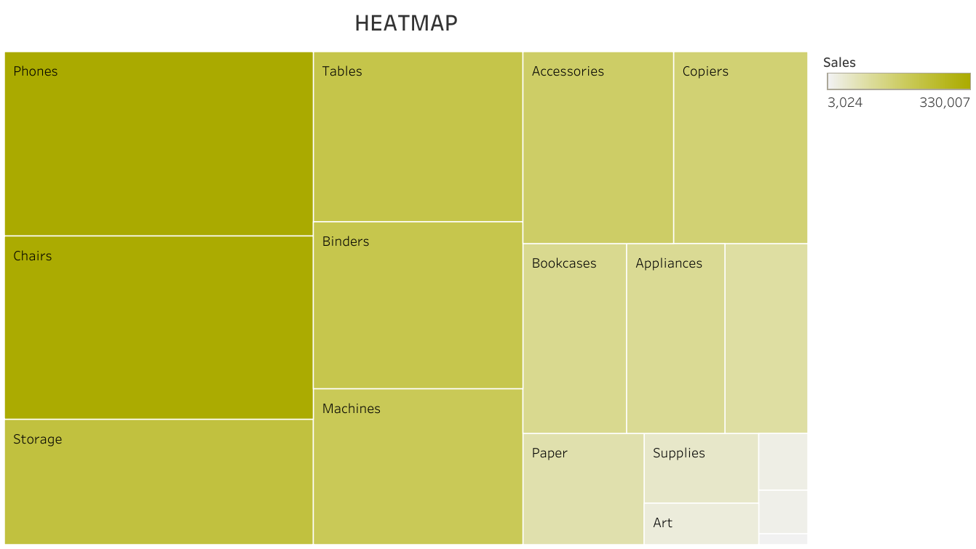

A Scatterplot shows the relationship between two quantitative variables measured for the same individuals.

Example:

