TUGAS 7 Activity Diagram and State Diagram
Nim : 1147050162
Nama : Susilawati
Kelas : Praktikum RPL Lanjut C
Kelompok : Susilawati, Ulfa Mardatillah

- Activity Diagram
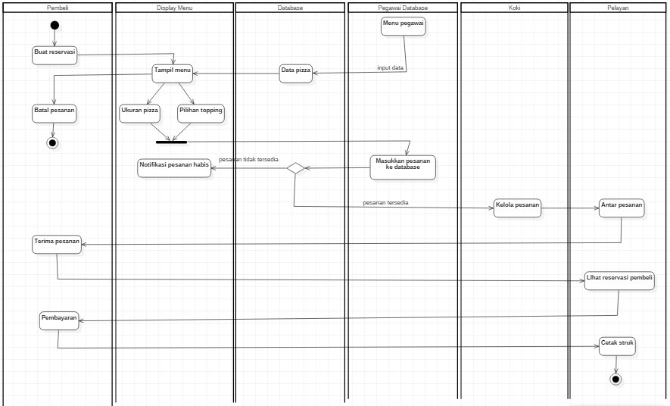

- State diagram
  - State Pembeli
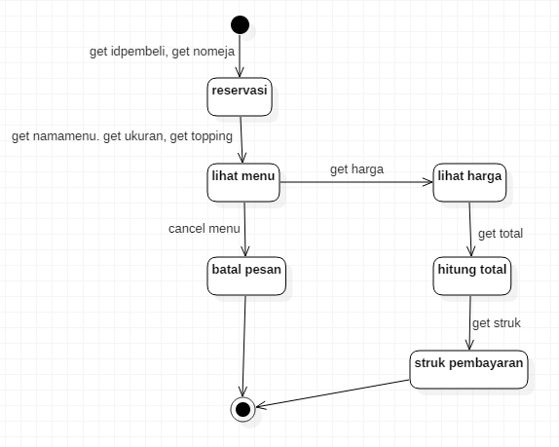
  - State Pizza
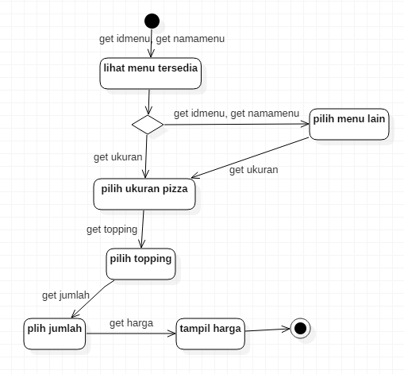

  - State koki
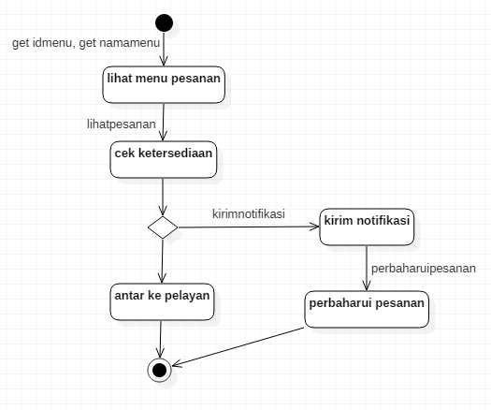

  - State pelayan
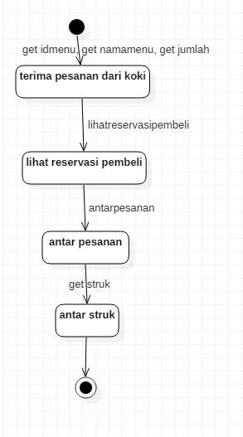

  - State pegawai database
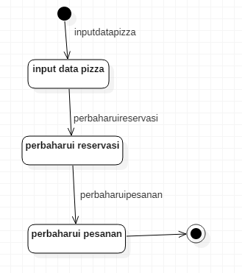
  - State pembayaran
