WEB APPLICATION DEVELOPMENT

COMP229009_2017F

**TEAM PROJECT**

**Ice Ski Shoes Rental Website**

**Member:**

**HOANG GIANG LE (300922977)**

Contents

Detailed description 3

Version History 3

Typography and Colour Section 4

Wireframes Section 4

Screen Capture Section 6

# Detailed description

A Website that build for an ice ski shoes rental user.

It allows users to view, update info of the shoes

You can choose whatever to sign in to be a member of the website

# Version History

Version 1: Finish design database + layout

Version 2: Finish main page (display all products)

Version 3: Detail Page can display all the product information

Version 4: User can modify product information on the detail page

Version 5: User can login or register

Version 6: Security functions to limit anonymous user from modify

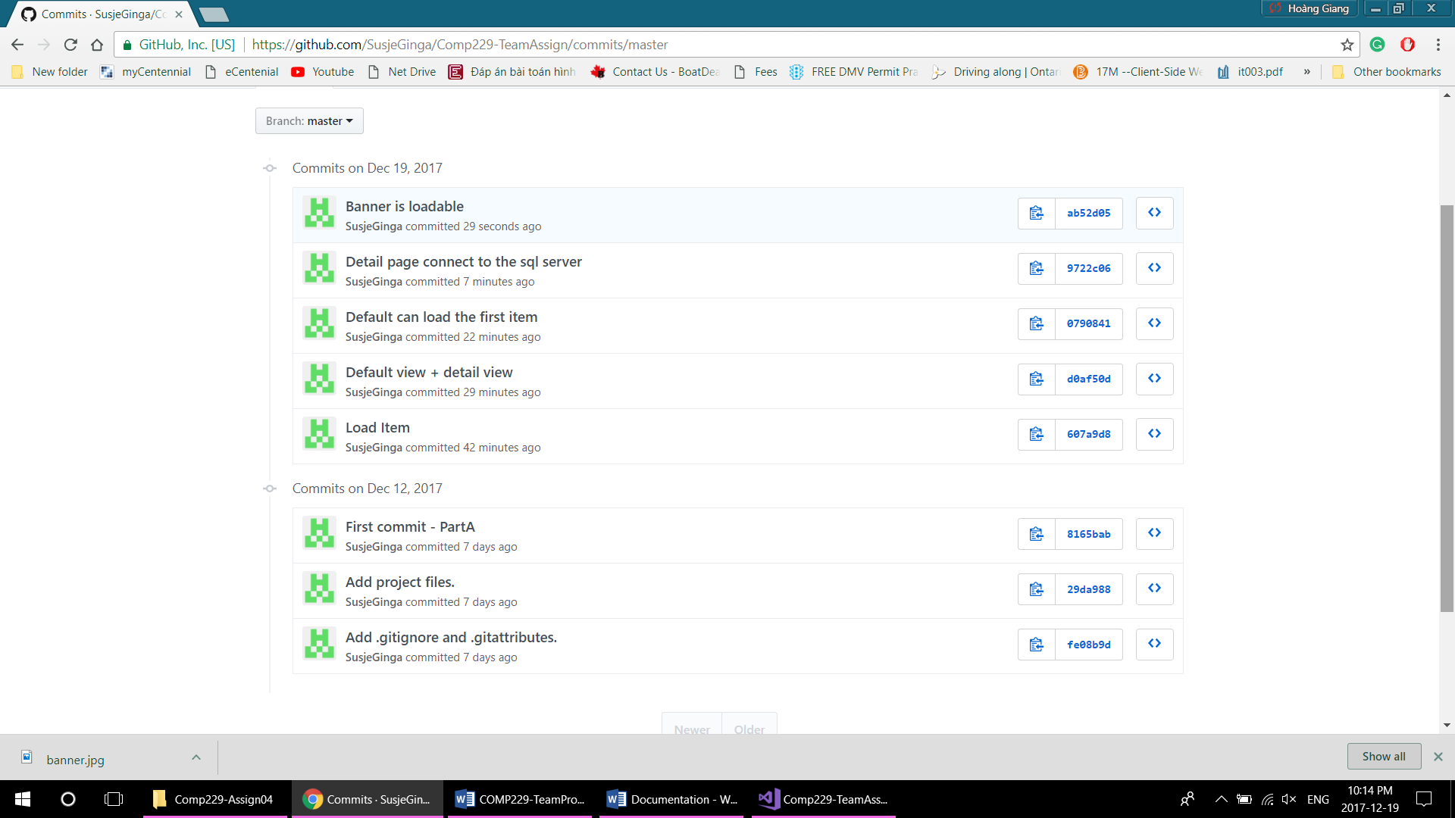

# Typography and Colour Section

All fonts are default by users

All colors will be by default by users

# Wireframes Section

The home page

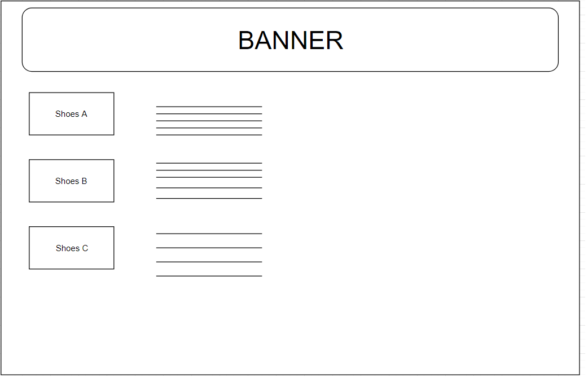

The detail page

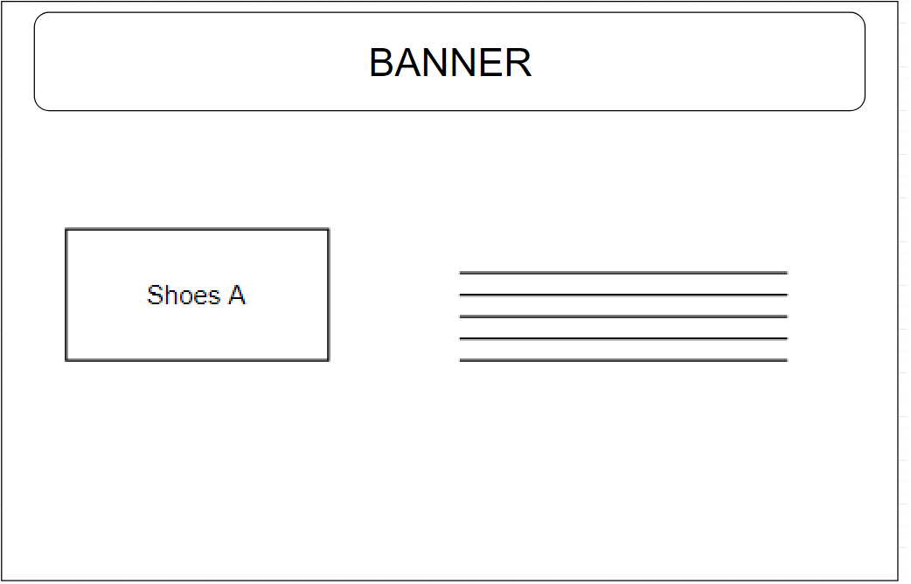

The Update page

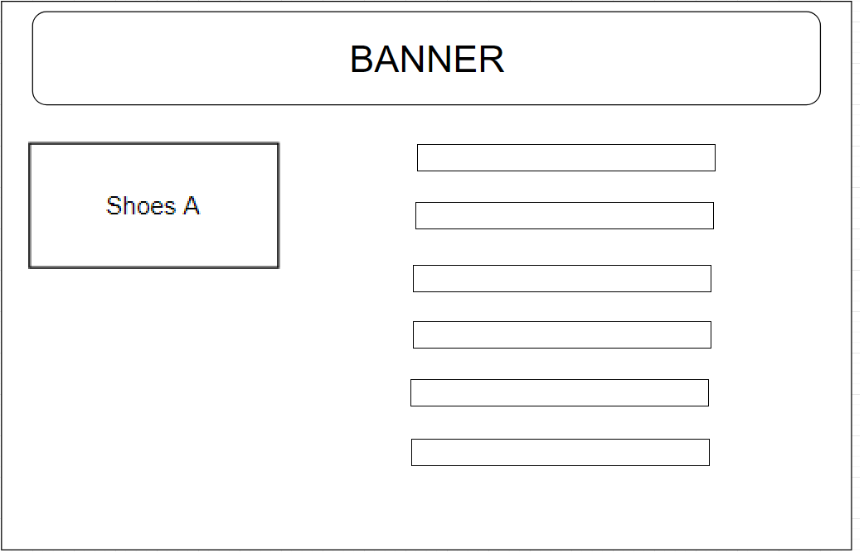

# Screen Capture Section

The home page

The updated home page

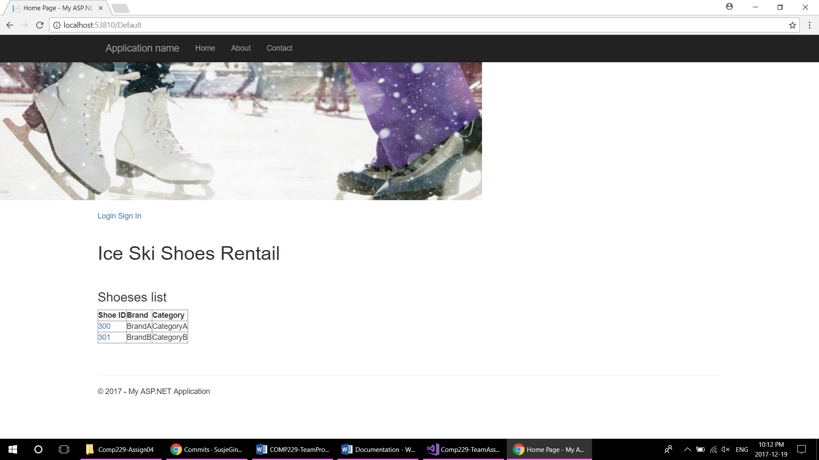

The detail page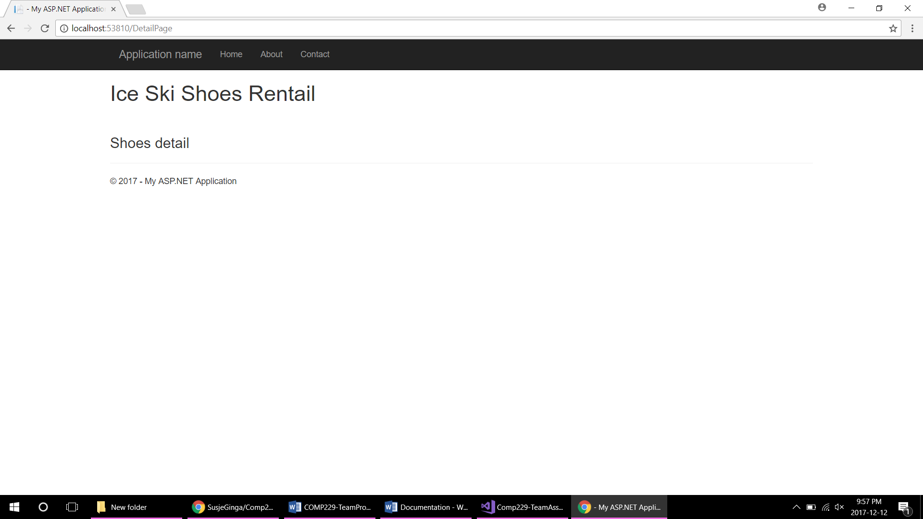

The sign in page

