A

Project Report on

**Energy consumption-Data Analytics**

**(Elective Module: 1)**

Submitted in partial fulfillment of completion of the course

Advanced Diploma in IT, Networking and Cloud Computing

Submitted by:

**Susma Kumari Singh**

Under Guidance of:

**Arpita Roy (Edunet)**

|  |  |  |
| --- | --- | --- |
| Description: IBM-Logo - Chicago Innovation | Description: DGT introduces high end diploma courses - digitalLEARNING Magazine | Description: Edunet Foundation-Delhi- CSR Organization profile |

Year 2023

**PROJECT OVERVIEW**

Abstract

Acknowledgement

Team Composition and Workload Division

Table of Contents

1. Introduction to Problem
2. Proposed Solution
3. Requirements

4.1 Technology Stack

4.2 Hardware

4.3 Software

4.4 Deployment Environment

5. User Requirements

6. Design Documentation

7. Implementation Details

8. Testing

9. Deployment

10. Future Scope

11. Conclusion

Appendix a Screenshot of Project

References

**ABSTRACT**

. This abstract provides a concise overview of the energy consumption issues in machine learning (ML). It outlines the escalating energy demands of ML applications and highlights challenges related to computational intensity, carbon footprint, and hardware choices. Current trends, including optimizations and distributed computing, are discussed as responses to these challenges. The abstract concludes by emphasizing the importance of sustainable solutions, encompassing responsible AI practices, renewable energy adoption, and collaborative efforts across disciplines to address the environmental impact of ML.

**ACKNOWLEDGEMENT**

We would like to express our sincere gratitude to all those who have supported and contributed to the successful completion of this project. Your assistance and encouragement have been invaluable throughout this journey.

First and foremost, we want to thank my project supervisors, Arpita Roy(Edunet) for their guidance, expertise, and unwavering support. Their insights and feedback have been instrumental in shaping the direction of this project.

We would also like to extend my appreciation to my fellow classmates who provided valuable input, shared resources, and engaged in stimulating discussions that enriched the project. Your collaborative spirit was a driving force behind our achievements.

Furthermore, we want to acknowledge our friends and family for their patience, understanding, and encouragement throughout this endeavor. Your support provided the motivation we needed to see this project through to its completion.

Last but not least, we are grateful to the entire faculty and staff of NSTI Kolkata for providing a conductive learning environment and the necessary resources to undertake this project.

This project has been a rewarding learning experience, and we are thankful for the collective efforts of everyone involved. Your support has been instrumental in making this project a reality.

Susma Kumari Singh,

NSTI KOLKATA

17/01/2024

**INTRODUCTION TO PROBLEM**

ML Advancements: Rapid evolution of machine learning (ML) technologies across various applications.

Computational Intensity: Escalating demand for computational power, especially in training deep learning models.

Environmental Impact: Large-scale model training contributes to a substantial environmental footprint, particularly in terms of carbon emissions.

Full Lifecycle Impact: Energy consumption extends beyond training to encompass the entire ML lifecycle, from data collection to deployment.

Hardware Decisions: Critical role of hardware choices in ML workflows, influencing overall energy efficiency.

Competitive Pressures: Organizations pursuing sophisticated ML models for competitive advantage may inadvertently intensify energy consumption.

Sustainable Imperative: Growing recognition of the need for sustainable solutions to balance technological advancements with environmental responsibility.

Host static files on IBM Cloud using IBM Cloud Object Storage.

Create a storage instance, upload files to a bucket, note API key and endpoint.

Deploy a simple web app on IBM Cloud Foundry with the static file build pack.

This can help protect against outages, safeguard against data loss, and help support disaster recovery strategies.

**PROPOSED SOLUTION**

In response to the pressing challenges posed by energy consumption, our proposed solution involves a comprehensive approach to analyse and interpret, energy consumption data. By harnessing the power of data analytics, this solution aims to uncover patterns, identify key factors, and inform evidence-based strategies for enhancing power saving.

Hosting static files on IBM Cloud ensures fast, reliable, and globally accessible content delivery, enhancing user experience, and optimizing web application performance.

**REQUIREMENTS**

**TECHNOLOGY STACK**

* Data Analysis and Machine Learning:

Building a robust technology stack for energy consumption data analysis involves selecting tools and technologies that can handle data collection, pre-processing, analysis, and visualization efficiently. Here's a suggested technology stack for energy consumption data analysis:

Python is a versatile language with rich libraries for data analysis and machine learning. Pandas and NumPy help with data manipulation, and Scikit-Learn provides tools for predictive modelling.

* Programming Languages: Python with Pandas, NumPy, and Scikit-Learn

**HARDWARE**

* CPU and RAM
* Storage: Adequate storage space for the csv file, application code, and uploaded files.
* Network Infrastructure: Reliable internet connectivity, firewalls, and security measures to protect the system.
* Processor: Intel(R) Core (TM) i5-9500 CPU @ 3.00GHz 3.00 GHz
* Installed RAM 8.00 GB (7.81 GB usable)
* System type 64-bit operating system, x64-based processor

**SOFTWARE**

* Operating System
* . IBM CLOUD : cloud object storage BY single website hosting.
* JUPYTER NOTEBOOK, POWER BI IBM CLOUD (DASHBOARD, JUPYTER)

**DEPLOYMENT ENVIRONMENT**

* The size and complexity of the project
* The security requirements of the project
* The budget for the project
* The technical expertise of the team

**USER REQUIREMENTS**

* Mobile Accessibility or PCs
* Internet Access
* Supported Browser
* Agreement to Terms

**DESIGN DOCUMENTATION**

**Step 1: Setup and Dependencies**

# Install required packages

import pandas as pd

import matplotlib.pyplot as plt

**Step 2: Data Loading**

Assuming you have a dataset in CSV format, load it into a Pandas DataFrame.

df=pd.read_csv('long_data.csv')

df

**Step 3: Data Preprocessing**

is a command used to display the first 5 rows of a DataFrame named.

print(df.head())

**Step 4: how many rows and columns of the DataFrame**

df.shape

**Step 5: used to understand the total number of elements in the DataFrame which type of data**

df.dtypes

**Step 6: show Top five states**

States_df=df['States’]

States_df.head()

**Step 7:** **Top five state, region, dates shows**

subset=df[['States','Regions','Dates']]

print(subset.head())

**SCREENSHOT OF PROJECT**

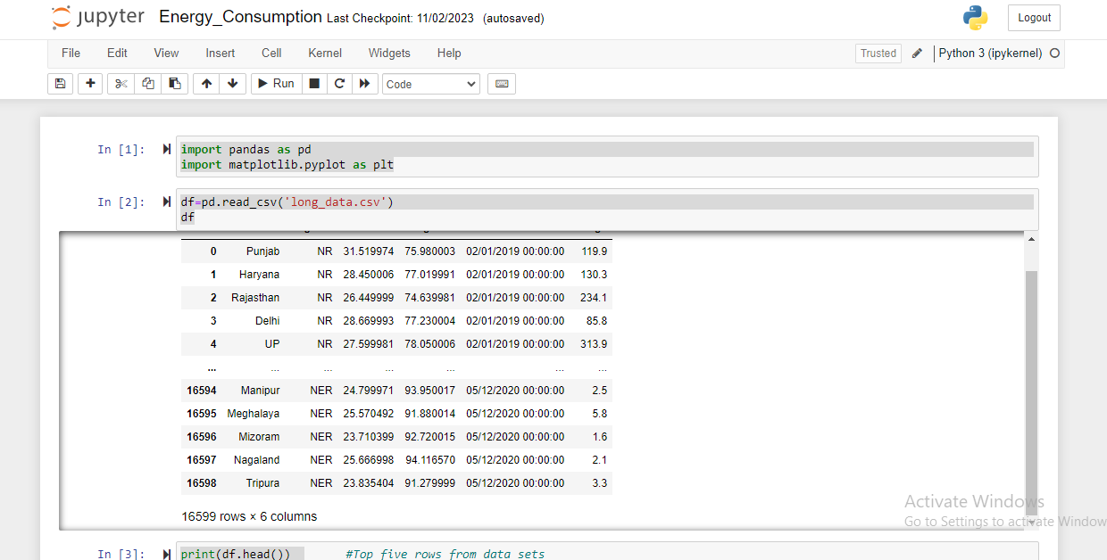

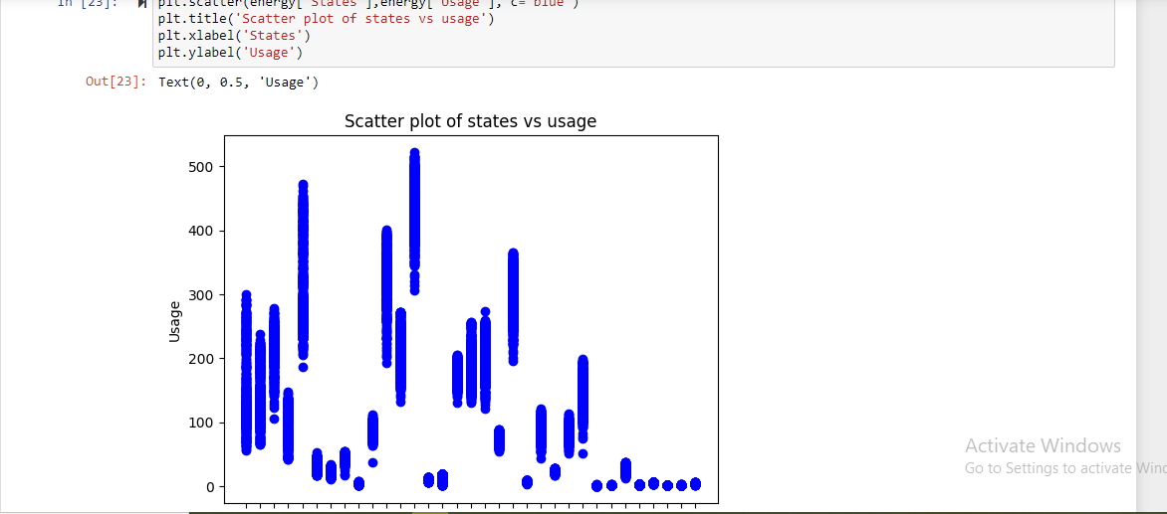



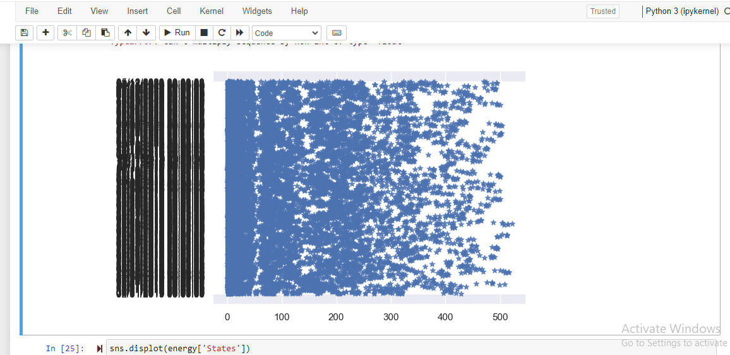

**IBM CLOUD(Screenshote)**

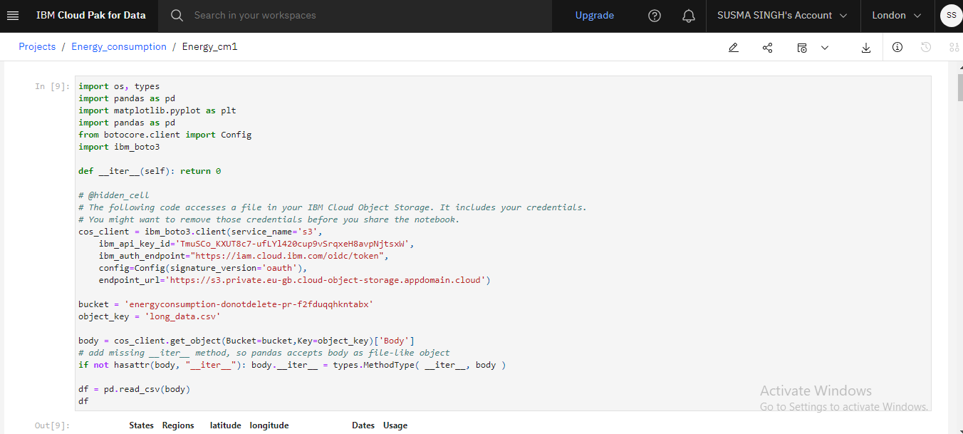

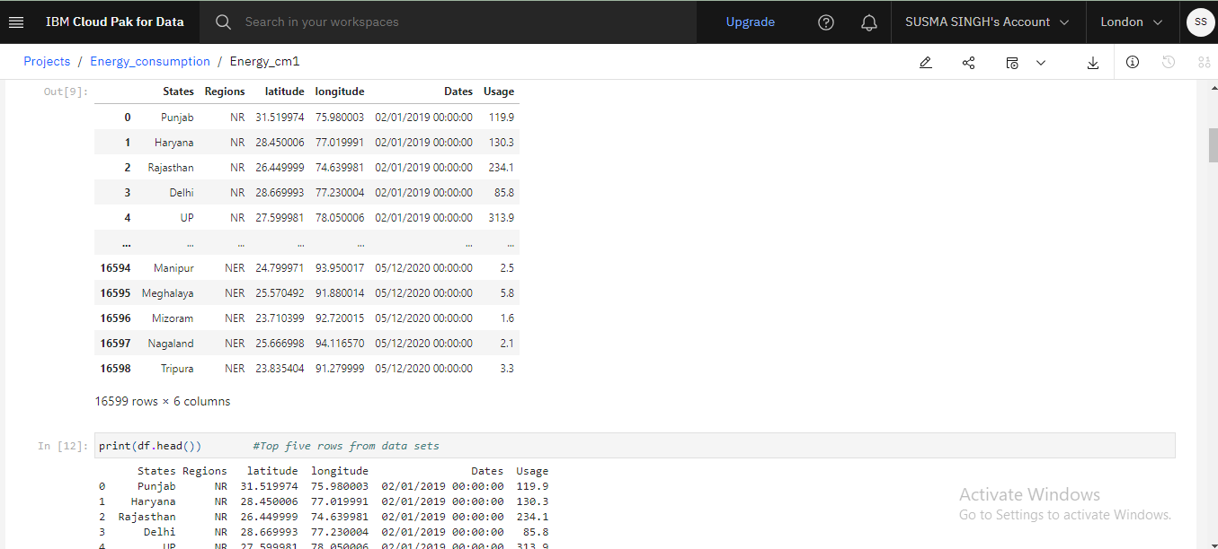

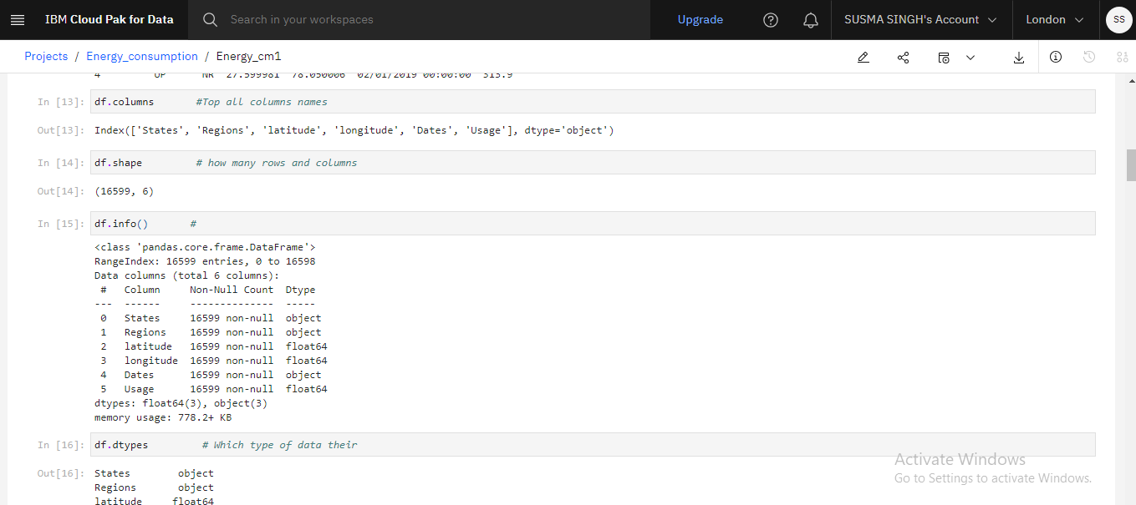

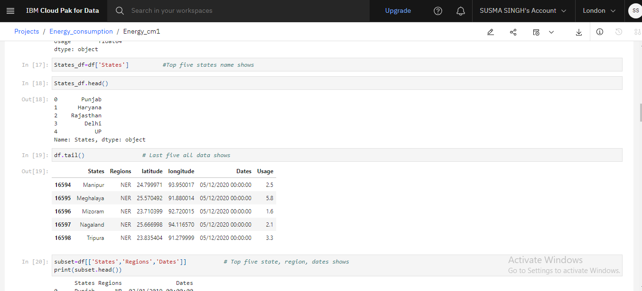

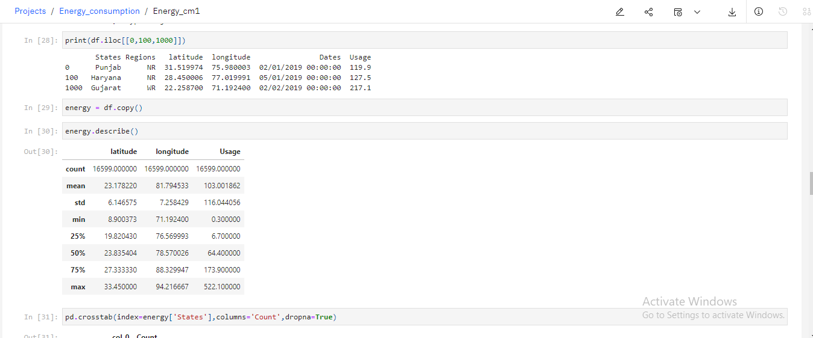

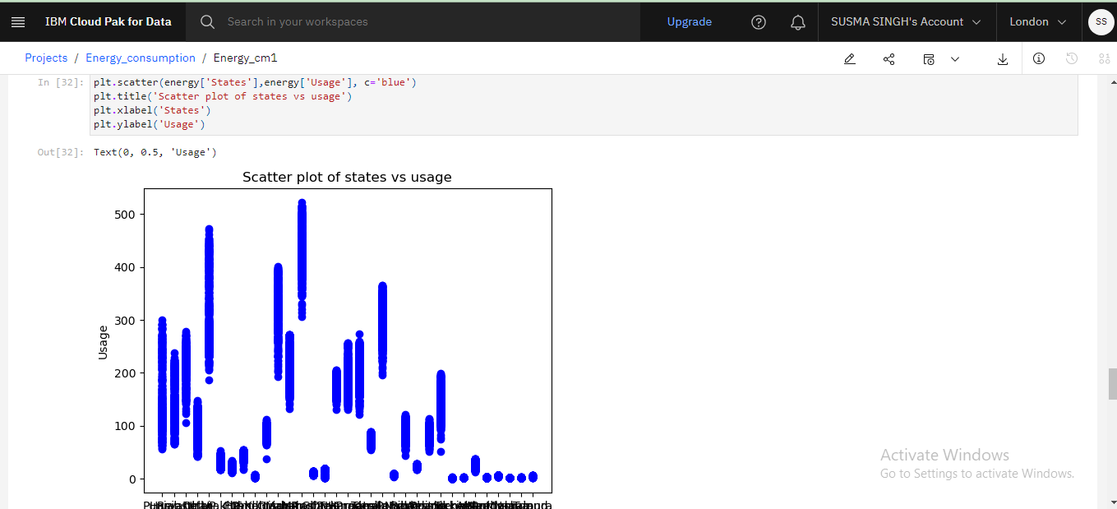

DASHBORD (Screenshot) 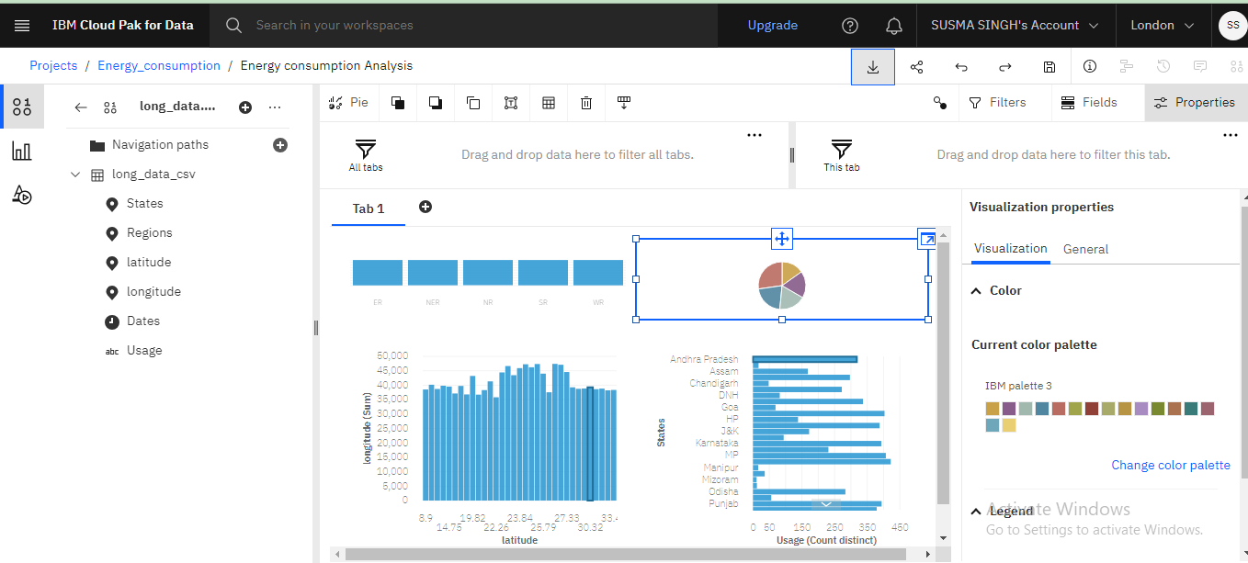

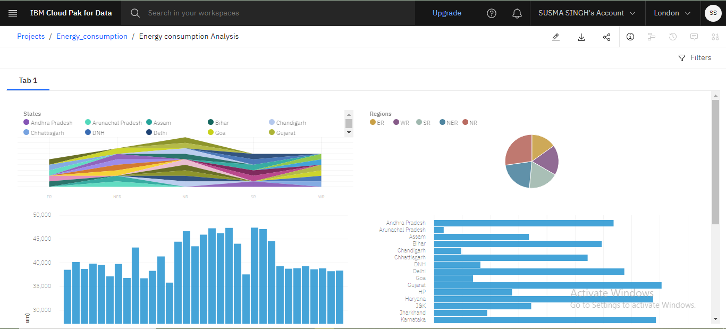

**FUTURE SCOPE**

The future of energy consumption in machine learning involves a combination of technological innovation, algorithmic advancements, and sustainable practices to ensure the continued growth of the field while minimizing its environmental impact.

**CONCLUSION**

Energy consumption data analysis is pivotal for informed decision-making in energy saving. Through data-driven insights, proactive measures can be implemented to prevent energy. Continuous technological advancements, holistic approaches, and global collaboration contribute to creating communities. The field's dynamic nature emphasizes the need for ongoing improvement and adaptation to address evolving challenges.