Sort Alphabetically. Do not display Inactive ports here.

Sort Alphabetically. Do not display Inactive ports here.

Carrier should come from table w2t_carrier . Sort order alphabetical

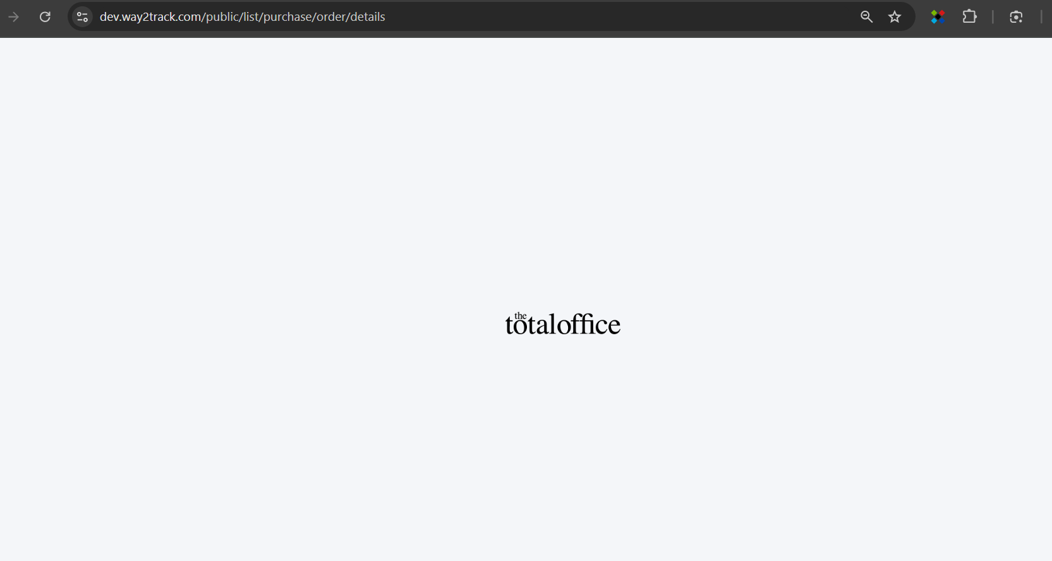

**After Import, performance issue . Unable to test further**

Insert now() into updated_at